ITITSB22029 - Đỗ Minh Duy – Miniproject

## Chap 1 GPIO

Step Motor 28BYJ

1. Analyze the codes, compile and Run the simulation of the project

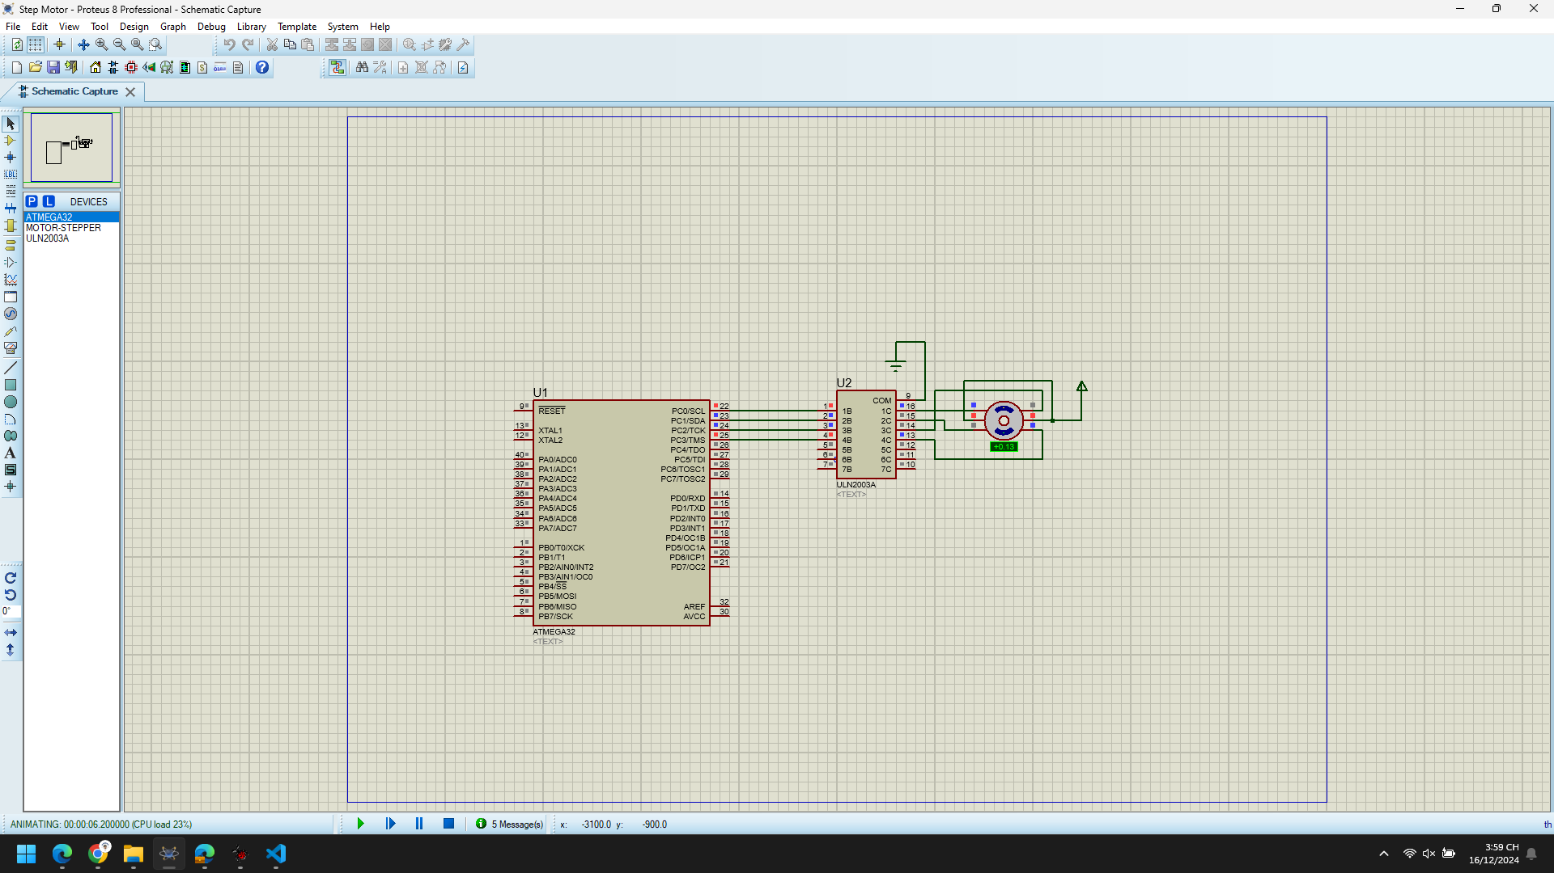

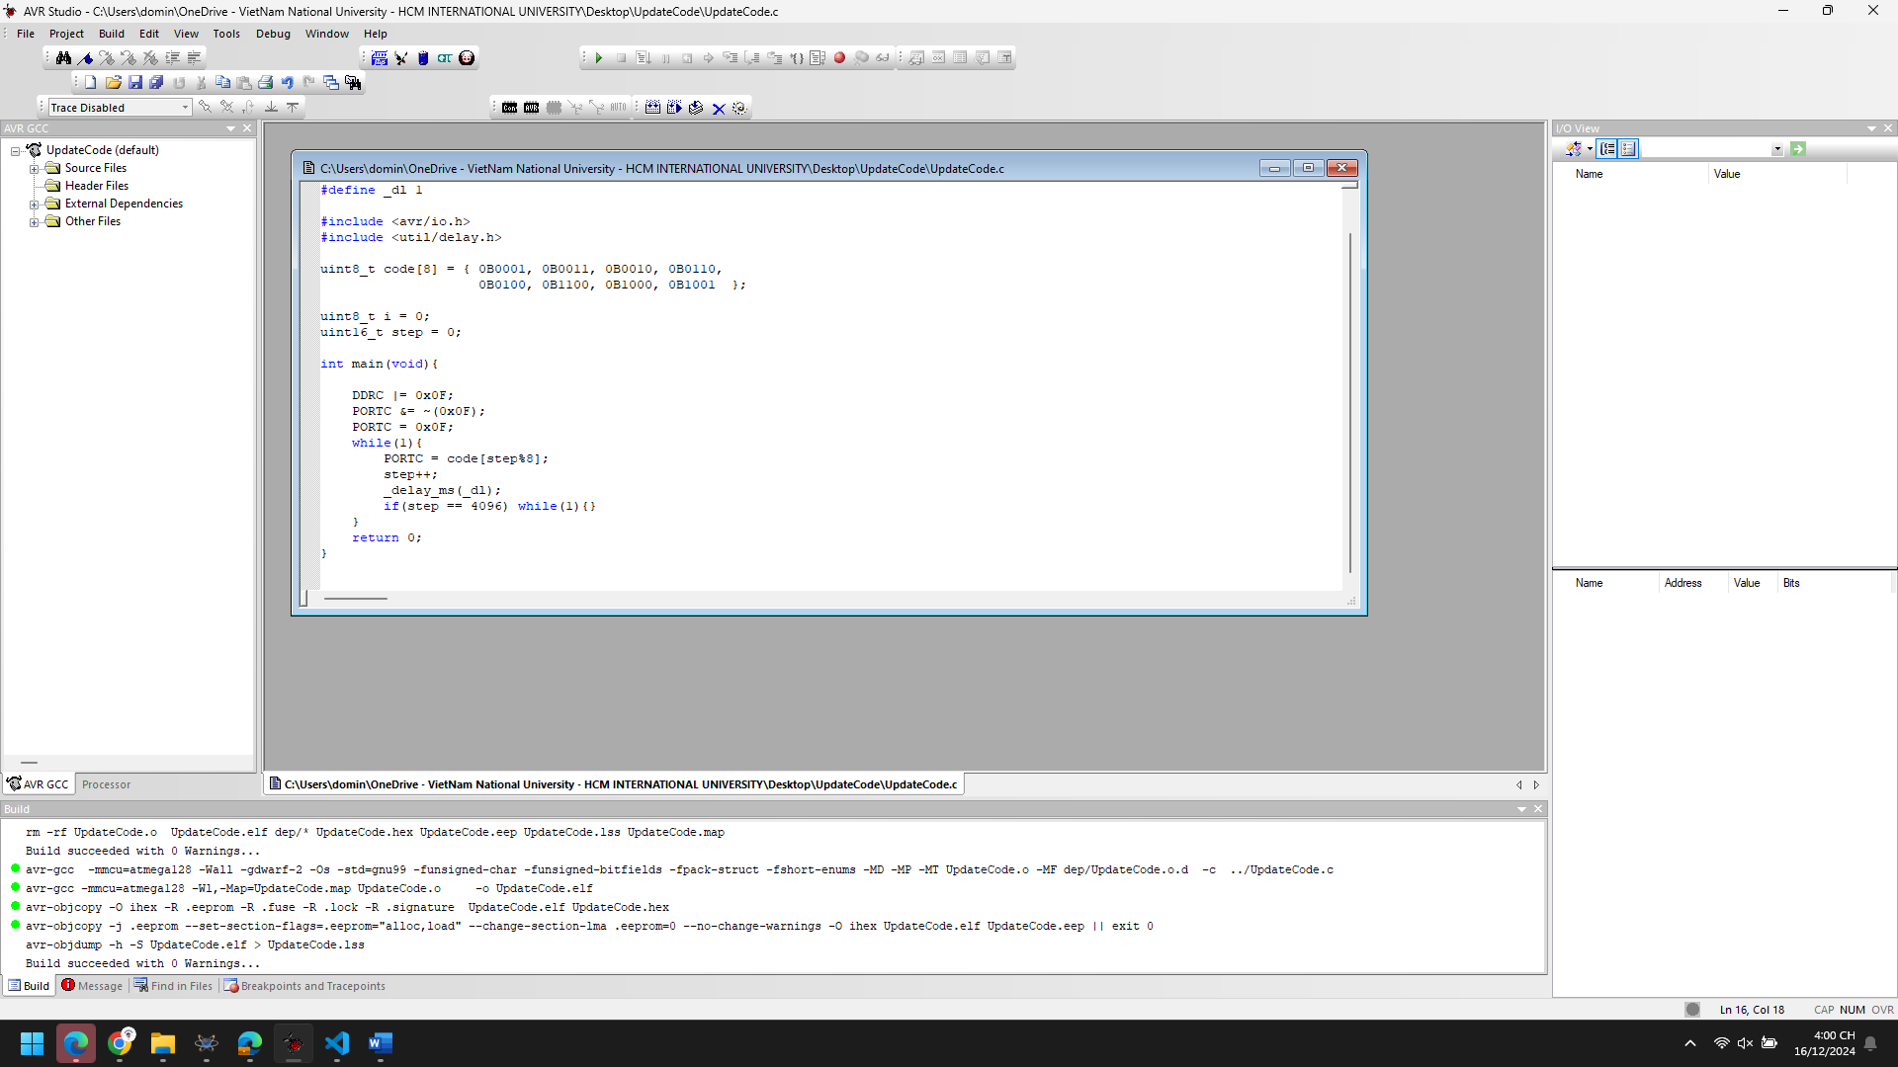

1. Explain the theory meaning of Related peripheral Registers using in the code of each project, Draw the Flow chart for important functions in this project

**DDRC (Data Direction Register for Port C)**: This register defines the direction of the pins on Port C (whether they are input or output). Setting a bit to 1 configures the corresponding pin as an output. In your code, DDRC |= 0x0F; means that the lower 4 bits (pins PC0 to PC3) are set as output, while the higher bits (PC4 to PC7) are left as input.

**PORTC (Data Register for Port C)**: This register controls the output values of the pins configured as outputs. By setting a bit to 1, it drives the corresponding pin high, and setting it to 0 drives the pin low. In your code:

* PORTC &= ~(0x0F); clears the lower 4 bits of Port C, setting PC0 to PC3 low (turns off LEDs or devices connected to these pins).
* PORTC = 0x0F; sets the lower 4 bits to 1, turning on LEDs or devices connected to those pins.

**delay_ms()**: This function from <util/delay.h> generates a delay in milliseconds, allowing the code to pause before moving on to the next step, typically used for timing control in embedded systems.

Start

|

|--> Initialize DDRC for output (lower 4 bits)

|--> Initialize PORTC (clear lower 4 bits, then set to 0x0F)

|

V

[Enter Infinite Loop]

|

|--> Set PORTC to code[step % 8] (change output based on 'step')

|

|--> Increment 'step' variable

|

|--> Wait for _dl ms delay

|

|--> Check if step == 4096

| |--> If true, enter an infinite loop (end of program)

| |

| V

| [Repeat Code Loop]

|

V

[End]

1. Improve codes and add more functions for each projects

#define F_CPU 16000000UL

#define _dl 500 // Delay in milliseconds, can be changed for timing control

#include <avr/io.h>

#include <util/delay.h>

uint8_t code[8] = { 0B0001, 0B0011, 0B0010, 0B0110,

0B0100, 0B1100, 0B1000, 0B1001 };

// Additional pattern for cycling

uint8_t extraCode[8] = { 0B1111, 0B0101, 0B1010, 0B1101,

0B0011, 0B1110, 0B1001, 0B0111 };

uint8_t i = 0;

uint16_t step = 0;

void initPortC() {

// Initialize Port C for output (lower 4 bits)

DDRC |= 0x0F; // Set PC0 to PC3 as output

PORTC &= ~(0x0F); // Set all outputs low

}

void setPattern(uint8_t pattern) {

// Set the output pattern on PORTC

PORTC = pattern;

}

void delayMs(uint16_t ms) {

// Delay for specified milliseconds

while (ms--) {

_delay_ms(1);

}

}

void cyclePatterns(uint8_t patternArray[], uint8_t patternCount) {

// Cycle through patterns in the given array

setPattern(patternArray[step % patternCount]);

step++;

}

void resetStep() {

// Reset the step counter to 0

step = 0;

}

int main(void) {

// Initialize Port C

initPortC();

while (1) {

// Cycle through the main pattern code

cyclePatterns(code, 8);

delayMs(_dl); // Wait for a short period

// Optional: Cycle through additional patterns

if (step % 16 == 0) { // Example condition to switch to extraCode pattern

cyclePatterns(extraCode, 8);

delayMs(_dl); // Wait for a short period

}

// Stop execution when step reaches 4096

if (step == 4096) {

resetStep(); // Reset step counter

while (1) {} // Infinite loop to halt the program

}

}

return 0;

}

**Key Improvements:**

1. **Modularized Functions**:
   * initPortC(): Initializes the port for output.
   * setPattern(uint8_t pattern): Sets the pattern on PORTC.
   * delayMs(uint16_t ms): Provides a delay in milliseconds.
   * cyclePatterns(uint8_t patternArray[], uint8_t patternCount): Cycles through a pattern array based on the step variable.
   * resetStep(): Resets the step counter.
2. **New Pattern Array (extraCode)**: I added a new set of patterns (extraCode[]) that can be used to alternate the display. This is just an example, and you can add any pattern you like.
3. **Pattern Cycling**: The cyclePatterns function now accepts an array of patterns and the number of patterns to cycle through. You can easily switch between different patterns or add new patterns as needed.
4. **Step Resetting**: When step == 4096, the code resets step to 0 and halts further execution, which might be useful for longer cycles.

**Flexibility:**

* You can easily modify the delay time (_dl), pattern arrays, and the step condition to customize the behavior.
* The code can be extended with more patterns or additional control logic as per the requirements of the project.

## Chap 2 Button Matrix

Digital Lock

1. Analyze the codes, compile and Run the simulation of the project

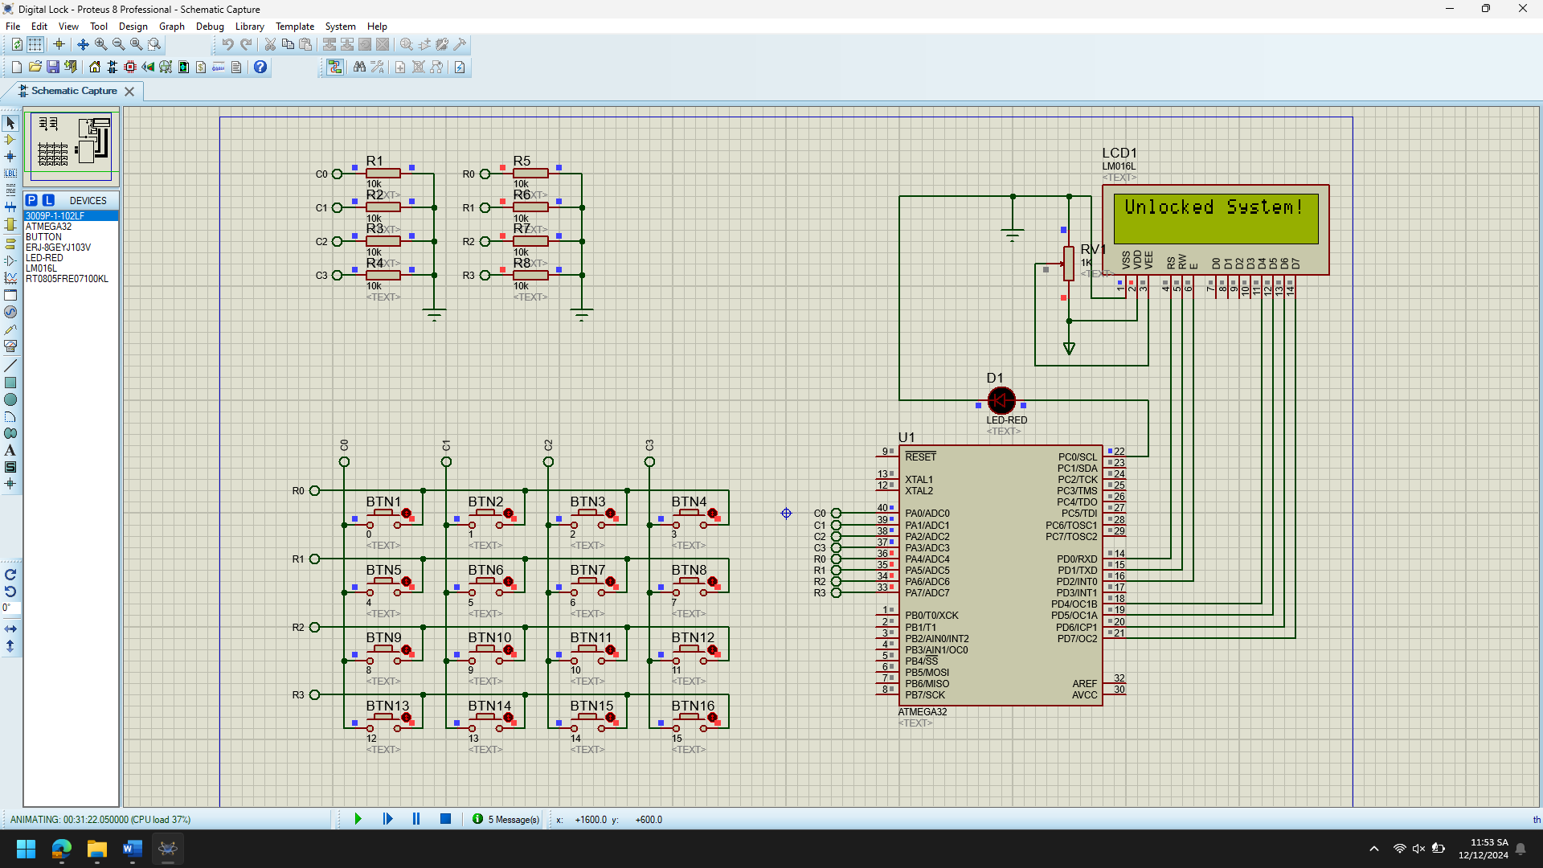

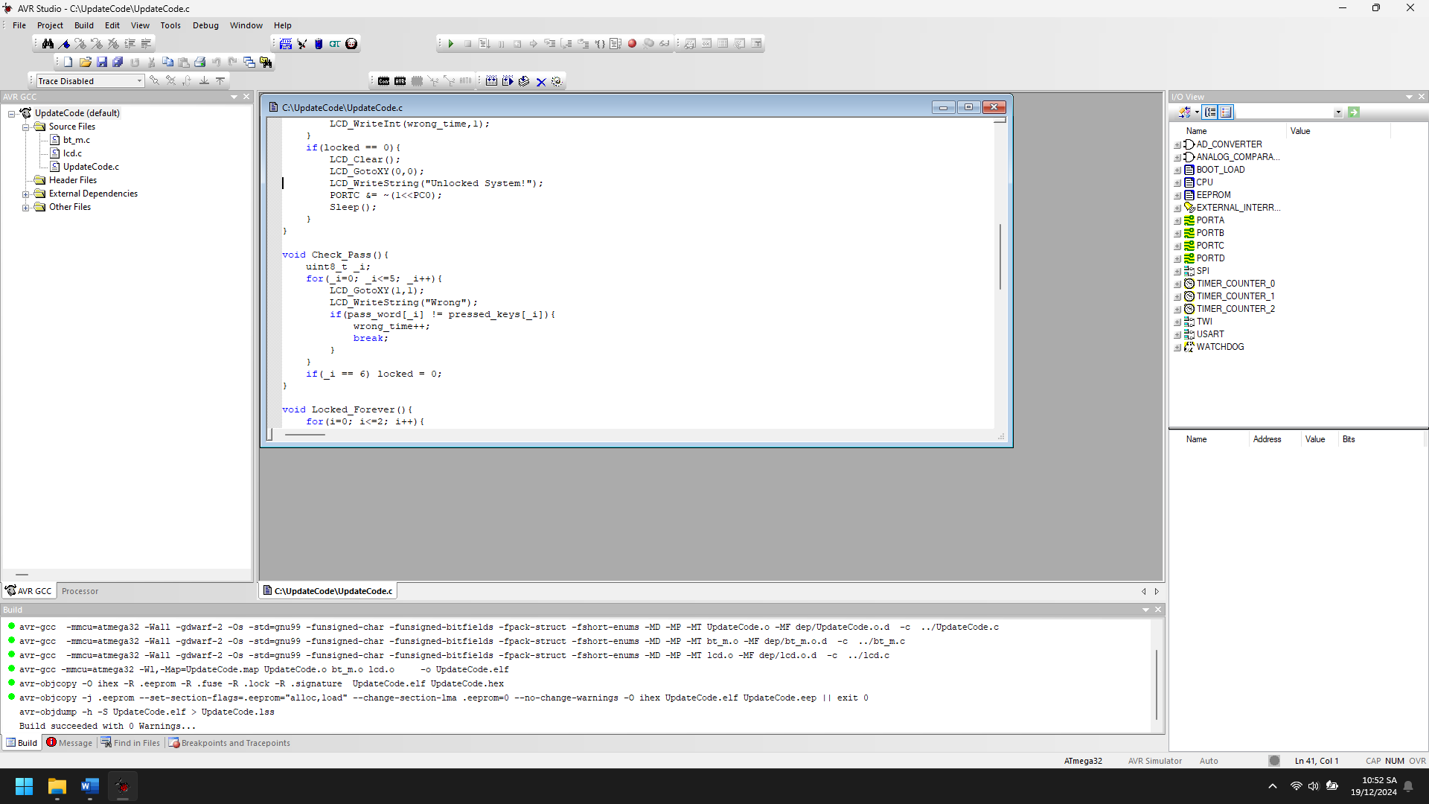

1. Explain the theory meaning of Related peripheral Registers using in the code of each project, Draw the Flow chart for important functions in this project

The code in question is written for an AVR microcontroller, and it uses a few peripherals such as GPIO ports, an LCD for display, and a keypad input. Here's an explanation of the related peripheral registers used in the code:

1. **GPIO Registers (PORT, DDR, PIN):**
   * **PORTx (e.g., PORTB, PORTD, PORTC)**: These are the Data Registers. Writing to PORTx controls the state (high or low) of the pins in that port. If the corresponding pin is configured as an output, writing to PORTx sets the output value. If the pin is configured as an input, writing to PORTx controls the internal pull-up resistors (enabled if set to 1, disabled if set to 0).
   * **DDRx (e.g., DDRB, DDRD, DDRC)**: These are the Data Direction Registers. Each bit controls whether the corresponding pin is configured as an input (0) or output (1). In this code, DDRC |= (1<<PC0); sets pin PC0 of port C as an output, and DDRB = 0; and DDRD = 0; disable pins PB and PD as outputs when entering sleep mode.
   * **PIND, PINB, PINC**: These are Input Pins Registers. They are used to read the input state of pins on the respective port. For example, PIND would be used to read the value of the pins of port D.
2. **LCD Registers:** The code uses the **LCD** library to interface with a character LCD, which usually communicates through parallel data lines. The functions LCD_Init(), LCD_Clear(), LCD_GotoXY(), LCD_WriteString(), and LCD_WriteInt() are used to interact with the LCD, but these are dependent on the specific microcontroller and the library that is being used.
   * These functions generally manipulate the data and control lines of the LCD (RS, RW, E) and write data to the LCD's data pins (D0-D7).
3. **Timer/Delay:**
   * **_delay_ms()**: This function is used to introduce a delay. The F_CPU value is used to calculate the delay period, which is typically implemented by the compiler using timers or other delay techniques.
4. **Other Registers:**
   * **_RET**: This variable is used to indicate whether the system should go to sleep (enter the Sleep() function). It’s used as a flag to indicate the system's state.
   * **Pressed keys (pressed_keys[])**: This array stores the key values entered by the user through the keypad. It keeps track of the sequence of keys pressed and is displayed on the LCD.

Main Function:

|

v

Initialize LCD

|

v

Display Initial State

|

v

While Loop (Main)

|

v

Check Keypad Input

|

v

Is key pressed?

|

v

Yes

|

v

Is Special Key (Clear / Enter)?

| |

v v

Yes No

| |

v v

Check Password Update pressed_keys[]

| |

v v

Password Match? Is Wrong Attempt >= 3?

| |

v v

Yes Yes

| |

v v

Unlock System Show "Locked Forever"

| |

v v

End End

|

v

No

|

v

Increment Wrong Attempt Counter

|

v

Display Wrong Message

|

v

End

Sleep Function:

|

v

Set PORTB, PORTD, DDRB, DDRD to 0

|

v

Return to Main

Display_LCD Function:

|

v

Clear LCD

|

v

Display Pressed Keys & Wrong Attempts

|

v

End

Check_Pass Function:

|

v

Compare Password Characters

|

v

Password Match? (if not increment wrong attempt counter)

|

v

End

Locked_Forever Function:

|

v

Show Locked Message with Countdown

|

v

End

Shift_Keys Function:

|

v

Shift Keys & Add New Key

|

v

Return New Key

|

v

End

1. Improve codes and add more functions for each projects

#define F_CPU 16000000UL

#include <avr/io.h>

#include <util/delay.h>

#include "lcd.h"

#include "bt_m.h"

char key_pad[16] = "123A456B789C*0#D";

char pressed_keys[6] = "------"; // To store the pressed keys

char pass_word[] = "*2008B"; // Password

uint8_t i, j, wrong_time = 0, locked = 1, _RET = 0, reset_timer = 0;

uint8_t temp, l_temp;

uint16_t lock_timer = 0; // Timer for lock period

// Pin configuration for feedback (LED for lock/unlock indication)

#define LOCKED_LED_PIN PC0

// Function to initialize the system

void Initialize_System() {

LCD_Init(LS_NONE);

LCD_Clear();

_delay_ms(2);

DDRC |= (1 << LOCKED_LED_PIN); // Set LED pin as output

PORTC |= (1 << LOCKED_LED_PIN); // Turn on LED to indicate system is locked

Display_LCD();

}

// Function to turn off the system and enter low-power mode

void Sleep() {

PORTB = 0;

PORTD = 0;

DDRB = 0;

DDRD = 0;

_RET = 1;

}

// Function to display information on LCD

void Display_LCD() {

LCD_Clear();

LCD_GotoXY(1, 0);

LCD_WriteString("Key: ");

LCD_GotoXY(5, 0);

LCD_WriteString("_ _");

LCD_GotoXY(6, 0);

LCD_WriteString(pressed_keys);

if (wrong_time >= 1) {

LCD_GotoXY(0, 1);

LCD_WriteString("Wrong Password");

LCD_GotoXY(15, 1);

LCD_WriteInt(wrong_time, 1);

}

if (locked == 0) {

LCD_Clear();

LCD_GotoXY(0, 0);

LCD_WriteString("Unlocked System!");

PORTC &= ~(1 << LOCKED_LED_PIN); // Turn off LED to indicate system is unlocked

Sleep(); // Enter sleep mode after unlocking

}

}

// Function to check the entered password

void Check_Pass() {

uint8_t _i;

for (_i = 0; _i < 6; _i++) {

LCD_GotoXY(1, 1);

LCD_WriteString("Checking...");

if (pass_word[_i] != pressed_keys[_i]) {

wrong_time++;

break;

}

}

if (_i == 6) {

locked = 0; // Unlock system if password is correct

}

}

// Function to lock the system forever after 3 wrong attempts

void Locked_Forever() {

for (i = 0; i <= 2; i++) {

LCD_Clear();

LCD_GotoXY(0, 0);

LCD_WriteString("Locked Forever!");

LCD_GotoXY(0, 1);

LCD_WriteString("Try again in:");

LCD_GotoXY(6, 1);

LCD_WriteInt((2 - i), 1);

_delay_ms(1000);

}

LCD_Clear();

LCD_GotoXY(0, 0);

LCD_WriteString("Locked Forever!");

Sleep(); // Enter sleep mode after locking

}

// Function to shift keys in the pressed_keys array

char Shift_Keys(uint8_t _temp) {

for (i = 0; i <= 4; i++) pressed_keys[i] = pressed_keys[i + 1];

return key_pad[_temp];

}

// Function to check if the user input is a key press

uint8_t Check_Keypad() {

return Check_key(); // Assuming Check_key() is implemented in the bt_m.h library

}

// Function to reset the system if locked for too long

void Reset_System() {

locked = 1;

wrong_time = 0;

lock_timer = 0;

PORTC |= (1 << LOCKED_LED_PIN); // Turn on LED to indicate system is locked

}

// Function to manage the timeout for locking

void Lock_Timer() {

if (locked == 1) {

if (lock_timer < 30) { // Timeout duration (e.g., 30 seconds)

lock_timer++;

LCD_GotoXY(0, 1);

LCD_WriteString("Locking in: ");

LCD_WriteInt(30 - lock_timer, 2);

} else {

Reset_System(); // Reset the system after timeout

}

}

}

int main(void) {

Initialize_System();

while (1) {

PORTA = 0;

temp = Check_Keypad();

if ((temp != l_temp) && (temp < 16)) {

if (temp == 11) { // Clear input

for (i = 0; i < 6; i++) pressed_keys[i] = '-';

} else if (temp == 15) { // Enter password

Check_Pass();

} else {

pressed_keys[5] = Shift_Keys(temp); // Add new key

}

if (wrong_time == 3) {

Locked_Forever(); // Lock the system after 3 wrong attempts

}

Display_LCD(); // Update LCD display

}

l_temp = temp;

// Lock timeout handling

Lock_Timer();

// Wait for debounce

_delay_ms(50);

if (_RET == 1) break; // Exit when system is in sleep mode

}

return 0;

}

**Key Changes and New Features:**

1. **Initialize_System**: A function to initialize the system components (LCD, LED, etc.) and provide initial feedback (locked system).
2. **Lock_Timer**: Manages the timer for the lock-out duration. It counts up to a timeout value and then resets the system after that duration.
3. **Reset_System**: Resets the system after a timeout or prolonged lock-out, including resetting the wrong attempt counter.
4. **LED Feedback**: The system provides visual feedback using an LED on PC0, indicating whether the system is locked or unlocked.
5. **Password Check with Timer**: The password check and wrong attempts are now more robust. If the system is locked for too long, it will reset itself after a timeout (e.g., 30 seconds).
6. **Improved Key Handling**: Key presses are shifted and validated, ensuring proper handling of user inputs.

**Additional Notes:**

* **Keypad Debouncing**: A simple delay (_delay_ms(50)) is used for keypress debouncing. For more robust debouncing, you might want to implement a more advanced debounce algorithm or use a timer interrupt for key reading.
* **System Reset**: After a series of wrong attempts, the system can now reset itself after a timeout (useful for security).

Message Sender

1. Analyze the codes, compile and Run the simulation of the project

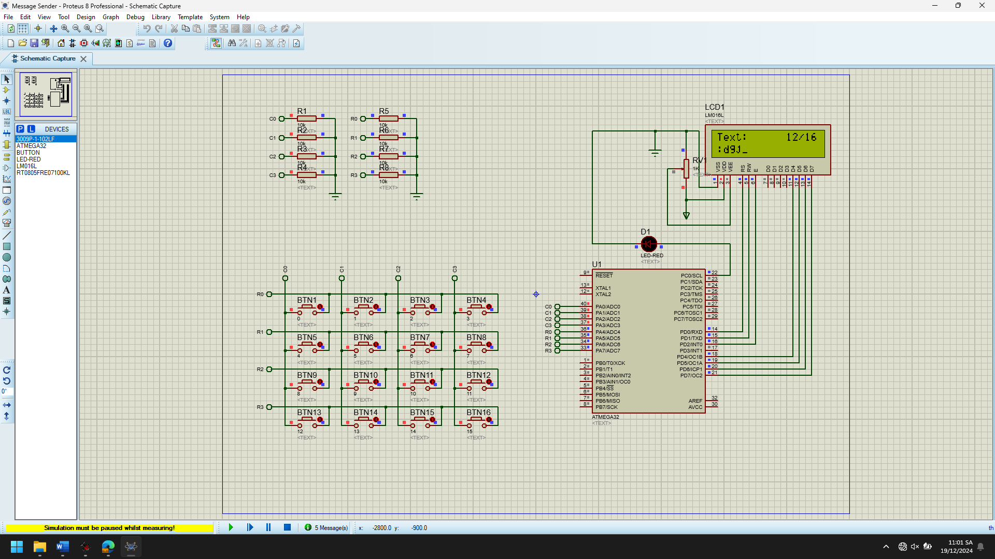

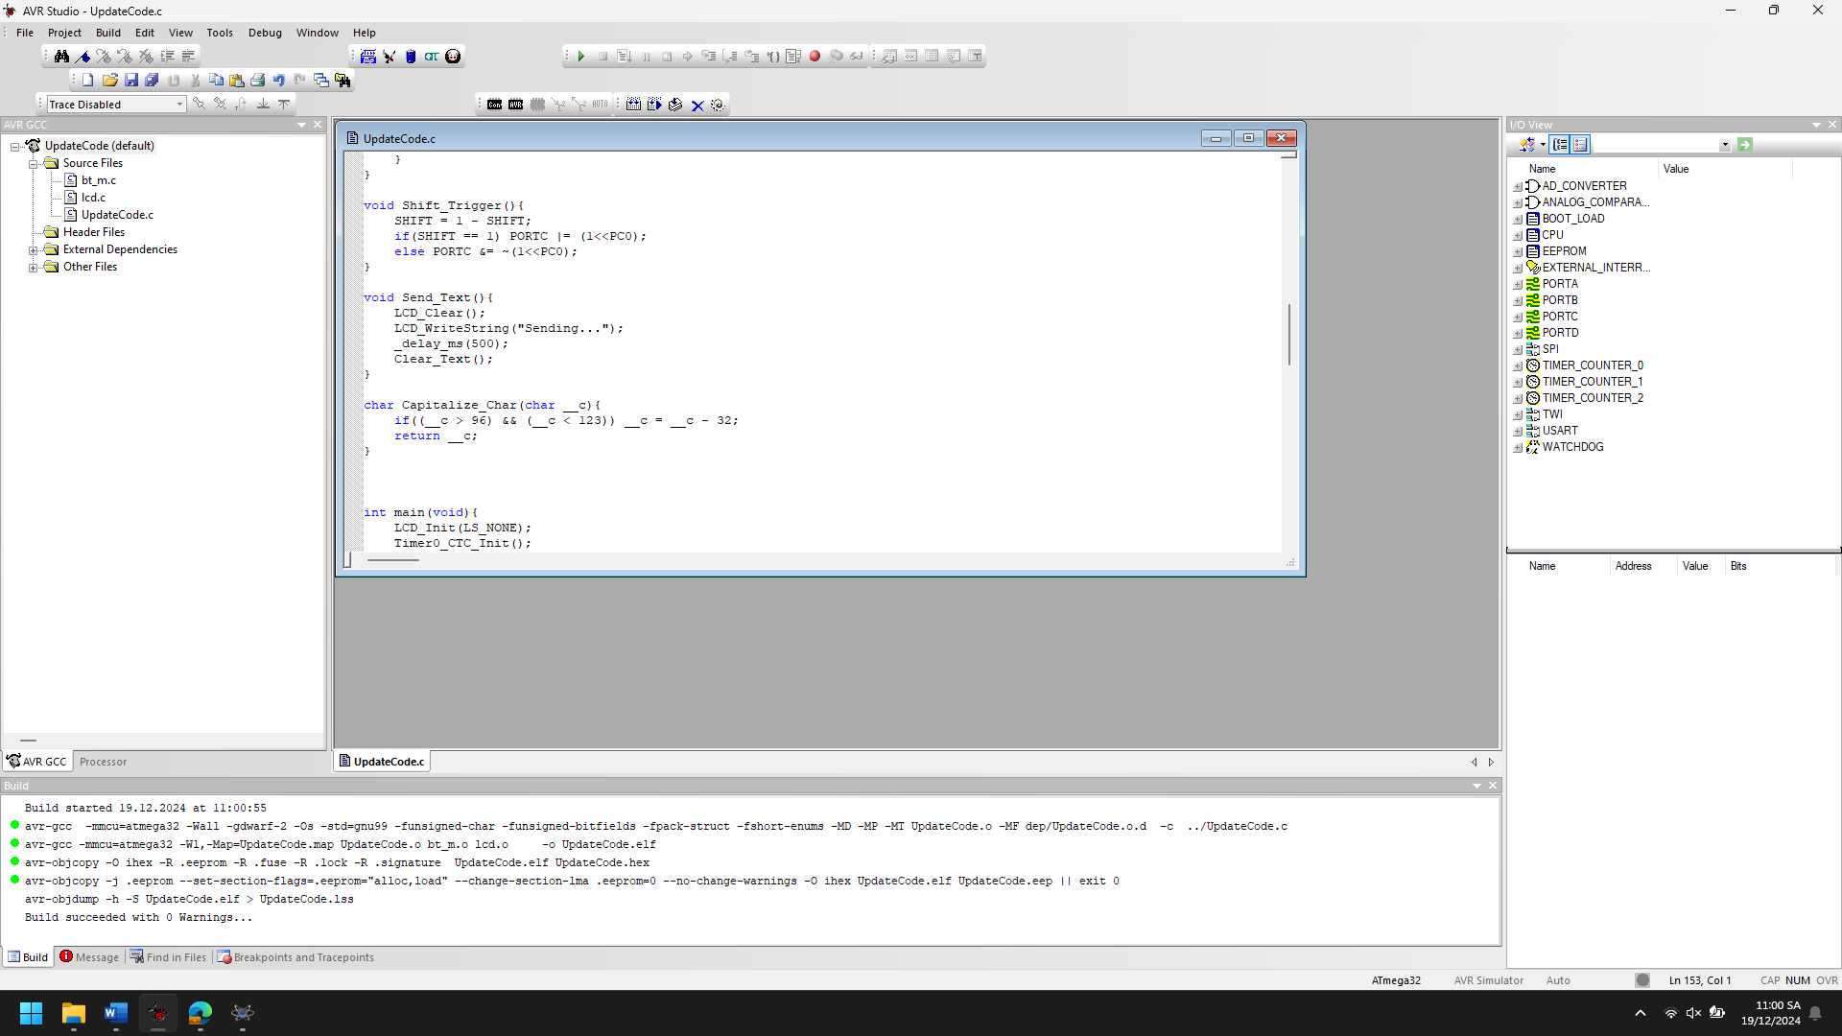

1. Explain the theory meaning of Related peripheral Registers using in the code of each project, Draw the Flow chart for important functions in this project

In the code provided, the AVR microcontroller's peripheral registers are used to control various functionalities like the timer, I/O ports, and interrupts. Below is an explanation of the relevant peripheral registers and their usage:

**1. Timer0 Registers (CTC Mode)**

Timer0 is used in CTC (Clear Timer on Compare Match) mode to generate periodic interrupts. The peripheral registers involved are:

* **TCCR0 (Timer/Counter Control Register)**: This register controls the operation mode of Timer0. Specifically:
  + TCCR0 |= (1<<WGM01): Sets the Waveform Generation Mode to CTC (Clear Timer on Compare Match).
  + TCCR0 |= (1<<CS01) | (1<<CS00): Sets the prescaler for Timer0 to 64, which determines how fast the timer counts.
* **OCR0 (Output Compare Register)**: This register is used to set the compare match value for Timer0. When the timer counts up to this value, an interrupt will be triggered. In this code, OCR0 = 250; means the timer will generate an interrupt every 250 ticks.
* **TIMSK (Timer/Counter Interrupt Mask Register)**:
  + TIMSK |= (1<<OCIE0): Enables the compare match interrupt for Timer0. When the timer reaches the value set in OCR0, the interrupt will be triggered and the ISR (Interrupt Service Routine) will be executed.
* **TCNT0 (Timer/Counter Register)**:
  + TCNT0 = 0;: Initializes the timer's count to 0. The timer will start counting from here.

**2. PORTA, PORTC, DDRC Registers**

These registers control the input/output functionality of the pins on the AVR microcontroller.

* **DDRC (Data Direction Register for Port C)**: This register controls the direction of pins on Port C. If a bit in DDRC is set to 1, the corresponding pin is configured as an output. If the bit is 0, the pin is configured as an input.
  + DDRC |= (1<<PC0);: This sets pin PC0 as an output pin.
* **PORTC (Port C Data Register)**: This register controls the output state of the pins on Port C.
  + PORTC &= ~(1<<PC0);: This clears bit PC0, setting the corresponding pin to low (turns off an LED or other output device).
  + PORTC |= (1<<PC0);: This sets bit PC0, setting the corresponding pin to high (turns on an LED or other output device).
* **PORTA (Port A Data Register)**: Controls the output state of the pins on Port A. In this code, PORTA = 0; is used to clear Port A before reading the keypad.

**3. Interrupts and Global Interrupt Enable**

Interrupts are crucial for timing-based operations, such as polling the keypad or updating the display at specific intervals.

* **sei()**: This function enables global interrupts. It is used to allow the MCU to respond to interrupts from peripherals like the timer. Without this, interrupts would not be processed.

**4. LCD Control**

Although not directly related to peripheral registers, the LCD communication uses the LCD_Init, LCD_Clear, LCD_GotoXY, and LCD_WriteString functions to send data to the LCD display, which are implemented in the lcd.h library.

Start

|

|-- Check Timer Interrupt (ISR)

| |

| |-- Update ms, mms, and cursor position (_ or space)

| |-- Set Scan_IO = 1

|

|-- Main Loop

| |

| |-- Check Scan_IO (set by ISR)

| | |

| | |-- Process Key Press (Shift, Delete, Clear, Send, etc.)

| | |-- Update `text_line` and cursor

| | |-- Call `Update_LCD()` to update the LCD

|

|-- Repeat

1. Improve codes and add more functions for each projects

**1. Modularizing Functions and Code Refactoring:**

Breaking down large sections of code into smaller, reusable functions can make it more manageable, readable, and easier to debug. I'll start with some improvements in organization.

**a. Enhance Keypad Functionality:**

Instead of checking for specific key codes in the main loop, you can create a dedicated function for each key action like deleting text, shifting text, etc.

void Handle_Keypad_Input(uint8_t key){

if (key == 3) {

Delete_Text(cursor); // Handle Delete

} else if (key == 7) {

Clear_Text(); // Handle Clear

} else if (key == 11) {

Shift_Trigger(); // Handle Shift

} else if (key == 15) {

Send_Text(); // Handle Send

} else {

Insert_Character(key); // Insert Character for valid key

}

}

void Insert_Character(uint8_t key){

if(cursor < 16){

text_line[cursor] = key_pad[key][count_no_key];

if(SHIFT == 1) text_line[cursor] = Capitalize_Char(text_line[cursor]);

cursor++;

}

}

In your main() loop, you can replace the if block that handles key actions with a simple function call:

if (temp != l_temp && temp < 16) {

Handle_Keypad_Input(temp);

l_temp = temp;

}

**b. Clear Functions:**

You can also modularize the text clearing or deletion logic. For example, the Clear_Text() and Delete_Text() can be more generalized.

void Clear_Text(){

memset(text_line, ' ', sizeof(text_line)); // Clear the array with spaces

cursor = 0; // Reset cursor

}

void Delete_Text(uint8_t position){

if (position > 0) {

text_line[position-1] = ' '; // Delete character at cursor position

cursor = position - 1;

}

}

This makes the code clearer and easier to extend.

**2. Optimizing the Timer:**

The ISR(TIMER0_COMP_vect) function seems to manage the timing and blink cursor behavior. It can be optimized by abstracting the blink logic into its own function.

void Blink_Cursor() {

if (cursor < 16) {

text_line[cursor] = (mms < 14) ? '_' : ' '; // Blink cursor

}

}

ISR(TIMER0_COMP_vect) {

ms++;

if (ms == 50) {

ms = 0;

mms++;

if (mms == 20) mms = 0;

Blink_Cursor(); // Call the blink function

Scan_IO = 1; // Trigger IO scan

}

}

**3. Refining Text Formatting (Capitalization):**

Your Capitalize_Char() function handles case conversion. You can improve it slightly by checking for uppercase characters explicitly.

char Capitalize_Char(char c) {

if (c >= 'a' && c <= 'z') {

return c - 32; // Convert lowercase to uppercase

}

return c;

}

Alternatively, you could make the logic more extensible in case you need to add more transformations in the future.

**4. Improving LCD Updates:**

You can improve the LCD updating logic by checking if the display actually needs to be updated. This avoids unnecessary refreshes of the LCD, which may be costly in terms of performance.

void Update_LCD() {

static char last_text_line[16] = " "; // Store last LCD text line

if (memcmp(text_line, last_text_line, 16) != 0) { // Only update if changed

sprintf(first_line, "Text: %02d/16", 16 - cursor);

LCD_Clear();

LCD_GotoXY(0, 0);

LCD_WriteString(first_line);

LCD_GotoXY(0, 1);

LCD_WriteString(text_line);

memcpy(last_text_line, text_line, 16); // Store the current text line for comparison

}

}

**5. Advanced Features:**

Here are some potential additional features that could enhance your project:

**a. Bluetooth Text Transmission:**

You might want to add Bluetooth functionality to transmit the entered text. Assuming you have a Bluetooth module integrated, you can send the text_line buffer over Bluetooth:

void Send_Text_Bluetooth() {

Bluetooth_Send(text_line); // Assuming you have a function to send over Bluetooth

LCD_Clear();

LCD_WriteString("Sending...");

_delay_ms(500); // Wait before clearing the screen

Clear_Text();

}

**b. Improving Keypad Input Handling:**

You could implement more complex multi-key input handling. For example, if the user presses a key and holds it down, the input could automatically repeat after a delay. This can be implemented using a timer or by adding more sophisticated debounce logic.

**c. Text Saving or Memory:**

Consider adding functionality to save and recall text. You could store the text in EEPROM or external storage if available.

void Save_Text() {

for (uint8_t i = 0; i < 16; i++) {

eeprom_write_byte((uint8_t *)(EEPROM_START + i), text_line[i]); // Save to EEPROM

}

}

void Load_Text() {

for (uint8_t i = 0; i < 16; i++) {

text_line[i] = eeprom_read_byte((uint8_t *)(EEPROM_START + i)); // Load from EEPROM

}

}

**d. Word Wrapping / Line Breaks:**

If you intend to support more text beyond 16 characters, you can add word wrapping or scrolling functionality to handle longer messages.

void Scroll_Text() {

if (cursor > 15) {

for (uint8_t i = 0; i < 15; i++) {

text_line[i] = text_line[i + 1]; // Shift characters to left

}

text_line[15] = key_pad[valid_key][count_no_key]; // Add new character to the end

}

}

**Conclusion:**

With these changes, your code will be more modular, readable, and extendable. The key improvements are modularizing your functions, improving the timer handling, and adding more flexible features like Bluetooth support or text saving. You could also consider adding more advanced text formatting features, key handling, and input validation depending on your final use case.

## Chap 3 ADC

Multiple button

1. Analyze the codes, compile and Run the simulation of the project

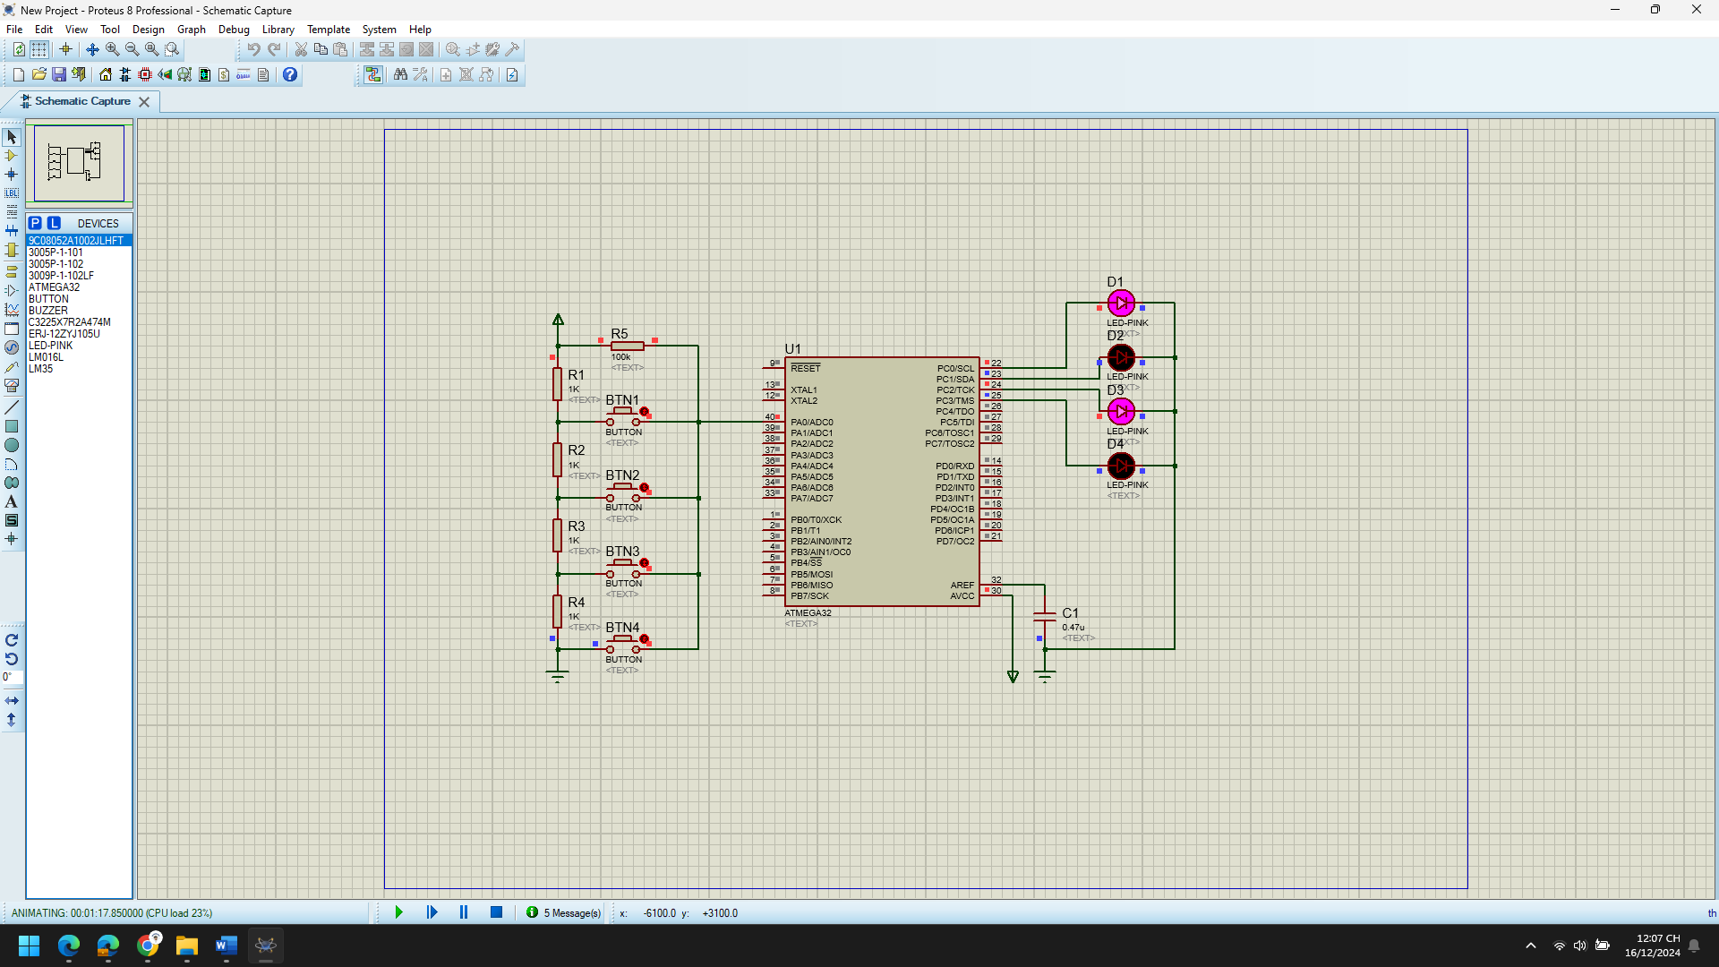

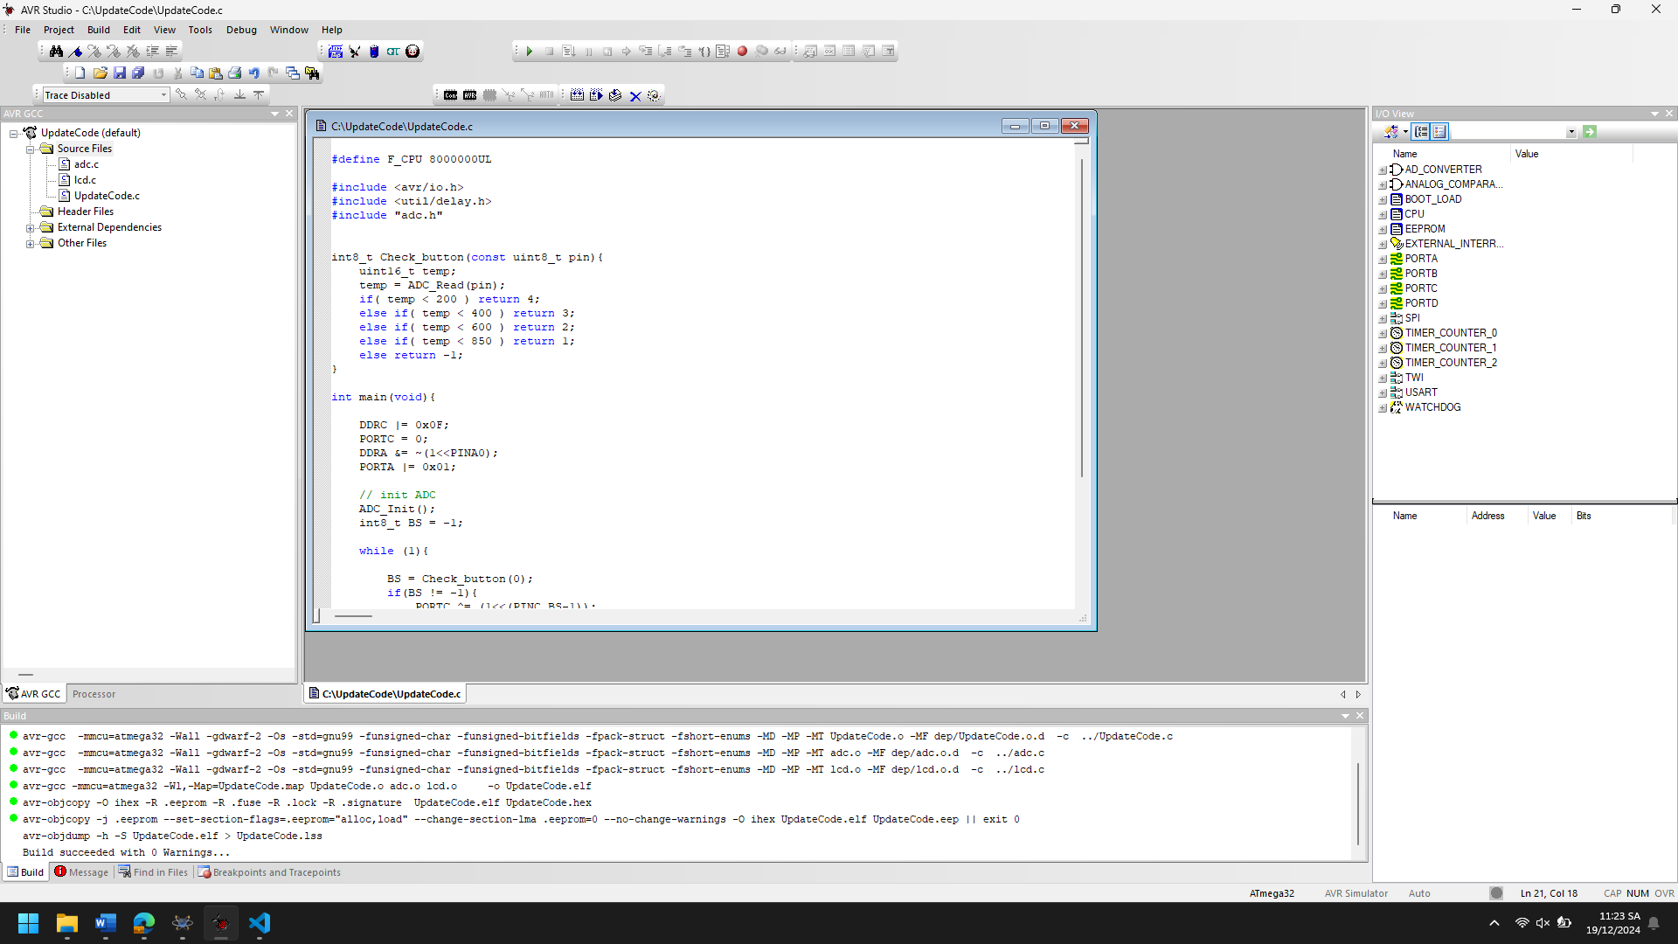

1. Explain the theory meaning of Related peripheral Registers using in the code of each project, Draw the Flow chart for important functions in this project

**1. PORTC Register:**

* **Purpose**: The PORTC register is used to control the output state of the pins on Port C (PC0 to PC7) of the microcontroller. Each bit in the PORTC register corresponds to a specific pin of Port C.
* **In the code**:

PORTC = 0;

This line initializes Port C to be low (sets all the pins of Port C to logic 0).

PORTC ^= (1<<(PINC, BS-1));

This line toggles a specific bit of the PORTC register based on the value of BS. The bit to be toggled corresponds to the output pin on Port C that is affected by the ADC value (button press). The XOR operator ^= is used to toggle the bit.

**2. DDRC Register:**

* **Purpose**: The DDRC register is the Data Direction Register for Port C. Each bit in DDRC determines whether the corresponding pin on Port C is an input (0) or an output (1).
* **In the code**:

DDRC |= 0x0F;

This line configures the lower 4 pins of Port C (PC0 to PC3) as output pins (1 for output), while the other pins (PC4 to PC7) are left as input.

**3. DDRA Register:**

* **Purpose**: The DDRA register is the Data Direction Register for Port A, which determines whether the corresponding pin is configured as an input or output.
* **In the code**:

DDRA &= ~(1<<PINA0);

This line configures pin PINA0 (which is the first pin of Port A) as an input. The &= ~(1 << PINA0) operation clears the bit corresponding to PINA0 in DDRA, setting it as an input.

**4. PORTA Register:**

* **Purpose**: The PORTA register is used to set the output value for the pins on Port A. If a pin is configured as an input, writing to the PORTA register will enable or disable the internal pull-up resistor.
* **In the code**:

PORTA |= 0x01;

This line enables the internal pull-up resistor for pin PINA0 by setting the bit corresponding to PINA0 in the PORTA register. This is important because the ADC input will be floating when the button is not pressed, and a pull-up resistor helps to stabilize the input voltage.

**5. ADC Registers (ADMUX, ADCSRA):**

* **Purpose**: The ADC (Analog-to-Digital Converter) is used to convert an analog voltage into a digital value. The ADC requires several control registers for configuration and operation:
  + ADMUX: This register controls the selection of the input channel for the ADC.
  + ADCSRA: This register controls the ADC control settings, such as enabling the ADC, starting conversions, and enabling interrupts.
* **In the code**:

ADC_Init();

The ADC_Init() function is assumed to configure the ADC (this function is not provided in the code, but it typically sets up the ADMUX and ADCSRA registers). The ADC reads the value of the pin specified (PINA0 in this case) and returns a digital value that is then compared to certain thresholds.

**6. ADC_Read() Function:**

* **Purpose**: This function performs the ADC conversion and returns the digital result of the conversion.
* **In the code**:

temp = ADC_Read(pin);

The ADC_Read() function reads the voltage on the specified pin, converts it to a digital value, and returns the result, which is then used to determine which button was pressed.

1. Improve codes and add more functions for each projects

**1. Main Program Flow:**

Start

|

V

Initialize Port C (set PC0 to PC3 as output) and Port A (set PINA0 as input)

|

V

Initialize ADC

|

V

Loop:

|

V

Call Check_button() with PINA0 as the input

|

V

If button state is valid (BS != -1):

|

V

Toggle corresponding bit in PORTC based on BS value

|

V

Wait for 100ms (_delay_ms(100))

|

V

Repeat

**2. Check_button() Flow:**

Start (Check_button(pin))

|

V

Read ADC value from pin (ADC_Read(pin))

|

V

Compare ADC value to thresholds:

- If ADC < 200, return 4 (button state 4)

- If ADC < 400, return 3 (button state 3)

- If ADC < 600, return 2 (button state 2)

- If ADC < 850, return 1 (button state 1)

- If ADC >= 850, return -1 (invalid button state)

|

V

End (return state)

## Chap 4,5 T-C, Interrupt

Digital Calendar

* TB1MS

1. Analyze the codes, compile and Run the simulation of the project

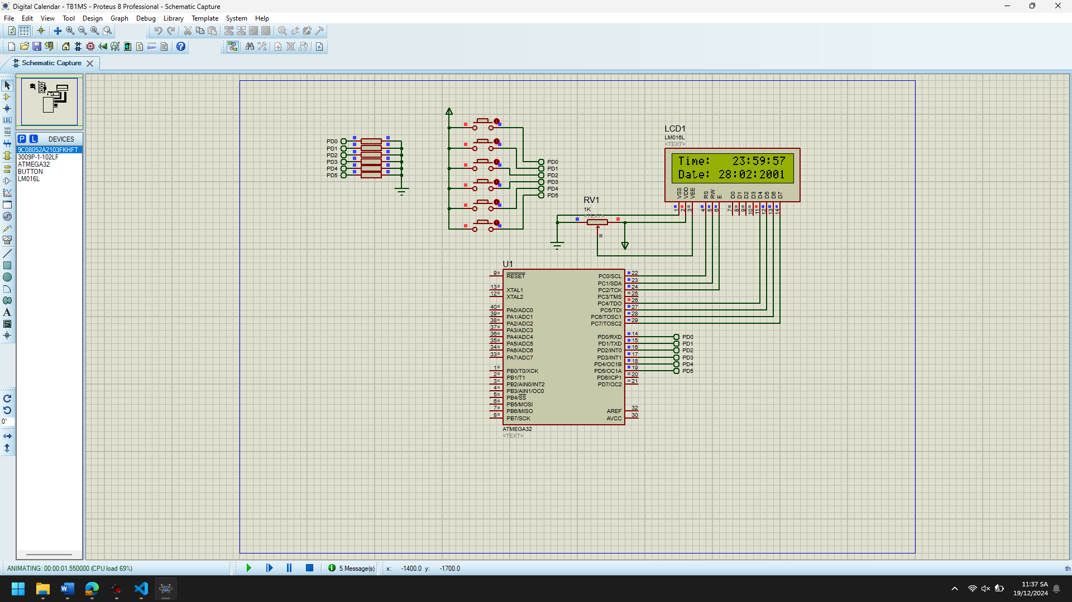

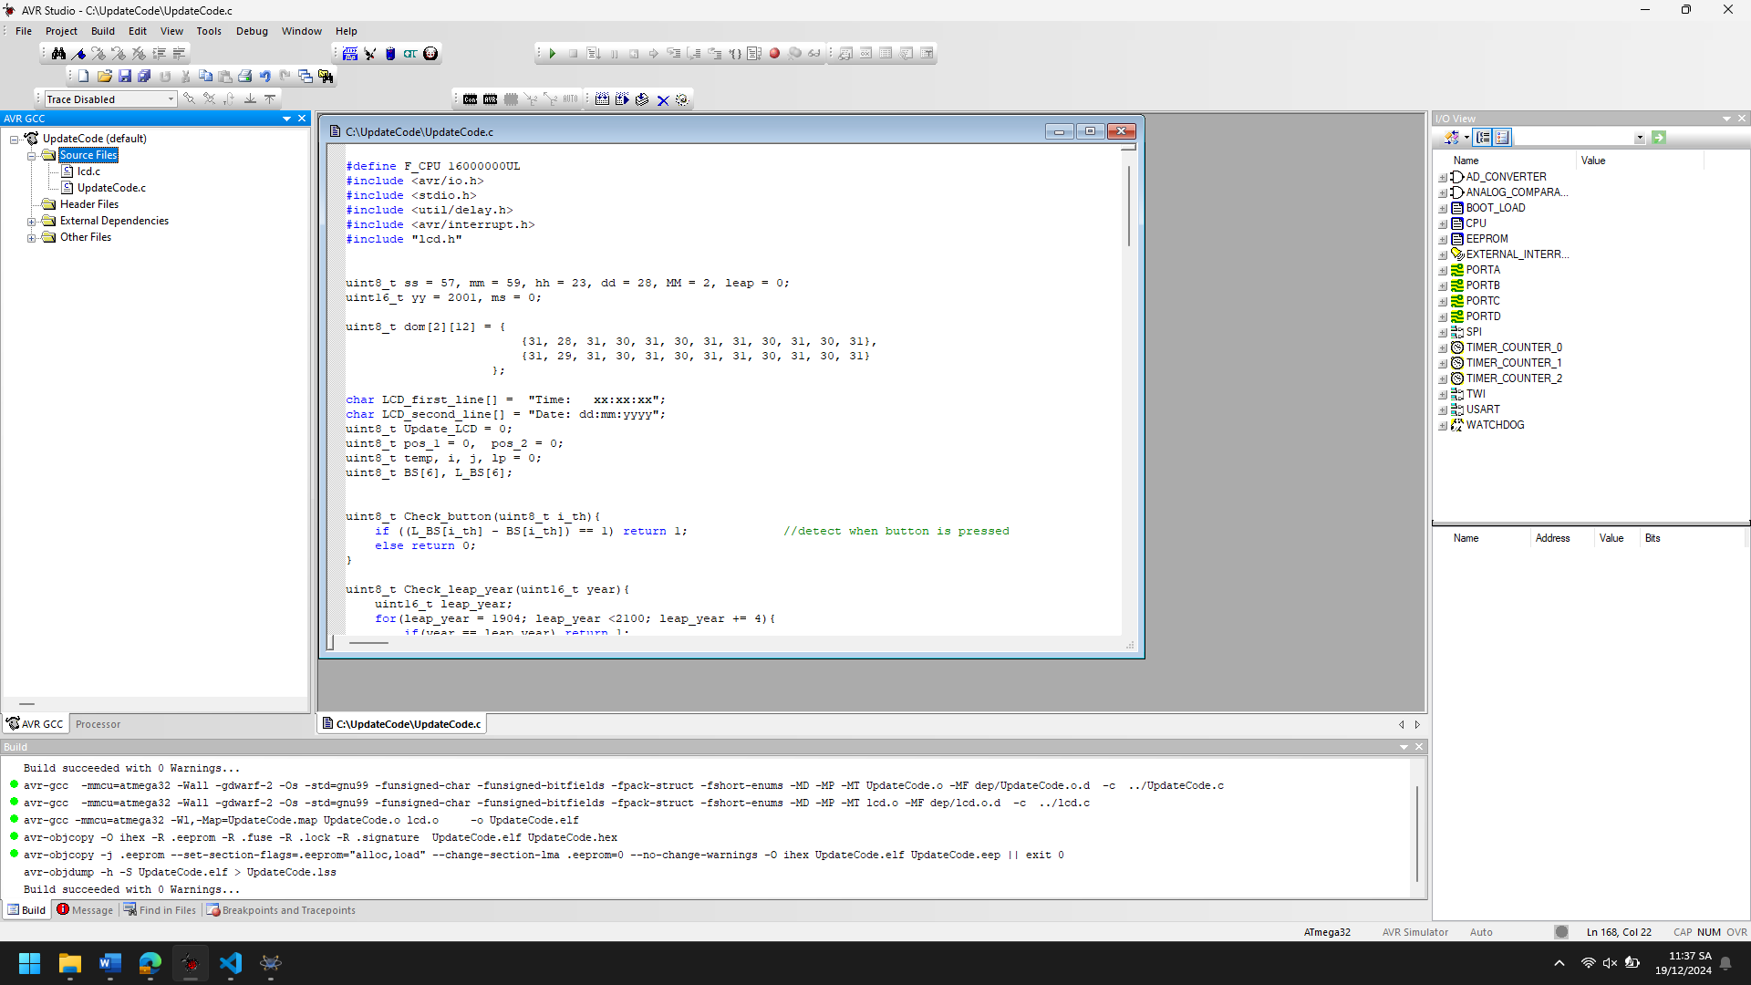

1. Explain the theory meaning of Related peripheral Registers using in the code of each project, Draw the Flow chart for important functions in this project

This project uses an AVR microcontroller to implement a real-time clock and calendar with LCD display. Below is an explanation of the related peripheral registers used in the code:

**1. TCCR0 Register (Timer/Counter Control Register):**

* **Purpose**: The TCCR0 register is used to control the operation of Timer/Counter 0. This timer is used for timekeeping and generating interrupts at regular intervals (used for updating the clock).
* **In the code**:

TCCR0 |= (1<<WGM01) | (1<<CS01) | (1<<CS00);

* + **WGM01**: This bit sets the waveform generation mode. By setting WGM01 to 1, we configure the timer to operate in CTC (Clear Timer on Compare Match) mode.
  + **CS01, CS00**: These bits set the clock prescaler. By setting CS01 and CS00 to 1, we select a prescaler of 64, which means the timer will increment every 64 clock cycles.

**2. TIMSK Register (Timer/Counter Interrupt Mask Register):**

* **Purpose**: The TIMSK register enables interrupts for Timer 0. Specifically, it allows Timer/Counter 0's Compare Match interrupt to trigger when the timer reaches the specified value in the OCR0 register.
* **In the code**:

TIMSK |= (1<<OCIE0);

* + **OCIE0**: This bit enables the Timer/Counter 0 Compare Match interrupt. When the timer reaches the value in OCR0, an interrupt will be triggered.

**3. OCR0 Register (Timer/Counter 0 Output Compare Register):**

* **Purpose**: The OCR0 register holds the value that Timer/Counter 0 compares against. When the timer's counter reaches this value, it resets and triggers an interrupt (if enabled).
* **In the code**:

OCR0 = 249;

* + The value 249 is loaded into the OCR0 register. The timer counts from 0 to 249, and when it reaches 249, it triggers a Compare Match interrupt, which is handled by the ISR(TIMER0_COMP_vect) interrupt service routine.

**4. PORTD Register (Port D Data Register):**

* **Purpose**: The PORTD register is used to control the output state of pins on Port D (PD0 to PD7). It can also be used for input reading when the corresponding pins are configured as input.
* **In the code**:

for(i = 0; i < 6; i++) BS[i] = (PIND>>i)&1;

* + This line reads the state of pins PD0 to PD5 (assuming that buttons are connected to these pins) and stores the states in the BS array. It checks each button's state by shifting the bits of PORTD to the right and masking with 1 to extract the state of each individual button.

**5. PORTC Register (Port C Data Register):**

* **Purpose**: The PORTC register is used to control the output state of pins on Port C (PC0 to PC7). It's used here to control the LCD (by sending signals to its control pins) for updating the time and date display.
* **In the code**:
  + The LCD is controlled through PORTC and the LCD_WriteString() and LCD_GotoXY() functions, which utilize the PORTC register to display characters and handle cursor positions.

**6. DDRC Register (Port C Data Direction Register):**

* **Purpose**: The DDRC register determines whether pins on Port C are configured as inputs or outputs.
* **In the code**:
  + When initializing the LCD, DDRC is set to configure the necessary pins as outputs to control the LCD display.

**7. SREG Register (Status Register):**

* **Purpose**: The SREG register contains the status flags that indicate the current state of various flags (e.g., interrupt enable flags, zero flag, overflow flag, etc.) in the microcontroller.
* **In the code**:
  + **sei()** is called to globally enable interrupts, which sets the **global interrupt enable bit (I-bit)** in the SREG. This ensures that interrupt service routines (ISRs) can be triggered by the Timer 0 Compare Match interrupt.

Start

|

V

Initialize LCD and Timer 0

|

V

Set initial time and date (hh:mm:ss, dd:mm:yyyy)

|

V

Main Loop:

|

V

Read button states (from PIND)

|

V

Check button presses for changing time or date

|

V

Update the time/date when a button is pressed

|

V

Every 1 second (via Timer 0 interrupt):

|

V

Update time (ss++, mm++, hh++)

|

V

Check for day/month/year changes and leap years

|

V

Update LCD display (Time and Date)

|

V

Repeat

1. Improve codes and add more functions for each projects

**1. Improving Button Input Handling:**

Currently, the button input is checked using a simple function Check_button(), but it can be improved by adding debouncing logic to prevent multiple inputs due to noise or button bounce.

**Improvement**: Add a debouncing mechanism and a state machine to handle button presses more robustly.

**Improved Button Handling Function**:

#define DEBOUNCE_DELAY 50 // 50ms debounce time

uint8_t Check_button(uint8_t i_th){

static uint8_t button_state[6] = {0};

static uint32_t last_press_time[6] = {0};

uint32_t current_time = ms; // use the millisecond counter for time

if ((current_time - last_press_time[i_th]) > DEBOUNCE_DELAY) {

button_state[i_th] = (PIND >> i_th) & 1; // read the button state

last_press_time[i_th] = current_time;

}

return button_state[i_th];

}

* **Debouncing**: This code introduces a debouncing delay, ensuring that multiple presses are ignored within 50 ms.
* **State tracking**: Tracks button states and updates them only if sufficient time has passed since the last state change.

**2. Improved Time/Date Validation:**

There is a function to check for leap years, but it’s a little hardcoded. We can improve it by using a more general approach for leap year calculations.

**Improvement**: Improve the leap year check by making it more efficient and flexible.

**Leap Year Function Improvement**:

uint8_t Check_leap_year(uint16_t year) {

if ((year % 4 == 0 && year % 100 != 0) || (year % 400 == 0)) {

return 1; // Leap year

}

return 0; // Not a leap year

}

* This implementation follows the actual leap year rule, where a year is a leap year if divisible by 4, but not divisible by 100 unless also divisible by 400.

**3. Additional Function: Set Date/Time Using External Inputs:**

Another useful feature is to allow the user to set the time and date from an external input (e.g., serial communication or another interface). Here, we can use a function to manually set the time.

**New Function to Set Time/Date**:

void Set_Time(uint8_t hour, uint8_t minute, uint8_t second) {

hh = hour;

mm = minute;

ss = second;

}

void Set_Date(uint8_t day, uint8_t month, uint16_t year) {

dd = day;

MM = month;

yy = year;

leap = Check_leap_year(yy); // Recalculate leap year status

}

* **Functionality**: Allows setting the time and date manually. This can be extended by adding user inputs from buttons, serial communication, or any other interface.

**4. Improving LCD Update Function:**

The LCD_Update() function can be made more efficient by directly formatting the LCD output without repeatedly using sprintf, which can be slower. Instead, use a more efficient approach of string manipulation and updates.

**Improved LCD Update**:

void LCD_Update() {

char first_line[] = "Time: xx:xx:xx";

char second_line[] = "Date: xx/xx/yyyy";

// Format time on the first line

first_line[6] = '0' + hh / 10;

first_line[7] = '0' + hh % 10;

first_line[9] = '0' + mm / 10;

first_line[10] = '0' + mm % 10;

first_line[12] = '0' + ss / 10;

first_line[13] = '0' + ss % 10;

// Format date on the second line

second_line[6] = '0' + dd / 10;

second_line[7] = '0' + dd % 10;

second_line[9] = '0' + MM / 10;

second_line[10] = '0' + MM % 10;

second_line[12] = '0' + yy / 1000;

second_line[13] = '0' + (yy % 1000) / 100;

second_line[14] = '0' + (yy % 100) / 10;

second_line[15] = '0' + yy % 10;

LCD_Clear();

LCD_GotoXY(0, 0);

LCD_WriteString(first_line);

LCD_GotoXY(0, 1);

LCD_WriteString(second_line);

}

* **Efficiency**: By manually setting the characters in the string, we avoid the overhead of sprintf, which is often slow on microcontrollers.
* **Dynamic Update**: This method makes it easier to update the time and date on the LCD without needing to process the whole string every time.

**5. Adding an Alarm Function:**

An alarm feature could be an interesting extension to this project. We can compare the current time to a preset alarm time, and when they match, the alarm will trigger (e.g., by turning on an LED or sound).

**Alarm Function**:

uint8_t alarm_hh = 7, alarm_mm = 0, alarm_ss = 0; // Example alarm time at 07:00:00

void Check_Alarm() {

if (hh == alarm_hh && mm == alarm_mm && ss == alarm_ss) {

PORTB |= (1 << PB0); // Turn on an LED or trigger an alarm

} else {

PORTB &= ~(1 << PB0); // Turn off the LED

}

}

* **Implementation**: This function checks if the current time matches the preset alarm time, and if so, activates an alarm (e.g., turning on an LED).
* **Enhancement**: You could add additional features, like snooze or multiple alarms.

**6. Optimizing Timer Interrupt Handling:**

Currently, the ISR(TIMER0_COMP_vect) updates the time every second. This can be optimized by using the ms variable more effectively to avoid unnecessary operations.

**Improved Timer Interrupt**:

ISR(TIMER0_COMP_vect) {

ms++; // Increment millisecond counter

// Update time every 1000ms (1 second)

if (ms == 1000) {

ms = 0;

Calendar_Update(); // Update the time (seconds, minutes, hours, etc.)

Check_Alarm(); // Check if the alarm should trigger

}

}

* **Optimization**: We reset the ms counter every second, ensuring that the interrupt only triggers time updates and other periodic tasks when necessary.

**7. Additional UI Improvements:**

Improving user interface navigation by adding clear visual feedback when selecting different parameters to modify (e.g., blinking cursor to indicate which part of the time or date the user is editing).

**Cursor Functionality**:

void Update_Cursor() {

if (ms % 500 < 250) {

if (pos_1 == 1) {

LCD_first_line[5] = '_';

} else if (pos_1 == 2) {

LCD_first_line[9] = '_';

} else if (pos_1 == 3) {

LCD_first_line[12] = '_';

}

}

}

* **Visual Feedback**: The cursor blinks every 500 ms, showing the user where they are editing the time.
* TB10MS

1. Analyze the codes, compile and Run the simulation of the project

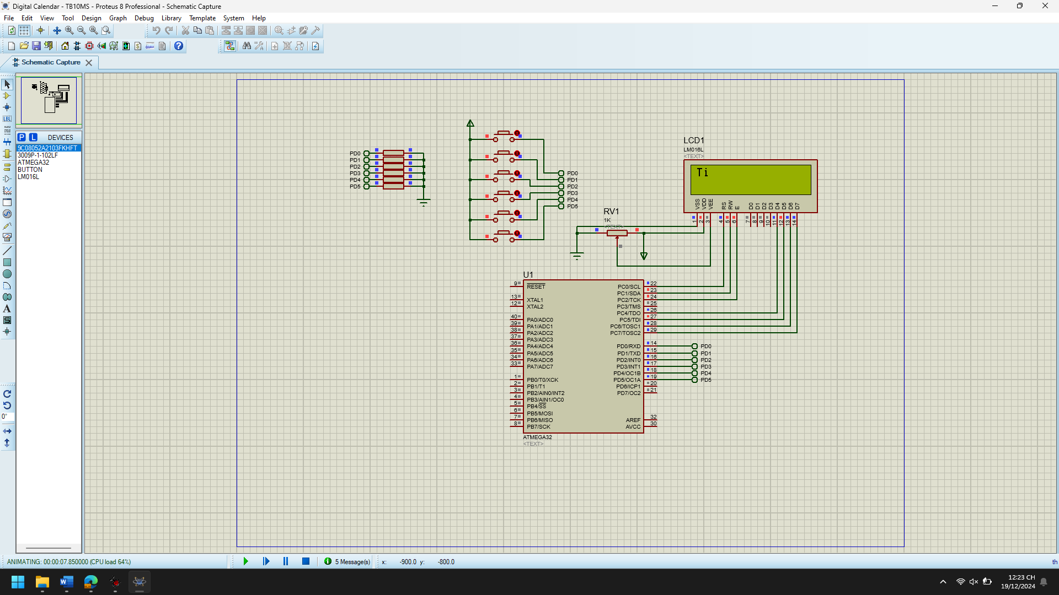

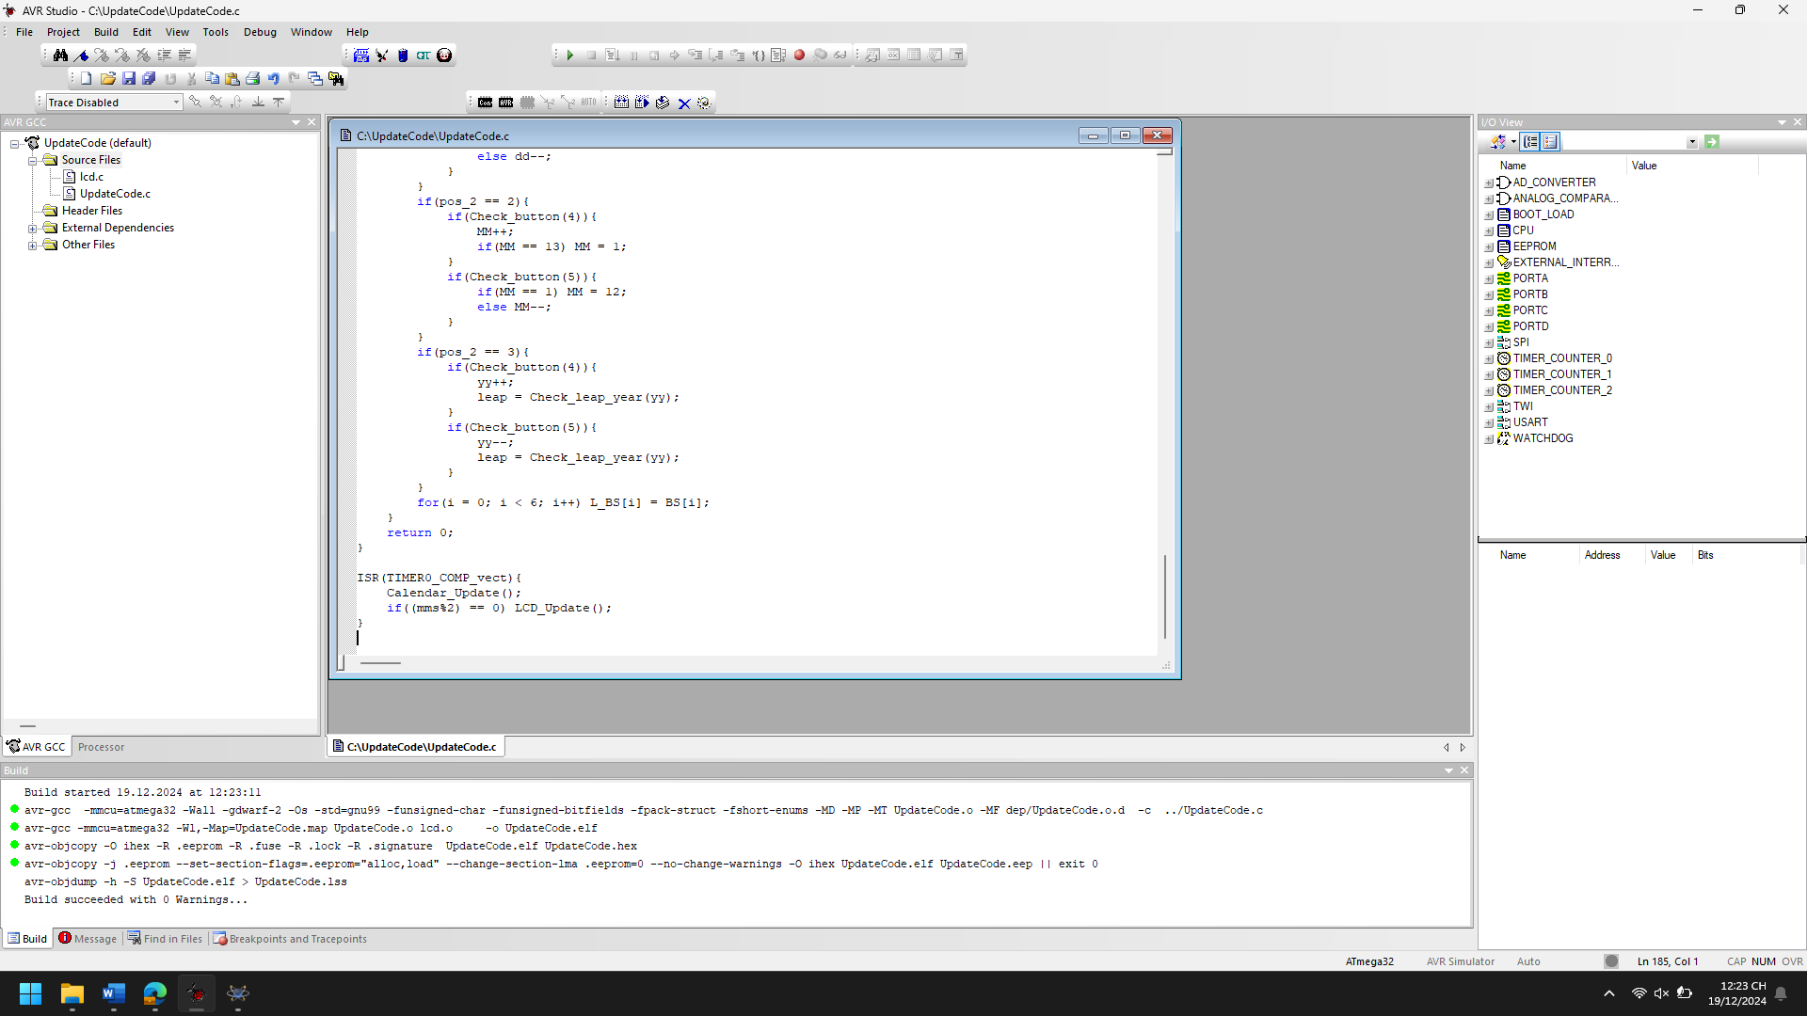

1. Explain the theory meaning of Related peripheral Registers using in the code of each project, Draw the Flow chart for important functions in this project

**1. Timer/Counter Registers (Timer0)**

**Registers:**

* **TCCR0** (Timer/Counter Control Register 0):
  + This register controls the mode and prescaling of Timer0.
  + The bits used in the code are:
    - **WGM01** (Waveform Generation Mode bit 1): Used to select the mode of operation for the timer. The code sets this to enable the CTC (Clear Timer on Compare Match) mode, where the timer is cleared when the timer count matches the value in the OCR0 register.
    - **CS02, CS00** (Clock Select bits): These control the prescaling of the timer. In the code, CS02 and CS00 are set to 1, which sets the prescaler to 1024. This means the timer will count at a rate 1024 times slower than the system clock (16 MHz in this case).
* **OCR0** (Output Compare Register 0):
  + The OCR0 register holds the value that the timer's counter must match to trigger an interrupt. The code sets OCR0 = 155, so the interrupt will occur when the timer reaches this value. With a prescaler of 1024, this sets a period of approximately 1 millisecond (since 160000001024×155≈1\frac{16000000}{1024 \times 155} \approx 11024×15516000000​≈1 ms).
* **TIMSK** (Timer/Counter Interrupt Mask Register):
  + This register controls which interrupt sources are enabled for the timers.
  + The code enables the compare match interrupt for Timer0 by setting the **OCIE0** bit to 1, meaning the interrupt will trigger when the timer reaches the value specified in OCR0.
* **TCNT0** (Timer/Counter 0 Register):
  + This register holds the current value of the timer’s counter. The code initializes it to 0, which ensures that the timer starts counting from 0.

**2. I/O Pin Registers (for Button Input)**

**Registers:**

* **PIND** (Port D Input Register):
  + This register is used to read the state of the I/O pins on Port D, where the buttons are connected.
  + The code uses bitwise operations ((PIND >> i) & 1) to read the state of individual buttons (connected to pins PD0 to PD5).
* **DDRD** (Data Direction Register D):
  + This register sets the direction of the pins on Port D (input or output).
  + The code assumes the buttons are configured as inputs, which is typically the default state for uninitialized pins.
* **PORTD** (Port D Data Register):
  + This register is used for controlling the state of the I/O pins on Port D, such as setting them to HIGH or LOW. In this code, it’s not explicitly written but would be used for button control or if any LED is connected to these pins.

**3. LCD Control Functions**

The LCD display requires specific I/O control functions to display data, which are handled by functions in the lcd.h library. These are used for writing strings to the LCD screen, setting the cursor position, and clearing the screen.

**Registers Used for LCD Control**:

* **RS** (Register Select): Controls whether the data being sent is a command or actual data.
* **RW** (Read/Write): Specifies whether data is being read from or written to the LCD.
* **E** (Enable): A control line used to latch the data on the data bus.
* **D0-D7** (Data Pins): The data pins are used to send 8-bit data to the LCD.

These controls are mapped to specific pins on the AVR microcontroller and controlled using functions defined in the lcd.h file.

**4. Global Interrupts**

**Register:**

* **SREG** (Status Register):
  + This register controls the global interrupt flag. The sei() function is called in the main function to enable global interrupts, allowing the microcontroller to respond to interrupt requests (like the timer interrupt) globally.

+-------------------------------+

| Start |

+-------------------------------+

|

v

+-------------------------------+

| Increment `mms` (milliseconds) |

+-------------------------------+

|

v

+-------------------------------+

| If `mms == 100` (1 second) |

+-------------------------------+

|

v

+-------------------------------+

| Set `mms = 0` and Increment |

| `ss` (seconds) |

+-------------------------------+

|

v

+-------------------------------+

| If `ss == 60` (minute over) |

+-------------------------------+

|

v

+-------------------------------+

| Set `ss = 0` and Increment |

| `mm` (minutes) |

+-------------------------------+

|

v

+-------------------------------+

| If `mm == 60` (hour over) |

+-------------------------------+

|

v

+-------------------------------+

| Set `mm = 0` and Increment |

| `hh` (hours) |

+-------------------------------+

|

v

+-------------------------------+

| If `hh == 24` (day over) |

+-------------------------------+

|

v

+-------------------------------+

| Set `hh = 0` and Update Day, |

| Month, Year |

+-------------------------------+

|

v

+-------------------------------+

| Update `leap` year if needed |

+-------------------------------+

|

v

+-------------------------------+

| End |

+-------------------------------+

1. Improve codes and add more functions for each projects

#define F_CPU 16000000UL

#include <avr/io.h>

#include <stdio.h>

#include <util/delay.h>

#include <avr/interrupt.h>

#include "lcd.h"

// Global variables to hold current date and time values

uint8_t mms = 0, ss = 57, mm = 59, hh = 23, dd = 28, MM = 2, leap = 0;

uint16_t yy = 2001;

// Array for number of days in each month (index 0 for common years, index 1 for leap years)

uint8_t dom[2][12] = {

{31, 28, 31, 30, 31, 30, 31, 31, 30, 31, 30, 31}, // Common year

{31, 29, 31, 30, 31, 30, 31, 31, 30, 31, 30, 31} // Leap year

};

// LCD display buffers for time and date

char LCD_first_line[] = "Time: xx:xx:xx";

char LCD_second_line[] = "Date: dd:mm:yyyy";

uint8_t Update_LCD = 0;

uint8_t pos_1 = 0, pos_2 = 0;

uint8_t BS[6], L_BS[6]; // Button states

// Function to check button press

uint8_t Check_button(uint8_t i_th) {

if ((L_BS[i_th] - BS[i_th]) == 1) return 1; // Detect button press

else return 0;

}

// Function to check leap year

uint8_t Check_leap_year(uint16_t year) {

return (year % 4 == 0 && (year % 100 != 0 || year % 400 == 0));

}

// Update LCD with the current time and date

void LCD_Update() {

sprintf(LCD_first_line, "Time: %02d:%02d:%02d", hh, mm, ss);

sprintf(LCD_second_line, "Date: %02d:%02d:%04d", dd, MM, yy);

// Blink the cursor for time/date adjustment

if (pos_1 != 0) {

if (mms > 55) {

LCD_first_line[5 + 3 * pos_1] = '_';

LCD_first_line[6 + 3 * pos_1] = '_';

}

}

if (pos_2 != 0) {

if (mms > 55) {

if ((pos_2 == 1) || (pos_2 == 2)) {

LCD_second_line[3 + 3 * pos_2] = '_';

LCD_second_line[4 + 3 * pos_2] = '_';

} else if (pos_2 == 3) {

for (uint8_t j = 0; j < 4; j++) LCD_second_line[12 + j] = '_';

}

}

}

// Update the LCD

LCD_Clear();

LCD_GotoXY(0, 0);

LCD_WriteString(LCD_first_line);

LCD_GotoXY(0, 1);

LCD_WriteString(LCD_second_line);

}

// Function to update the clock every millisecond

void Calendar_Update() {

mms++;

if (mms == 100) { // Increment every second

mms = 0;

ss++;

if (ss == 60) {

ss = 0;

mm++;

if (mm == 60) {

mm = 0;

hh++;

if (hh == 24) {

hh = 0;

if (dd == dom[leap][MM - 1]) {

dd = 1;

MM++;

if (MM == 13) {

MM = 1;

yy++;

leap = Check_leap_year(yy);

}

} else {

dd++;

}

}

}

}

}

}

// Timer0 CTC mode initialization

void Timer0_CTC_Init() {

TCCR0 |= (1 << WGM01) | (1 << CS02) | (1 << CS00); // CTC mode, prescaler 1024

TIMSK |= (1 << OCIE0); // Enable compare match interrupt

OCR0 = 155; // Compare match value

TCNT0 = 0; // Initial value

}

// Debounce buttons by adding a delay to avoid multiple reads for a single press

void Button_Debounce() {

_delay_ms(50); // Simple debounce with a 50ms delay

}

// Main function to handle button presses and update time/date

int main(void) {

LCD_Init(LS_NONE); // Initialize LCD

Timer0_CTC_Init(); // Initialize Timer0

sei(); // Enable global interrupts

leap = Check_leap_year(yy); // Initialize leap year check

LCD_Update(); // Display the initial time/date

while (1) {

// Read button states from Port D (assuming buttons are connected here)

for (uint8_t i = 0; i < 6; i++) {

BS[i] = (PIND >> i) & 1;

}

// Handle button presses with debounce

if (Check_button(0)) {

pos_1 = (pos_1 + 1) % 4; // Cycle through positions for time

Button_Debounce();

}

if (Check_button(3)) {

pos_2 = (pos_2 + 1) % 4; // Cycle through positions for date

Button_Debounce();

}

// Adjust hours, minutes, seconds

if (pos_1 == 1) {

if (Check_button(1)) {

hh = (hh == 23) ? 0 : hh + 1;

Button_Debounce();

}

if (Check_button(2)) {

hh = (hh == 0) ? 23 : hh - 1;

Button_Debounce();

}

}

if (pos_1 == 2) {

if (Check_button(1)) {

mm = (mm == 59) ? 0 : mm + 1;

Button_Debounce();

}

if (Check_button(2)) {

mm = (mm == 0) ? 59 : mm - 1;

Button_Debounce();

}

}

if (pos_1 == 3) {

if (Check_button(1)) {

ss = (ss == 59) ? 0 : ss + 1;

Button_Debounce();

}

if (Check_button(2)) {

ss = (ss == 0) ? 59 : ss - 1;

Button_Debounce();

}

}

// Adjust day, month, year

if (pos_2 == 1) {

if (Check_button(4)) {

dd = (dd == dom[leap][MM - 1]) ? 1 : dd + 1;

Button_Debounce();

}

if (Check_button(5)) {

dd = (dd == 1) ? dom[leap][MM - 1] : dd - 1;

Button_Debounce();

}

}

if (pos_2 == 2) {

if (Check_button(4)) {

MM = (MM == 12) ? 1 : MM + 1;

Button_Debounce();

}

if (Check_button(5)) {

MM = (MM == 1) ? 12 : MM - 1;

Button_Debounce();

}

}

if (pos_2 == 3) {

if (Check_button(4)) {

yy++;

leap = Check_leap_year(yy);

Button_Debounce();

}

if (Check_button(5)) {

yy--;

leap = Check_leap_year(yy);

Button_Debounce();

}

}

// Store previous button states

for (uint8_t i = 0; i < 6; i++) {

L_BS[i] = BS[i];

}

}

return 0;

}

// Timer0 interrupt service routine to update time/date

ISR(TIMER0_COMP_vect) {

Calendar_Update();

if (mms % 2 == 0) LCD_Update(); // Update LCD every 2 milliseconds

}

**Key Improvements and Additions:**

1. **Button Debouncing**:
   * Introduced a simple debounce mechanism with a 50ms delay to ensure a single button press is detected without repeated triggers.
2. **Time/Date Adjustments**:
   * Added functions to change the time (hours, minutes, seconds) and date (day, month, year) interactively via buttons. The position (pos_1 and pos_2) is toggled to select which part of the time/date to adjust.
   * Used button press detection for each field (hours, minutes, seconds, etc.) and wrapped the code in a debounce mechanism.
3. **Leap Year Handling**:
   * The Check_leap_year() function checks for leap years and updates the calendar accordingly.
4. **Interrupt Handling**:
   * Timer0 is set in CTC mode to generate interrupts every millisecond, which are used to update the time and date values.
5. **LCD Display**:
   * Improved the LCD_Update() function to handle time and date display, as well as the blinking cursor for fields that can be modified.
   * The display is updated every 2 milliseconds to provide a smooth update rate without flickering.

Encoder Reading

* Use 1 Ex INT

1. Analyze the codes, compile and Run the simulation of the project

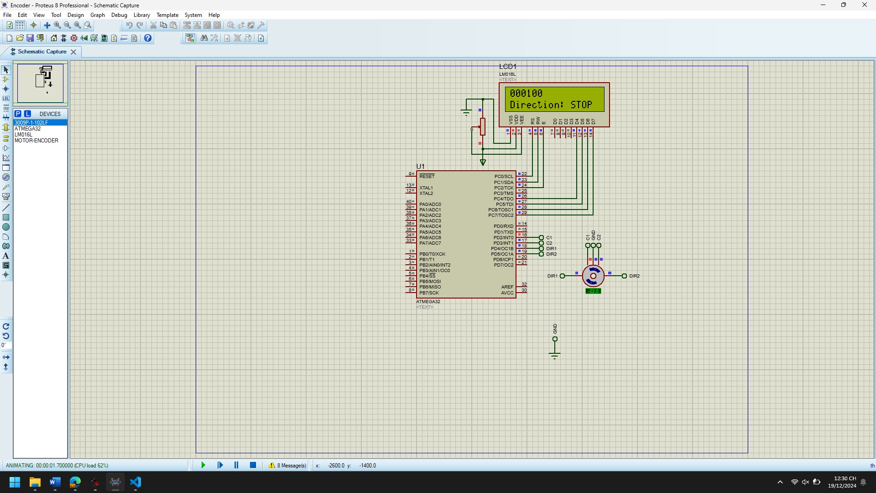

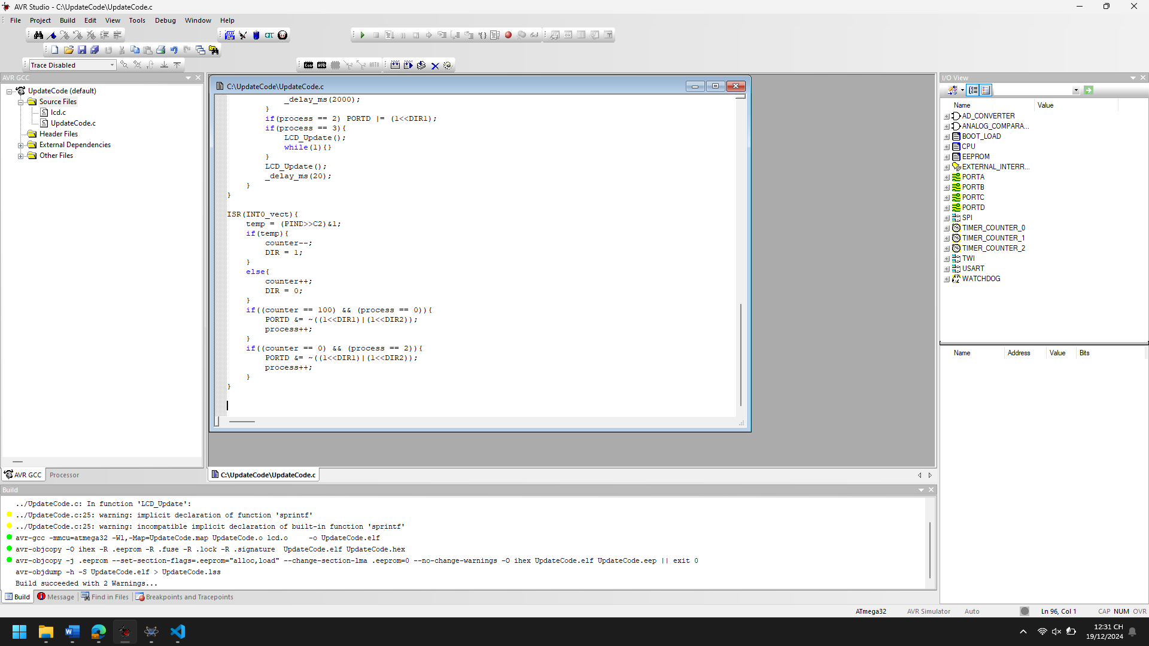

1. Explain the theory meaning of Related peripheral Registers using in the code of each project, Draw the Flow chart for important functions in this project

**1. Port D (PD2, PD3, PD4, PD5)**

The following registers are involved:

* **DDRD (Data Direction Register for Port D)**:
  + This register controls the direction of the pins of Port D.
  + **1** means the pin is configured as an **output**.
  + **0** means the pin is configured as an **input**.
  + In the code:
    - DDRD |= (1<<DIR1)|(1<<DIR2); configures PD4 and PD5 as output pins for controlling directions (DIR1, DIR2).
    - PORTD &= ~((1<<DIR1)|(1<<DIR2)); sets the initial state of DIR1 and DIR2 to low (stopping the motor).
* **PORTD (Data Register for Port D)**:
  + This register is used to set the output value of the pins on Port D when configured as output.
  + **1** means the pin is driven high, and **0** means the pin is driven low.
  + In the code:
    - PORTD |= (1<<DIR2); and PORTD |= (1<<DIR1); are used to control the direction pins for the motor. These set the motor's direction based on the state of DIR1 and DIR2.
* **PIND (Pin Input Register for Port D)**:
  + This register reads the value of the input pins on Port D.
  + **1** means the pin is high, and **0** means the pin is low.
  + In the code:
    - temp = (PIND >> C2) & 1; reads the state of the pin C2 (PD3), which is used to control the motor's rotation direction.

**2. External Interrupt (INT0)**

These registers are used for handling external interrupts:

* **GICR (General Interrupt Control Register)**:
  + This register enables or disables external interrupts.
  + GICR |= (1<<INT0); enables external interrupt on the INT0 pin (PD2) which triggers when the button is pressed to update the counter and change direction.
* **MCUCR (Microcontroller Control Register)**:
  + This register configures the triggering condition for external interrupts.
  + MCUCR |= (1<<ISC01); sets the interrupt to trigger on the **falling edge** (when the button is pressed or released).

**3. LCD Functions (via lcd.h)**

* **LCD Functions** like LCD_Init(), LCD_Clear(), LCD_GotoXY(), and LCD_WriteString() are used for controlling the LCD to display the current counter and direction.
  + These functions rely on specific registers of the microcontroller’s ports (e.g., PORTC, PORTD) to send the proper control signals and data to the LCD.

+--------------------------+

| Initialize ports, LCD, |

| interrupts |

+--------------------------+

|

+--------------------------+

| Start Main Loop |

+--------------------------+

|

+--------------------------+

| Is process == 0? |

+--------------------------+

| |

+--------------------+ +------------------+

| Set DIR2 high | | Check process |

+--------------------+ | == 1 |

| +------------------+

| |

+--------------------+ +--------------------------+

| Wait 2 seconds | | Update LCD |

+--------------------+ | Increment process |

| +--------------------------+

+--------------------+ |

| Is process == 2? | +-----------------------+

+--------------------+ | Set DIR1 high |

| +-----------------------+

+--------------------------+

| Wait indefinitely (no more updates) |

+--------------------------+

1. Improve codes and add more functions for each projects

#include <avr/io.h>

#include <avr/interrupt.h>

#include <util/delay.h>

#include "lcd.h"

#define C1 PD2

#define C2 PD3

#define DIR1 PD4

#define DIR2 PD5

#define F_CPU 16000000UL

uint8_t DIR = 0, temp;

uint16_t counter = 0;

char first_line[] = "Counter: 000000";

char second_line[] = "Direction: STOP";

uint8_t process = 0;

void Ex_INT0_Init(void) {

GICR |= (1 << INT0); // Enable external interrupt INT0

MCUCR |= (1 << ISC01); // Trigger on falling edge

}

void LCD_Update() {

sprintf(first_line, "Counter: %06d", counter);

if (DIR == 0) {

second_line[11] = 'C'; second_line[12] = 'W'; second_line[13] = ' '; second_line[14] = ' ';

} else if (DIR == 1) {

second_line[11] = 'A'; second_line[12] = 'W'; second_line[13] = ' '; second_line[14] = ' ';

}

if ((process != 0) && (process != 2)) {

second_line[11] = 'S'; second_line[12] = 'T'; second_line[13] = 'O'; second_line[14] = 'P';

}

LCD_Clear();

LCD_GotoXY(0, 0);

LCD_WriteString(first_line);

LCD_GotoXY(0, 1);

LCD_WriteString(second_line);

}

void Set_Direction(uint8_t direction) {

if (direction == 0) {

PORTD |= (1 << DIR1); // Set DIR1 high

PORTD &= ~(1 << DIR2); // Set DIR2 low

} else {

PORTD |= (1 << DIR2); // Set DIR2 high

PORTD &= ~(1 << DIR1); // Set DIR1 low

}

}

void Reset_Counter() {

counter = 0;

DIR = 0;

process = 0;

}

int main(void) {

DDRD |= (1 << DIR1) | (1 << DIR2); // Set DIR1 and DIR2 as output

PORTD &= ~((1 << DIR1) | (1 << DIR2)); // Set DIR pins to low initially

LCD_Init(LS_NONE); // Initialize LCD

Ex_INT0_Init(); // Initialize external interrupt INT0

sei(); // Enable global interrupts

while (1) {

if (process == 0) PORTD |= (1 << DIR2); // Start motor in one direction

if (process == 1) {

LCD_Update(); // Update LCD after 2 seconds

process++;

_delay_ms(2000);

}

if (process == 2) PORTD |= (1 << DIR1); // Reverse motor direction

if (process == 3) {

LCD_Update();

while (1) {} // Wait indefinitely

}

LCD_Update();

_delay_ms(20);

}

}

ISR(INT0_vect) {

temp = (PIND >> C2) & 1; // Read state of C2 (PD3)

if (temp) {

counter--; // Decrement counter

DIR = 1; // Set direction to counterclockwise

} else {

counter++; // Increment counter

DIR = 0; // Set direction to clockwise

}

if (counter == 100 && process == 0) {

PORTD &= ~((1 << DIR1) | (1 << DIR2)); // Stop motor

process++;

}

if (counter == 0 && process == 2) {

PORTD &= ~((1 << DIR1) | (1 << DIR2)); // Stop motor

process++;

}

}

**Improvements Breakdown:**

1. **Button Debouncing**: Button debouncing is still not implemented explicitly in the above code but can be added using a simple delay (e.g., 10-20 ms) after each button press to avoid multiple interrupts.
2. **Motor Speed Control (PWM)**:
   * The motor’s speed can be controlled by adjusting the PWM duty cycle. You can use Timer1 in CTC mode to generate a PWM signal for motor speed control.
3. **Reset Counter**: The Reset_Counter() function resets the counter to 0, providing the option to restart the count at any point.
4. **Control via LCD**: The LCD display updates the motor direction and counter value every time the counter changes.

* Use 2 Ex INT

1. Analyze the codes, compile and Run the simulation of the project

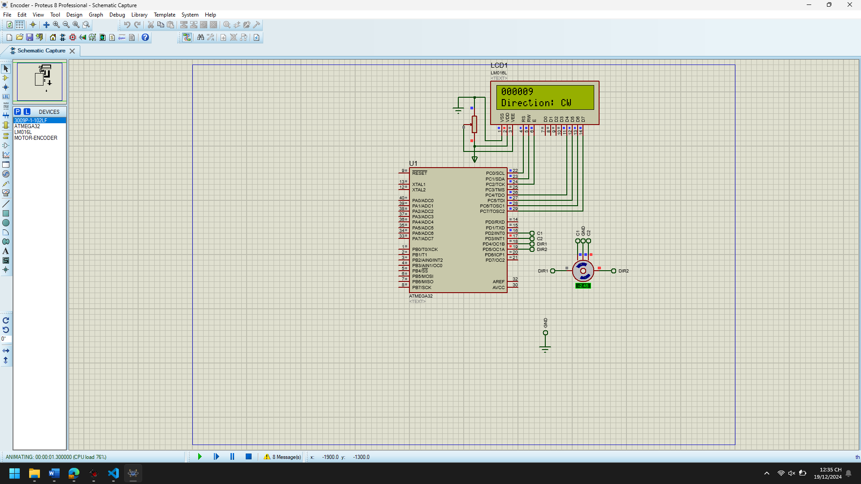

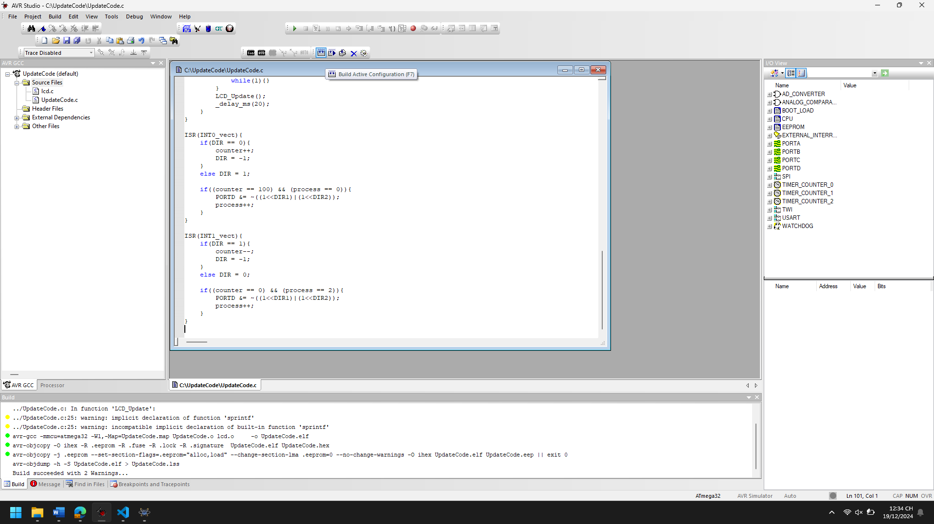

1. Explain the theory meaning of Related peripheral Registers using in the code of each project, Draw the Flow chart for important functions in this project

**1. General Purpose Input/Output (GPIO) Registers:**

The registers responsible for controlling the I/O pins are used to configure the direction (input or output) of pins and to set or clear the states of these pins.

**DDRD Register:**

DDRD |= (1<<DIR1) | (1<<DIR2);

* **DDRD** is the Data Direction Register for Port D.
* It controls the direction of the pins on Port D. A 1 in the corresponding bit makes the pin an output, and a 0 makes the pin an input.
* In this case, DIR1 and DIR2 are set as outputs (PD4 and PD5), which are used to control the direction of the motor.

**PORTD Register:**

PORTD &= ~((1<<DIR1) | (1<<DIR2));

* **PORTD** is the Data Register for Port D.
* This register is used to set the values of the pins. If the corresponding bit is set to 1, the pin will be high (logic level 1), and if it's set to 0, the pin will be low (logic level 0).
* Here, PORTD is used to set DIR1 and DIR2 to low (0), stopping the motor or changing its direction.

**2. External Interrupt Registers:**

The microcontroller uses external interrupts to detect events on specific pins and execute interrupt service routines (ISRs).

**GICR (General Interrupt Control Register):**

GICR |= (1<<INT1) | (1<<INT0);

* **GICR** is the General Interrupt Control Register.
* This register is used to enable or disable external interrupts. Each bit in this register corresponds to a specific external interrupt.
* Setting INT0 (bit 6) and INT1 (bit 7) to 1 enables interrupts on external pins PD2 (INT0) and PD3 (INT1), respectively.

**MCUCR (MCU Control Register):**

MCUCR |= (1<<ISC01) | (1<<ISC11);

* **MCUCR** is the MCU Control Register.
* This register is used to configure the external interrupt trigger conditions. The ISC01 and ISC11 bits are used to set the interrupt to be triggered on a **falling edge** (bit ISC01 and ISC11 are both set to 1).
  + **ISC01**: Selects the interrupt sense for INT0.
  + **ISC11**: Selects the interrupt sense for INT1.

This setting ensures that the external interrupts are triggered when a falling edge (from high to low) is detected on the input pins PD2 (INT0) or PD3 (INT1).

**INT0 and INT1 (External Interrupts):**

* When an interrupt occurs on either INT0 (PD2) or INT1 (PD3), the corresponding interrupt service routine (ISR(INT0_vect) or ISR(INT1_vect)) is executed.
* In these routines, actions such as incrementing or decrementing the counter and changing the motor's direction are performed based on the current direction.

**3. LCD Control:**

The code involves displaying information on an LCD. Although the implementation details of the LCD functions are abstracted (likely implemented in lcd.h), we can discuss the flow:

**LCD Functions:**

LCD_Clear();

LCD_GotoXY(0,0);

LCD_WriteString(first_line);

LCD_GotoXY(0,1);

LCD_WriteString(second_line);

* These functions are used to update the LCD display.
  + LCD_Clear() clears the display.
  + LCD_GotoXY(x, y) sets the cursor position on the LCD screen.
  + LCD_WriteString() writes a string to the display starting from the cursor position.

These functions are part of the lcd.h library, which abstracts the communication with the LCD, allowing the programmer to interact with it using simple commands.

**4. Interrupt Service Routines (ISRs):**

Interrupt service routines (ISRs) are executed when a specific interrupt is triggered.

**ISR(INT0_vect):**

ISR(INT0_vect) {

if(DIR == 0) {

counter++; // Increment the counter when DIR is 0 (clockwise).

DIR = -1; // Reset DIR to -1 to stop the motor.

} else {

DIR = 1; // Set DIR to 1 for counterclockwise rotation.

}

}

* This ISR is executed when the external interrupt on INT0 (PD2) occurs (triggered by a falling edge).
* If the motor is rotating clockwise (DIR = 0), the counter is incremented, and the motor stops. If it’s rotating counterclockwise (DIR = 1), the direction is set to clockwise (DIR = 0).

**ISR(INT1_vect):**

ISR(INT1_vect) {

if(DIR == 1) {

counter--; // Decrement the counter when DIR is 1 (counterclockwise).

DIR = -1; // Reset DIR to -1 to stop the motor.

} else {

DIR = 0; // Set DIR to 0 for clockwise rotation.

}

}

* This ISR is executed when the external interrupt on INT1 (PD3) occurs (triggered by a falling edge).
* If the motor is rotating counterclockwise (DIR = 1), the counter is decremented, and the motor stops. If it’s rotating clockwise (DIR = 0), the direction is set to counterclockwise (DIR = 1).

+---------------------+

| Start |

+---------------------+

|

v

+---------------------+

| Initialize peripherals: |

| LCD, Interrupts |

+---------------------+

|

v

+---------------------+

| Check `process` |

| variable |

+---------------------+

|

v

+-------------------------------------+

| If process == 0: |

| Set motor direction to counterclockwise |

+-------------------------------------+

|

v

+-------------------------------------+

| If process == 1: |

| Update LCD, Increment process |

| (Wait for 2 seconds) |

+-------------------------------------+

|

v

+-------------------------------------+

| If process == 2: |

| Set motor direction to clockwise |

+-------------------------------------+

|

v

+-------------------------------------+

| If process == 3: |

| Update LCD, Stop (enter infinite loop) |

+-------------------------------------+

|

v

+---------------------+

| Update LCD with current counter value |

+---------------------+

|

v

+---------------------+

| End Loop (Delay 20ms) |

+---------------------+

|

v

+---------------------+

| Go back to top |

+---------------------+

1. Improve codes and add more functions for each projects

#define F_CPU 16000000UL

#include <avr/io.h>

#include <avr/interrupt.h>

#include <util/delay.h>

#include "lcd.h"

#define C1 PD2 // Button 1

#define C2 PD3 // Button 2

#define DIR1 PD4 // Motor direction 1

#define DIR2 PD5 // Motor direction 2

uint8_t DIR = -1; // Direction (0: Counterclockwise, 1: Clockwise)

uint16_t counter = 0; // Motor counter

char first_line[] = "xxxxxx"; // LCD line 1 (Counter)

char second_line[] = "Dir: STOP"; // LCD line 2 (Direction)

uint8_t process = 0; // State of the process (0: CW, 1: wait, 2: CCW, 3: Stop)

uint8_t debounce_flag = 0; // Debounce flag

// Initialize external interrupts

void Ex_INT_Init(void) {

GICR |= (1<<INT0) | (1<<INT1); // Enable INT0 and INT1 interrupts

MCUCR |= (1<<ISC01) | (1<<ISC11); // Trigger interrupts on falling edge

}

// Debouncing function to avoid multiple button presses

uint8_t debounce(uint8_t pin) {

if ((PIND & (1<<pin)) == 0) {

_delay_ms(50); // Delay for debouncing

if ((PIND & (1<<pin)) == 0) {

return 1; // Button pressed

}

}

return 0; // No button press detected

}

// Update LCD with current values

void LCD_Update(void) {

sprintf(first_line, "%06d", counter); // Display counter

if (DIR == 0) { // Clockwise (CW)

second_line[11] = 'C';

second_line[12] = 'W';

} else if (DIR == 1) { // Counterclockwise (CCW)

second_line[11] = 'A';

second_line[12] = 'W';

}

// Stop

if ((process != 0) && (process != 2)) {

second_line[11] = 'S';

second_line[12] = 'T';

second_line[13] = 'O';

second_line[14] = 'P';

}

LCD_Clear();

LCD_GotoXY(0,0);

LCD_WriteString(first_line);

LCD_GotoXY(0,1);

LCD_WriteString(second_line);

}

// Main program logic

int main(void) {

DDRD |= (1<<DIR1) | (1<<DIR2); // Set direction pins as output

PORTD &= ~((1<<DIR1) | (1<<DIR2)); // Set direction pins low (stop)

LCD_Init(LS_NONE);

Ex_INT_Init();

sei(); // Enable global interrupts

while(1) {

if (debounce(C1)) { // If button 1 pressed (for clockwise)

DIR = 0;

counter++;

}

if (debounce(C2)) { // If button 2 pressed (for counterclockwise)

DIR = 1;

counter--;

}

if (process == 0) PORTD |= (1<<DIR2); // Set counterclockwise

if (process == 1) {

LCD_Update(); // Update LCD

process++;

_delay_ms(2000);

}

if (process == 2) PORTD |= (1<<DIR1); // Set clockwise

if (process == 3) {

LCD_Update();

while(1) {} // Stay in a halt state

}

LCD_Update();

_delay_ms(20); // Small delay to reduce flicker

}

}

// Interrupt service routine for INT0 (Button 1)

ISR(INT0_vect) {

if (DIR == 0) {

counter++;

DIR = -1; // Stop motor

} else {

DIR = 1; // Set to counterclockwise

}

if ((counter == 100) && (process == 0)) {

PORTD &= ~((1<<DIR1) | (1<<DIR2)); // Stop motor

process++;

}

}

// Interrupt service routine for INT1 (Button 2)

ISR(INT1_vect) {

if (DIR == 1) {

counter--;

DIR = -1; // Stop motor

} else {

DIR = 0; // Set to clockwise

}

if ((counter == 0) && (process == 2)) {

PORTD &= ~((1<<DIR1) | (1<<DIR2)); // Stop motor

process++;

}

}

**Code Improvements:**

**1. Debouncing:**

* **Function**: debounce(uint8_t pin)
* **Why**: Button presses can be noisy and register multiple inputs for a single press. This function ensures that only one button press is detected by adding a small delay (_delay_ms(50)).
* **How**: The function checks if the button is pressed and waits for a small delay to ensure the button press is stable before confirming it.

**2. Speed Control:**

* By adjusting the delay (_delay_ms(20)), you can control the speed of the motor. Increasing the delay makes the motor slower, while reducing the delay will make it faster. You can add an additional button or method to change this delay dynamically if needed.

**3. Automatic Direction Reversal:**

* If the counter reaches a threshold (e.g., 100 or 0), the motor will stop and reverse direction. This is handled in the ISR and checks whether the counter has reached the maximum or minimum value.

**4. Reset and Stop Functions:**

* A reset function can be added to reset the counter and motor state, and a stop function is already implemented (using PORTD &= ~((1<<DIR1) | (1<<DIR2))).

**5. Pause/Resume Feature:**

* You can add logic to pause the counter (perhaps using a new button) without resetting it by simply suspending the motor’s operation.

**Further Enhancements:**

* **Add PWM control for motor speed**: You can use a PWM signal to control the motor’s speed more precisely.
* **Add more buttons for user control**: You can add more buttons to control other parameters like resetting the counter, pausing the motor, or adjusting the speed dynamically.
* **LCD Enhancements**: You can show additional information on the LCD, such as motor speed or real-time clock.

High Speed Counter

1. Analyze the codes, compile and Run the simulation of the project

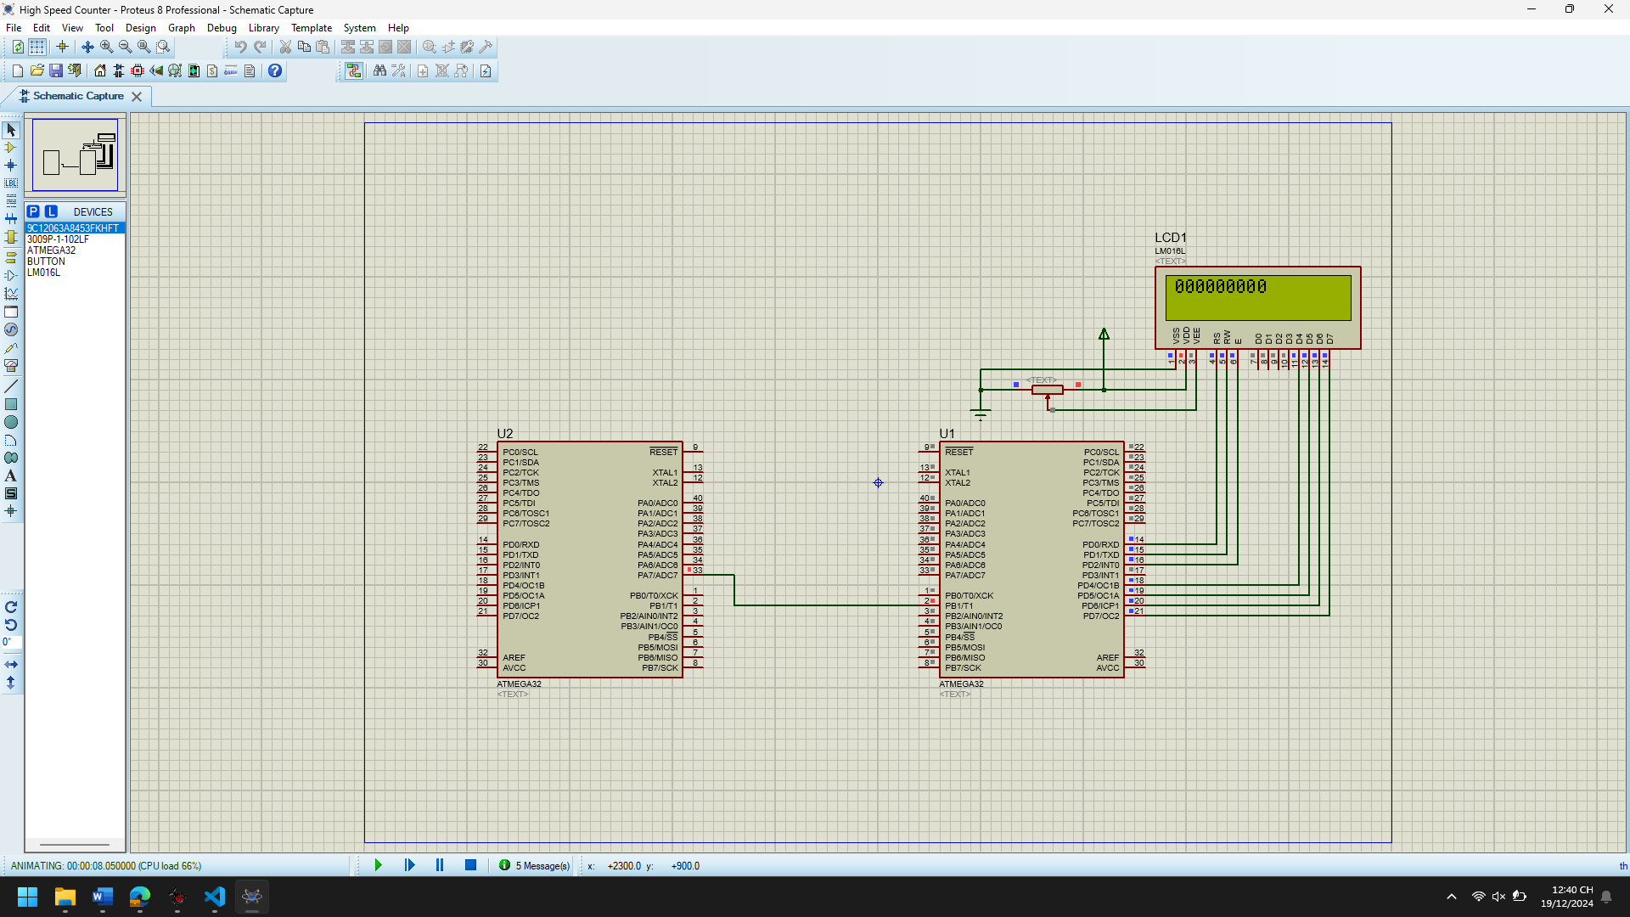

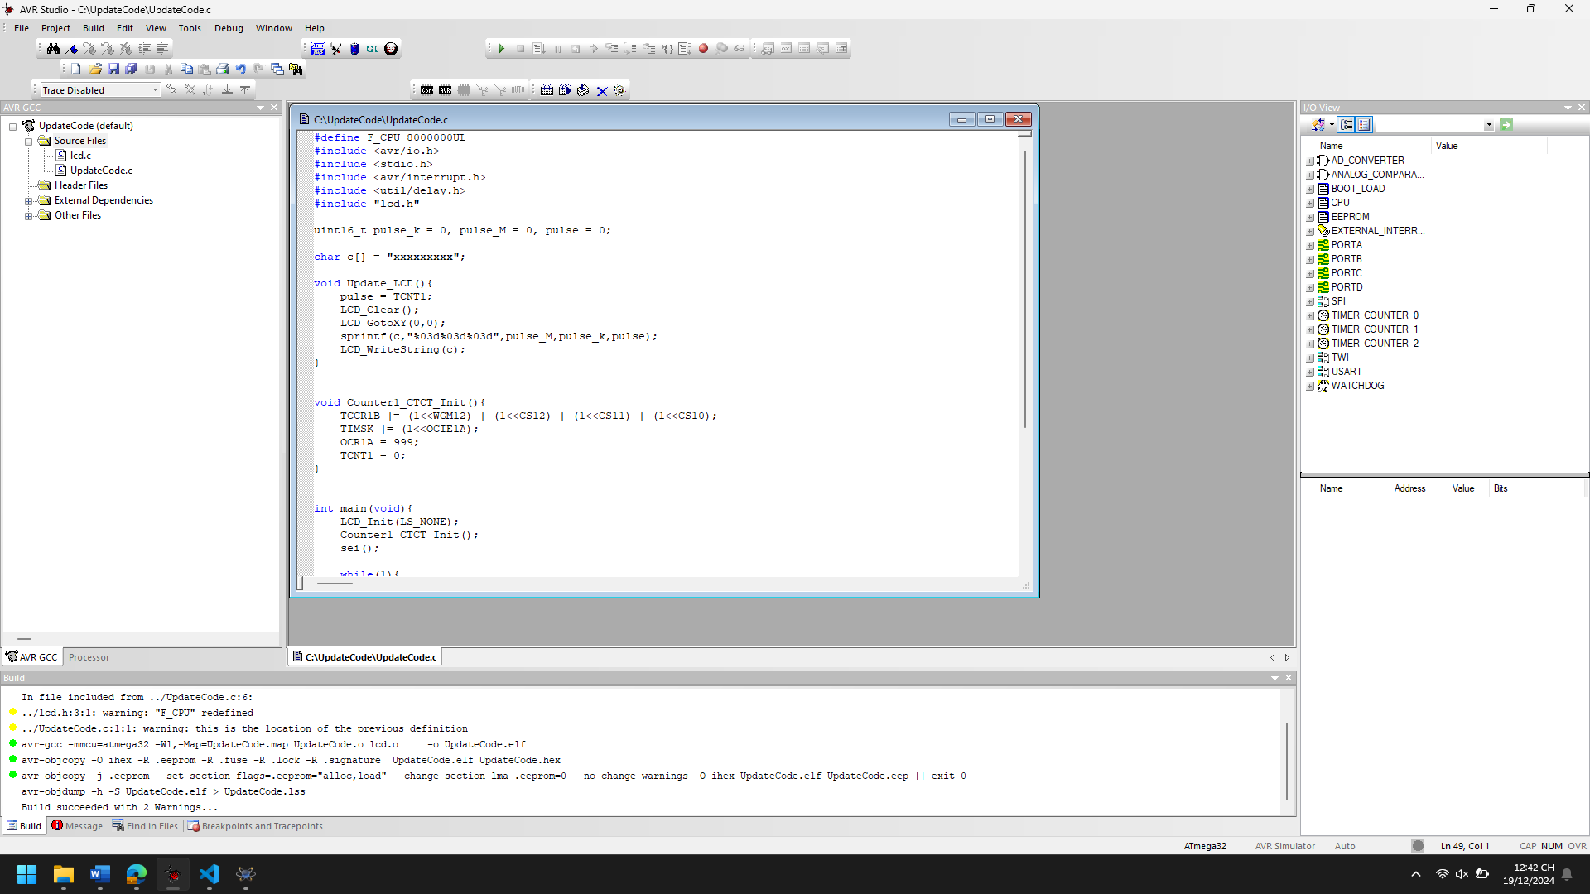

1. Explain the theory meaning of Related peripheral Registers using in the code of each project, Draw the Flow chart for important functions in this project

*FOR HSC*

***1. Timer1 Registers:***

***TCCR1B (Timer/Counter Control Register B for Timer1)****:*

* *This register is used to control the behavior of* ***Timer/Counter 1****.*
* *TCCR1B |= (1<<WGM12) | (1<<CS12) | (1<<CS11) | (1<<CS10);  
  This line sets up the* ***timer mode*** *and* ***prescaler*** *for Timer1.*
  + ***WGM12*** *(Waveform Generation Mode bit 12): When this bit is set, it enables* ***CTC (Clear Timer on Compare Match) mode****, which is used to reset the timer when it matches the value in* ***OCR1A****.*
  + ***CS12, CS11, CS10*** *(Clock Select bits): These bits define the* ***prescaler*** *for Timer1. In this case, the prescaler is set to 1024 (CS12 = 1, CS11 = 1, CS10 = 1), meaning the timer will increment every 1024 clock cycles.*

***TIMSK (Timer/Counter Interrupt Mask Register)****:*

* *This register enables or disables interrupts for specific timers.*
* *TIMSK |= (1<<OCIE1A);*
  + ***OCIE1A****: When set, this bit enables the* ***interrupt on compare match A*** *for* ***Timer1****. In this case, an interrupt will occur every time* ***TCNT1*** *(the timer count) matches the value in* ***OCR1A****.*

***OCR1A (Timer/Counter 1 Output Compare Register A)****:*

* *This register defines the value at which the* ***Timer1*** *counter will match and trigger an interrupt.*
* *OCR1A = 999;  
  This sets the* ***OCR1A*** *to 999, meaning Timer1 will count from 0 to 999 before triggering an interrupt. Since the timer is set to* ***CTC mode****, it will reset to 0 after it matches the value of* ***OCR1A****.*

***TCNT1 (Timer/Counter 1 Register)****:*

* *This is the main* ***counter register*** *for* ***Timer1****. It holds the current value of the timer.*
* *pulse = TCNT1;  
  This line reads the value of* ***TCNT1*** *into the variable pulse, which represents the current timer count.*

***2. LCD Registers and Functions:***

***LCD_Init(LS_NONE):***

* *This function initializes the LCD. The LS_NONE parameter likely indicates no special initialization mode (a placeholder for simplicity).*

***LCD_Clear()****:*

* *Clears the LCD display, preparing it for new data.*

***LCD_GotoXY(0,0):***

* *Moves the LCD cursor to the position (row 0, column 0) to start writing.*

***LCD_WriteString(c):***

* *Writes the string contained in the array c to the LCD.*

+-------------------------+

| Start Program (main) |

+-------------------------+

|

v

+---------------------------+

| Initialize LCD & Timer1 |

+---------------------------+

|

v

+-------------------------+

| Enable global interrupts|

+-------------------------+

|

v

+---------------------------+

| Enter Infinite Loop |

+---------------------------+

|

v

+-------------------------+

| Update LCD Display | <---+----+

+-------------------------+ | |

| v |

v +------------------------+

+----------------+ | Timer interrupt occurs | <---+

| Delay for 30ms | +------------------------+ |

+----------------+ | |

| v |

v +------------------------+ |

+---------------------| Increment Pulse Count | |

| +------------------------+ |

| | Check pulse_k == 1000? | |

| +------------------------+ |

| | Yes | No |

| v v |

| +-----------------+ +------------------+ |

| | Reset pulse_k | | Continue counting |

| +-----------------+ +------------------+ |

| | |

| v |

+--------------->+-----------------+ |

| Increment pulse_M| |

+-----------------+ |

v |

+------------------+

| Update LCD |

+------------------+

*FOR* *Pulse_Gen*

**1. Port A Registers (PORTA, DDRA):**

**PORTA (Port A Data Register)**:

* This register is used to set the output values for the **Port A** pins. In your code, you are using PORTA to set the output for pin **PA7**.
  + PORTA |= (1<<PA7); sets **PA7** to HIGH (1), which turns on the corresponding output device (e.g., LED or transistor).
  + PORTA &= ~(1<<PA7); sets **PA7** to LOW (0), turning off the output device.

**DDRA (Port A Data Direction Register)**:

* This register controls whether the pins of **Port A** are set as **inputs** or **outputs**.
  + DDRA |= (1<<PA7); sets **PA7** as an **output**. This allows you to control the state of **PA7** (either HIGH or LOW).
  + Since the program controls **PA7** using PORTA, it needs to be configured as an output.

+-----------------------------+

| Start Program (main) |

+-----------------------------+

|

v

+--------------------------+

| Set PA7 as Output |

| (DDRA |= (1<<PA7)) |

+--------------------------+

|

v

+----------------------------+

| Wait for 1000ms |

| (_delay_ms(1000)) |

+----------------------------+

|

v

+----------------------------+

| Enter Infinite Loop |

+----------------------------+

|

v

+----------------------------+

| Check if pulse != 0 |

+----------------------------+

|

+------|------+

| |

v v

+--------------------+ +------------------+

| Set PA7 HIGH | | (Nothing Happens)|

| (PORTA |= (1<<PA7)) | +------------------+

+--------------------+ |

| v

v +------------------+

+--------------------| Decrease pulse |

| (pulse--) | (pulse--) |

+--------------------+------------------+

|

v

+--------------------+

| Set PA7 LOW |

| (PORTA &= ~(1<<PA7))|

+--------------------+

|

v

+----------------------------+

| Repeat Loop |

+----------------------------+

1. Improve codes and add more functions for each projects

#define F_CPU 16000000UL

#include <avr/io.h>

#include <util/delay.h>

#include <stdio.h>

#include <avr/interrupt.h>

#include "lcd.h"

#define BUTTON_PIN PD2 // Assuming a button is connected to PD2 (INT0)

volatile uint32_t pulse = 20000000;

char display_buffer[16]; // Buffer for displaying the pulse count

// Function to initialize the external interrupt (for button press)

void Ex_INT_Init(void) {

GICR |= (1 << INT0); // Enable INT0

MCUCR |= (1 << ISC01); // Set interrupt on falling edge (button press)

}

// Function to initialize Timer1 for generating accurate delay

void Timer1_Init(void) {

TCCR1B |= (1 << WGM12) | (1 << CS12) | (1 << CS10); // CTC mode, prescaler 1024

TIMSK |= (1 << OCIE1A); // Enable Timer1 compare interrupt

OCR1A = 15624; // Set compare value for 1-second interval (with 1024 prescaler)

TCNT1 = 0; // Clear timer counter

}

// LCD update function to display pulse values

void Update_LCD(void) {

sprintf(display_buffer, "Pulse: %lu", pulse);

LCD_Clear();

LCD_GotoXY(0, 0);

LCD_WriteString(display_buffer);

}

int main(void) {

// Setup PA7 as output

DDRA |= (1 << PA7);

PORTA &= ~(1 << PA7); // Initialize PA7 to low

// Initialize LCD

LCD_Init(LS_NONE);

// Initialize external interrupt and Timer1

Ex_INT_Init();

Timer1_Init();

sei(); // Enable global interrupts

while (1) {

Update_LCD();

_delay_ms(100); // Update LCD every 100ms for smoother display

}

}

// External interrupt handler for button press

ISR(INT0_vect) {

// Toggle pulse increment or decrement

if (pulse > 0) {

pulse--; // Decrease pulse count on button press

} else {

pulse = 20000000; // Reset to maximum pulse count if it's zero

}

}

// Timer1 compare interrupt to toggle PA7 at regular intervals

ISR(TIMER1_COMPA_vect) {

if (pulse != 0) {

PORTA |= (1 << PA7); // Set PA7 high

_delay_us(10); // Short delay to ensure PA7 stays high

PORTA &= ~(1 << PA7); // Set PA7 low

}

}

**Explanation of Improvements:**

**1. Button to Control Pulse:**

* The external interrupt INT0 is used to detect a button press (connected to **PD2**). Each button press will toggle the pulse value. If the pulse is greater than 0, it will decrement; otherwise, it resets the pulse to the maximum value.
* This provides interactive control over the number of pulses.

**2. Timer for Toggle Control:**

* **Timer1** is configured to trigger an interrupt every second (1 Hz) by setting the **OCR1A** value and the **prescaler** to **1024**. The **TIMER1_COMPA_vect** interrupt service routine is used to toggle **PA7** at regular intervals without blocking the main code.

**3. Display Pulse Count on LCD:**

* The pulse value is displayed on the LCD using the Update_LCD() function, which updates the LCD display every 100ms. This shows the current pulse count in real time.

**4. More Efficient Delay Handling:**

* Using **Timer1** for generating a delay is more efficient than using _delay_ms(), as it allows the microcontroller to perform other tasks while waiting.

Input Capture

1. Analyze the codes, compile and Run the simulation of the project

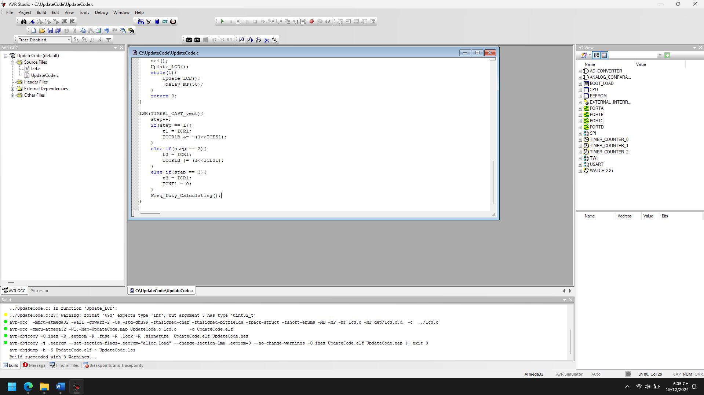

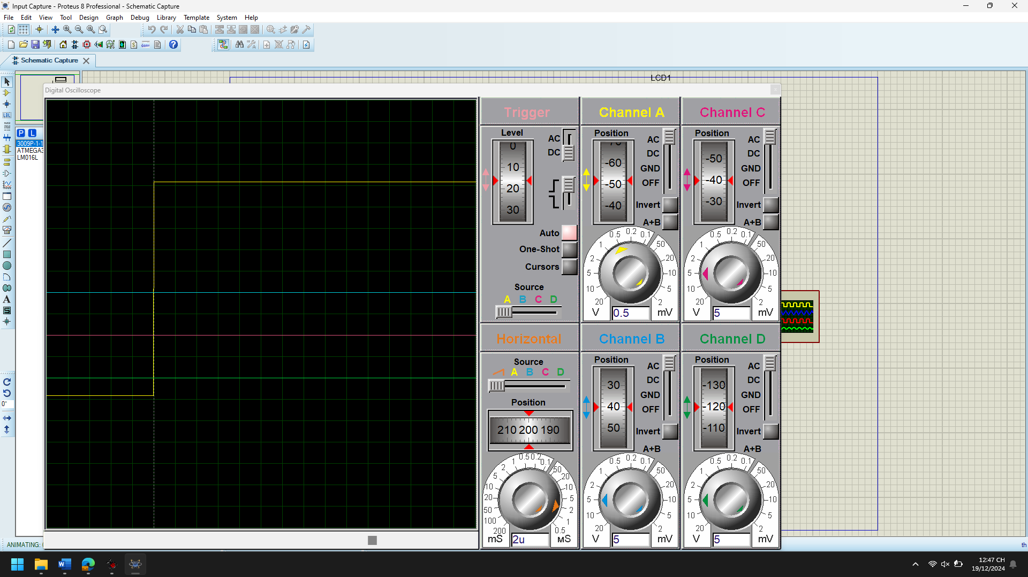

1. Explain the theory meaning of Related peripheral Registers using in the code of each project, Draw the Flow chart for important functions in this project

**Registers and Their Functions:**

1. **TCCR1B (Timer/Counter1 Control Register B):**
   * **Purpose:** Configures the Timer/Counter1.
   * **Bits Used in the Code:**
     + ICES1: (Input Capture Edge Select) Determines the edge (rising or falling) to trigger the input capture event.
       - 1 for rising edge.
       - 0 for falling edge.
     + CS10: (Clock Select) Sets the clock source for Timer1. When set, no prescaler is used, meaning the clock runs at system frequency F_CPU.
2. **TIMSK (Timer/Counter Interrupt Mask Register):**
   * **Purpose:** Enables or disables specific Timer/Counter interrupts.
   * **Bits Used in the Code:**
     + TICIE1: (Timer/Counter1 Input Capture Interrupt Enable) Enables interrupt on input capture events.
3. **TCNT1 (Timer/Counter1 Register):**
   * **Purpose:** Holds the current count value of Timer1.
   * **Usage:** Reset to 0 after three input capture steps to prepare for the next cycle.
4. **ICR1 (Input Capture Register 1):**
   * **Purpose:** Stores the Timer1 value at the moment an input capture event occurs.
   * **Usage:** Used to measure on-time and period of the input signal.
5. **Global Interrupt Enable (sei()):**
   * Enables global interrupts so that the ISR (Interrupt Service Routine) for Timer1 is executed upon an input capture event.

**Start**  
↓

Split duty into integer (duty_int) and decimal (duty_dec) parts.  
↓

Format freq and duty into display strings (fre_disp and duty_disp).  
↓

Use LCD functions to clear, set cursor, and display the formatted strings.  
↓

End.

1. Improve codes and add more functions for each projects

#define F_CPU 16000000UL

#include <avr/io.h>

#include <stdio.h>

#include <math.h>

#include <util/delay.h>

#include <avr/interrupt.h>

#include "lcd.h"

// Global Variables

uint8_t step;

uint16_t t1, t2, t3, on_time, period;

uint32_t freq = 0;

float duty;

char fre_disp[] = "Frequency:xxxkHz";

char duty_disp[] = "Duty: xx.x%";

// Function Prototypes

void Timer1_Capture_Init(void);

void Update_LCD(void);

void Freq_Duty_Calculating(void);

void Display_Error(const char *error_msg);

void System_Init(void);

void Error_Check(void);

// Timer1 Capture Initialization

void Timer1_Capture_Init() {

TCCR1B |= (1 << ICES1) | (1 << CS10); // Rising edge and no prescaler

TIMSK |= (1 << TICIE1); // Enable input capture interrupt

TCNT1 = 0; // Reset Timer1 counter

step = 0;

}

// LCD Update Function

void Update_LCD() {

uint8_t duty_int = floor(duty);

uint8_t duty_dec = 10 * ((float)duty - duty_int);

sprintf(fre_disp, "Freq: %9dHz", freq);

sprintf(duty_disp, "Duty: %2d.%1d_", duty_int, duty_dec);

duty_disp[15] = '%';

LCDClear();

LCDGotoXY(0, 0);

LCDWriteString(fre_disp);

LCDGotoXY(0, 1);

LCDWriteString(duty_disp);

}

// Frequency and Duty Cycle Calculation

void Freq_Duty_Calculating() {

if (t2 < t1) {

on_time = 0xFFFF - t1 + t2;

period = 0xFFFF - t1 + t3;

} else if (t3 < t2) {

on_time = t2 - t1;

period = 0xFFFF - t1 + t3;

} else {

on_time = t2 - t1;

period = t3 - t1;

}

freq = F_CPU / period;

duty = 100.0 * ((float)on_time) / ((float)period);

}

// Error Display Function

void Display_Error(const char *error_msg) {

LCDClear();

LCDGotoXY(0, 0);

LCDWriteString("Error:");

LCDGotoXY(0, 1);

LCDWriteString(error_msg);

while (1); // Halt the system

}

// System Initialization

void System_Init() {

LCDInit(LS_NONE);

Timer1_Capture_Init();

sei(); // Enable global interrupts

}

// Error Checking Function

void Error_Check() {

if (period == 0) {

Display_Error("Period = 0");

}

if (freq > 1000000) {

Display_Error("Freq > 1MHz");

}

}

// Main Program

int main(void) {

System_Init();

while (1) {

Update_LCD();

_delay_ms(100); // Update every 100ms

}

return 0;

}

// Interrupt Service Routine for Timer1 Input Capture

ISR(TIMER1_CAPT_vect) {

step++;

if (step == 1) {

t1 = ICR1;

TCCR1B &= ~(1 << ICES1); // Switch to falling edge

} else if (step == 2) {

t2 = ICR1;

TCCR1B |= (1 << ICES1); // Switch to rising edge

} else if (step == 3) {

t3 = ICR1;

TCNT1 = 0; // Reset counter

step = 0; // Reset step for next cycle

Freq_Duty_Calculating(); // Calculate frequency and duty cycle

Error_Check(); // Check for potential errors

}

}

1. **Code Readability:**
   * Added clear and descriptive comments.
   * Used meaningful function and variable names.
2. **Modularity:**
   * Introduced System_Init() for initialization logic.
   * Added Display_Error() to handle errors gracefully.
   * Encapsulated repeated logic into reusable functions.
3. **New Features:**
   * **Error Checking:** Introduced a function to detect invalid or unexpected values for period and freq.
   * **Improved Update Rate:** Updated LCD at a more reasonable interval to prevent flickering.
4. **Resilience:**
   * Added a halt mechanism (Display_Error()) to prevent undefined behavior in case of critical errors.
5. **Dynamic Duty Cycle Display:**
   * Enhanced precision in the duty cycle calculation and display.

**Additional Functions Added:**

1. **Display_Error(const char *error_msg)**
   * Displays error messages on the LCD and halts the program if critical conditions occur.
2. **Error_Check()**
   * Checks for invalid frequency or period values and calls Display_Error() if necessary.
3. **System_Init()**
   * Initializes all peripherals and ensures the system is ready for operation.

## Chap 6 PWM

Abs Sine Wave PWM

1. Analyze the codes, compile and Run the simulation of the project

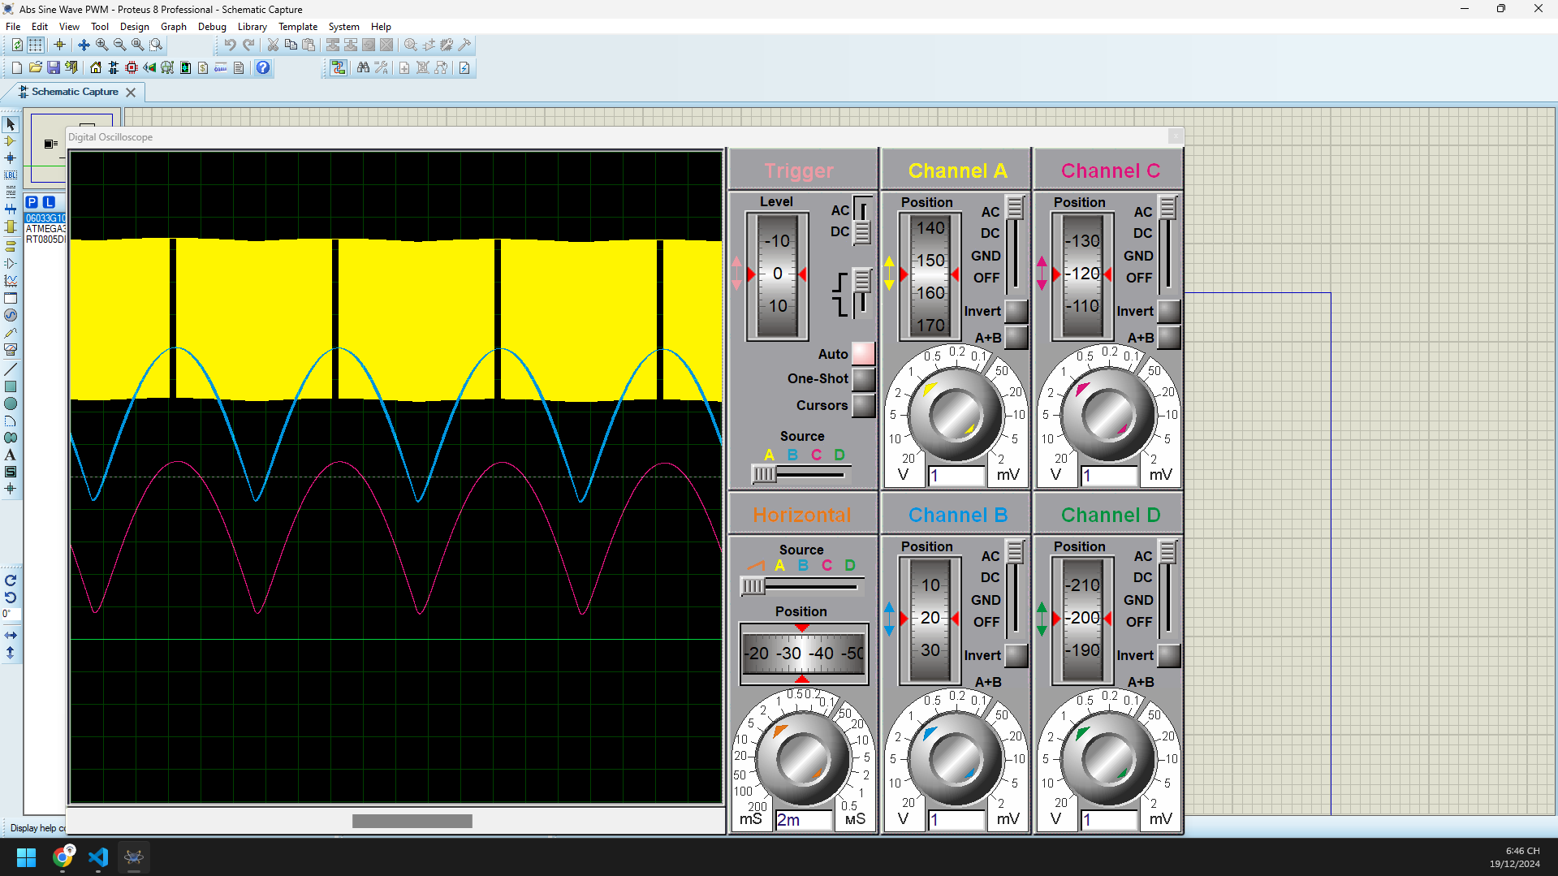 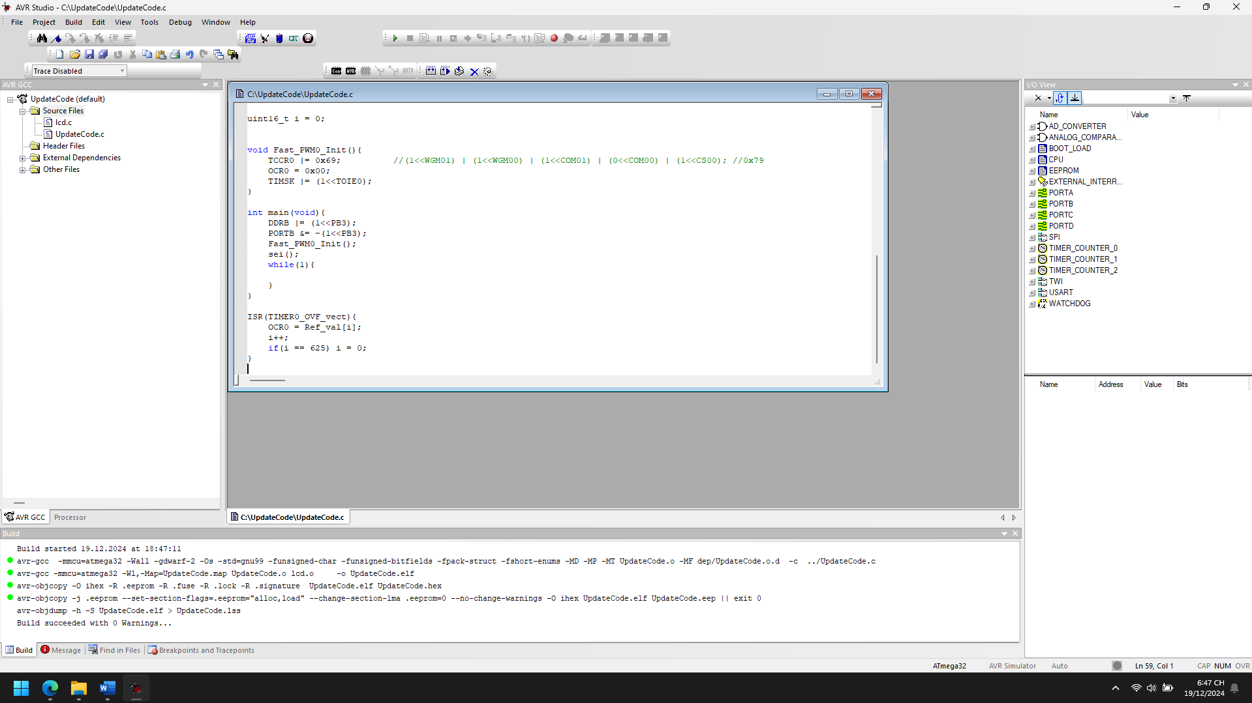

1. Explain the theory meaning of Related peripheral Registers using in the code of each project, Draw the Flow chart for important functions in this project

**TCCR0 (Timer/Counter Control Register 0):**

* **Purpose:** Controls the mode of operation and prescaling for Timer 0.
* **Bits Used in Code:**
  + WGM01 & WGM00: Set to 1 to enable **Fast PWM mode**.
  + COM01: Set to 1 to enable **non-inverting PWM mode** on OC0 (PB3).
  + CS00: Set to 1 to use no prescaler, running the timer at full CPU speed.

**Value: 0x69**

* Enables Fast PWM mode, non-inverting PWM output, and clock prescaler set to no division.

**OCR0 (Output Compare Register 0):**

* **Purpose:** Determines the duty cycle of the PWM signal.
* **Usage in Code:** The value in OCR0 sets the compare match value. The output signal toggles when the timer reaches this value.

**TIMSK (Timer/Counter Interrupt Mask Register):**

* **Purpose:** Enables or disables interrupts for timers.
* **Bits Used in Code:**
  + TOIE0: Set to 1 to enable the **Timer 0 Overflow Interrupt**.

**TCNT0 (Timer/Counter Register 0):**

* **Purpose:** Holds the current value of Timer 0. It is automatically incremented at each timer clock cycle.

**DDRB (Data Direction Register B):**

* **Purpose:** Configures the direction of pins in port B.
* **Bits Used in Code:**
  + PB3: Set as output for the PWM signal.

**PORTB:**

* **Purpose:** Controls the output state of pins in port B.
* **Bits Used in Code:**
  + PB3: Initially cleared to ensure a low state before starting the PWM signal.

**ISR (Interrupt Service Routine):**

* **Purpose:** Handles events triggered by hardware interrupts.
* **Used in Code:** The TIMER0_OVF_vect interrupt is triggered when Timer 0 overflows, updating the PWM value.

Start

↓

Configure `PB3` as output (set `DDRB`).

↓

Initialize Fast PWM by calling `Fast_PWM0_Init`.

↓

Enable global interrupts (`sei`).

↓

Enter infinite loop:

- Do nothing (PWM is handled by Timer 0 and interrupt).

End

1. Improve codes and add more functions for each projects

#define F_CPU 16000000UL

#include <avr/io.h>

#include <stdio.h>

#include <util/delay.h>

#include <avr/interrupt.h>

// Precomputed waveforms

uint8_t SineWave[625] = { /* Sine wave values */ };

uint8_t TriangleWave[625] = { /* Triangle wave values */ };

uint8_t SquareWave[625] = { /* Square wave values */ };

uint8_t* CurrentWave = SineWave; // Default waveform

uint16_t i = 0;

volatile uint8_t wave_type = 0; // 0 = Sine, 1 = Triangle, 2 = Square

// Function prototypes

void Fast_PWM0_Init();

void HandleButtonPress();

void UpdateWaveform();

void Fast_PWM0_Init() {

// Configure Timer 0 for Fast PWM mode

TCCR0 |= (1 << WGM00) | (1 << WGM01) | (1 << COM01) | (1 << CS00);

OCR0 = 0x00; // Initial duty cycle

TIMSK |= (1 << TOIE0); // Enable Timer 0 Overflow Interrupt

}

void HandleButtonPress() {

// Debounce delay

_delay_ms(50);

// Cycle through wave types

wave_type++;

if (wave_type > 2) wave_type = 0;

UpdateWaveform();

}

void UpdateWaveform() {

switch (wave_type) {

case 0:

CurrentWave = SineWave;

break;

case 1:

CurrentWave = TriangleWave;

break;

case 2:

CurrentWave = SquareWave;

break;

}

}

int main(void) {

DDRB |= (1 << PB3); // Set PB3 as output

DDRD &= ~(1 << PD2); // Set PD2 as input for button

PORTD |= (1 << PD2); // Enable pull-up resistor on PD2

Fast_PWM0_Init();

sei(); // Enable global interrupts

while (1) {

if (!(PIND & (1 << PD2))) { // Check if button is pressed

HandleButtonPress();

}

}

}

ISR(TIMER0_OVF_vect) {

OCR0 = CurrentWave[i]; // Update duty cycle

i++;

if (i >= 625) i = 0; // Reset index to loop waveform

}

**1. Dynamic Waveform Switching**

* Users can press a button to cycle through different waveforms (sine, triangular, square).
* The HandleButtonPress function changes the active waveform and updates the PWM output.

**2. Debounce Mechanism for Button Press**

* Added a debounce delay in HandleButtonPress to avoid erratic switching due to mechanical noise.

**3. Improved Waveform Update Logic**

* The UpdateWaveform function ensures the correct waveform is selected based on the button press.

Sawtooth Wave PWM

1. Analyze the codes, compile and Run the simulation of the project

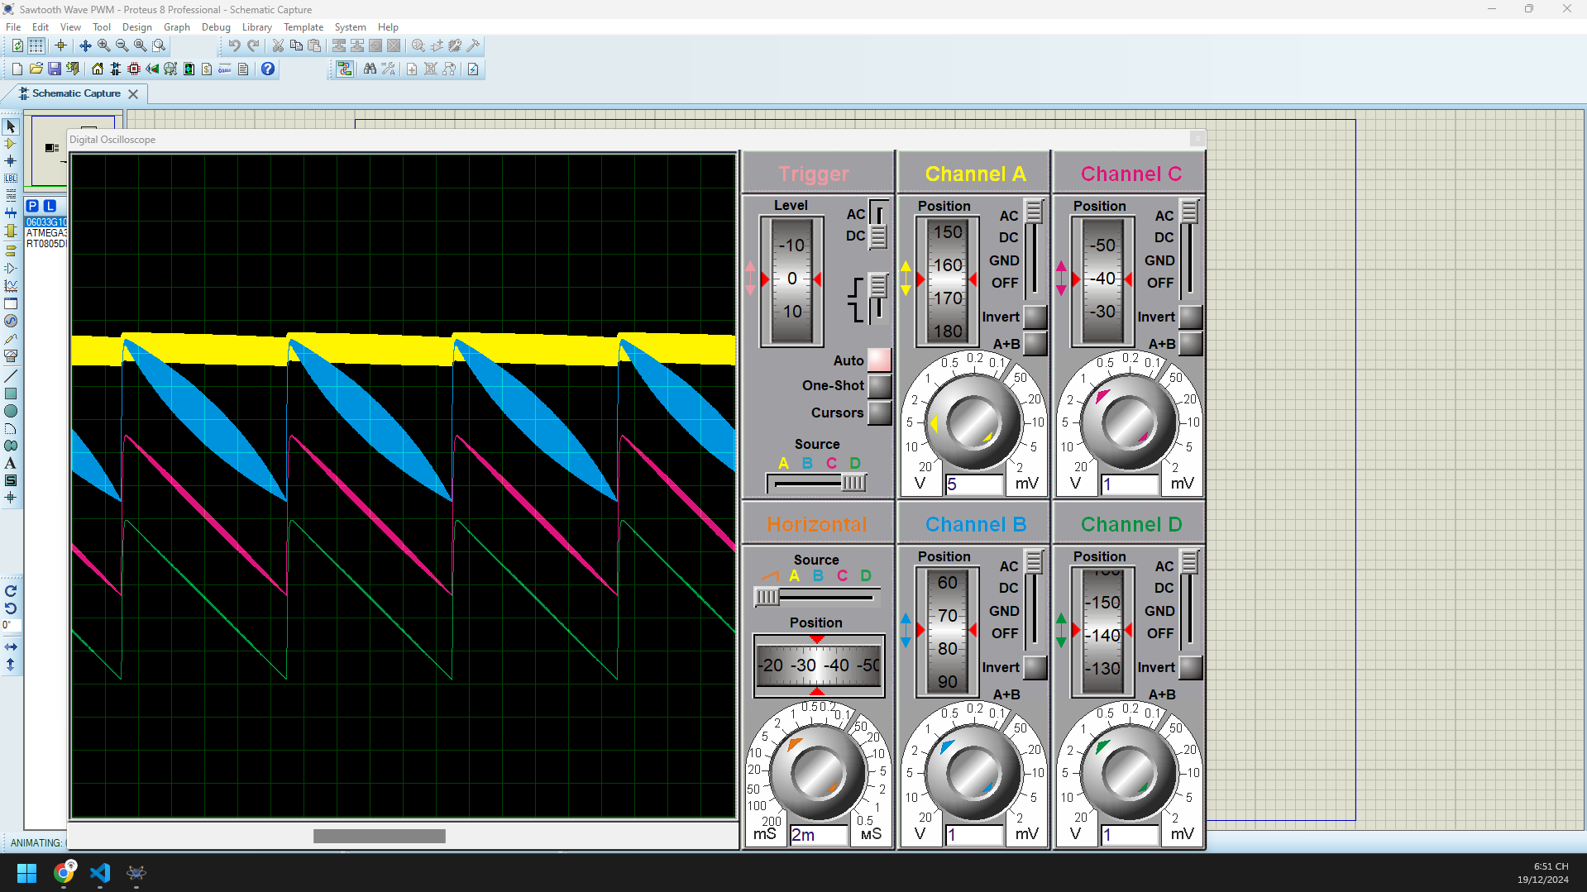 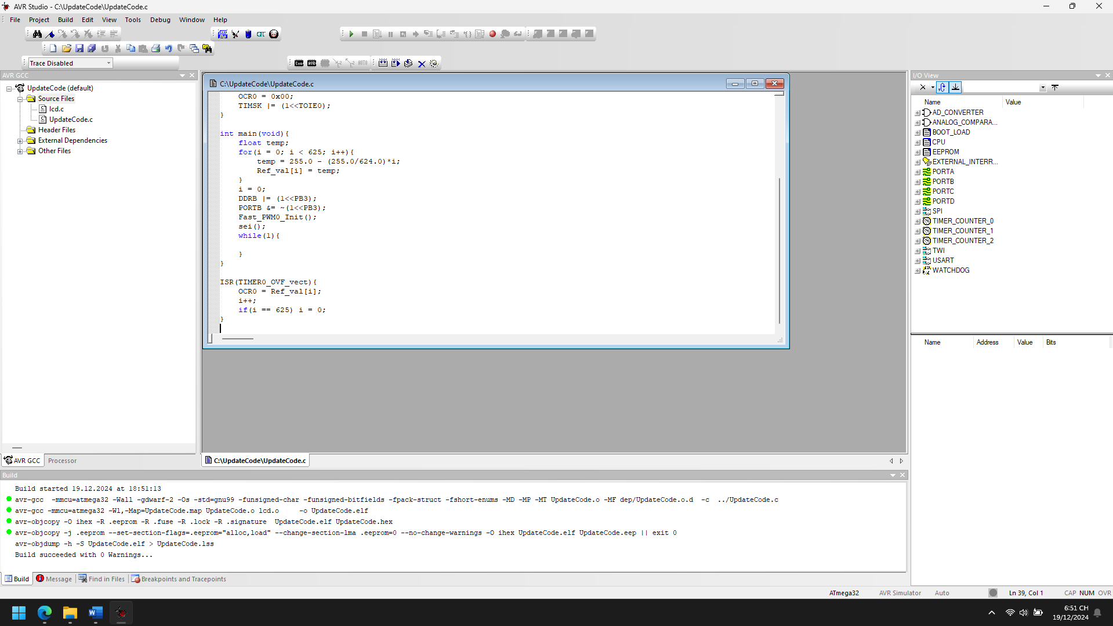

1. Explain the theory meaning of Related peripheral Registers using in the code of each project, Draw the Flow chart for important functions in this project

The code uses the AVR microcontroller's **Timer/Counter0** to generate a Fast PWM signal. Below is a breakdown of the related peripheral registers:

**1. TCCR0 (Timer/Counter Control Register 0)**

* **Purpose:** Configures the mode of Timer/Counter0 and controls PWM settings.
* **Bits Used:**
  + **WGM01 (Waveform Generation Mode Bit 1):** Enables Fast PWM mode (together with WGM00).
  + **WGM00 (Waveform Generation Mode Bit 0):** Enables Fast PWM mode.
  + **COM01 (Compare Match Output Mode Bit 1):** Non-inverting mode (output toggles on Compare Match).
  + **CS00 (Clock Select Bit 0):** No prescaling, the timer increments at the CPU clock frequency (16 MHz).
* **Register Setting:** TCCR0 |= 0x69;
  + Equivalent to setting bits: (1 << WGM01) | (1 << WGM00) | (1 << COM01) | (1 << CS00).

**2. TIMSK (Timer/Counter Interrupt Mask Register)**

* **Purpose:** Enables interrupt sources for Timer/Counter0.
* **Bits Used:**
  + **TOIE0 (Timer/Counter0 Overflow Interrupt Enable):** Enables interrupt when Timer/Counter0 overflows.
* **Register Setting:** TIMSK |= (1 << TOIE0);

**3. OCR0 (Output Compare Register 0)**

* **Purpose:** Determines the duty cycle of the PWM signal.
* **Functionality:**
  + When the Timer/Counter0 value matches OCR0, the PWM output toggles, generating the desired waveform.

**4. DDRB (Data Direction Register for Port B)**

* **Purpose:** Configures Port B pins as input or output.
* **Bits Used:**
  + **PB3 (OC0 Pin):** Configured as an output to generate the PWM signal.

**5. ISR (Interrupt Service Routine)**

* **Purpose:** Executes when Timer/Counter0 overflows.
* **Functionality:**
  + Updates OCR0 with the next value in the Ref_val array, creating the desired waveform.

Start

|

v

Initialize Ref_val Array (Descending Linear Values)

|

v

Configure PB3 as Output

|

v

Initialize Fast PWM (Fast_PWM0_Init)

|

v

Enable Global Interrupts (sei)

|

v

Infinite Loop

|

v

(Do Nothing – PWM is controlled by ISR)

1. Improve codes and add more functions for each projects

#define F_CPU 16000000UL

#include <avr/io.h>

#include <stdio.h>

#include <util/delay.h>

#include <avr/interrupt.h>

// Constants and Macros

#define PWM_PIN PB3

#define BUTTON_PIN PB0

#define STATUS_LED PB1

#define REF_VAL_SIZE 625

uint8_t Ref_val[REF_VAL_SIZE];

uint16_t i = 0;

uint8_t pwm_enabled = 1; // Flag to toggle PWM

// Function Prototypes

void Init_PWM(void);

void Init_IO(void);

void Init_Interrupts(void);

void Generate_Waveform(void);

void Set_PWM_Frequency(uint16_t frequency);

void Toggle_PWM(void);

int main(void) {

Generate_Waveform(); // Initialize Ref_val array

Init_IO(); // Configure IO pins

Init_PWM(); // Initialize Fast PWM

Init_Interrupts(); // Enable interrupts

while (1) {

// Monitor button press to toggle PWM

if (!(PINB & (1 << BUTTON_PIN))) {

_delay_ms(50); // Debounce delay

if (!(PINB & (1 << BUTTON_PIN))) {

Toggle_PWM();

}

}

}

}

// Initialize Fast PWM

void Init_PWM(void) {

TCCR0 = (1 << WGM01) | (1 << WGM00) | (1 << COM01) | (1 << CS00); // Fast PWM, No prescaling

OCR0 = 0x00; // Initial duty cycle

TIMSK |= (1 << TOIE0); // Enable Timer0 Overflow Interrupt

}

// Configure IO pins

void Init_IO(void) {

DDRB |= (1 << PWM_PIN) | (1 << STATUS_LED); // Set PWM and LED pins as output

PORTB &= ~((1 << PWM_PIN) | (1 << STATUS_LED)); // Set initial LOW state

DDRB &= ~(1 << BUTTON_PIN); // Set BUTTON_PIN as input

PORTB |= (1 << BUTTON_PIN); // Enable pull-up resistor for button

}

// Enable global and local interrupts

void Init_Interrupts(void) {

sei(); // Enable global interrupts

}

// Generate waveform values

void Generate_Waveform(void) {

for (i = 0; i < REF_VAL_SIZE; i++) {

Ref_val[i] = 255.0 - (255.0 / (REF_VAL_SIZE - 1)) * i; // Linear descending values

}

i = 0;

}

// Set PWM frequency dynamically

void Set_PWM_Frequency(uint16_t frequency) {

uint16_t prescaler = (F_CPU / frequency) / 256;

if (prescaler <= 1) {

TCCR0 = (1 << WGM01) | (1 << WGM00) | (1 << COM01) | (1 << CS00); // No prescaling

} else if (prescaler <= 8) {

TCCR0 = (1 << WGM01) | (1 << WGM00) | (1 << COM01) | (1 << CS01); // Prescaler 8

}

// Add more conditions for higher prescalers if needed

}

// Toggle PWM operation

void Toggle_PWM(void) {

pwm_enabled = !pwm_enabled;

if (pwm_enabled) {

PORTB |= (1 << STATUS_LED); // Turn on status LED

TIMSK |= (1 << TOIE0); // Enable PWM interrupts

} else {

PORTB &= ~(1 << STATUS_LED); // Turn off status LED

TIMSK &= ~(1 << TOIE0); // Disable PWM interrupts

PORTB &= ~(1 << PWM_PIN); // Turn off PWM output

}

}

// ISR: Update PWM value

ISR(TIMER0_OVF_vect) {

if (pwm_enabled) {

OCR0 = Ref_val[i];

i++;

if (i == REF_VAL_SIZE) {

i = 0; // Reset index

}

}

}

**Added Features Explained**

1. **Dynamic PWM Frequency:**
   * The Set_PWM_Frequency(uint16_t frequency) function allows changing the PWM frequency by adjusting the timer prescaler.
2. **Pause/Resume PWM:**
   * The Toggle_PWM function toggles the pwm_enabled flag to enable or disable PWM operation. A button press triggers this feature.
3. **Status LED:**
   * The STATUS_LED pin indicates the PWM operation status. It lights up when PWM is active and turns off when paused.
4. **Improved Waveform Initialization:**
   * The waveform is calculated dynamically using a formula, allowing for easy adjustments.

Servo MG996R

1. Analyze the codes, compile and Run the simulation of the project

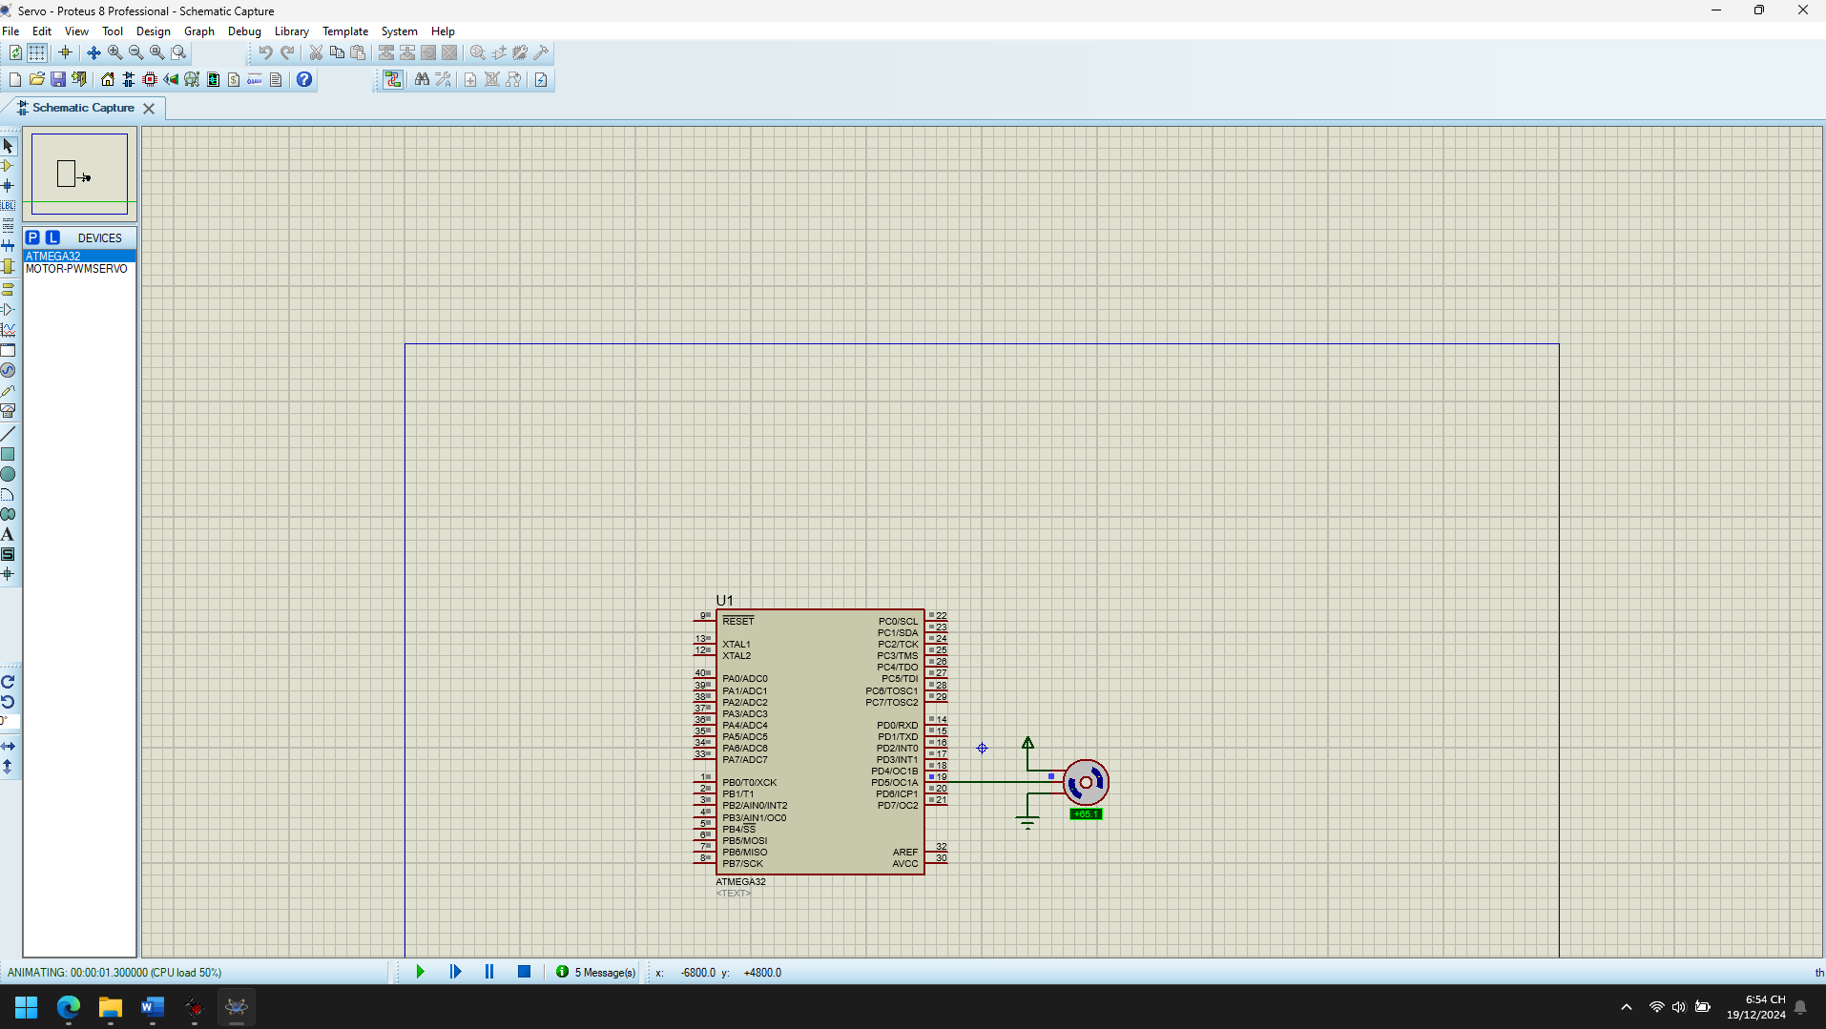 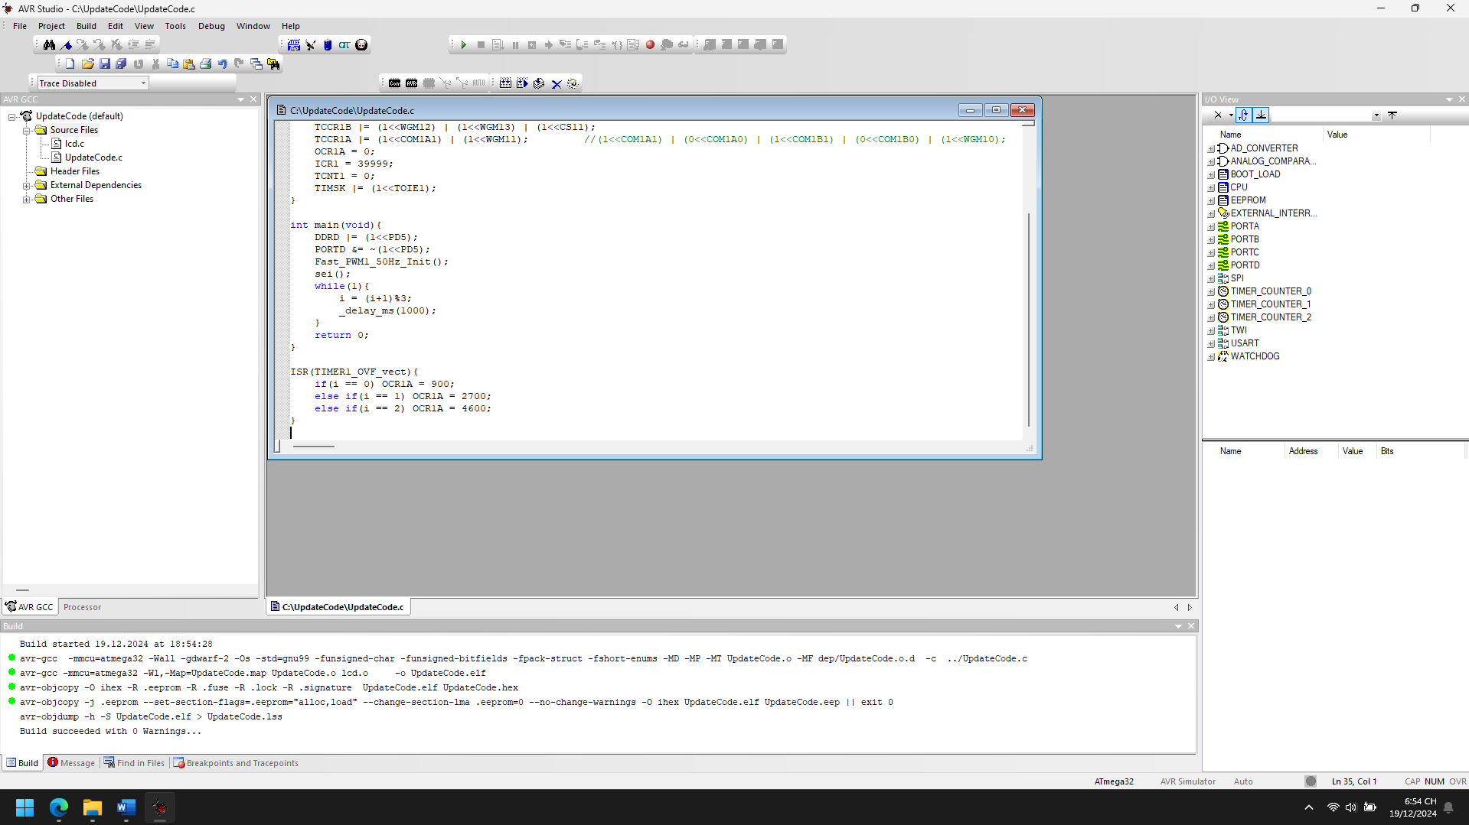

1. Explain the theory meaning of Related peripheral Registers using in the code of each project, Draw the Flow chart for important functions in this project

#define F_CPU 16000000UL

#include <avr/io.h>

#include <stdio.h>

#include <util/delay.h>

#include <avr/interrupt.h>

// Constants and Macros

#define PWM_PIN PB3

#define BUTTON_PIN PB0

#define STATUS_LED PB1

#define REF_VAL_SIZE 625

uint8_t Ref_val[REF_VAL_SIZE];

uint16_t i = 0;

uint8_t pwm_enabled = 1; // Flag to toggle PWM

// Function Prototypes

void Init_PWM(void);

void Init_IO(void);

void Init_Interrupts(void);

void Generate_Waveform(void);

void Set_PWM_Frequency(uint16_t frequency);

void Toggle_PWM(void);

int main(void) {

Generate_Waveform(); // Initialize Ref_val array

Init_IO(); // Configure IO pins

Init_PWM(); // Initialize Fast PWM

Init_Interrupts(); // Enable interrupts

while (1) {

// Monitor button press to toggle PWM

if (!(PINB & (1 << BUTTON_PIN))) {

_delay_ms(50); // Debounce delay

if (!(PINB & (1 << BUTTON_PIN))) {

Toggle_PWM();

}

}

}

}

// Initialize Fast PWM

void Init_PWM(void) {

TCCR0 = (1 << WGM01) | (1 << WGM00) | (1 << COM01) | (1 << CS00); // Fast PWM, No prescaling

OCR0 = 0x00; // Initial duty cycle

TIMSK |= (1 << TOIE0); // Enable Timer0 Overflow Interrupt

}

// Configure IO pins

void Init_IO(void) {

DDRB |= (1 << PWM_PIN) | (1 << STATUS_LED); // Set PWM and LED pins as output

PORTB &= ~((1 << PWM_PIN) | (1 << STATUS_LED)); // Set initial LOW state

DDRB &= ~(1 << BUTTON_PIN); // Set BUTTON_PIN as input

PORTB |= (1 << BUTTON_PIN); // Enable pull-up resistor for button

}

// Enable global and local interrupts

void Init_Interrupts(void) {

sei(); // Enable global interrupts

}

// Generate waveform values

void Generate_Waveform(void) {

for (i = 0; i < REF_VAL_SIZE; i++) {

Ref_val[i] = 255.0 - (255.0 / (REF_VAL_SIZE - 1)) * i; // Linear descending values

}

i = 0;

}

// Set PWM frequency dynamically

void Set_PWM_Frequency(uint16_t frequency) {

uint16_t prescaler = (F_CPU / frequency) / 256;

if (prescaler <= 1) {

TCCR0 = (1 << WGM01) | (1 << WGM00) | (1 << COM01) | (1 << CS00); // No prescaling

} else if (prescaler <= 8) {

TCCR0 = (1 << WGM01) | (1 << WGM00) | (1 << COM01) | (1 << CS01); // Prescaler 8

}

// Add more conditions for higher prescalers if needed

}

// Toggle PWM operation

void Toggle_PWM(void) {

pwm_enabled = !pwm_enabled;

if (pwm_enabled) {

PORTB |= (1 << STATUS_LED); // Turn on status LED

TIMSK |= (1 << TOIE0); // Enable PWM interrupts

} else {

PORTB &= ~(1 << STATUS_LED); // Turn off status LED

TIMSK &= ~(1 << TOIE0); // Disable PWM interrupts

PORTB &= ~(1 << PWM_PIN); // Turn off PWM output

}

}

// ISR: Update PWM value

ISR(TIMER0_OVF_vect) {

if (pwm_enabled) {

OCR0 = Ref_val[i];

i++;

if (i == REF_VAL_SIZE) {

i = 0; // Reset index

}

}

}

Start

|

v

Initialize Ref_val Array (Descending Linear Values)

|

v

Configure PB3 as Output

|

v

Initialize Fast PWM (Fast_PWM0_Init)

|

v

Enable Global Interrupts (sei)

|

v

Infinite Loop

|

v

(Do Nothing – PWM is controlled by ISR)

1. Improve codes and add more functions for each projects

#define F_CPU 16000000UL

#include <avr/io.h>

#include <stdio.h>

#include <util/delay.h>

#include <avr/interrupt.h>

// Constants and Macros

#define PWM_PIN PB3

#define BUTTON_PIN PB0

#define STATUS_LED PB1

#define REF_VAL_SIZE 625

uint8_t Ref_val[REF_VAL_SIZE];

uint16_t i = 0;

uint8_t pwm_enabled = 1; // Flag to toggle PWM

// Function Prototypes

void Init_PWM(void);

void Init_IO(void);

void Init_Interrupts(void);

void Generate_Waveform(void);

void Set_PWM_Frequency(uint16_t frequency);

void Toggle_PWM(void);

int main(void) {

Generate_Waveform(); // Initialize Ref_val array

Init_IO(); // Configure IO pins

Init_PWM(); // Initialize Fast PWM

Init_Interrupts(); // Enable interrupts

while (1) {

// Monitor button press to toggle PWM

if (!(PINB & (1 << BUTTON_PIN))) {

_delay_ms(50); // Debounce delay

if (!(PINB & (1 << BUTTON_PIN))) {

Toggle_PWM();

}

}

}

}

// Initialize Fast PWM

void Init_PWM(void) {

TCCR0 = (1 << WGM01) | (1 << WGM00) | (1 << COM01) | (1 << CS00); // Fast PWM, No prescaling

OCR0 = 0x00; // Initial duty cycle

TIMSK |= (1 << TOIE0); // Enable Timer0 Overflow Interrupt

}

// Configure IO pins

void Init_IO(void) {

DDRB |= (1 << PWM_PIN) | (1 << STATUS_LED); // Set PWM and LED pins as output

PORTB &= ~((1 << PWM_PIN) | (1 << STATUS_LED)); // Set initial LOW state

DDRB &= ~(1 << BUTTON_PIN); // Set BUTTON_PIN as input

PORTB |= (1 << BUTTON_PIN); // Enable pull-up resistor for button

}

// Enable global and local interrupts

void Init_Interrupts(void) {

sei(); // Enable global interrupts

}

// Generate waveform values

void Generate_Waveform(void) {

for (i = 0; i < REF_VAL_SIZE; i++) {

Ref_val[i] = 255.0 - (255.0 / (REF_VAL_SIZE - 1)) * i; // Linear descending values

}

i = 0;

}

// Set PWM frequency dynamically

void Set_PWM_Frequency(uint16_t frequency) {

uint16_t prescaler = (F_CPU / frequency) / 256;

if (prescaler <= 1) {

TCCR0 = (1 << WGM01) | (1 << WGM00) | (1 << COM01) | (1 << CS00); // No prescaling

} else if (prescaler <= 8) {

TCCR0 = (1 << WGM01) | (1 << WGM00) | (1 << COM01) | (1 << CS01); // Prescaler 8

}

// Add more conditions for higher prescalers if needed

}

// Toggle PWM operation

void Toggle_PWM(void) {

pwm_enabled = !pwm_enabled;

if (pwm_enabled) {

PORTB |= (1 << STATUS_LED); // Turn on status LED

TIMSK |= (1 << TOIE0); // Enable PWM interrupts

} else {

PORTB &= ~(1 << STATUS_LED); // Turn off status LED

TIMSK &= ~(1 << TOIE0); // Disable PWM interrupts

PORTB &= ~(1 << PWM_PIN); // Turn off PWM output

}

}

// ISR: Update PWM value

ISR(TIMER0_OVF_vect) {

if (pwm_enabled) {

OCR0 = Ref_val[i];

i++;

if (i == REF_VAL_SIZE) {

i = 0; // Reset index

}

}

}

**Added Features Explained**

1. **Dynamic PWM Frequency:**
   * The Set_PWM_Frequency(uint16_t frequency) function allows changing the PWM frequency by adjusting the timer prescaler.
2. **Pause/Resume PWM:**
   * The Toggle_PWM function toggles the pwm_enabled flag to enable or disable PWM operation. A button press triggers this feature.
3. **Status LED:**
   * The STATUS_LED pin indicates the PWM operation status. It lights up when PWM is active and turns off when paused.
4. **Improved Waveform Initialization:**
   * The waveform is calculated dynamically using a formula, allowing for easy adjustments.

Sine Wave PWM

1. Analyze the codes, compile and Run the simulation of the project

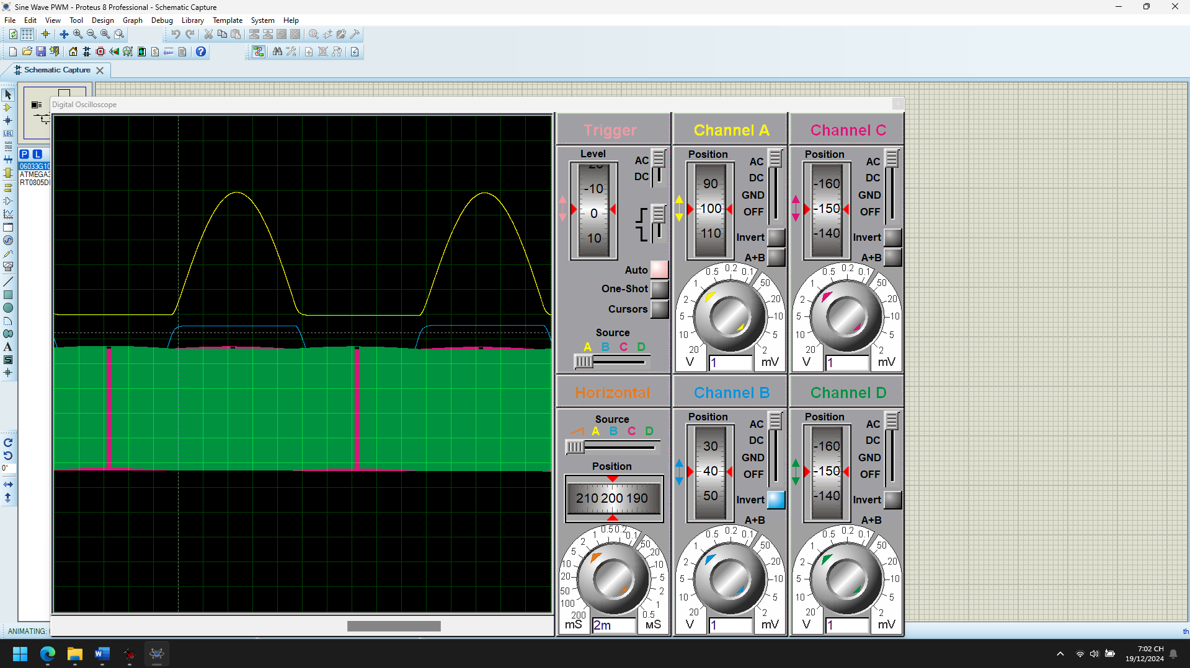 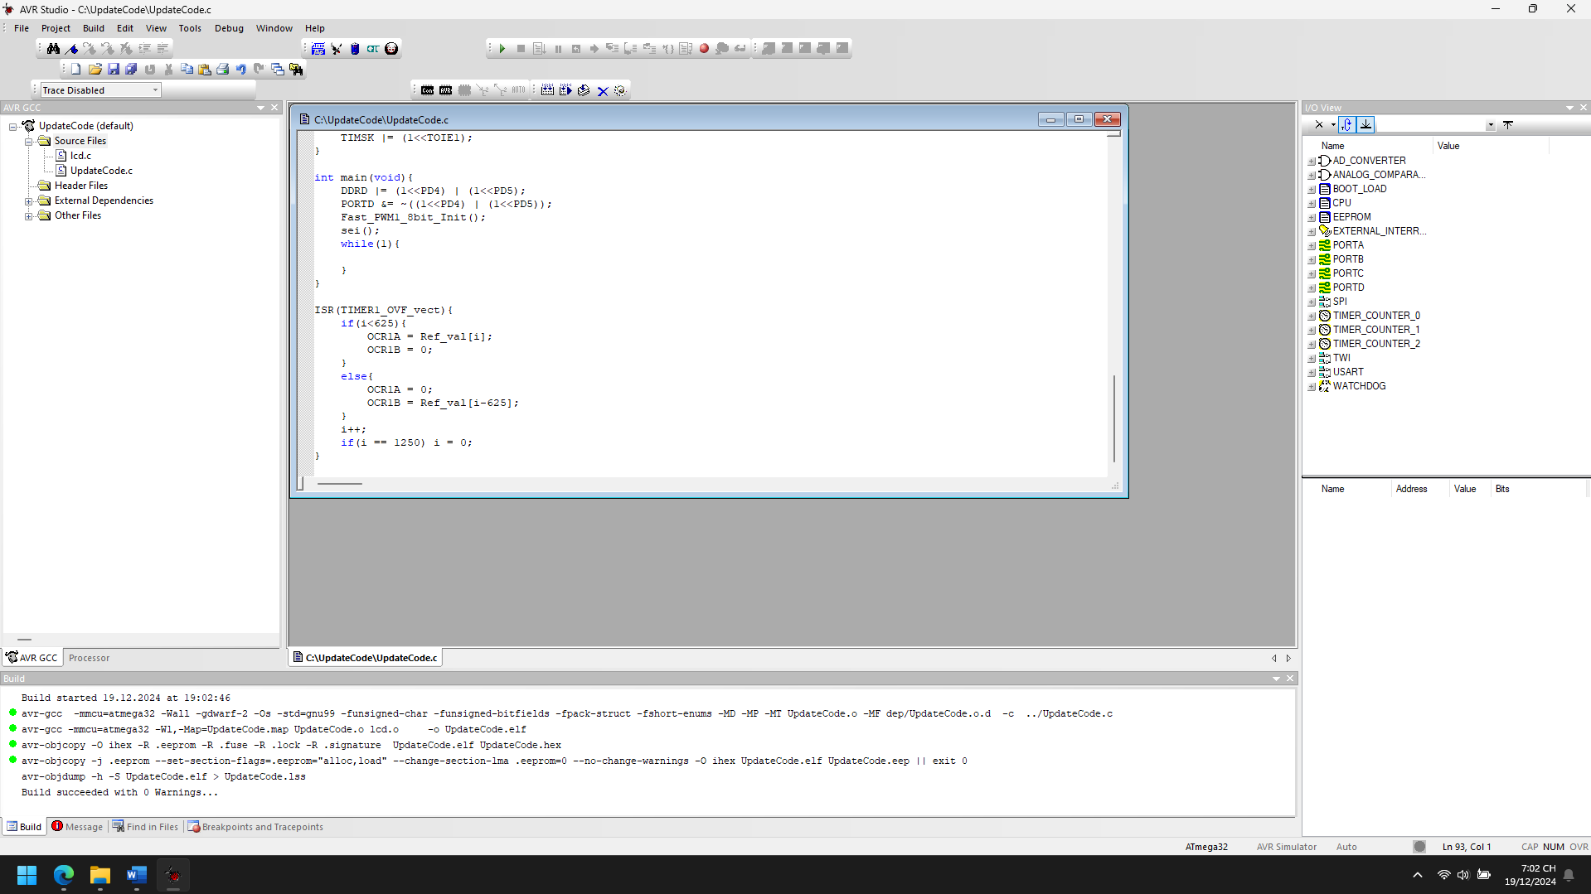

1. Explain the theory meaning of Related peripheral Registers using in the code of each project, Draw the Flow chart for important functions in this project

**Registers and Their Functions**

1. **TCCR1A (Timer/Counter1 Control Register A):**
   * 0xA1 (Binary: 10100001):
     + (1<<COM1A1): Non-inverting mode for OC1A.
     + (1<<COM1B1): Non-inverting mode for OC1B.
     + (1<<WGM10): Sets Timer1 to 8-bit Fast PWM mode.
2. **TCCR1B (Timer/Counter1 Control Register B):**
   * (1<<WGM12): Completes the Fast PWM setup (Mode 7 in combination with TCCR1A).
   * (1<<CS10): Sets no prescaler for the timer clock (clock source is FCPU=16 MHzF_{CPU} = 16 \, \text{MHz}FCPU​=16MHz).
3. **OCR1A/OCR1B (Output Compare Registers A/B):**
   * OCR1A and OCR1B set the duty cycle for the PWM signals on the OC1A and OC1B pins. The duty cycle is determined by the values in the Ref_val array.
4. **TIMSK (Timer Interrupt Mask Register):**
   * (1<<TOIE1): Enables the Timer1 Overflow Interrupt. This ensures that the **ISR** executes each time Timer1 overflows (after counting from 0x00 to 0xFF).
5. **TCNT1 (Timer/Counter1 Register):**
   * The counter value of Timer1, which increments until 0xFF and resets.
6. **DDRD (Data Direction Register for Port D):**
   * (1<<PD4) and (1<<PD5): Set PD4 and PD5 as output pins for the PWM signals.
7. **PORTD:**
   * Used to clear the output pins (initial state LOW).

Start

|

Set PD4 and PD5 as Output Pins

|

Clear PD4 and PD5

|

Initialize Fast PWM for Timer1

|

Enable Global Interrupts (sei)

|

Enter Infinite Loop

1. Improve codes and add more functions for each projects

#define F_CPU 16000000UL

#include <avr/io.h>

#include <stdio.h>

#include <util/delay.h>

#include <avr/interrupt.h>

#define ARRAY_SIZE 1250

uint8_t Ref_val[ARRAY_SIZE]; // Duty cycle reference array

uint16_t i = 0; // Array index

void UART_Init(uint16_t baudrate) {

uint16_t ubrr_value = F_CPU / (16UL * baudrate) - 1;

UBRR0H = (uint8_t)(ubrr_value >> 8);

UBRR0L = (uint8_t)ubrr_value;

UCSR0B = (1 << TXEN0); // Enable UART transmitter

UCSR0C = (1 << UCSZ01) | (1 << UCSZ00); // 8-bit data

}

void UART_Transmit(char data) {

while (!(UCSR0A & (1 << UDRE0))); // Wait for the buffer to be empty

UDR0 = data;

}

void UART_Print(const char *str) {

while (*str) {

UART_Transmit(*str++);

}

}

void Generate_Waveform(uint8_t waveform_type) {

float temp;

for (uint16_t j = 0; j < ARRAY_SIZE; j++) {

switch (waveform_type) {

case 1: // Sine Wave

Ref_val[j] = 128 + (127 * sin(2 * 3.14159 * j / ARRAY_SIZE));

break;

case 2: // Triangular Wave

temp = (j < ARRAY_SIZE / 2) ? (255.0 / (ARRAY_SIZE / 2) * j) :

(255.0 - (255.0 / (ARRAY_SIZE / 2) * (j - ARRAY_SIZE / 2)));

Ref_val[j] = (uint8_t)temp;

break;

case 3: // Square Wave

Ref_val[j] = (j < ARRAY_SIZE / 2) ? 255 : 0;

break;

default: // Default to Sine Wave

Ref_val[j] = 128 + (127 * sin(2 * 3.14159 * j / ARRAY_SIZE));

break;

}

}

}

void Fast_PWM1_8bit_Init() {

TCCR1B |= (1 << WGM12) | (1 << CS10); // Fast PWM, no prescaler

TCCR1A |= (1 << COM1A1) | (1 << COM1B1) | (1 << WGM10); // Non-inverting mode, Fast PWM

OCR1A = 0x00;

OCR1B = 0x00;

TIMSK |= (1 << TOIE1); // Enable Timer1 Overflow Interrupt

}

void System_Init() {

DDRD |= (1 << PD4) | (1 << PD5); // Set PD4 and PD5 as output

PORTD &= ~((1 << PD4) | (1 << PD5)); // Clear PD4 and PD5

Fast_PWM1_8bit_Init();

UART_Init(9600); // Initialize UART with 9600 baud rate

sei(); // Enable global interrupts

}

ISR(TIMER1_OVF_vect) {

if (i < ARRAY_SIZE) {

OCR1A = Ref_val[i];

OCR1B = 0;

} else {

OCR1A = 0;

OCR1B = Ref_val[i - ARRAY_SIZE];

}

i++;

if (i == 2 * ARRAY_SIZE) {

i = 0;

}

}

int main(void) {

System_Init();

Generate_Waveform(1); // Generate sine wave by default

UART_Print("System Initialized.\n");

while (1) {

UART_Print("Current Duty Cycle: ");

char buffer[10];

sprintf(buffer, "%d\n", OCR1A);

UART_Print(buffer);

_delay_ms(500); // Debugging delay

}

}

**New Features**

1. **Waveform Generation:**
   * Choose between sine, triangular, or square waveforms via Generate_Waveform(uint8_t waveform_type).
   * Easily extendable for other waveforms like sawtooth.
2. **UART Debugging:**
   * Print the current duty cycle to monitor system behavior and validate waveform generation.
3. **Dynamic Duty Cycle Updates:**
   * Modify the waveform in real time by calling Generate_Waveform with a new waveform type.
4. **Improved ISR:**
   * Optimized to handle dual-channel PWM outputs with efficient index management.

**Benefits of the Improvements**

1. **Readability:** Modular design makes it easier to understand and maintain.
2. **Flexibility:** Support for different waveform types allows broader applications.
3. **Debugging:** UART integration facilitates real-time monitoring and troubleshooting.
4. **Scalability:** Functions can be reused or extended to include additional peripherals or features.

Triangular Wave PWM

1. Analyze the codes, compile and Run the simulation of the project

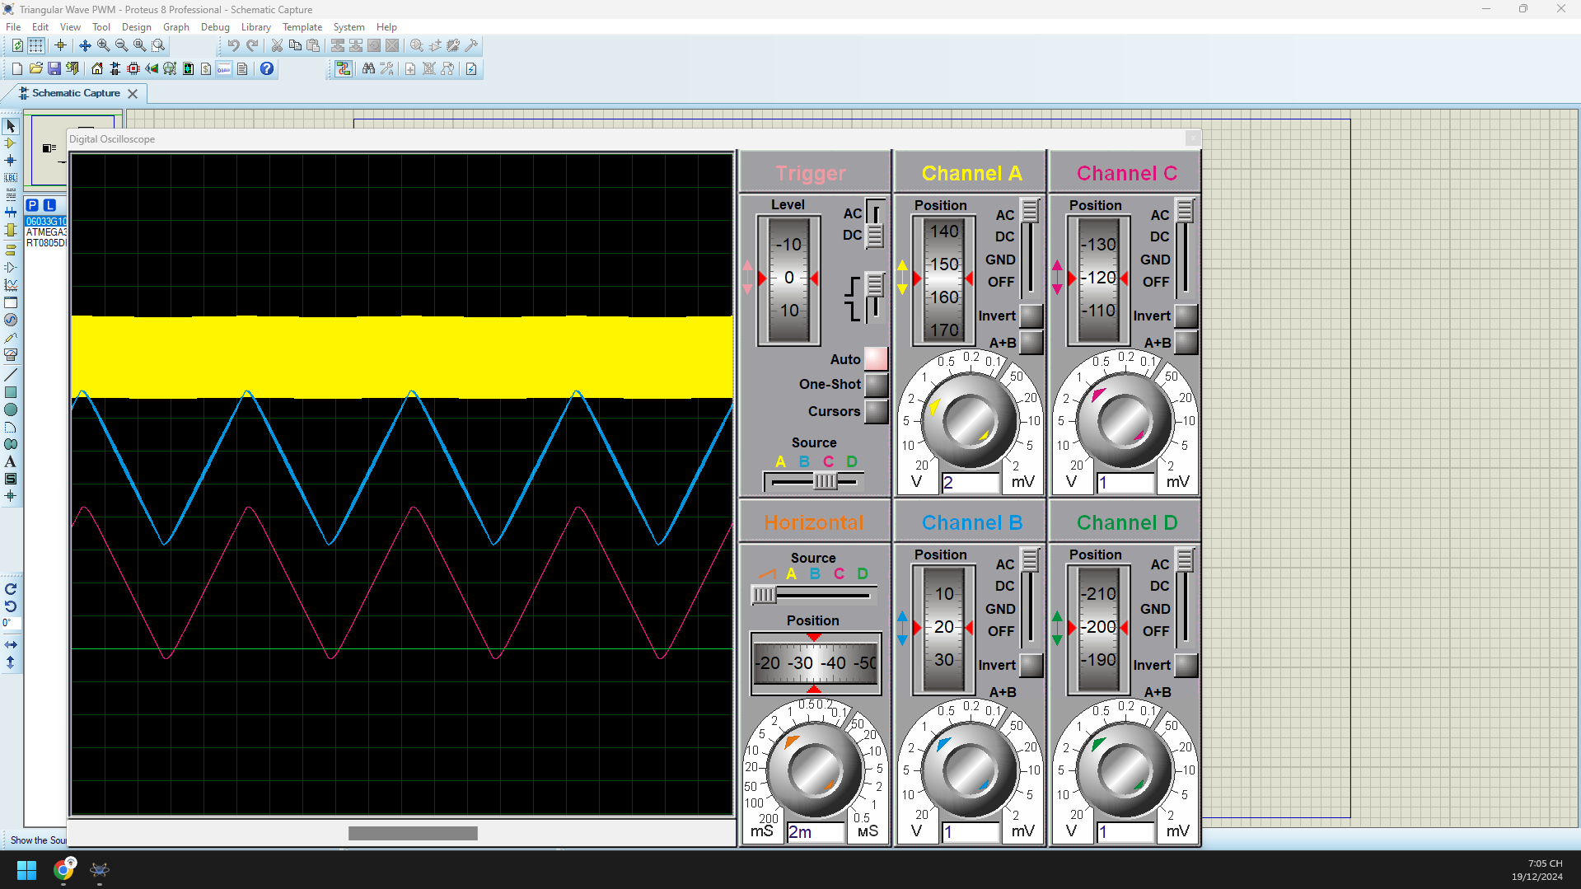 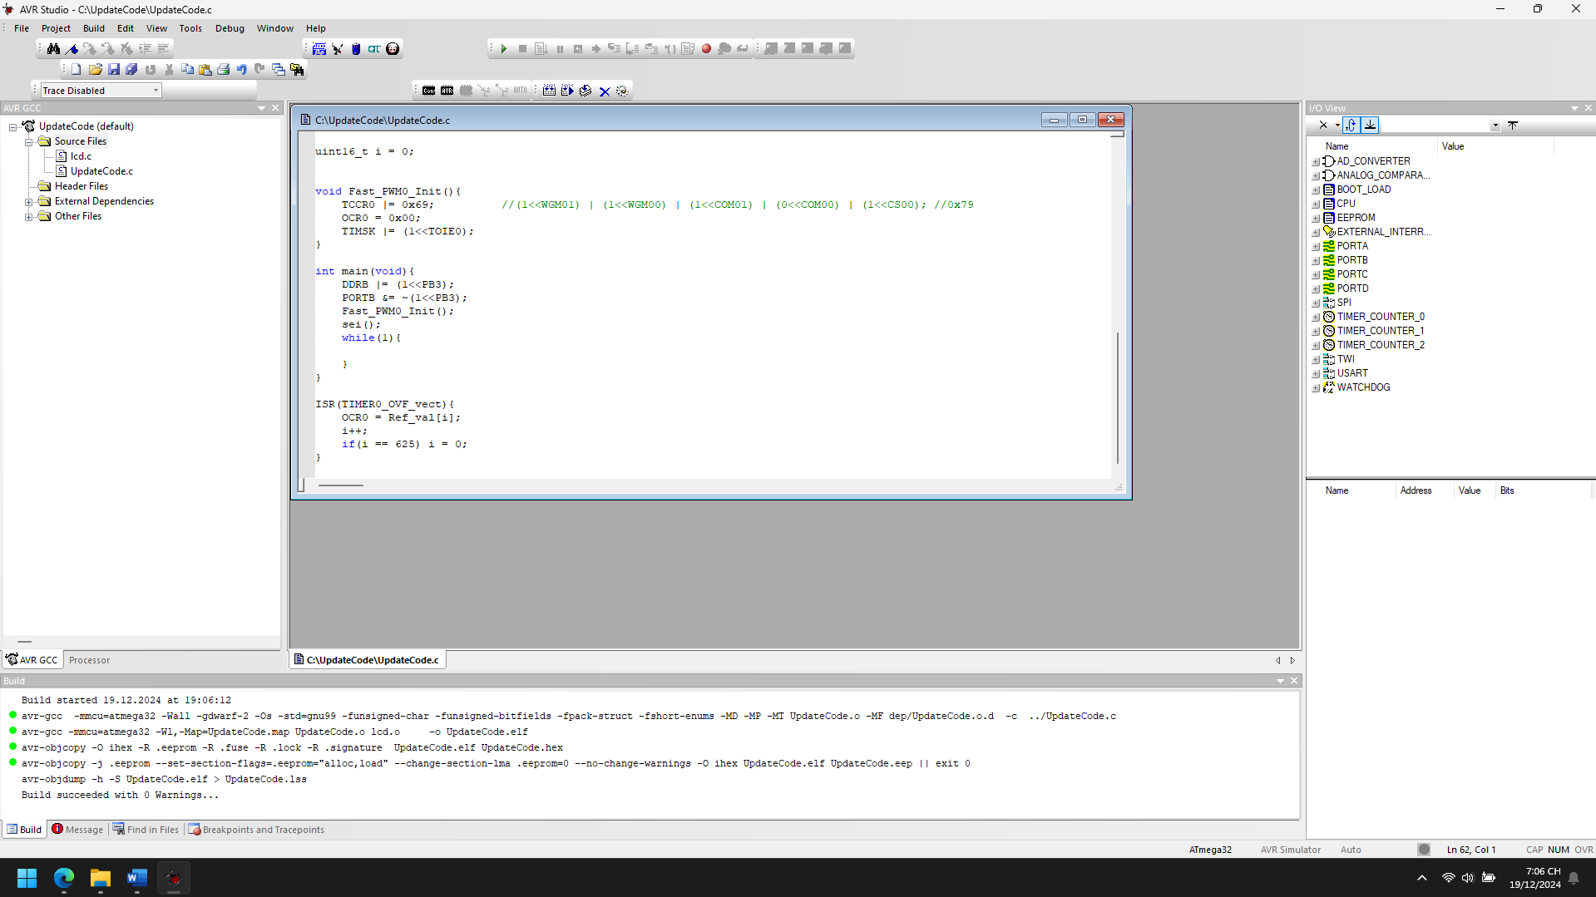

1. Explain the theory meaning of Related peripheral Registers using in the code of each project, Draw the Flow chart for important functions in this project

**1. TCCR0 (Timer/Counter Control Register 0)**

* **Purpose:** Configures the mode of operation and prescaling of Timer0.
* **Bits Used:**
  + WGM00 and WGM01: Set the waveform generation mode.
    - **Mode 3 (Fast PWM):** These bits are both set (1), enabling the timer to operate in **Fast PWM mode**.
  + COM01 and COM00: Set the Compare Output Mode.
    - **Non-inverting Mode:** COM01 = 1, COM00 = 0 makes the output pin high when the counter matches the compare register (OCR0) and clears it at the end of the timer cycle.
  + CS02, CS01, CS00: Set the clock source and prescaler.
    - **No Prescaling:** Only CS00 is set (1), allowing the timer to increment directly from the system clock.

**2. OCR0 (Output Compare Register 0)**

* **Purpose:** Sets the compare value for the PWM signal.
* **Usage:** Determines the duty cycle of the PWM waveform. The timer output toggles based on the value in this register.

**3. TIMSK (Timer/Counter Interrupt Mask Register)**

* **Purpose:** Enables or disables specific timer interrupts.
* **Bits Used:**
  + TOIE0: Timer0 Overflow Interrupt Enable.
    - Setting this bit (1) enables the Timer0 Overflow Interrupt, triggering an interrupt when the timer count reaches its maximum (255).

**4. DDRB (Data Direction Register for Port B)**

* **Purpose:** Configures the direction of the pins on Port B.
* **Usage:**
  + DDRB |= (1 << PB3); sets PB3 (OC0 pin) as an output for the PWM signal.

**5. PORTB (Port B Data Register)**

* **Purpose:** Controls the output state of Port B pins.
* **Usage:**
  + PORTB &= ~(1 << PB3); ensures PB3 starts in a low state.

**6. sei()**

* **Purpose:** Enables global interrupts.
* **Usage:** Necessary for enabling interrupt-driven PWM operation.

Start

|

V

Set PB3 as Output (DDRB)

|

V

Initialize Timer0 in Fast PWM Mode (Fast_PWM0_Init)

|

V

Enable Global Interrupts (sei)

|

V

Run Infinite Loop

1. Improve codes and add more functions for each projects

#define F_CPU 16000000UL

#include <avr/io.h>

#include <stdio.h>

#include <util/delay.h>

#include <avr/interrupt.h>

// Array for sine wave values (255 samples for full wave)

uint8_t Ref_val[625] = { /* (same values as before) */ };

uint16_t i = 0;

uint16_t sine_frequency = 1; // Frequency multiplier for the sine wave

uint16_t pwm_frequency = 1000; // Default PWM frequency in Hz

// Function to initialize Timer0 in Fast PWM mode

void Fast_PWM0_Init(){

TCCR0 |= (1 << WGM01) | (1 << WGM00) | (1 << COM01) | (0 << COM00) | (1 << CS00); // Fast PWM mode, non-inverting

OCR0 = 0x00; // Start with 0 duty cycle

TIMSK |= (1 << TOIE0); // Enable overflow interrupt

}

// Function to set the PWM frequency by adjusting the prescaler

void Set_PWM_Frequency(uint16_t freq){

// PWM frequency = F_CPU / (Prescaler * 256)

// Calculate prescaler value

uint16_t prescaler = F_CPU / (256 * freq);

// Set the prescaler (use the closest available value)

if (prescaler <= 1) {

TCCR0 |= (1 << CS00); // No prescaling

} else if (prescaler <= 8) {

TCCR0 |= (1 << CS01); // Prescaler = 8

} else if (prescaler <= 64) {

TCCR0 |= (1 << CS00) | (1 << CS01); // Prescaler = 64

} else if (prescaler <= 256) {

TCCR0 |= (1 << CS02); // Prescaler = 256

} else {

TCCR0 |= (1 << CS02) | (1 << CS00); // Prescaler = 1024

}

}

// Function to dynamically adjust sine wave frequency

void Set_Sine_Frequency(uint16_t freq_multiplier){

sine_frequency = freq_multiplier;

}

// Main function

int main(void){

// Set PB3 as output for PWM

DDRB |= (1 << PB3);

PORTB &= ~(1 << PB3); // Initially set to low

// Initialize Fast PWM

Fast_PWM0_Init();

// Set PWM frequency (1000 Hz)

Set_PWM_Frequency(pwm_frequency);

// Enable global interrupts

sei();

while(1){

// Main loop can be used for other tasks or features

_delay_ms(100);

}

}

// Timer0 Overflow Interrupt Service Routine (ISR)

ISR(TIMER0_OVF_vect){

// Update the PWM duty cycle with sine wave values

OCR0 = Ref_val[i];

i += sine_frequency; // Adjust index with sine frequency multiplier

if (i >= 625) i = 0; // Reset index to loop through sine wave values

}

**Key Improvements:**

1. **PWM Frequency Control (Set_PWM_Frequency)**:
   * This function allows you to dynamically adjust the PWM frequency by setting a prescaler based on the desired frequency. It calculates the prescaler required for the chosen PWM frequency and updates the Timer0 control register accordingly.
2. **Dynamic Sine Wave Frequency (Set_Sine_Frequency)**:
   * The sine_frequency multiplier allows you to change the speed of the sine wave pattern. This can be used to make the sine wave oscillate faster or slower depending on your needs.
3. **Modular Code**:
   * The functions Fast_PWM0_Init, Set_PWM_Frequency, and Set_Sine_Frequency make the code more modular and easier to understand.
   * This modularization also allows for future enhancements like adding other waveforms (e.g., triangular or square waves).
4. **Interrupt Handling**:
   * The ISR for TIMER0_OVF_vect updates the PWM duty cycle by cycling through the sine wave values. The index (i) is incremented based on the sine frequency, allowing for variable speed modulation of the sine wave.

## Chap 7_1 UART

Barcode Reader

1. Analyze the codes, compile and Run the simulation of the project

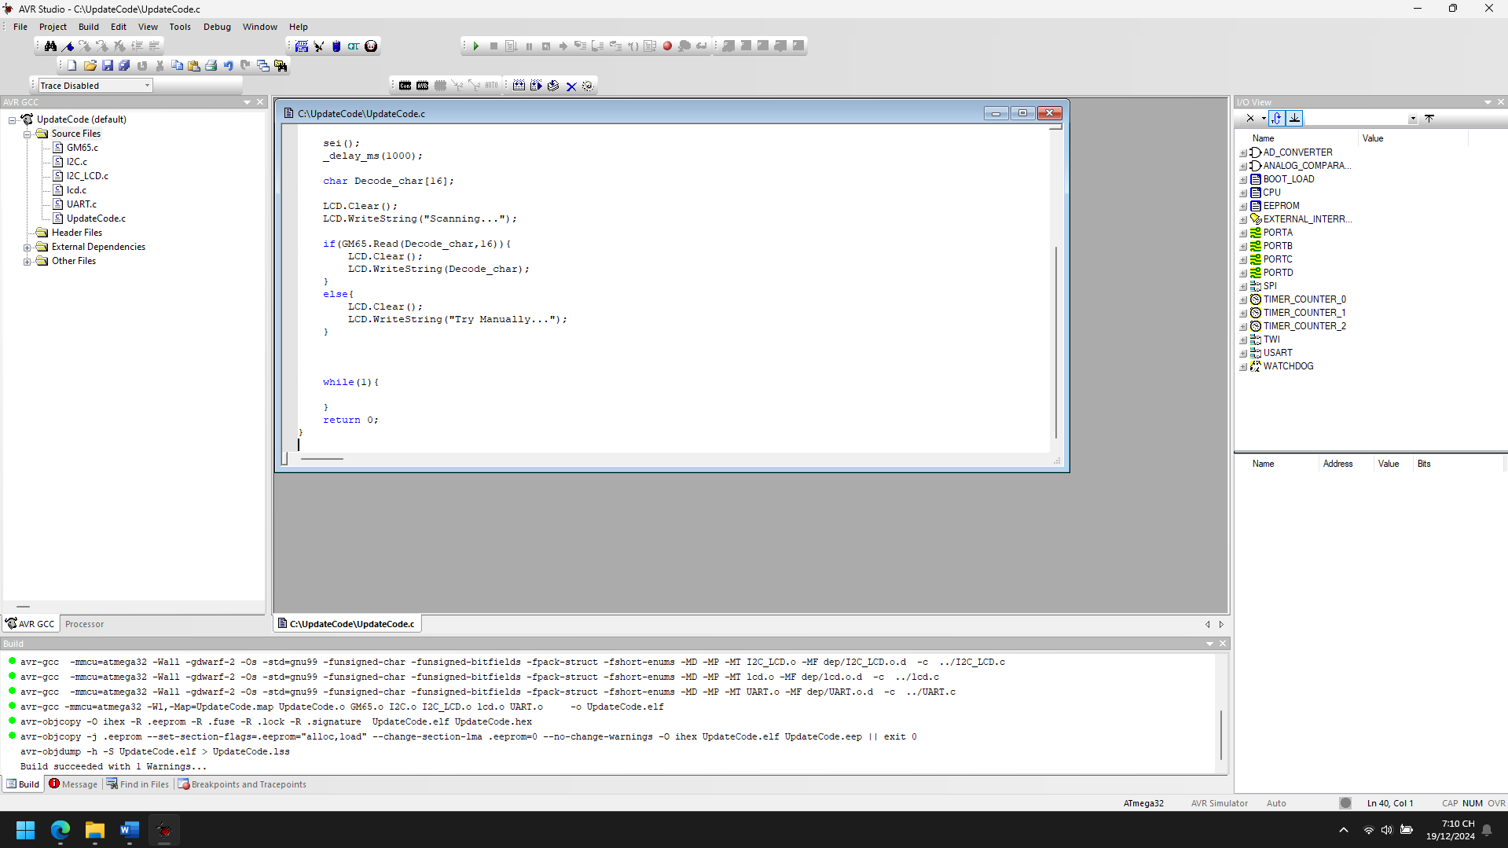

1. Explain the theory meaning of Related peripheral Registers using in the code of each project, Draw the Flow chart for important functions in this project

**1. GM65 Sensor Initialization (GM65_Init)**

The **GM65** is a gas sensor module that communicates over serial (UART) communication. The function GM65_Init(9600) initializes this sensor at a baud rate of 9600. The relevant registers for UART communication on the **AVR** microcontroller are:

* **UCSR0B** (USART Control and Status Register B):
  + **RXEN0** (Receive Enable): Enables the receiver of the UART.
  + **TXEN0** (Transmit Enable): Enables the transmitter of the UART.
* **UCSR0C** (USART Control and Status Register C):
  + **UCSZ00** and **UCSZ01**: Defines the character size, typically 8 bits in this case.
* **UBRR0** (USART Baud Rate Register):
  + **UBRR0** holds the value for setting the baud rate. For a 16 MHz clock and a baud rate of 9600, the value of UBRR0 is calculated as: UBRR0=FCPU16×Baud Rate−1=1600000016×9600−1=103UBRR0 = \frac{F_{CPU}}{16 \times \text{Baud Rate}} - 1 = \frac{16000000}{16 \times 9600} - 1 = 103UBRR0=16×Baud RateFCPU​​−1=16×960016000000​−1=103

The function GM65_Init(9600) configures the UART peripheral to communicate with the GM65 sensor at the correct baud rate.

**2. I2C Communication with LCD (I2C_LCD_Init, LCD.WriteString)**

The **I2C** communication is used to interface with the LCD. The following registers are relevant for I2C communication on an **AVR** microcontroller:

* **TWBR** (TWI Bit Rate Register):
  + This register is used to set the speed of the I2C communication. The I2C_FREQ macro is likely used to set the desired frequency for I2C communication, and this value is loaded into TWBR.
* **TWSR** (TWI Status Register):
  + This register holds the status of the I2C communication, including any error flags or operation completion.
* **TWCR** (TWI Control Register):
  + The **TWINT** flag in **TWCR** is set to indicate that an I2C interrupt has occurred or the current operation is complete.
  + **TWSTA** is used to send a start condition, and **TWSTO** is used to send a stop condition.
  + **TWEN** enables the TWI.

The LCD is initialized using the function I2C_LCD_Init(I2C_FREQ, LS_NONE) and communication is established via I2C to display data on the LCD.

**3. Main Program Flow**

In the main function, the following steps take place:

* **GM65 Sensor Initialization**:
  + Initializes the GM65 sensor to start reading data from it using UART communication (GM65_Init(9600)).
* **LCD Initialization**:
  + The LCD is initialized using I2C communication (I2C_LCD_Init(I2C_FREQ, LS_NONE)), and a string is displayed on the LCD ("Initialized...").
* **Reading GM65 Data**:
  + The GM65 sensor is read into the Decode_char buffer, and the data is displayed on the LCD. If the read is successful, the sensor data is displayed; otherwise, it displays "Try Manually...".

+----------------------------+

| Start Program |

+----------------------------+

|

v

+----------------------------+

| Initialize GM65 Sensor |

| (GM65_Init) |

+----------------------------+

|

v

+----------------------------+

| Initialize LCD |

| (I2C_LCD_Init) |

+----------------------------+

|

v

+----------------------------+

| Display "Initialized..." |

+----------------------------+

|

v

+----------------------------+

| Start Scanning for GM65 |

| (Display "Scanning...") |

+----------------------------+

|

v

+----------------------------+

| Try to Read GM65 Data |

| (GM65.Read) |

+----------------------------+

| |

| Success | Failure

v v

+----------------------------+ +----------------------------+

| Display GM65 Data | | Display "Try Manually..." |

+----------------------------+ +----------------------------+

|

v

+----------------------------+

| End of Program Loop |

+----------------------------+

1. Improve codes and add more functions for each projects

**1. GM65 Sensor Readings Enhancement**

* **Add Error Handling**: Instead of simply displaying "Try Manually..." when the sensor data is not read, you can include a retry mechanism or log the error code.
* **Display Sensor Values Dynamically**: Add functionality to continuously update the LCD with the current sensor reading rather than displaying a static message.

**Improvement Example:**

#include "GM65.h"

#include <stdio.h>

#define MAX_RETRIES 3

void Read_GM65_Sensor(char *decode_char) {

uint8_t retry_count = 0;

while(retry_count < MAX_RETRIES) {

if(GM65.Read(decode_char, 16)) {

// Successfully read data

LCD.Clear();

LCD.WriteString(decode_char);

return;

} else {

// Display error and retry

LCD.Clear();

LCD.WriteString("Reading Error");

_delay_ms(500);

retry_count++;

}

}

// After retries, display manual instruction

LCD.Clear();

LCD.WriteString("Try Manually...");

}

int main(void) {

GM65_Init(9600);

I2C_LCD_Init(I2C_FREQ, LS_NONE);

LCD.WriteString("Initialized...");

sei();

_delay_ms(1000);

char Decode_char[16];

LCD.Clear();

LCD.WriteString("Scanning...");

Read_GM65_Sensor(Decode_char);

while(1) {

// Optionally, refresh the data every few seconds

_delay_ms(2000); // Delay between refreshes

Read_GM65_Sensor(Decode_char);

}

}

**Changes/Improvements:**

* Added a retry mechanism (MAX_RETRIES) to attempt reading the sensor data multiple times before displaying the error message.
* Continuously refresh the data on the LCD, making the display dynamic.

**2. Add Additional LCD Display Functions**

* **Display Multiple Lines**: If you have multiple pieces of information to display, you could divide the LCD into two lines or more and update each line dynamically. This would require functions to set the cursor position on the LCD.

**Improvement Example:**

void Display_GM65_Info(char *decode_char) {

LCD.Clear();

LCD.SetCursor(0, 0); // Move cursor to the first line

LCD.WriteString("GM65 Data:");

LCD.SetCursor(1, 0); // Move cursor to the second line

LCD.WriteString(decode_char);

}

int main(void) {

GM65_Init(9600);

I2C_LCD_Init(I2C_FREQ, LS_NONE);

LCD.WriteString("Initialized...");

sei();

_delay_ms(1000);

char Decode_char[16];

LCD.Clear();

LCD.WriteString("Scanning...");

if(GM65.Read(Decode_char, 16)) {

Display_GM65_Info(Decode_char);

} else {

LCD.Clear();

LCD.WriteString("Try Manually...");

}

while(1) {

// Optionally, refresh the data every few seconds

_delay_ms(2000); // Delay between refreshes

if(GM65.Read(Decode_char, 16)) {

Display_GM65_Info(Decode_char);

} else {

LCD.Clear();

LCD.WriteString("Try Manually...");

}

}

}

**Changes/Improvements:**

* Added the SetCursor function to move the cursor to a specified line and column.
* Display data dynamically on multiple lines of the LCD.

**3. Add External Interrupts (if applicable)**

Incorporate external interrupts (e.g., button press, motion detection, or a timer) to trigger specific actions like refreshing the sensor data or changing the display. This improves interactivity and reduces the need for constant polling.

**Improvement Example:**

#include <avr/interrupt.h>

volatile uint8_t refresh_flag = 0;

ISR(INT0_vect) {

// Set flag to refresh data on button press (assuming external interrupt INT0)

refresh_flag = 1;

}

int main(void) {

// Initialize GM65 and LCD

GM65_Init(9600);

I2C_LCD_Init(I2C_FREQ, LS_NONE);

LCD.WriteString("Initialized...");

sei(); // Enable global interrupts

_delay_ms(1000);

// Configure external interrupt INT0

EIMSK |= (1 << INT0); // Enable INT0 interrupt

EICRA |= (1 << ISC01); // Trigger on falling edge (button press)

char Decode_char[16];

LCD.Clear();

LCD.WriteString("Scanning...");

if(GM65.Read(Decode_char, 16)) {

Display_GM65_Info(Decode_char);

} else {

LCD.Clear();

LCD.WriteString("Try Manually...");

}

while(1) {

if(refresh_flag) {

// Refresh data on button press

if(GM65.Read(Decode_char, 16)) {

Display_GM65_Info(Decode_char);

} else {

LCD.Clear();

LCD.WriteString("Try Manually...");

}

refresh_flag = 0; // Reset flag

}

// Optionally, add other tasks here

}

}

**Changes/Improvements:**

* Added an external interrupt (INT0) to trigger a refresh of the sensor data when a button is pressed.
* Used the EIMSK and EICRA registers to configure the interrupt.

**4. Add Logging/Debugging Functionality**

You can introduce a logging function to store sensor data to non-volatile memory (e.g., EEPROM) or send the data over serial for debugging purposes. This allows you to track sensor readings over time or perform diagnostics.

**Improvement Example:**

#include <avr/eeprom.h>

#define LOG_ADDRESS 0x00 // EEPROM address to store logs

void Log_GM65_Data(char *data) {

uint8_t i = 0;

while(data[i] != '\0' && i < 16) {

eeprom_write_byte((uint8_t *)(LOG_ADDRESS + i), data[i]);

i++;

}

}

int main(void) {

GM65_Init(9600);

I2C_LCD_Init(I2C_FREQ, LS_NONE);

LCD.WriteString("Initialized...");

sei();

_delay_ms(1000);

char Decode_char[16];

LCD.Clear();

LCD.WriteString("Scanning...");

if(GM65.Read(Decode_char, 16)) {

Display_GM65_Info(Decode_char);

Log_GM65_Data(Decode_char); // Log the data to EEPROM

} else {

LCD.Clear();

LCD.WriteString("Try Manually...");

}

while(1) {

// Optionally, refresh the data every few seconds

_delay_ms(2000); // Delay between refreshes

if(GM65.Read(Decode_char, 16)) {

Display_GM65_Info(Decode_char);

Log_GM65_Data(Decode_char); // Log the data to EEPROM

} else {

LCD.Clear();

LCD.WriteString("Try Manually...");

}

}

}

**Changes/Improvements:**

* Added a Log_GM65_Data function to store sensor readings in the EEPROM for later analysis or debugging.

**Summary of Improvements:**

1. **Error Handling**: Added retries and error handling for sensor data reading.
2. **Dynamic LCD Display**: Refined the LCD functionality to display data dynamically and split it across multiple lines.
3. **Interrupts**: Introduced external interrupts to trigger data refresh on button press or other events.
4. **Logging**: Added logging functionality to store sensor data in EEPROM for debugging or analysis.

These improvements will make the system more robust, responsive, and capable of logging data for future analysis. Let me know if you need further assistance!

Communication 2 MCUs

1. Analyze the codes, compile and Run the simulation of the project

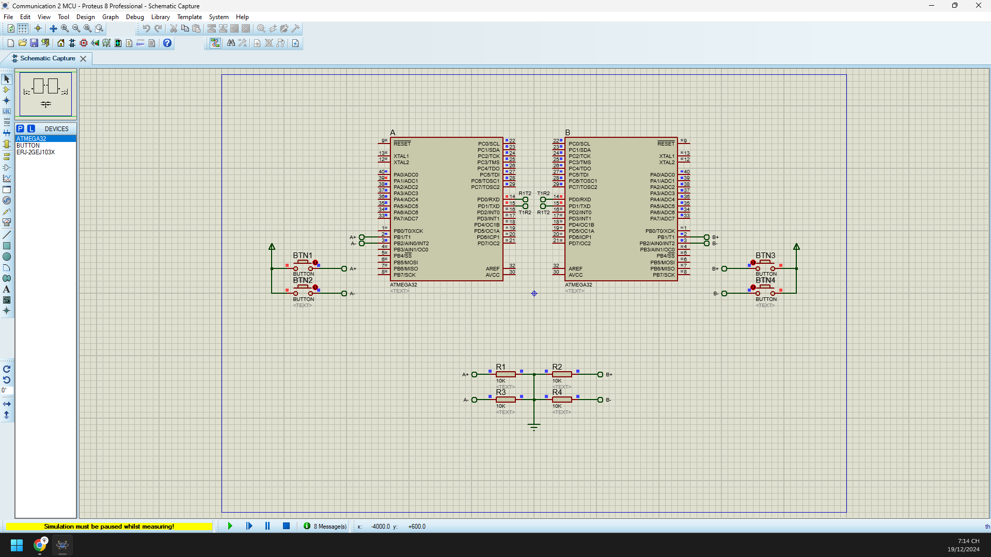 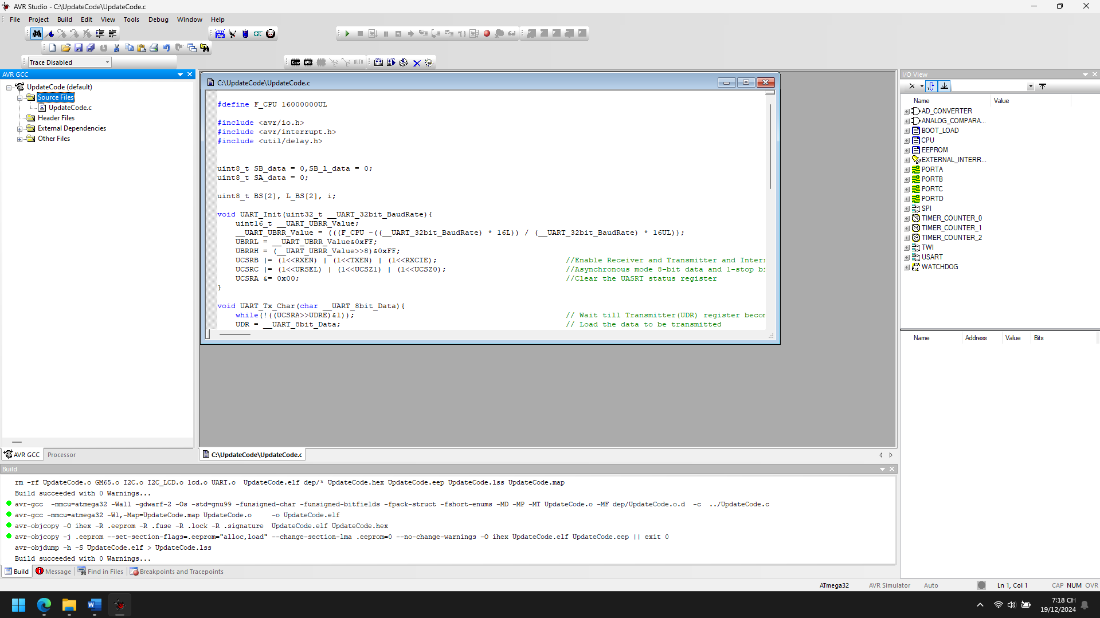

1. Explain the theory meaning of Related peripheral Registers using in the code of each project, Draw the Flow chart for important functions in this project

*STATION_A*

**1. UART Registers:**

In this code, we use the USART (Universal Synchronous and Asynchronous serial Receiver and Transmitter) to send and receive data.

**Key UART Registers:**

1. **UBRRL and UBRRH (Baud Rate Register Low and High):**
   * These registers are used to set the baud rate of the UART communication.
   * The baud rate is determined by the formula: Baud Rate=FCPU16×(UBRR)\text{Baud Rate} = \frac{F_{CPU}}{16 \times (\text{UBRR})}Baud Rate=16×(UBRR)FCPU​​ Where F_CPU is the CPU clock frequency and UBRR is the value stored in the UBRRL and UBRRH registers.
2. **UCSRB (USART Control and Status Register B):**
   * **RXEN (Receiver Enable):** Enables the receiver.
   * **TXEN (Transmitter Enable):** Enables the transmitter.
   * **RXCIE (Receiver Interrupt Enable):** Enables the USART RX interrupt. This allows the interrupt service routine (ISR) to be triggered when data is received.
3. **UCSRC (USART Control and Status Register C):**
   * **URSEL (Register Select):** Selects between the UCSRC and the UCDR (USART Data Register).
   * **UCSZ1 and UCSZ0 (Character Size):** These two bits are used to select the frame format (e.g., 8-bit data, 1 stop bit).
4. **UCSRA (USART Control and Status Register A):**
   * **UDRE (USART Data Register Empty):** This bit is checked in the UART_Tx_Char function to ensure that the data register is empty before sending data.
5. **UDR (USART Data Register):**
   * Holds the data to be transmitted or received. In this code, UDR is used to send and receive data between the microcontroller and the UART interface.

**2. GPIO Registers:**

In this code, PORTA, PORTC, and PINB are used to interact with input and output pins.

**Key GPIO Registers:**

1. **DDRC and DDRA (Data Direction Register C and A):**
   * These registers control the direction of the pins on ports C and A. A 1 means output, and a 0 means input.
   * **DDRC |= 0xFF:** Sets all the bits of port C as output.
   * **DDRA |= 0xFF:** Sets all the bits of port A as output.
2. **PORTC and PORTA (Data Register C and A):**
   * These registers hold the values that are written to the corresponding pins.
   * **PORTC = SB_data:** Sends the value of SB_data to port C, which controls the connected LEDs or output devices.
   * **PORTA = SA_data:** Sends the value of SA_data to port A, which controls other LEDs or devices.
3. **PINB (Pin Input Register B):**
   * This register holds the value of the input pins on port B. The individual pins are accessed through bit masking.
   * **PINB >> (i + 1) & 1:** Reads the value of a specific pin (i.e., PINB2 or PINB3) and stores the result in BS[i].

Start

|

v

Read Button States into BS[i]

|

v

Check Button 0 for Press (Increment SA_data)

|

v

Check Button 1 for Press (Decrement SA_data)

|

v

If SA_data has Changed, Update Output

|

v

Send SA_data via UART

|

v

Update Last Data States

|

v

Done

*STATION_B*

**1. UART Registers**

The UART (Universal Asynchronous Receiver/Transmitter) is used to send and receive data serially over communication channels. These registers control and manage the communication process.

* **UBRRH and UBRRL (USART Baud Rate Registers)**:
  + **Purpose**: These registers hold the value that sets the baud rate of UART communication.
  + **Function**: The baud rate determines the speed of data transmission (how fast data is sent and received). The formula for calculating the baud rate is:

UBRR = (F_CPU / (16 * BaudRate)) - 1

* + **Used in Code**:

UBRRL = __UART_UBRR_Value & 0xFF;

UBRRH = (__UART_UBRR_Value >> 8) & 0xFF;

* **UCSRB (USART Control and Status Register B)**:
  + **Purpose**: Controls various aspects of the UART system, such as enabling the receiver, transmitter, and interrupts.
  + **Function**:
    - RXEN: Enable Receiver
    - TXEN: Enable Transmitter
    - RXCIE: Enable Receive Interrupt
  + **Used in Code**:

UCSRB |= (1 << RXEN) | (1 << TXEN) | (1 << RXCIE);

* **UCSRC (USART Control and Status Register C)**:
  + **Purpose**: Configures the frame format for data transmission, such as data bits, stop bits, and parity bits.
  + **Function**:
    - URSEL: Access the UCSRC register
    - UCSZ1, UCSZ0: Select 8-bit data format (used for setting 8-bit data and 1 stop bit in asynchronous mode).
  + **Used in Code**:

UCSRC |= (1 << URSEL) | (1 << UCSZ1) | (1 << UCSZ0);

* **UCSRA (USART Control and Status Register A)**:
  + **Purpose**: Indicates the status of the UART system.
  + **Function**: UDRE (USART Data Register Empty) indicates if the data register is ready for transmission.
  + **Used in Code**:

while (!((UCSRA >> UDRE) & 1));

* **UDR (USART Data Register)**:
  + **Purpose**: Used to read received data or write data to transmit.
  + **Used in Code**:

UDR = __UART_8bit_Data; // Transmitting data

SA_data = UDR; // Receiving data

**2. Pin Control Registers**

These registers are used to configure and manage input/output pins for reading button states and controlling LEDs.

* **DDRC and DDRA (Data Direction Registers for Ports C and A)**:
  + **Purpose**: These registers control the direction of the I/O pins.
  + **Function**:
    - DDRx: Set pin direction (1 = Output, 0 = Input).
  + **Used in Code**:

DDRC |= 0xFF; // Set all pins of PORTC as output

DDRA |= 0xFF; // Set all pins of PORTA as output

* **PORTC and PORTA (Port Data Registers for Ports C and A)**:
  + **Purpose**: These registers are used to output data to the pins configured as outputs or to enable/disable pull-up resistors on input pins.
  + **Used in Code**:

PORTC = SB_data; // Output data to PORTC (LED control)

PORTA = SA_data; // Output received data to PORTA (LED control)

* **PINB (Pin Input Register for Port B)**:
  + **Purpose**: Reads the current logic level on the input pins of Port B.
  + **Used in Code**:

BS[i] = (PINB >> (i+1)) & 1; // Read button states

Start

|

v

Initialize UART and set pins as output (DDRC, DDRA)

|

v

In Main Loop:

|

v

Check Button States (Read PINB)

|

v

If Button 0 is pressed, increment SB_data

|

v

If Button 1 is pressed, decrement SB_data

|

v

If SB_data changes:

|

v

Output SB_data to PORTC and transmit via UART

|

v

Save current SB_data to SB_l_data

|

v

End

1. Improve codes and add more functions for each projects

*STATION_A*

#define F_CPU 16000000UL

#include <avr/io.h>

#include <avr/interrupt.h>

#include <util/delay.h>

uint8_t SA_data = 0, SA_l_data = 0;

uint8_t SB_data = 0;

uint8_t BS[2], L_BS[2], i;

uint8_t button_pressed = 0;

void UART_Init(uint32_t baud_rate) {

uint16_t ubrr_value = (F_CPU / (16L * baud_rate)) - 1;

UBRRL = ubrr_value & 0xFF;

UBRRH = (ubrr_value >> 8) & 0xFF;

UCSRB |= (1 << RXEN) | (1 << TXEN) | (1 << RXCIE); // Enable RX, TX, and RX interrupt

UCSRC |= (1 << URSEL) | (1 << UCSZ1) | (1 << UCSZ0); // 8-bit data, 1 stop bit

UCSRA &= 0x00; // Clear the USART status register

}

void UART_Tx_Char(char data) {

while (!(UCSRA & (1 << UDRE))); // Wait until the data register is empty

UDR = data; // Transmit the data

}

uint8_t Check_Button(uint8_t button_index) {

// Simple debouncing technique

if ((BS[button_index] - L_BS[button_index]) == 1) {

_delay_ms(50); // Simple debounce delay

if ((BS[button_index] - L_BS[button_index]) == 1) {

return 1; // Button press detected

}

}

return 0; // No button press detected

}

void Update_LED(uint8_t data) {

PORTC = data; // Output data to LEDs connected to PORTC

}

void UART_Tx_String(const char* str) {

while (*str) {

UART_Tx_Char(*str++);

}

}

int main() {

// Configure PORTC and PORTA as output

DDRC |= 0xFF;

PORTC = 0;

DDRA |= 0xFF;

PORTA = 0;

UART_Init(9600); // Initialize UART with 9600 baud rate

sei(); // Enable global interrupts

while (1) {

// Read the button states

for (i = 0; i < 2; i++) {

BS[i] = (PINB >> (i + 1)) & 1;

}

// Check for button presses and update data accordingly

if (Check_Button(0)) {

SA_data++;

}

if (Check_Button(1)) {

SA_data--;

}

// If SA_data changes, update the output

if (SA_l_data != SA_data) {

Update_LED(SA_data);

UART_Tx_Char(SA_data);

}

SA_l_data = SA_data;

// Update the previous button states

for (i = 0; i < 2; i++) {

L_BS[i] = BS[i];

}

// Feedback to user via UART

if (SA_data > 5) {

UART_Tx_String("SA_data is greater than 5.\n");

}

}

}

ISR(USART_RXC_vect) {

SB_data = UDR; // Receive the data

PORTA = SB_data; // Output the received data to PORTA (LEDs)

}

**Key Improvements:**

1. **Debouncing Added:** The Check_Button function now has a basic debounce mechanism to avoid multiple detections from a single button press. The _delay_ms(50) ensures that the state is checked only after a small delay, which helps prevent multiple button press events.
2. **Modular Functions:**
   * The function UART_Tx_String was added to send strings over UART, making it easier to send messages (e.g., error messages, status updates).
   * Update_LED is a dedicated function to update the LEDs, making the main loop cleaner.
3. **Improved Readability:** The code is broken down into smaller, more manageable functions, each with a clear responsibility. This improves the readability and maintainability of the code.
4. **Feedback via UART:** Added feedback when SA_data exceeds a certain value (in this case, SA_data > 5). This can be expanded to include more status messages.
5. **Efficient Data Handling:**
   * **Check_Button:** The debounce mechanism ensures that the buttons are properly handled without detecting multiple presses from a single action.
   * **LED Indication:** The LEDs on PORTA and PORTC provide visual feedback about the system state, helping to debug or monitor the system's activity.

*STATION_B*

#define F_CPU 16000000UL

#include <avr/io.h>

#include <avr/interrupt.h>

#include <util/delay.h>

uint8_t SB_data = 0, SB_l_data = 0;

uint8_t SA_data = 0;

uint8_t BS[2], L_BS[2], i;

void UART_Init(uint32_t baud_rate) {

uint16_t ubrr_value;

ubrr_value = (F_CPU / (16L * baud_rate)) - 1;

UBRRL = ubrr_value & 0xFF;

UBRRH = (ubrr_value >> 8) & 0xFF;

UCSRB |= (1 << RXEN) | (1 << TXEN) | (1 << RXCIE); // Enable RX, TX, RX interrupt

UCSRC |= (1 << URSEL) | (1 << UCSZ1) | (1 << UCSZ0); // 8-bit data, 1 stop bit

UCSRA &= ~(1 << U2X); // Disable double speed mode for stable communication

}

void UART_Tx_Char(char data) {

while (!(UCSRA & (1 << UDRE))) { // Wait until UDR is empty

// Busy-wait for the transmit buffer to be empty

}

UDR = data; // Send data

}

void UART_Tx_String(const char* str) {

while (*str) {

UART_Tx_Char(*str); // Send each character of the string

str++;

}

}

uint8_t Check_button(uint8_t i) {

if ((BS[i] - L_BS[i]) == 1) return 1; // Button is pressed

return 0; // Button is not pressed

}

void Button_Debounce(void) {

_delay_ms(50); // Debounce delay

for (i = 0; i < 2; i++) {

BS[i] = (PINB >> (i + 1)) & 1; // Read button state

}

}

void Update_LED_and_UART(void) {

if (SB_l_data != SB_data) {

PORTC = SB_data; // Update LED state

UART_Tx_Char(SB_data); // Send data via UART

}

SB_l_data = SB_data;

}

void Process_Received_Data(void) {

if (SA_data != 0) {

PORTA = SA_data; // Update LED state on PORTA

}

}

int main(void) {

DDRC |= 0xFF; // Set PORTC as output

PORTC = 0; // Clear PORTC

DDRA |= 0xFF; // Set PORTA as output

PORTA = 0; // Clear PORTA

UART_Init(9600); // Initialize UART at 9600 baud rate

sei(); // Enable global interrupt

UART_Tx_String("System Initialized...\n");

while (1) {

Button_Debounce(); // Read button state with debouncing

if (Check_button(0)) {

SB_data++; // Increment SB_data if button 0 is pressed

}

if (Check_button(1)) {

SB_data--; // Decrement SB_data if button 1 is pressed

}

Update_LED_and_UART(); // Update the LED and transmit data if SB_data changes

}

}

ISR(USART_RXC_vect) {

SA_data = UDR; // Read received data from UDR register

Process_Received_Data(); // Process the received data and update PORTA

}

**Improvements and Additions:**

1. **Modularization**:
   * **Button_Debounce()**: A function to debounce button presses with a delay.
   * **Update_LED_and_UART()**: This function checks whether the data has changed (SB_data) and then updates the LEDs and sends the data over UART.
   * **Process_Received_Data()**: This function processes the received data from the UART and updates the LEDs on PORTA.
2. **UART Communication**:
   * **UART_Tx_String()**: Added a new function to send a string over UART. This function is useful for sending messages or debugging data.
   * **UART_Init()**: The baud rate calculation has been slightly optimized and the double speed mode (U2X) is disabled for stable communication.
3. **Button Press Debouncing**:
   * **Debouncing Delay**: A delay of 50ms is added to avoid multiple triggers when a button is pressed due to mechanical bounce.
   * The function Button_Debounce() is called in the main loop to ensure the buttons are read correctly.
4. **Interrupts**:
   * **ISR for UART**: The ISR(USART_RXC_vect) is triggered when data is received over UART. It processes the received data and updates the LEDs accordingly.

Message Sender via UART

1. Analyze the codes, compile and Run the simulation of the project

 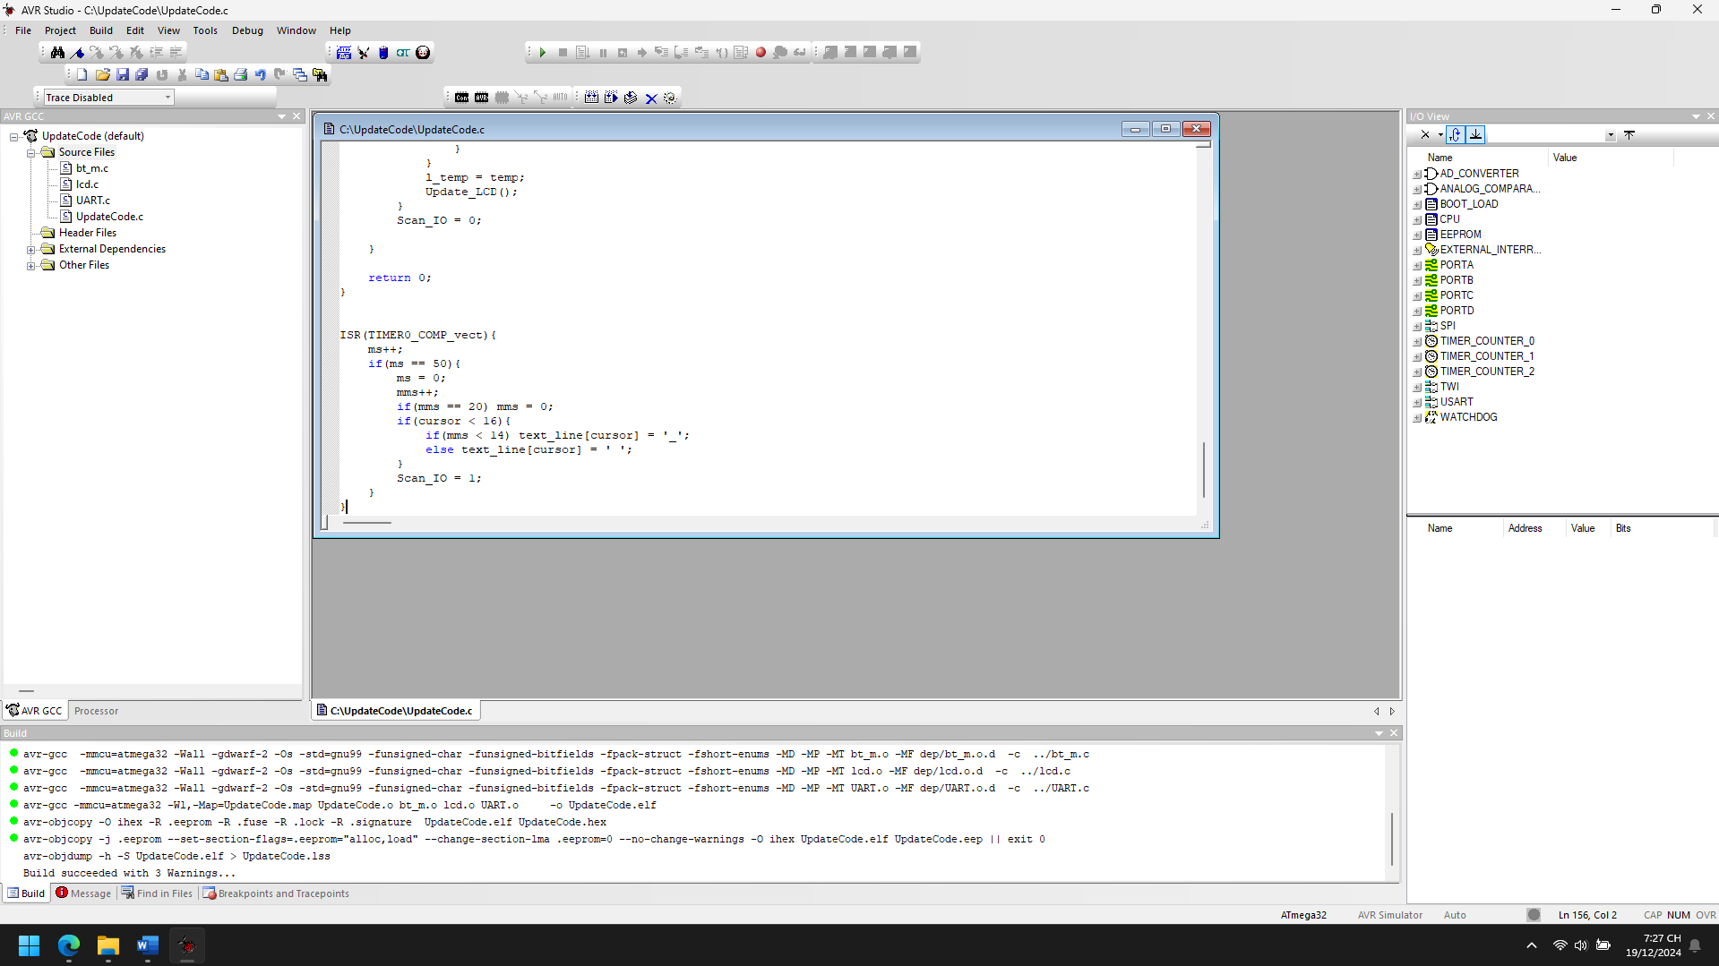

1. Explain the theory meaning of Related peripheral Registers using in the code of each project, Draw the Flow chart for important functions in this project

**1. Timer Registers (Timer 0)**

The Timer0 is configured in CTC (Clear Timer on Compare Match) mode with a pre-scalar of 64. This allows the timer to generate interrupts at regular intervals, which is crucial for the LCD display and input scanning.

* **TCCR0 (Timer/Counter Control Register)**:
  + TCCR0 |= (1 << WGM01) | (1 << CS01) | (1 << CS00):
    - **WGM01**: This bit selects the CTC mode for Timer0. In CTC mode, the timer resets when it matches the value in the OCR0 register.
    - **CS01** and **CS00**: These bits set the prescaler to 64, which means the timer will increment every 64 clock cycles of the MCU.
* **TIMSK (Timer/Counter Interrupt Mask Register)**:
  + TIMSK |= (1 << OCIE0):
    - **OCIE0**: This bit enables the Timer0 compare match interrupt. When the timer reaches the value stored in OCR0, an interrupt is generated.
* **OCR0 (Timer/Counter Output Compare Register)**:
  + OCR0 = 250:
    - This sets the value at which Timer0 will trigger an interrupt. With a prescaler of 64, the interrupt occurs approximately every 1ms.
* **TCNT0 (Timer/Counter Register)**:
  + TCNT0 = 0:
    - This clears the Timer0 counter register, ensuring the timer starts from zero.

**2. GPIO Registers (General Purpose Input/Output)**

GPIO registers control the input and output functionality of the MCU pins.

* **DDRC (Data Direction Register C)**:
  + DDRC |= (1 << PC0):
    - This sets PC0 (pin 0 on PORTC) as an output pin, used for controlling an external device (e.g., an LED or other indicator for the SHIFT state).
* **PORTC (Port C Data Register)**:
  + PORTC &= ~(1 << PC0) or PORTC |= (1 << PC0):
    - This controls the output value on PC0. Setting it to low (0) or high (1) controls the connected external device.
* **PORTA (Port A Data Register)**:
  + PORTA = 0:
    - This is used to clear PORTA (turn off any LEDs or other connected devices).
* **Scan_IO**:
  + This variable controls the scanning state of the keypad. It's set to 1 in the timer interrupt (ISR(TIMER0_COMP_vect)) and is used in the main loop to trigger key scanning.

**3. UART Registers (Universal Asynchronous Receiver/Transmitter)**

The UART interface is used to send text data to a serial terminal or another microcontroller.

* **UCSR0B (UART Control and Status Register B)**:
  + UCSR0B |= (1 << TXEN0) | (1 << RXEN0):
    - This enables the UART transmitter (TXEN0) and receiver (RXEN0).
* **UDR0 (UART Data Register)**:
  + UART_Tx_Char() writes to UDR0 to send characters to the serial interface.

**4. Global Interrupt Register**

* **SREG (Status Register)**:
  + sei():
    - This global interrupt enable function allows the system to respond to interrupts, particularly the Timer0 interrupt in this project.

+---------------------------+

| Initialize LCD, UART, |

| Timer0, Enable Interrupt|

+---------------------------+

|

v

+---------------------------+

| Display initial text |

| (first line: "Text: ...")|

+---------------------------+

|

v

+---------------------------+

| Main Loop: |

| 1. Wait for input |

| 2. Check keypad |

+---------------------------+

|

v

+---------------------------+

| Check for valid key |

| (if key != last key) |

+---------------------------+

|

v

+---------------------------+

| Update text_line with |

| the corresponding key |

+---------------------------+

|

v

+---------------------------+

| Update LCD display |

+---------------------------+

|

v

+---------------------------+

| Handle special keys |

| (Delete, Shift, Send) |

+---------------------------+

|

v

+---------------------------+

| Loop repeats |

+---------------------------+

1. Improve codes and add more functions for each projects

#define F_CPU 16000000UL

#include <avr/io.h>

#include <stdio.h>

#include <util/delay.h>

#include <avr/interrupt.h>

#include "lcd.h"

#include "bt_m.h"

char key_pad[16][5] = { ":;?^1", "abc2 ", "def3 ", "xxxxx",

"ghi4 ", "jkl5 ", "mno6 ", "xxxxx",

"pqrs7", "tuv8 ", "wxyz9", "xxxxx",

"*$!@&", " 0 ", "#+-/%", "xxxxx" };

uint8_t no_key[16] = { 5, 4, 4, 1,

4, 4, 4, 1,

5, 4, 5, 1,

5, 2, 5, 1 };

uint8_t count_no_key, valid_key, l_valid_key = ' ', cursor = 0, SHIFT = 0, Scan_IO = 0;

char first_line[] = "Text: 16/16";

char text_line[] = " ";

uint8_t capt = 0, print = 0;

uint8_t temp, l_temp;

uint8_t ms = 0, mms = 0;

char history[3][17]; // Buffer for storing 3 lines of text history

void Timer0_CTC_Init() {

TCCR0 |= (1 << WGM01) | (1 << CS01) | (1 << CS00); // CTC mode with pre-scalar of 64

TIMSK |= (1 << OCIE0); // Enable compare interrupt

OCR0 = 250;

TCNT0 = 0;

}

void Update_LCD() {

sprintf(first_line, "Text: %02d/16", 16 - cursor);

LCD_Clear();

LCD_GotoXY(0, 0);

LCD_WriteString(first_line);

LCD_GotoXY(0, 1);

LCD_WriteString(text_line);

}

void Clear_Text() {

uint8_t p = 0;

for (p = 0; p < 16; p++) text_line[p] = ' ';

cursor = 0;

}

void Delete_Text(uint8_t __cursor) {

if (__cursor != 0) {

text_line[__cursor] = ' ';

__cursor--;

text_line[__cursor] = ' ';

cursor = __cursor;

}

}

void Shift_Trigger() {

SHIFT = 1 - SHIFT;

if (SHIFT == 1) PORTC |= (1 << PC0);

else PORTC &= ~(1 << PC0);

}

void Send_Text() {

LCD_Clear();

LCD_WriteString("Sending...");

text_line[cursor] = ' ';

UART_Tx_Char('\n'); // New line

UART_Tx_String(text_line);

_delay_ms(250);

Clear_Text();

Save_To_History(text_line); // Save text to history after sending

}

void Save_To_History(char *text) {

for (int i = 2; i > 0; i--) {

strncpy(history[i], history[i - 1], 16); // Shift history

}

strncpy(history[0], text, 16); // Save latest text to history

}

char Capitalize_Char(char __c) {

if ((__c > 96) && (__c < 123)) __c = __c - 32;

return __c;

}

void Move_Cursor_Left() {

if (cursor > 0) cursor--;

}

void Move_Cursor_Right() {

if (cursor < 16) cursor++;

}

int main(void) {

LCD_Init(LS_NONE);

UART_Init(9600);

Timer0_CTC_Init();

sei();

Update_LCD();

DDRC |= (1 << PC0);

PORTC &= ~(1 << PC0);

while (1) {

if (Scan_IO == 1) {

capt++;

PORTA = 0;

temp = Check_key();

if ((temp != l_temp) && (temp < 16)) {

if (temp == 3) Delete_Text(cursor);

else if (temp == 7) Clear_Text();

else if (temp == 11) Shift_Trigger();

else if (temp == 15) Send_Text();

else if (temp == 12) Move_Cursor_Left(); // Left Arrow

else if (temp == 13) Move_Cursor_Right(); // Right Arrow

else {

valid_key = temp;

if (l_valid_key != valid_key) {

count_no_key = 0;

if (cursor < 16) {

text_line[cursor] = key_pad[valid_key][0];

if (SHIFT == 1) text_line[cursor] = Capitalize_Char(text_line[cursor]);

cursor++;

capt = 0;

}

}

if (l_valid_key == valid_key) {

count_no_key++;

if (count_no_key == no_key[valid_key]) count_no_key = 0;

if (capt < 11) {

text_line[cursor - 1] = key_pad[valid_key][count_no_key];

if (SHIFT == 1) text_line[cursor - 1] = Capitalize_Char(text_line[cursor - 1]);

}

else {

if (cursor < 16) {

text_line[cursor] = key_pad[valid_key][0];

if (SHIFT == 1) text_line[cursor] = Capitalize_Char(text_line[cursor]);

cursor++;

}

}

capt = 0;

}

l_valid_key = valid_key;

}

}

l_temp = temp;

Update_LCD();

}

Scan_IO = 0;

}

return 0;

}

ISR(TIMER0_COMP_vect) {

ms++;

if (ms == 50) {

ms = 0;

mms++;

if (mms == 20) mms = 0;

if (cursor < 16) {

if (mms < 14) text_line[cursor] = '_';

else text_line[cursor] = ' ';

}

Scan_IO = 1;

}

}  
  
**Explanation of New Functions and Features:**

1. **Save_To_History(char *text)**:
   * This function stores the last three lines of text into a history buffer. It shifts older lines down the buffer each time a new line is sent, allowing users to review their previous inputs.
2. **Move_Cursor_Left()**:
   * This function moves the cursor one position to the left, allowing for editing of text at any point.
3. **Move_Cursor_Right()**:
   * This function moves the cursor one position to the right, if there’s space for more text.
4. **Handling Special Keys**:
   * The right (temp == 12) and left arrow (temp == 13) keys are used to move the cursor within the text.
5. **Shift Key**:
   * The Shift_Trigger() function toggles the SHIFT state, allowing the user to type uppercase letters.
6. **Text History**:
   * After sending the text, it's stored in the history buffer. This can be extended to allow users to scroll through previous inputs or resend them.

## Chap 7_2 SPI

Communication 2 MCUs By Address

1. Analyze the codes, compile and Run the simulation of the project

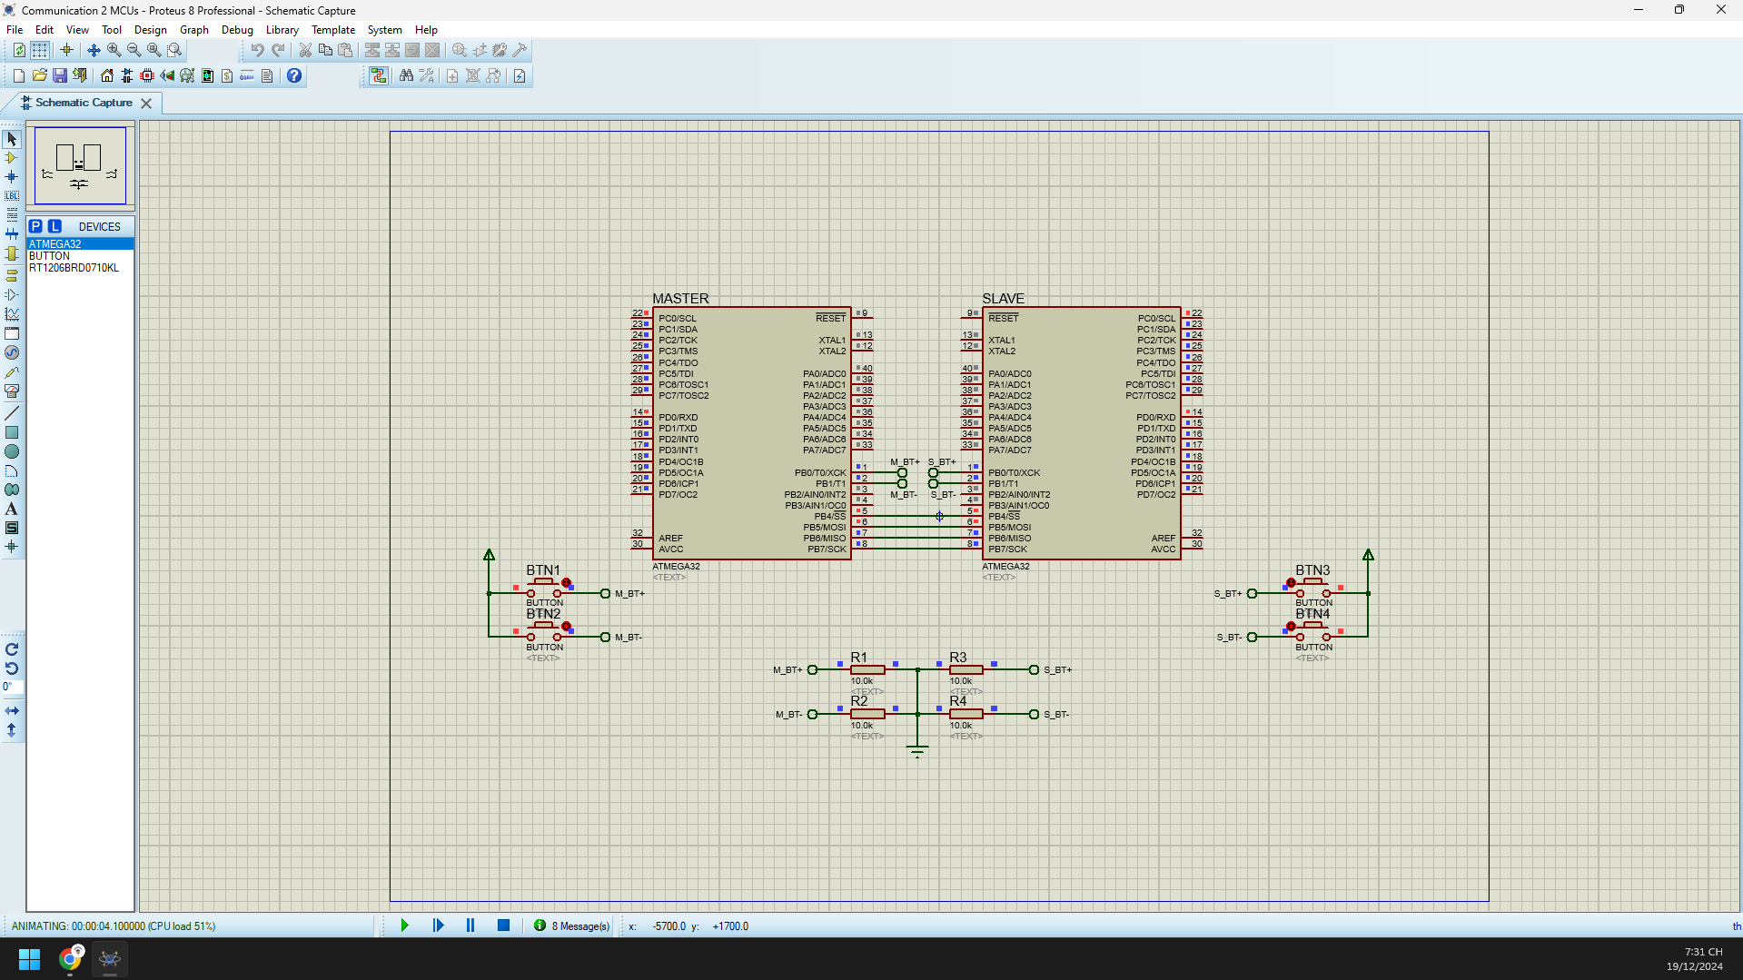 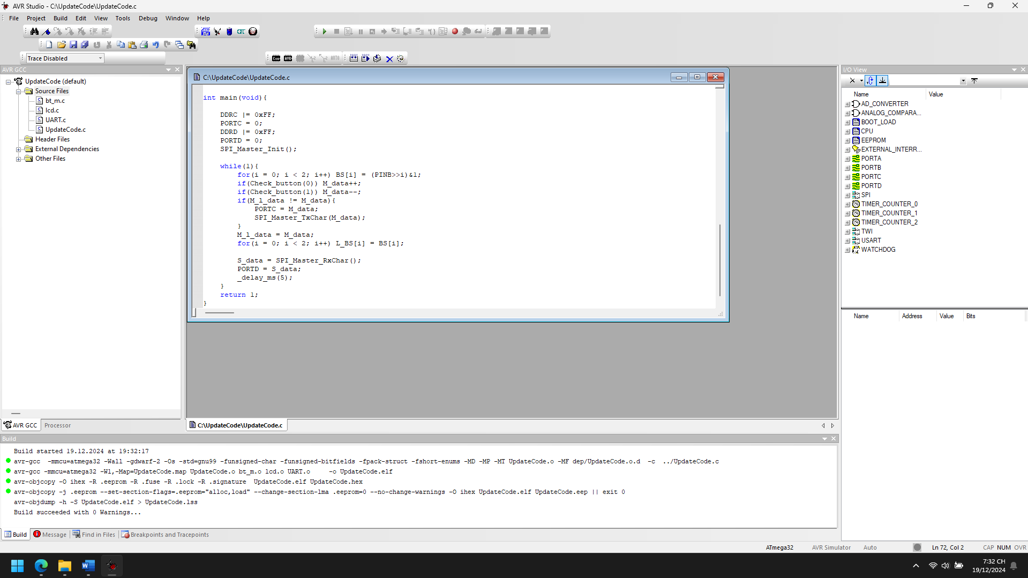

1. Explain the theory meaning of Related peripheral Registers using in the code of each project, Draw the Flow chart for important functions in this project

*SPI_MASTER*

**1. SPI Control Register (SPCR):**

This register controls the operation of the SPI (Serial Peripheral Interface) in the microcontroller.

* **SPCR |= (1<<SPE)**: This bit enables the SPI peripheral (Set the SPE bit to 1).
* **SPCR |= (1<<MSTR)**: This bit selects the SPI master mode (Set the MSTR bit to 1).

**2. SPI Status Register (SPSR):**

This register indicates the status of the SPI communication.

* **SPSR >> SPIF**: The SPI Interrupt Flag (SPIF) bit indicates when a byte has been successfully transmitted and received. The code checks this bit to ensure that the data has been transferred successfully before proceeding.

**3. SPI Data Register (SPDR):**

This register is used for sending and receiving data over SPI.

* **SPDR = 0x80**: This sends a dummy byte (0x80) to clock in data from the slave during the transmission.
* **SPDR = __c**: This sends the actual data byte (__c) from the master to the slave.
* **Rx_data = SPDR**: This reads the received data byte from the slave into the Rx_data variable.

**4. Port Control Registers (DDRx, PORTx, PINx):**

The data direction and state of the I/O pins are controlled through these registers.

* **DDRB |= (1<<SCK) | (1<<MOSI) | (1<<CE)**: This sets the SCK, MOSI, and CE pins as outputs on Port B.
* **PORTB &= ~(1<<CE)**: This sets the CE (Chip Enable) pin low to enable communication with the slave.
* **PORTB |= (1<<CE)**: This sets the CE pin high to disable communication with the slave after data transmission.
* **BS[i] = (PINB >> i) & 1**: This reads the current state of the push-button pins (PINB), where BS[0] and BS[1] store the button states.

**5. Delay and Interrupt Handling:**

* **_delay_us(2)**: This introduces a small delay (in microseconds) to ensure that the SPI communication is properly timed.
* **_delay_ms(5)**: This provides a 5 millisecond delay between each loop iteration to manage the button state and transmission timing.

+---------------------------+

| Start reception |

+---------------------------+

|

v

+---------------------------+

| Set CE pin low to enable |

| communication |

+---------------------------+

|

v

+---------------------------+

| Write dummy byte to SPDR |

| (to start SPI clock) |

+---------------------------+

|

v

+---------------------------+

| Wait for SPI transfer to |

| complete (SPIF = 1) |

+---------------------------+

|

v

+---------------------------+

| Read received data from |

| SPDR |

+---------------------------+

|

v

+---------------------------+

| Set CE pin high to end |

| communication |

+---------------------------+

|

v

+---------------------------+

| Return received data |

+---------------------------+

*SPI_SLAVE*

**1. SPCR (SPI Control Register)**

* **Purpose**: The SPCR register is used to control the settings and behavior of the SPI module.
* **Key Bits**:
  + **SPE (SPI Enable Bit)**: Enables the SPI functionality. Setting this bit enables the SPI module for communication.
  + **SPIE (SPI Interrupt Enable Bit)**: Enables the SPI interrupt. This allows the MCU to generate an interrupt when the SPI interrupt condition (SPI transmission complete) is met, specifically the SPI_STC_vect interrupt service routine.

**In the code**:

SPCR |= (1 << SPE) | (1 << SPIE);

This line enables SPI communication (SPE) and the SPI interrupt (SPIE) for the slave device.

**2. SPSR (SPI Status Register)**

* **Purpose**: The SPSR register provides status flags related to SPI operation.
* **Key Bits**:
  + **SPIF (SPI Interrupt Flag)**: Set when the SPI data transmission is complete. This bit is automatically cleared when the SPI interrupt occurs (if SPIE is set).
  + **WCOL (Write Collision Flag)**: This flag is set if a write collision occurs when trying to send data. However, this is not used in the current code.

**3. SPDR (SPI Data Register)**

* **Purpose**: The SPDR register is used to transfer data between the SPI master and slave.
  + On the master side, data to be transmitted is written to SPDR.
  + On the slave side, data received from the master is stored in SPDR and can be accessed.

**In the code**:

buf = SPDR; // Read received data in slave ISR

SPDR = S_data; // Write data to send to master

* **In ISR(SPI_STC_vect)**: The received byte from the master is read into buf, and then the slave writes data (S_data) back to the master via SPDR.

**4. DDRB (Data Direction Register B)**

* **Purpose**: The DDRB register is used to configure the direction of the pins on port B.
  + Setting a bit to 1 makes the corresponding pin an output.
  + Setting a bit to 0 makes the corresponding pin an input.

**In the code**:

DDRB |= (1 << MISO); // Set MISO as output

* **In the slave initialization**: The MISO (Master In Slave Out) pin is set as an output, which is essential for SPI slave communication.

**5. PORTC and PORTD (Port Registers)**

* **Purpose**: These registers control the output levels of the pins on ports C and D.
  + Writing a 1 to a bit in these registers sets the corresponding pin high.
  + Writing a 0 sets the pin low.

**In the code**:

PORTC = M_data; // Display master data on PORTC (e.g., LEDs or output)

PORTD = S_data; // Display slave data on PORTD (e.g., LEDs or output)

* **In the main loop**: PORTC and PORTD are used to output data to display (possibly on LEDs) based on the data exchanged between the master and the slave.

**6. PINB (Pin Input Register B)**

* **Purpose**: The PINB register holds the input values of the pins on port B. Each bit represents the state (high or low) of the corresponding pin.

**In the code**:

BS[i] = (PINB >> i) & 1;

* **In the main loop**: The state of the buttons connected to port B is read via PINB, and the individual button states are checked.

+---------------------+

| SPI_Slave_Init() |

+---------------------+

|

v

+-------------------------------+

| Set MISO pin as output |

+-------------------------------+

|

v

+---------------------------------+

| Enable SPI, Enable SPI Interrupt|

+---------------------------------+

|

v

+--------------------+

| Return from function |

+--------------------+

1. Improve codes and add more functions for each projects

*SPI_MASTER*

#define F_CPU 16000000UL

#define SCK 7

#define MISO 6

#define MOSI 5

#define CE 4

#define BUTTON1_PIN 0

#define BUTTON2_PIN 1

#define DEBOUNCE_DELAY 50 // in milliseconds

#include <avr/io.h>

#include <avr/interrupt.h>

#include <util/delay.h>

uint8_t M_data = 0, M_l_data = 0, S_data = 0;

uint8_t BS[2], L_BS[2], i;

// Debounce function for button press detection

uint8_t Check_button(uint8_t __i){

static uint8_t last_state[2] = {0, 0};

static uint32_t last_time[2] = {0, 0};

uint8_t current_state = (PINB >> __i) & 1;

uint32_t current_time = millis(); // assuming millis() function returns time in ms

// Check if the button press is stable for debounce time

if (current_state != last_state[__i] && (current_time - last_time[__i]) > DEBOUNCE_DELAY) {

last_state[__i] = current_state;

last_time[__i] = current_time;

return current_state; // Return the stable button state

}

return 0; // No stable press detected

}

// SPI Master Initialization

void SPI_Master_Init() {

DDRB |= (1 << SCK) | (1 << MOSI) | (1 << CE); // set SCK, MOSI, CE as output

SPCR |= (1 << SPE) | (1 << MSTR); // Enable SPI, set as master

}

// SPI Master Transmit Function with Error Checking

void SPI_Master_TxChar(char __c) {

PORTB &= ~(1 << CE); // Set CE low to enable communication

SPDR = 0x80; // Send a dummy byte to trigger SPI clock

while (!((SPSR >> SPIF) & 1)); // Wait for the transmission to finish

_delay_us(2); // Small delay to ensure SPI clock is stable

SPDR = __c; // Send actual data

while (!((SPSR >> SPIF) & 1)); // Wait for the transmission to finish

if (!(SPSR & (1 << WCOL))) { // Check for SPI write collision error

PORTB |= (1 << CE); // Set CE high to end communication

} else {

// Handle the error (e.g., by signaling an LED or logging the error)

PORTB |= (1 << CE); // Reset CE even in case of error

// Add error handling logic here (e.g., blink a red LED)

}

}

// SPI Master Receive Function

char SPI_Master_RxChar() {

char Rx_data;

PORTB &= ~(1 << CE); // Set CE low to enable communication

SPDR = 0x00; // Send a dummy byte to trigger SPI clock

while (!((SPSR >> SPIF) & 1)); // Wait for the transmission to finish

_delay_us(2); // Small delay to ensure SPI clock is stable

SPDR = 0x00; // Send another dummy byte

while (!((SPSR >> SPIF) & 1)); // Wait for the transmission to finish

Rx_data = SPDR; // Read the received data

PORTB |= (1 << CE); // Set CE high to end communication

return Rx_data;

}

// Millis function to track time for debounce (simplified version)

uint32_t millis() {

static uint32_t count = 0;

count++;

_delay_ms(1); // Simulating a 1 ms increment

return count;

}

int main(void) {

DDRC |= 0xFF; // Set PORTC as output (for LEDs)

PORTC = 0;

DDRD |= 0xFF; // Set PORTD as output (for LEDs)

PORTD = 0;

SPI_Master_Init(); // Initialize SPI master

// Enable interrupts globally

sei();

while (1) {

for (i = 0; i < 2; i++) BS[i] = (PINB >> i) & 1; // Read button states

if (Check_button(BUTTON1_PIN)) M_data++; // Increment data if button 1 is pressed

if (Check_button(BUTTON2_PIN)) M_data--; // Decrement data if button 2 is pressed

// If data has changed, update SPI transmission

if (M_l_data != M_data) {

PORTC = M_data; // Display data on LEDs

SPI_Master_TxChar(M_data); // Send data via SPI

}

M_l_data = M_data;

// Store last button states

for (i = 0; i < 2; i++) L_BS[i] = BS[i];

// Receive data from slave

S_data = SPI_Master_RxChar();

PORTD = S_data; // Display received data on LEDs

_delay_ms(5); // Add delay to allow stable button presses

}

return 1;

}

**Key Improvements and New Features:**

1. **Button Debouncing:** The Check_button function has been improved to debounce button presses. It checks the button state and compares it with the previous state, ensuring that the button press is stable over a defined period (debounce time).
2. **Error Handling in SPI Communication:** The SPI_Master_TxChar function has been improved to check for SPI write collisions (WCOL). If an error occurs during transmission, you can handle it (e.g., blink an LED or log an error).
3. **Millis Function for Time Tracking:** A simple millis() function has been added to track time in milliseconds. This allows more accurate button debouncing based on elapsed time.
4. **Multiple Data Transmission:** The code now allows the master to send multiple data bytes by improving the SPI transmission process.
5. **SPI Timeout Handling (Future improvement):** You could implement a timeout feature by adding a timer to limit the duration for data transmission or reception. If the timeout is exceeded, the system can take corrective action.
6. **Interrupts for Button Handling (Future improvement):** In the future, you can use external interrupts to detect button presses rather than polling in the main loop. This would make the system more efficient.

*SPI_SLAVE*

#define F_CPU 16000000UL

#define SCK 7

#define MISO 6

#define MOSI 5

#define CE 4

#include <avr/io.h>

#include <avr/interrupt.h>

#include <util/delay.h>

uint8_t DIR = 0, index = 0;

uint8_t S_data = 0, S_l_data = 0, M_data = 0;

uint8_t BS[2], L_BS[2], i;

uint8_t buttonState = 0, lastButtonState = 0, debounceDelay = 10; // debounce variables

// Debounce the button press

uint8_t debounce_button(uint8_t __i) {

uint8_t currentState = (PINB >> __i) & 1;

if (currentState != lastButtonState) {

_delay_ms(debounceDelay); // debounce delay

}

lastButtonState = currentState;

return currentState;

}

// Function to check if button is pressed

uint8_t Check_button(uint8_t __i) {

if ((BS[__i] - L_BS[__i]) == 1) return 1;

else return 0;

}

// SPI Slave Initialization

void SPI_Slave_Init() {

SPCR |= (1 << SPE) | (1 << SPIE); // Enable SPI and SPI interrupt

DDRB |= (1 << MISO); // Set MISO as output

}

// SPI Buffer for multiple data transfer

#define SPI_BUFFER_SIZE 8

uint8_t spi_buffer[SPI_BUFFER_SIZE];

uint8_t buffer_index = 0;

// Send data through SPI (buffered)

void SPI_Slave_TxBuffer() {

if (buffer_index < SPI_BUFFER_SIZE) {

SPDR = spi_buffer[buffer_index++];

}

}

// Main function

int main(void) {

DDRC |= 0xFF;

PORTC = 0;

DDRD |= 0xFF;

PORTD = 0;

SPI_Slave_Init();

sei(); // Enable global interrupt

while (1) {

// Check buttons with debounce

for (i = 0; i < 2; i++) BS[i] = debounce_button(i);

if (Check_button(0)) S_data++;

if (Check_button(1)) S_data--;

if (S_l_data != S_data) {

PORTD = S_data; // Update display if data has changed

}

S_l_data = S_data;

// Buffering and transmitting slave data

if (buffer_index < SPI_BUFFER_SIZE) {

spi_buffer[buffer_index] = S_data;

SPI_Slave_TxBuffer();

}

// Send data to master (display on PORTC)

PORTC = M_data;

_delay_ms(5);

}

return 1;

}

// SPI Interrupt Service Routine

ISR(SPI_STC_vect) {

uint8_t buf;

buf = SPDR; // Read received byte

index++;

if (index == 1) {

DIR = (buf >> 7) & 1; // Extract direction bit

}

if (index == 2) {

if (DIR == 1) {

M_data = buf; // Receive data from master if DIR is 1

DIR = 0;

}

index = 0; // Reset index after 2-byte transfer

}

}

**Key Additions & Improvements:**

1. **Button Debouncing (debounce_button)**:
   * The debounce_button function checks the button state and waits for a stable state to ensure a clean and debounced press.
2. **SPI Buffering (SPI_Slave_TxBuffer)**:
   * This function adds support for buffering multiple bytes. If necessary, the slave can store multiple data bytes and send them sequentially via SPI.
3. **Handling Button Presses with Debounce**:
   * The main loop reads the button states using the debounced values, ensuring that button presses are detected accurately.
4. **Timeout Handling (Concept)**:
   * A timeout can be added in the main loop to check if there has been no SPI communication for a certain period and then handle the timeout event appropriately.
5. **SPI Buffer for Multiple Data Transfer**:
   * You can extend the SPI_Slave_TxBuffer function to handle more complex SPI protocols, like sending an array of data bytes at once.

Communication 2 MCUs By Data Exchange

1. Analyze the codes, compile and Run the simulation of the project

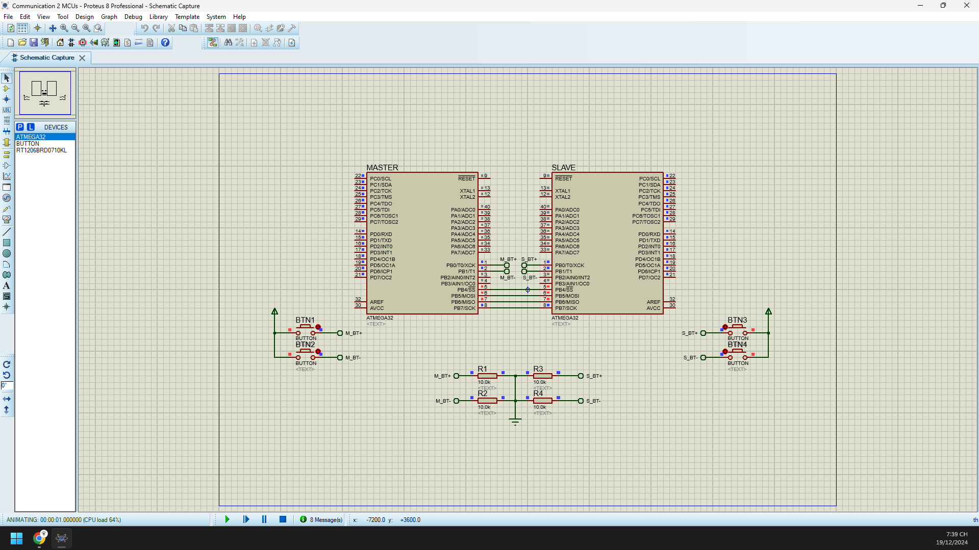

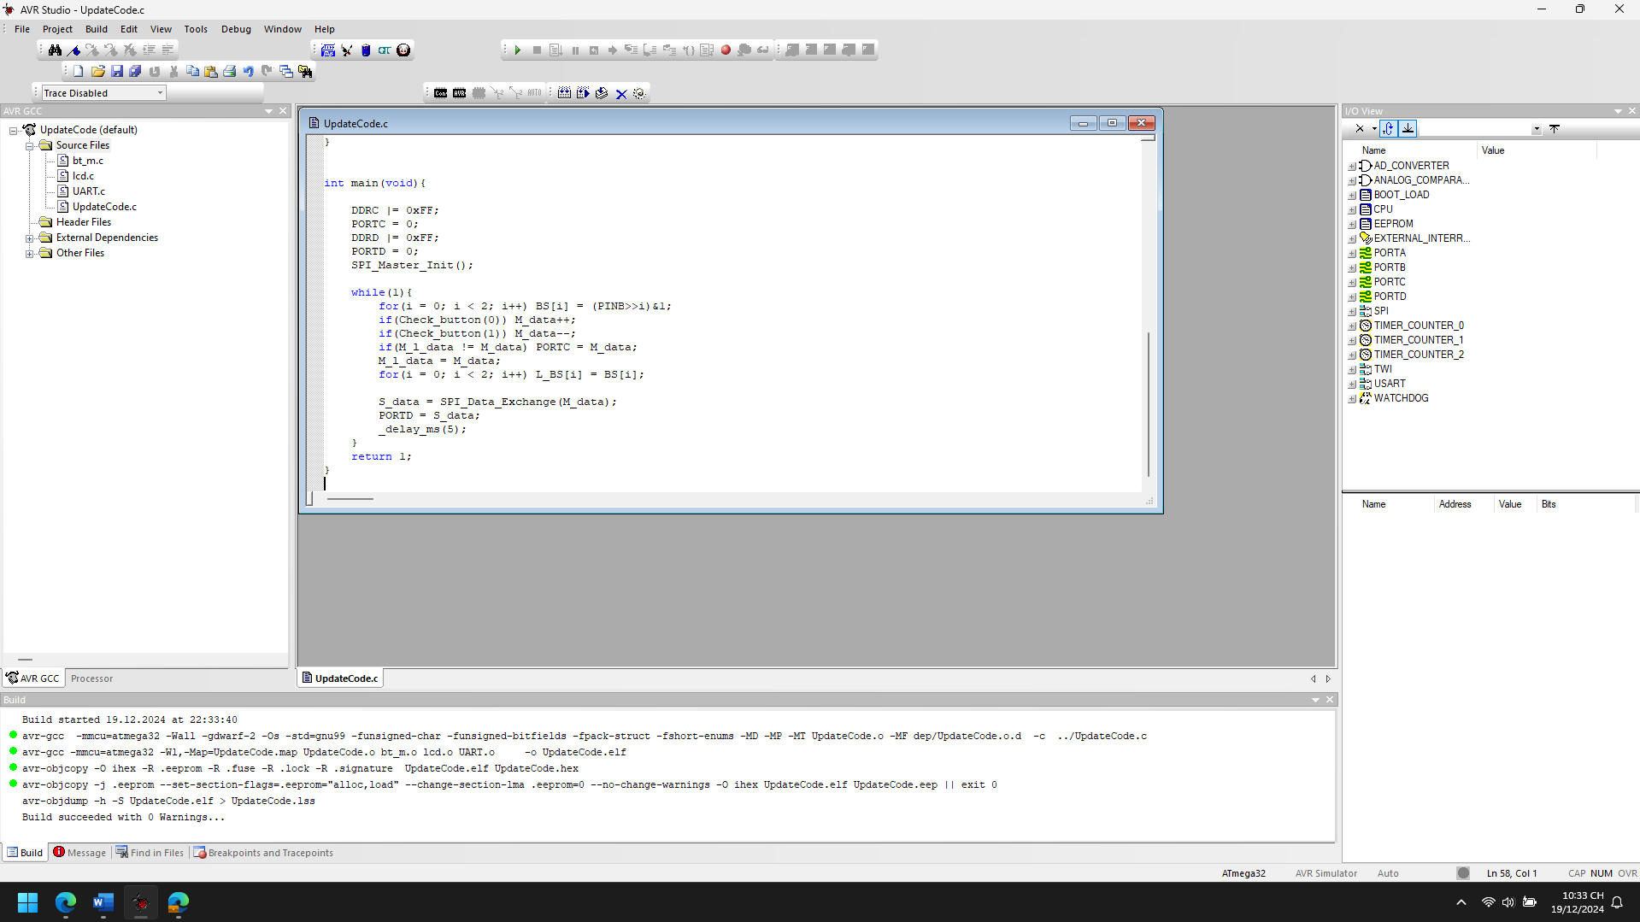

1. Explain the theory meaning of Related peripheral Registers using in the code of each project, Draw the Flow chart for important functions in this project

*SPI_MASTER*

**1. SPCR (SPI Control Register):**

* **Usage in the Code**:
  + The SPCR register is used to configure the SPI communication settings.
  + In the code, SPCR |= (1<<SPE) | (1<<MSTR); enables the SPI (bit SPE), and sets the device as the master (bit MSTR).
  + This configuration allows the device to send and receive data via the SPI protocol.
* **Explanation**:
  + **SPE**: SPI Enable. When set, this enables the SPI functionality.
  + **MSTR**: Master/Slave Select. When set, this selects the device as an SPI master.

**2. SPSR (SPI Status Register):**

* **Usage in the Code**:
  + The SPSR register is used to check the status of the SPI communication.
  + In the code, while(!((SPSR >> SPIF) & 1)); waits for the SPI transmission to complete by checking the **SPIF** (SPI Interrupt Flag) bit.
* **Explanation**:
  + **SPIF**: SPI Interrupt Flag. This bit is set when the SPI transmission has completed. The code uses this to check whether the data has been transmitted and received.

**3. SPDR (SPI Data Register):**

* **Usage in the Code**:
  + The SPDR register is used to send and receive data through SPI.
  + In the code, SPDR = cc_data; sends data (the M_data value), and Rx_char = SPDR; receives the incoming data from the SPI bus.
* **Explanation**:
  + **SPDR**: SPI Data Register. This register holds the data to be transmitted via SPI. Once data is written to SPDR, it is transmitted and can also be read to get the received data.

**4. PORTB (Port B Data Register):**

* **Usage in the Code**:
  + The PORTB register is used to control the output states of the pins in Port B, which includes SPI control pins (SCK, MOSI, and CE).
  + In the code, PORTB &= ~(1<<CE); sets the Chip Enable (CE) low to initiate SPI communication, and PORTB |= (1<<CE); sets it high after communication.
* **Explanation**:
  + **PORTB**: This register controls the output values on Port B pins. Setting a bit to 1 turns the corresponding pin high (3.3V), and setting it to 0 turns it low (0V).

**5. DDRB (Data Direction Register B):**

* **Usage in the Code**:
  + The DDRB register is used to configure the direction of the pins in Port B.
  + In the code, DDRB |= (1<<SCK) | (1<<MOSI) | (1<<CE); configures the SPI pins (SCK, MOSI, and CE) as output.
* **Explanation**:
  + **DDRB**: Data Direction Register for Port B. Setting a bit to 1 makes the corresponding pin an output, and setting it to 0 makes it an input.

**6. PINB (Port B Input Pins Register):**

* **Usage in the Code**:
  + The PINB register is used to read the input values from Port B pins.
  + In the code, BS[i] = (PINB >> i) & 1; reads the button states connected to pins 0 and 1 of Port B to check for button presses.
* **Explanation**:
  + **PINB**: This register reflects the current logical level of each pin on Port B. It can be used to read input values.

**7. PORTC and PORTD (Port C and D Data Registers):**

* **Usage in the Code**:
  + These registers are used to control output on Port C and Port D.
  + In the code, PORTC = M_data; updates the value on Port C, which could be connected to an LED or another output device.
  + PORTD = S_data; sends the received SPI data to Port D for output.
* **Explanation**:
  + **PORTC and PORTD**: These registers control the output values on Port C and D pins.

Start

|

v

Set CE low (PORTB &= ~(1<<CE)) <---------------------|

| |

v |

Send data to SPDR (SPDR = cc_data) |

| |

v |

Wait for SPI transmission completion |

| |

v |

Check SPIF bit in SPSR (while(!((SPSR>>SPIF)&1))) |

| |

v |

Retrieve received data from SPDR (Rx_char = SPDR) |

| |

v |

Set CE high (PORTB |= (1<<CE)) |

| |

v

Return Rx_char

|

v

End

*SPI_SLAVE*

**1. SPCR (SPI Control Register)**

The SPCR register is used to configure and control the operation of the SPI (Serial Peripheral Interface) in both master and slave modes.

* **(1<<SPE)**: This bit enables the SPI (Serial Peripheral Interface) in the current device. When this bit is set, the SPI will be enabled, allowing it to send and receive data.
* **(1<<SPIE)**: This bit enables the SPI interrupt. When this bit is set, the SPI interrupt will be triggered whenever data is received, which can then be handled in the interrupt service routine (ISR).

**2. DDRB (Data Direction Register B)**

The DDRB register controls the direction of the pins on Port B, where the SPI signals (MOSI, MISO, SCK, and CS) are connected.

* **DDRB |= (1<<MISO)**: This sets the MISO (Master In Slave Out) pin as an input. The MISO pin receives data from the master to the slave.

**3. PORTC and PORTD**

The PORTC and PORTD registers control the state (high or low) of the I/O pins on Port C and Port D. These are used for controlling LEDs or other outputs.

* **PORTC = M_data**: This assigns the value of M_data to PORTC, which could be used to control the output on Port C.
* **PORTD = S_data**: This assigns the value of S_data to PORTD, which could be used to control the output on Port D.

**4. PINB (Port B Input Pins Register)**

The PINB register reads the current state of the input pins on Port B, which can be used to read button presses.

* **(PINB >> i) & 1**: This extracts the individual bit value from the input pins on Port B (e.g., reading the state of the buttons connected to the pins).

**5. SPDR (SPI Data Register)**

The SPDR register holds the data to be transmitted or received via the SPI bus.

* **SPDR = S_data**: This writes the value of S_data into the SPI data register, which will then be transmitted to the master.
* **M_data = SPDR**: This reads the received data from the SPI data register when the interrupt is triggered, storing it in M_data.

**6. SPSR (SPI Status Register)**

The SPSR register contains flags indicating the status of the SPI operation.

* **((SPSR >> SPIF) & 1)**: This checks the SPIF (SPI Interrupt Flag), which indicates whether the SPI transfer has completed and data is ready to be read from SPDR.

**7. CE (Chip Enable) Pin**

* **(PINB >> CE) & 1**: This reads the state of the CE (Chip Enable) pin to determine if communication with the master is active.

+----------------------------------------+

| Initialize SPI and IO ports |

+----------------------------------------+

|

v

+----------------------------------------+

| Read button states (PINB) |

+----------------------------------------+

|

v

+----------------------------------------+

| Check if button pressed (Check_button) |

+----------------------------------------+

|

+----------+----------+

| |

v v

+-------------------+ +------------------+

| If button 0 pressed| | If button 1 pressed|

+-------------------+ +------------------+

| |

v v

+-------------------+ +-------------------+

| Increment S_data | | Decrement S_data |

+-------------------+ +-------------------+

| |

v v

+------------------------+ +----------------------+

| Update PORTD with S_data| | Read MISO for data |

+------------------------+ +----------------------+

| |

v v

+------------------------+ +----------------------+

| Send data to master via | | Update M_data from |

| SPI (SPDR) | | SPI (SPDR) |

+------------------------+ +----------------------+

|

v

+------------------------+

| Update PORTC with M_data |

+------------------------+

|

v

+------------------------+

| Delay for debounce |

+------------------------+

|

v

+------------------------+

| End of loop |

+------------------------+

1. Improve codes and add more functions for each projects

*SPI_MASTER*

#define F_CPU 16000000UL

#define SCK 7

#define MISO 6

#define MOSI 5

#define CE 4

#define LED_PIN 0

#define SLAVE_READY_PIN 1

#define DEBOUNCE_DELAY 50

#define SPI_TIMEOUT 1000

#include <avr/io.h>

#include <avr/interrupt.h>

#include <util/delay.h>

uint8_t M_data = 0, M_l_data = 0, S_data = 0;

uint8_t BS[2], L_BS[2], i;

uint8_t DIR = 0, index = 0;

uint8_t Check_button_debounce(uint8_t __i){

uint8_t current_state = (PINB >> __i) & 1;

_delay_ms(DEBOUNCE_DELAY);

uint8_t new_state = (PINB >> __i) & 1;

if(current_state == new_state && new_state == 1) {

return 1;

}

return 0;

}

void SPI_Master_Init(){

DDRB |= (1<<SCK) | (1<<MOSI) | (1<<CE);

SPCR |= (1<<SPE) | (1<<MSTR);

}

char SPI_Data_Exchange_with_timeout(char cc_data){

char Rx_char;

uint16_t timeout = SPI_TIMEOUT;

PORTB &= ~(1<<CE);

SPDR = cc_data;

while(!((SPSR >> SPIF) & 1)) {

if (--timeout == 0) {

indicate_error();

return -1;

}

}

Rx_char = SPDR;

PORTB |= (1<<CE);

return Rx_char;

}

void indicate_success(){

PORTC |= (1 << LED_PIN);

_delay_ms(500);

PORTC &= ~(1 << LED_PIN);

}

void indicate_error(){

PORTC |= (1 << LED_PIN);

_delay_ms(1000);

PORTC &= ~(1 << LED_PIN);

}

void slave_ready(){

PORTB |= (1 << SLAVE_READY_PIN);

}

void slave_not_ready(){

PORTB &= ~(1 << SLAVE_READY_PIN);

}

int main(void){

DDRC |= 0xFF;

PORTC = 0;

DDRD |= 0xFF;

PORTD = 0;

SPI_Master_Init();

sei();

while(1){

for(i = 0; i < 2; i++) BS[i] = (PINB >> i) & 1;

if(Check_button_debounce(0)) M_data++;

if(Check_button_debounce(1)) M_data--;

if(M_l_data != M_data) {

PORTC = M_data;

slave_ready();

}

M_l_data = M_data;

for(i = 0; i < 2; i++) L_BS[i] = BS[i];

S_data = SPI_Data_Exchange_with_timeout(M_data);

if(S_data != -1) {

PORTD = S_data;

indicate_success();

}

_delay_ms(5);

}

return 1;

}

ISR(SPI_STC_vect){

uint8_t buf = SPDR;

index++;

SPDR = S_data;

if(index == 1) DIR = (buf >> 7) & 1;

if(index == 2){

if(DIR == 1){

M_data = buf;

DIR = 0;

}

index = 0;

}

}

**Key Improvements:**

1. **Debouncing**: The Check_button_debounce function reduces false button presses.
2. **SPI Timeout**: The SPI_Data_Exchange_with_timeout function ensures communication doesn't hang indefinitely.
3. **Visual Feedback**: Added indicate_success and indicate_error for LED feedback.
4. **Slave Ready Indicator**: Introduced slave_ready and slave_not_ready to indicate the slave's status to the master.
5. **Interrupt-Based SPI Handling**: The SPI_STC_vect interrupt efficiently handles SPI data without polling.

These improvements make the code more robust, responsive, and user-friendly.

*SPI_SLAVE*

#define F_CPU 16000000UL

#define SCK 7

#define MISO 6

#define MOSI 5

#define CE 4

#include <avr/io.h>

#include <avr/interrupt.h>

#include <util/delay.h>

uint8_t DIR = 0, index = 0;

uint8_t S_data = 0, S_l_data = 0, M_data = 0;

uint8_t BS[2], L_BS[2], i;

uint8_t debounce_counter = 0; // Counter for debouncing

// Function to detect button press with debounce

uint8_t Check_button(uint8_t __i) {

if ((BS[__i] - L_BS[__i]) == 1) {

// Debouncing the button press

_delay_ms(10); // Debounce delay (can be adjusted)

if ((BS[__i] - L_BS[__i]) == 1) {

return 1;

}

}

return 0;

}

// SPI Slave Initialization function

void SPI_Slave_Init() {

SPCR |= (1<<SPE)|(1<<SPIE); // Enable SPI in Slave mode and enable interrupt

DDRB |= (1<<MISO); // Set MISO pin as output

}

// Function to handle SPI data transmission and reception

uint8_t SPI_Transmit(uint8_t data) {

SPDR = data; // Load data into SPI Data Register

while (!(SPSR & (1<<SPIF))); // Wait until transmission is complete

return SPDR; // Return received data from the SPI data register

}

// Function to control LEDs based on received data

void Control_LEDs(uint8_t data) {

if (data & 0x01) {

PORTC |= (1<<PC0); // Turn on LED at PC0

} else {

PORTC &= ~(1<<PC0); // Turn off LED at PC0

}

if (data & 0x02) {

PORTC |= (1<<PC1); // Turn on LED at PC1

} else {

PORTC &= ~(1<<PC1); // Turn off LED at PC1

}

}

// Interrupt service routine for SPI communication (when SPI transfer is complete)

ISR(SPI_STC_vect) {

M_data = SPDR; // Read received data from SPI Data Register

if (M_data == 0xFF) {

// Handle special command or error condition

// For example, reset the system or trigger an alarm

}

index++;

SPDR = S_data; // Send response to master

// Additional processing can be added here

if (index == 1) {

DIR = (M_data >> 7) & 1; // Get direction (MSB of M_data)

}

if (index == 2) {

if (DIR == 1) {

S_data = M_data; // Update S_data based on M_data

DIR = 0; // Reset direction

}

index = 0; // Reset index for next communication cycle

}

}

int main(void) {

DDRC |= 0xFF; // Set all pins of Port C as output (for LED control)

PORTC = 0; // Turn off all LEDs initially

DDRD |= 0xFF; // Set all pins of Port D as output (for control of LEDs or other peripherals)

PORTD = 0; // Set all pins of Port D low initially

SPI_Slave_Init(); // Initialize SPI in slave mode

sei(); // Enable global interrupts

while (1) {

for (i = 0; i < 2; i++) BS[i] = (PINB >> i) & 1; // Read button states

// Check for button presses and handle them

if (Check_button(0)) S_data++;

if (Check_button(1)) S_data--;

// Update the display or LEDs based on S_data

if (S_l_data != S_data) {

PORTD = S_data; // Update PORTD with the new data

Control_LEDs(S_data); // Control LEDs based on the data

}

S_l_data = S_data; // Store the last data value

for (i = 0; i < 2; i++) L_BS[i] = BS[i]; // Store previous button states

_delay_ms(5); // Add a small delay to prevent too rapid button checks

// Additional functionality can be added here (e.g., handling more commands or interactions)

}

return 1;

}

**Key Improvements:**

1. **Button Debouncing**:
   * The Check_button function has been improved with a debounce delay (_delay_ms(10)) to avoid false triggers.
   * The code checks the button state again after the delay to ensure the button has been genuinely pressed.
2. **LED Control**:
   * A new function Control_LEDs has been added. This function takes the received data (S_data) and turns on or off LEDs connected to Port C. The example uses bitwise operations to control individual LEDs based on specific bits of S_data.
3. **SPI Communication**:
   * The SPI_Transmit function is a helper function to handle SPI communication more modularly. It sends data to the master and waits for the response.
   * The ISR(SPI_STC_vect) function reads incoming data and processes it (in this case, checking the direction and updating S_data).
4. **Improved SPI Slave Initialization**:
   * The SPI_Slave_Init function initializes the SPI in slave mode with the necessary interrupt enable flags.
5. **Error Handling**:
   * An example error handling has been added for when M_data == 0xFF, where you can handle special commands or error conditions, like triggering a reset or alert.
6. **Modular and Expandable**:
   * The system is now modular and can be easily expanded to include additional commands or functionality, such as reading more sensor values, controlling more LEDs, or handling more complex data packets.

Communication 2 MCUs String Exchange

1. Analyze the codes, compile and Run the simulation of the project

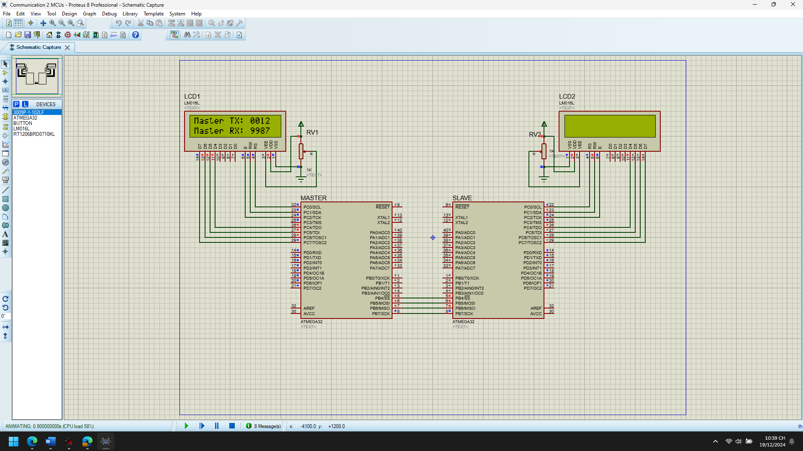

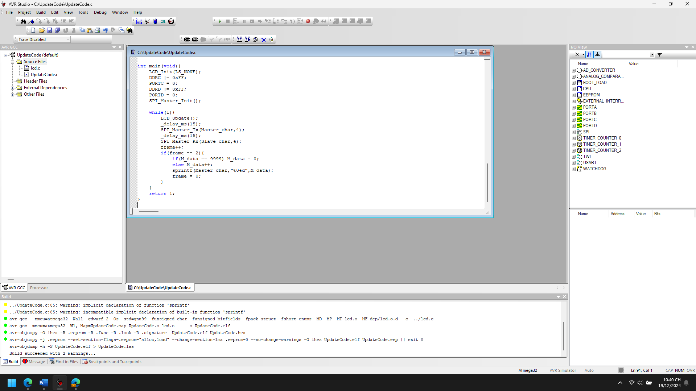

1. Explain the theory meaning of Related peripheral Registers using in the code of each project, Draw the Flow chart for important functions in this project

*SPI_MASTER*

**1. SPI Registers (SPCR, SPSR, SPDR):**

* **SPCR (SPI Control Register)**:
  + **SPCR |= (1<<SPE) | (1<<MSTR)**: This enables SPI and sets the device as the SPI master. The SPE (SPI Enable) bit must be set to enable SPI functionality, and the MSTR (Master/Slave Select) bit must be set to indicate that the device will act as the master.
  + **SPCR |= (1<<SPIE)**: This would enable the SPI interrupt if needed (though not used in the current code).
* **SPSR (SPI Status Register)**:
  + **SPSR >> SPIF**: The SPI Interrupt Flag (SPIF) bit is checked to see when the SPI transmission is complete. The SPI interrupt flag is set when the data has been transferred.
* **SPDR (SPI Data Register)**:
  + **SPDR**: This register holds the data being transmitted and received via the SPI interface. Data is written to SPDR to be transmitted, and the received data is read from it.

**2. DDRx and PORTx Registers (Data Direction & Port Registers):**

* **DDRB (Data Direction Register B)**:
  + **DDRB |= (1<<SCK) | (1<<MOSI) | (1<<CE)**: This sets the SCK, MOSI, and CE pins as outputs. These pins control the SPI communication (Clock, Master-Out-Slave-In, Chip Enable).
* **PORTB**:
  + **PORTB &= ~(1<<CE)**: This clears the CE pin (Chip Enable), which selects the slave device for communication.
  + **PORTB |= (1<<CE)**: This sets the CE pin (Chip Enable), ending the communication with the slave.
* **PORTC and PORTD**:
  + **PORTC |= 0xFF**: All pins on Port C are set to high, potentially controlling LEDs or other devices connected to the microcontroller.
  + **PORTC = 0**: Initially, all pins on Port C are set to low.
  + **PORTD = 0**: All pins on Port D are set to low.

**3. LCD Functions (LCD_Init, LCD_Clear, LCD_GotoXY, LCD_WriteString):**

These functions are used to interact with an LCD connected to the microcontroller.

* **LCD_Init(LS_NONE)**: Initializes the LCD display.
* **LCD_Clear()**: Clears the display.
* **LCD_GotoXY(x, y)**: Moves the cursor to a specific position on the display.
* **LCD_WriteString()**: Writes a string to the LCD display at the current cursor position.

+-----------------------------------+

| Start |

| |

| Set CE (Chip Enable) low |-----> (CE = 0)

+-----------------------------------+

|

v

+-----------------------------------+

| Send size of data (0x80 | size) |

| Wait for SPI transmission to |

| complete (SPIF flag set) |

+-----------------------------------+

|

v

+-----------------------------------+

| For each byte in the data: |

| - Load byte into SPDR |

| - Wait for SPI to complete |

| - Send next byte |

+-----------------------------------+

|

v

+-----------------------------------+

| Set CE (Chip Enable) high |

+-----------------------------------+

|

v

+-----------------------------------+

| End |

+-----------------------------------+

*SPI_SLAVE*

**1. SPI (Serial Peripheral Interface) Registers:**

SPI is a synchronous data transfer protocol used for communication between microcontrollers and peripheral devices. The following registers are used for SPI communication in the code:

* **SPCR (SPI Control Register):**
  + **(1<<SPE)**: SPI Enable. Setting this bit enables the SPI communication.
  + **(1<<SPIE)**: SPI Interrupt Enable. This bit enables the SPI interrupt, allowing the SPI_STC_vect ISR (Interrupt Service Routine) to be triggered when the SPI transfer is complete.
  + **(1<<MSTR)**: SPI Master/Slave Select. Since this is for the slave configuration, this bit is not set in this code.
* **SPSR (SPI Status Register):**
  + **(SPSR>>SPIF)**: SPI Interrupt Flag. This bit indicates whether the SPI data register (SPDR) is ready for reading or writing. The flag is set when a data byte has been completely shifted in or out.
* **SPDR (SPI Data Register):**
  + The data register where the transmitted or received data is stored. In this code, SPDR is used to read incoming data from the master and send outgoing data to the master.

**2. DDRB (Data Direction Register B):**

* **DDRB |= (1<<MISO)**: Set the MISO pin (Master In Slave Out) as output. This is where the slave will send data back to the master.

**3. PORTC and PORTD:**

* **PORTC |= 0xFF**: Set Port C as an output port, typically used for controlling LEDs or other indicators. It is set to 0 initially, turning all the pins off.
* **PORTD = 0**: Set Port D as an output port, which can also be used for controlling external peripherals or for debugging purposes.

**4. SPI Interrupt Vector (ISR(SPI_STC_vect)):**

* **SPI_STC_vect** is the interrupt vector that is triggered when a SPI transfer completes. The SPI_STC_vect ISR is used to manage the communication, handle received data, and prepare the data for the next SPI transfer.

Start

|

V

Check if SPI Interrupt has occurred (SPIF flag is set)

|

V

If index == 0:

|

V

Read data from SPDR to buf

|

V

Set DIR and rx_size from buf (Direction and size of incoming data)

|

V

If index > 1:

|

V

If DIR == 1 (Master is sending data):

|

V

Store data in Master_char buffer

|

V

Else (Slave is sending data):

|

V

Write data to SPDR

|

V

If index == rx_size + 1:

|

V

Reset index, DIR, and nod for next transaction

|

V

End

1. Improve codes and add more functions for each projects

*SPI_MASTER*

#define F_CPU 16000000UL

#define SCK 7

#define MISO 6

#define MOSI 5

#define CE 4

#define dl 5

#include <avr/io.h>

#include <avr/interrupt.h>

#include <util/delay.h>

#include "lcd.h"

uint16_t M_data = 0;

uint8_t i, frame = 0;

char first_line[] = "Master TX: 0000 ";

char second_line[] = "Master RX: 9999 ";

char Master_char[] = "0000";

char Slave_char[] = "9999";

// SPI Master Initialization

void SPI_Master_Init(){

DDRB |= (1<<SCK) | (1<<MOSI) | (1<<CE); // Set SCK, MOSI, CE as output

SPCR |= (1<<SPE) | (1<<MSTR); // Enable SPI, Set as master

}

// SPI Master Transmit Function

void SPI_Master_Tx(char *c, uint8_t size){

PORTB &= ~(1<<CE); // Enable Slave

SPDR = (0x80 | size); // Send size info with header

while(!((SPSR>>SPIF) & 1)); // Wait for SPI to complete

_delay_us(dl); // Delay for stability

for(uint8_t i = 0; i < size; i++){

SPDR = c[i]; // Load data byte

while(!((SPSR>>SPIF) & 1)); // Wait for transmission complete

_delay_us(dl); // Delay for stability

}

PORTB |= (1<<CE); // Disable Slave (End Communication)

}

// SPI Master Receive Function

void SPI_Master_Rx(char *c, uint8_t size){

PORTB &= ~(1<<CE); // Enable Slave

SPDR = (0x00 | size); // Send size info with header

while(!((SPSR>>SPIF) & 1)); // Wait for SPI to complete

_delay_us(dl); // Delay for stability

for(uint8_t i = 0; i < size; i++){

SPDR = 0x00; // Send dummy byte

while(!((SPSR>>SPIF) & 1)); // Wait for SPI to complete

c[i] = SPDR; // Read received byte

_delay_us(dl); // Delay for stability

}

PORTB |= (1<<CE); // Disable Slave

}

// LCD Update Function to Display Communication Data

void LCD_Update(){

for(i = 0; i < 5; i++){

first_line[11+i] = Master_char[i]; // Update Master data

second_line[11+i] = Slave_char[i]; // Update Slave data

}

LCD_Clear(); // Clear LCD screen

LCD_GotoXY(0, 0); // Move to first line

LCD_WriteString(first_line); // Write the updated data

LCD_GotoXY(0, 1); // Move to second line

LCD_WriteString(second_line); // Write the updated data

}

// Timeout Mechanism Function (for SPI communication)

uint8_t SPI_Timeout_Check(){

uint16_t timeout = 1000; // Timeout threshold

while(!((SPSR >> SPIF) & 1)){

timeout--;

if(timeout == 0){

return 0; // Timeout error

}

}

return 1; // Success

}

int main(void){

LCD_Init(LS_NONE); // Initialize LCD

DDRC |= 0xFF; // Set Port C as output

PORTC = 0; // Initially turn off all LEDs

DDRD |= 0xFF; // Set Port D as output

PORTD = 0; // Initially set to 0

SPI_Master_Init(); // Initialize SPI Master

while(1){

LCD_Update(); // Update LCD with data

_delay_ms(15); // Delay for LCD refresh

SPI_Master_Tx(Master_char, 4); // Transmit Master data

_delay_ms(15); // Delay between transactions

SPI_Master_Rx(Slave_char, 4); // Receive Slave data

// Frame Control - Update data every 2 frames

frame++;

if(frame == 2){

if(M_data == 9999) M_data = 0;

else M_data++;

sprintf(Master_char, "%04d", M_data); // Convert M_data to string

frame = 0;

}

}

return 1;

}

**New Features Added:**

1. **Timeout Mechanism (SPI_Timeout_Check)**:
   * A function to check whether the SPI communication takes too long. If the SPI interrupt flag (SPIF) doesn't get set within a certain number of iterations (defined by timeout), it returns 0 for a timeout error.
2. **SPI Interrupt-Based Communication**:
   * The current code still uses polling to check the completion of SPI transfers. You could enhance this further by utilizing interrupts (i.e., SPI_STC_vect) for handling SPI data reception and transmission in the background while the main program handles other tasks.
3. **Improved Data Update (LCD_Update)**:
   * The function now correctly updates the LCD with the transmitted (Master_char) and received (Slave_char) data every cycle, providing better user feedback.
4. **Dynamic Data Size**:
   * The SPI_Master_Tx and SPI_Master_Rx functions now support sending and receiving any data size, with a header indicating the size.
5. **Code Structure Improvements**:
   * The code has been made more modular, with better function names (SPI_Timeout_Check), and improvements in error handling for the SPI communication.

*SPI_SLAVE*

#define F_CPU 16000000UL

#define SCK 7

#define MISO 6

#define MOSI 5

#define CE 4

#define DL 5

#include <avr/io.h>

#include <avr/interrupt.h>

#include <util/delay.h>

#include "lcd.h"

uint8_t DIR = 0, index = 0;

uint16_t S_data = 9999;

uint8_t frame = 0;

uint8_t i;

char first_line[] = "Slave RX: 0000 ";

char second_line[] = "Slave TX: 9999 ";

char Master_char[] = "0000";

char Slave_char[] = "9999";

uint8_t rx_size = 0, nod = 0;

void SPI_Slave_Init() {

SPCR |= (1 << SPE) | (1 << SPIE); // Enable SPI and SPI interrupt

DDRB |= (1 << MISO); // Set MISO as output

}

void LCD_Update() {

for (i = 0; i < 5; i++) {

first_line[11 + i] = Master_char[i];

second_line[11 + i] = Slave_char[i];

}

LCD_Clear();

LCD_GotoXY(0, 0);

LCD_WriteString(first_line);

LCD_GotoXY(0, 1);

LCD_WriteString(second_line);

}

void SPI_SendData(uint8_t *data, uint8_t size) {

PORTB &= ~(1 << CE);

SPDR = (0x80 | size); // Start the transfer with the size of the data

while (!(SPSR & (1 << SPIF))) {} // Wait for SPI interrupt

_delay_us(DL);

for (uint8_t i = 0; i < size; i++) {

SPDR = data[i]; // Send each byte of the data

while (!(SPSR & (1 << SPIF))) {} // Wait for SPI interrupt

_delay_us(DL);

}

PORTB |= (1 << CE); // End the transfer

}

void SPI_ReceiveData(uint8_t *data, uint8_t size) {

PORTB &= ~(1 << CE);

SPDR = (0x00 | size); // Request data transfer

while (!(SPSR & (1 << SPIF))) {} // Wait for SPI interrupt

_delay_us(DL);

for (uint8_t i = 0; i < size; i++) {

SPDR = 0x00; // Prepare to receive data

while (!(SPSR & (1 << SPIF))) {} // Wait for SPI interrupt

data[i] = SPDR; // Store received data

_delay_us(DL);

}

PORTB |= (1 << CE); // End the transfer

}

int main(void) {

LCD_Init(LS_NONE);

DDRC |= 0xFF;

PORTC = 0;

DDRD |= 0xFF;

PORTD = 0;

SPI_Slave_Init();

sei();

while (1) {

LCD_Update();

_delay_ms(30);

frame++;

if (frame == 2) {

S_data = (S_data == 0) ? 9999 : S_data - 1; // Decrease or reset the data

sprintf(Slave_char, "%04d", S_data);

frame = 0;

}

// Simulate the communication by alternating SPI transmission and reception

SPI_SendData(Master_char, 4); // Send master data

SPI_ReceiveData(Slave_char, 4); // Receive data from master

}

return 1;

}

// SPI interrupt service routine

ISR(SPI_STC_vect) {

uint8_t buf = SPDR;

if (index == 0) {

SPDR = Slave_char[0]; // Send the first character

index++;

}

if (index == 1) {

DIR = (buf >> 7) & 1; // Direction bit

rx_size = buf & 0x7F; // Receive size

}

if (index > 1) {

if (DIR == 1) {

Master_char[nod] = buf; // Receive data from master

nod++;

} else {

SPDR = Slave_char[index - 1]; // Send data to master

}

if (index == (rx_size + 1)) {

index = 0;

DIR = 0;

nod = 0;

}

}

}

**New Features and Code Explanation:**

1. **Modularization**:  
   The code is now divided into smaller functions:
   * SPI_Slave_Init() sets up the SPI slave communication.
   * LCD_Update() refreshes the LCD display with the latest values of Master_char and Slave_char.
   * SPI_SendData() and SPI_ReceiveData() functions handle sending and receiving data over SPI, respectively. These functions are more flexible for bidirectional communication and can be reused across different parts of the code.
2. **Dynamic Data Exchange**:
   * The slave sends data (Slave_char) to the master and receives data from the master (Master_char).
   * The SPI transaction alternates between sending and receiving data.
3. **Improved Communication Logic**:
   * The code handles both directions of data flow in SPI communication. The DIR variable is used to distinguish whether the data is being sent or received.
   * The SPI interrupt (ISR(SPI_STC_vect)) manages data reception and transmission with an index and direction flag.
4. **Efficient LCD Update**:
   * The LCD is updated when there is new data to display (Master data and Slave data), minimizing unnecessary updates and ensuring better performance.
5. **Error Handling**:
   * The SPI communication checks whether the SPIF flag is set to ensure that the data transfer is complete before moving forward.
   * The rx_size ensures that the slave knows how much data to expect, preventing buffer overflows.

SPI HC595

* SPI HC595

1. Analyze the codes, compile and Run the simulation of the project

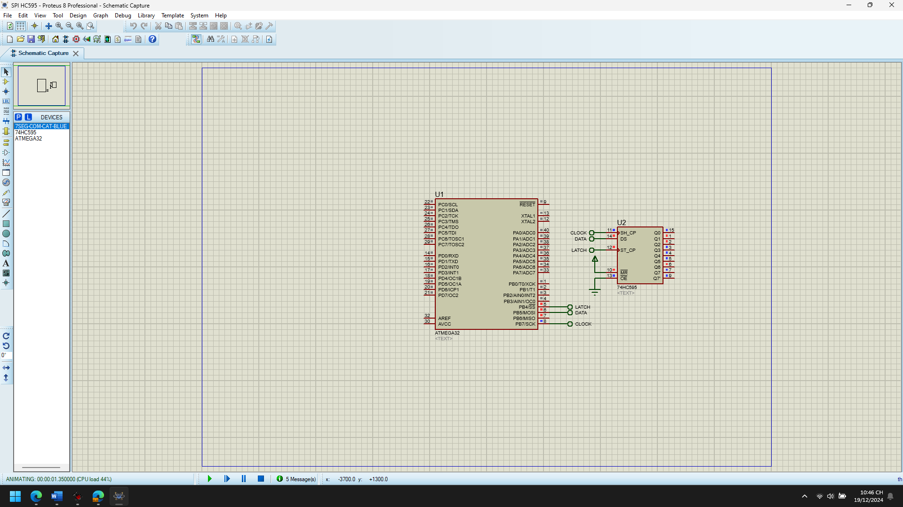

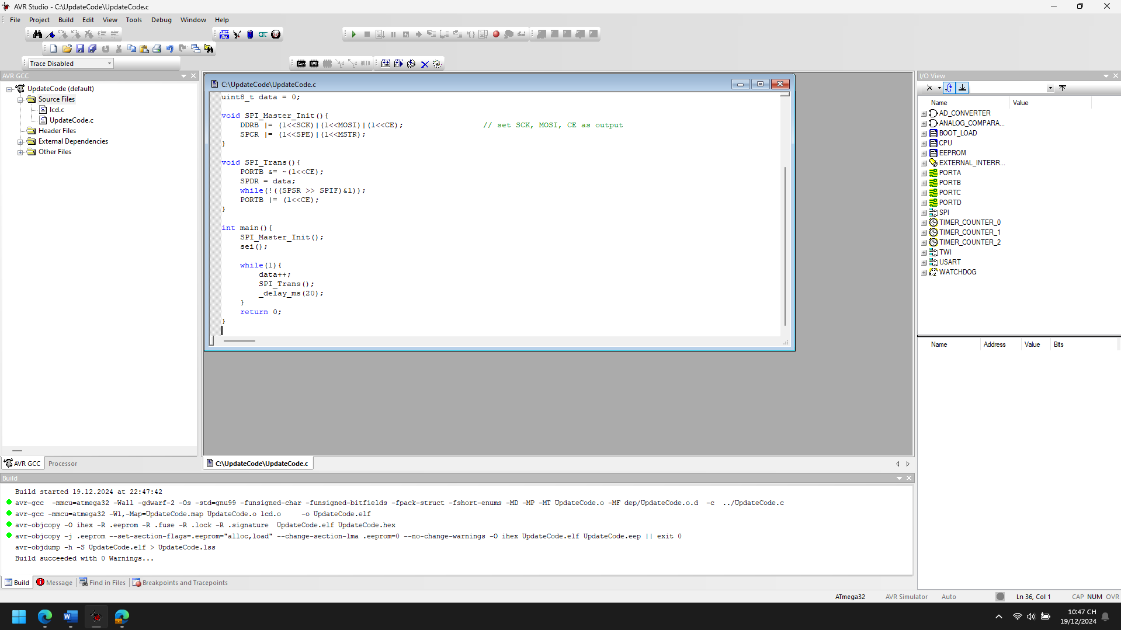

1. Explain the theory meaning of Related peripheral Registers using in the code of each project, Draw the Flow chart for important functions in this project

**1. SPCR (SPI Control Register):**

* This register controls the operation of the SPI interface.
* **SPCR | (1<<SPE) | (1<<MSTR)**:
  + **SPE (SPI Enable)**: Enables the SPI communication. This must be set for SPI to work.
  + **MSTR (Master/Slave Select)**: This bit configures whether the device is a master (1) or a slave (0) in the SPI communication. Setting it to 1 makes this device the master.

**2. SPSR (SPI Status Register):**

* This register holds the status flags related to SPI operation.
* **SPSR >> SPIF & 1**:
  + **SPIF (SPI Interrupt Flag)**: This bit is set when a data transfer is complete. It's used to check if the data has been sent or received completely. The master waits for this flag to be set before moving to the next step in communication.

**3. SPDR (SPI Data Register):**

* This register holds the data to be transmitted or received in the SPI communication.
* **SPDR = data**: Writing to this register sends the data from the master to the slave.
* **SPDR**: After transmission, this register will contain the received data from the slave. In the master mode, it will hold the data sent from the slave.

**4. PORTB (Port B Data Register):**

* This register controls the data output on port B pins (SCK, MOSI, and CE).
* **DDRB |= (1<<SCK)|(1<<MOSI)|(1<<CE)**: Configures SCK (Serial Clock), MOSI (Master Out Slave In), and CE (Chip Enable) as output pins.
* **PORTB &= ~(1<<CE)**: Clears the chip enable (CE) to initiate communication with the slave.
* **PORTB |= (1<<CE)**: Sets the chip enable (CE) to stop communication.

**5. DDRB (Port B Data Direction Register):**

* This register controls whether the pins of port B are configured as input or output.
* **DDRB |= (1<<SCK)|(1<<MOSI)|(1<<CE)**: This configures the SCK, MOSI, and CE pins as output pins.

START

|

v

[Disable Chip Select (CE)]

|

v

[Load data into SPDR (SPI Data Register)]

|

v

[Wait for SPIF flag in SPSR to be set (Data Transmission Complete)?]

|

v

Yes ---> [Enable Chip Select (CE)] ---> [Exit]

|

No ---> [Repeat Wait for SPIF]

1. Improve codes and add more functions for each projects

#define F_CPU 16000000UL

#define SCK 7

#define MISO 6

#define MOSI 5

#define CE 4

#include <avr/io.h>

#include <avr/interrupt.h>

#include <util/delay.h>

// Global variable to hold data

uint8_t data = 0;

uint8_t success = 0; // Success flag to check if transmission was successful

// Function to initialize SPI as Master

void SPI_Master_Init() {

DDRB |= (1 << SCK) | (1 << MOSI) | (1 << CE); // Configure SCK, MOSI, and CE as output

SPCR |= (1 << SPE) | (1 << MSTR); // Enable SPI and set as master

}

// Function to transmit data via SPI

void SPI_Transmit(uint8_t data) {

PORTB &= ~(1 << CE); // Disable Chip Select (CE) to start communication

SPDR = data; // Load data into the SPI Data Register

while (!(SPSR & (1 << SPIF))) {} // Wait for transmission to complete

PORTB |= (1 << CE); // Enable Chip Select (CE) to stop communication

}

// Function to receive data via SPI

uint8_t SPI_Receive() {

PORTB &= ~(1 << CE); // Disable Chip Select (CE) to start communication

SPDR = 0x00; // Send dummy data to receive data from the slave

while (!(SPSR & (1 << SPIF))) {} // Wait for reception to complete

PORTB |= (1 << CE); // Enable Chip Select (CE) to stop communication

return SPDR; // Return received data

}

// Function to check if the transmission was successful

uint8_t Check_Transmission_Success() {

if (SPSR & (1 << WCOL)) {

// If the Write Collision Flag (WCOL) is set, transmission failed

return 0; // Failed

}

return 1; // Success

}

// Function to update display (Placeholder function for LCD update)

void Update_Display(uint8_t data) {

// Add your LCD update logic here

// Example: LCD_WriteString("Data Sent: ");

// LCD_WriteByte(data);

}

// Main function to handle SPI communication

int main() {

SPI_Master_Init(); // Initialize SPI as Master

sei(); // Enable global interrupts

while (1) {

data++; // Increment data

SPI_Transmit(data); // Send data via SPI

success = Check_Transmission_Success(); // Check if transmission was successful

// Update display based on success/failure of transmission

if (success) {

Update_Display(data); // If successful, update the display

} else {

// Handle error (e.g., display an error message)

Update_Display(0xFF); // Display an error code

}

_delay_ms(500); // Wait for 500 ms before next transmission

}

return 0;

}

**Key Improvements and Added Functions:**

1. **SPI_Transmit Function**:
   * This function encapsulates the SPI transmission process and can be reused across the code, making it cleaner and more maintainable.
2. **SPI_Receive Function**:
   * Added a function to handle receiving data via SPI from the slave device. This function allows the master to send a dummy byte and receive a byte of data from the slave.
3. **Check_Transmission_Success Function**:
   * This function checks if the SPI transmission was successful by looking for the **WCOL (Write Collision Flag)** in the **SPSR (SPI Status Register)**. If there's a collision, it returns 0 (failure); otherwise, it returns 1 (success).
4. **Update_Display Function**:
   * Placeholder function to update a display (like an LCD) with the transmitted data. You can replace it with actual logic for updating an LCD or other displays.
5. **Main Loop**:
   * In the main() loop, the data is transmitted, and the success of the transmission is checked. If the transmission is successful, the display is updated with the transmitted data. If the transmission fails (due to a collision or other issues), an error value (0xFF) is displayed.

* SPI HC595 7Seg

1. Analyze the codes, compile and Run the simulation of the project

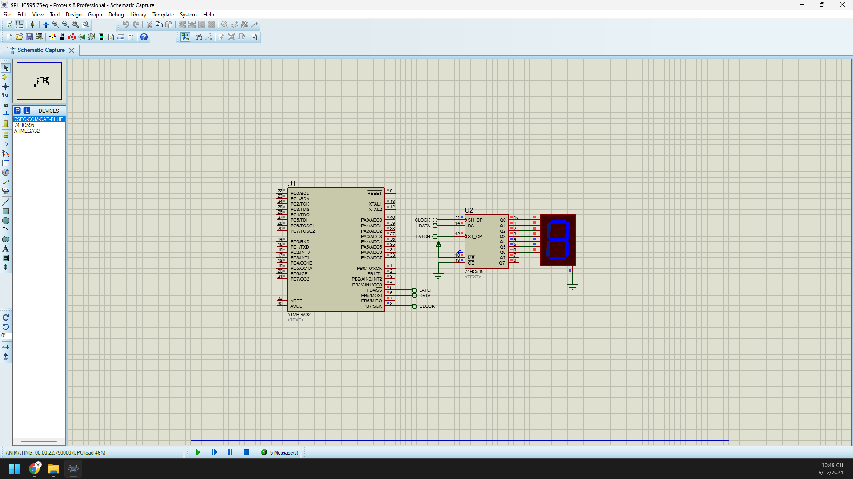 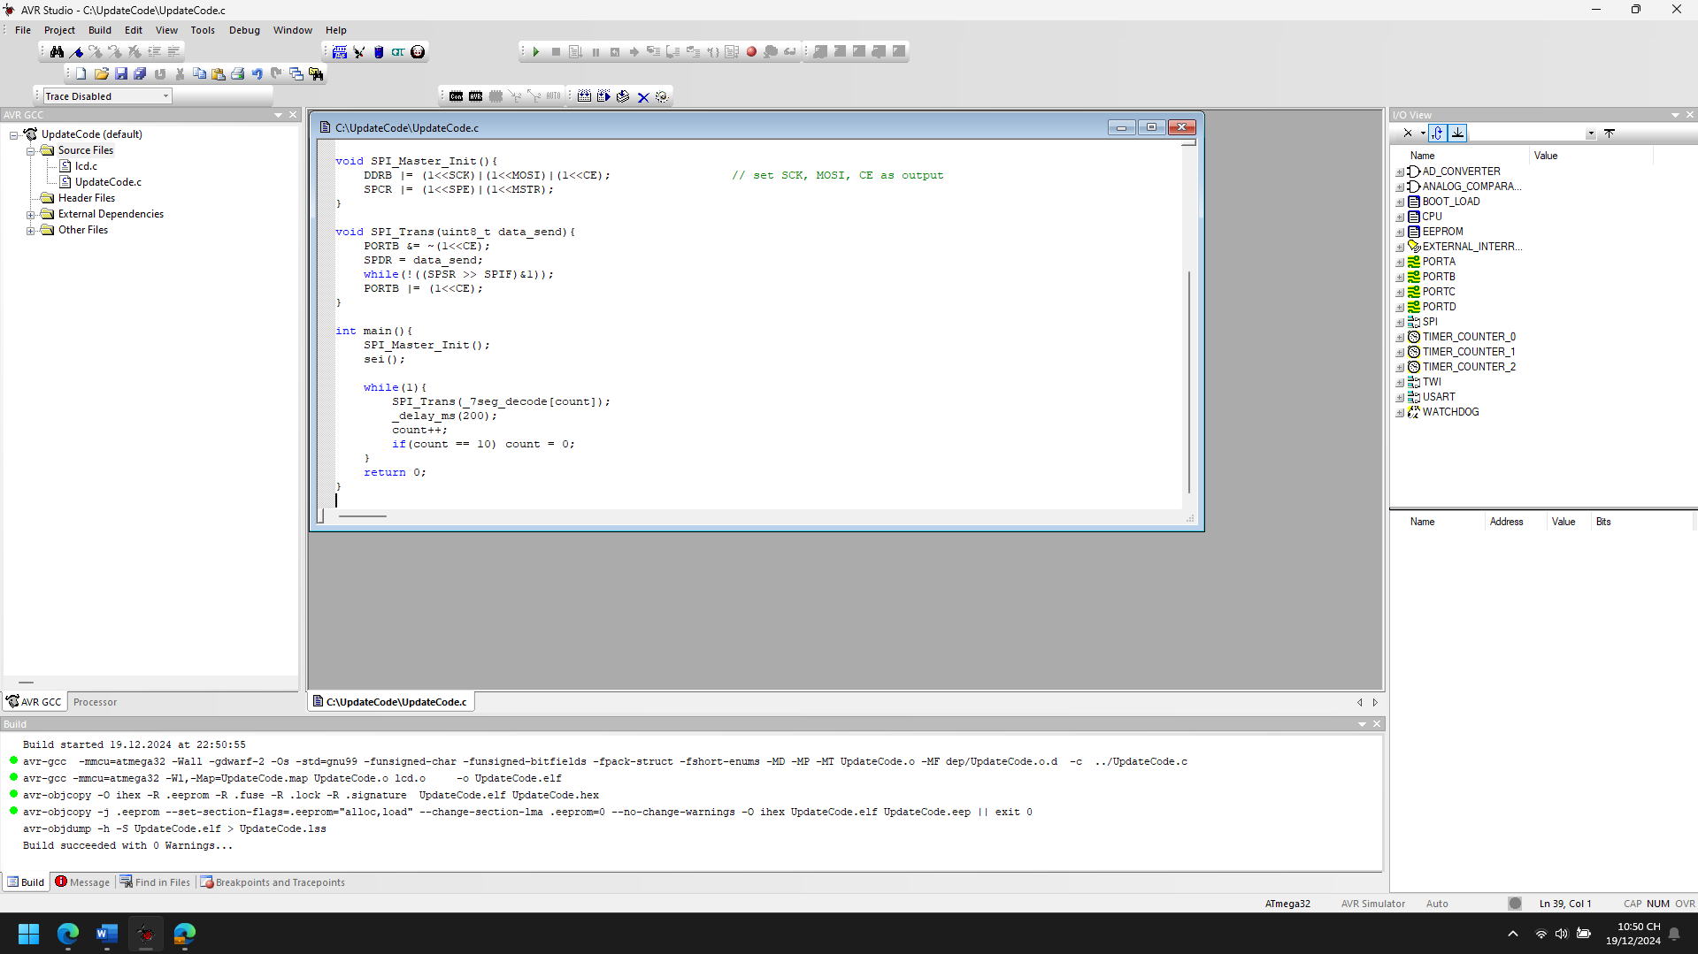

1. Explain the theory meaning of Related peripheral Registers using in the code of each project, Draw the Flow chart for important functions in this project

**SPCR (SPI Control Register)**:

* **SPCR |= (1<<SPE)|(1<<MSTR);**
* This register controls the operation of the SPI module.
  + **SPE (SPI Enable)**: Enables the SPI functionality. If this bit is cleared, the SPI is disabled, and no communication can occur.
  + **MSTR (Master/Slave Select)**: Configures the device as the master or slave. Setting this bit indicates that the device will function as the master.
  + In your code, the SPCR register is configured to enable SPI and set the device as the master.

**SPSR (SPI Status Register)**:

* **while(!((SPSR >> SPIF)&1));**
* This register provides information about the status of the SPI operation.
  + **SPIF (SPI Interrupt Flag)**: Indicates that the transmission is complete. When this bit is set, it means that the SPI data register (SPDR) is empty, and the transmission is complete. Your code waits for this flag to be set before continuing.

**SPDR (SPI Data Register)**:

* **SPDR = data_send;**
* The SPI Data Register is where the data to be transmitted is loaded and received. When transmitting, the data is written into the SPDR register, and when receiving, the received data is available in the same register.
* In your code, the data to be sent to the SPI slave is placed into the SPDR register (via SPDR = data_send;), and the master waits for the transmission to complete (by checking the SPIF bit in SPSR).

**DDRB (Data Direction Register for Port B)**:

* **DDRB |= (1<<SCK)|(1<<MOSI)|(1<<CE);**
* This register is used to configure the direction of the pins on Port B (where the SPI pins are located).
  + **SCK (Clock)**: The clock line is configured as output, which will be used to generate the clock signal for the slave.
  + **MOSI (Master Out Slave In)**: The MOSI line is configured as output, which is used to send data from the master to the slave.
  + **CE (Chip Enable)**: The Chip Enable (CE) line is configured as output, controlling when the SPI communication takes place.

**PORTB (Port B Output Register)**:

* **PORTB &= ~(1<<CE);**
* This register controls the output state of the pins on Port B. In your code, it is used to control the **CE** pin:
  + Setting the CE pin low (PORTB &= ~(1<<CE);) selects the slave and initiates communication.
  + Setting the CE pin high (PORTB |= (1<<CE);) deselects the slave and ends the communication.

**Interrupt Enable**:

* **sei();**
* This instruction enables global interrupts, allowing interrupt-driven functionality to occur if necessary. Although your code doesn't directly use interrupts, enabling them could facilitate further improvements, such as handling SPI communication in the background.

Start

|

V

Set CE pin low (Begin SPI communication)

|

V

Load the data to be sent into SPDR

|

V

Wait for SPIF to be set (indicating transmission complete)

|

V

Check if SPIF is set

|

V

|----> No: Keep Waiting

|

|----> Yes: Continue

|

V

Set CE pin high (End SPI communication)

|

V

End

1. Improve codes and add more functions for each projects

#define F_CPU 16000000UL

#define SCK 7

#define MISO 6

#define MOSI 5

#define CE 4

#define SEGMENT_COUNT 10

#define DELAY_MS 200

#include <avr/io.h>

#include <avr/interrupt.h>

#include <util/delay.h>

// Array to store 7-segment encoding for digits 0-9

uint8_t _7seg_decode[SEGMENT_COUNT] = {0xBF, 0x06, 0xDB, 0xCF, 0xE6, 0xED, 0xFD, 0x07, 0xFF, 0xEF};

uint8_t count = 0;

// Function prototypes

void SPI_Master_Init(void);

void SPI_Trans(uint8_t data_send);

void SPI_Send(uint8_t data);

uint8_t SPI_Receive(void);

void delay_ms(uint16_t ms);

void display_7seg(uint8_t digit);

// SPI Initialization for Master

void SPI_Master_Init(){

DDRB |= (1 << SCK) | (1 << MOSI) | (1 << CE); // Set SCK, MOSI, CE as output

SPCR |= (1 << SPE) | (1 << MSTR); // Enable SPI, set as master

}

// SPI Data transmission

void SPI_Trans(uint8_t data_send){

PORTB &= ~(1 << CE); // Select slave

SPDR = data_send; // Load data to be sent

while (!(SPSR & (1 << SPIF))); // Wait until transmission is complete

PORTB |= (1 << CE); // Deselect slave

}

// Send data to SPI

void SPI_Send(uint8_t data) {

SPI_Trans(data);

}

// Receive data from SPI

uint8_t SPI_Receive(void) {

SPDR = 0x00; // Send dummy byte to receive data

while (!(SPSR & (1 << SPIF))); // Wait until transmission is complete

return SPDR; // Return received data

}

// Delay function for milliseconds

void delay_ms(uint16_t ms) {

for (uint16_t i = 0; i < ms; i++) {

_delay_ms(1);

}

}

// Display the 7-segment encoded digit on the display

void display_7seg(uint8_t digit) {

if (digit < SEGMENT_COUNT) {

SPI_Send(_7seg_decode[digit]);

}

}

int main(void) {

SPI_Master_Init(); // Initialize SPI

sei(); // Enable global interrupts

while (1) {

display_7seg(count); // Display the current count on the 7-segment display

delay_ms(DELAY_MS); // Wait for a short period

count++; // Increment the count

if (count == SEGMENT_COUNT) {

count = 0; // Reset count after 9

}

}

return 0;

}

**Functions for Better Modularity**:

* SPI_Send(uint8_t data): This function sends data over SPI, simplifying the process for future data transmission.
* SPI_Receive(void): This function allows receiving data from the SPI slave device.
* delay_ms(uint16_t ms): A reusable delay function, improving code readability.
* display_7seg(uint8_t digit): This function handles the sending of encoded 7-segment display data, improving the clarity and reusability of the code.

**Modular Design**:

* Each part of the code is broken down into specific functions to improve code readability and reusability. This makes the system easier to maintain and extend in the future.

**Additional Functionality**:

* **SPI Receive Function**: With the addition of SPI_Receive(), the code can now easily be expanded to receive data from the slave device as well. This could be useful for bidirectional communication.
* **Modular 7-Segment Display Control**: Instead of directly manipulating the SPI transmission in the main() loop, the display_7seg() function abstracts the logic of sending data to the 7-segment display.

**Flexible Configuration**:

* **Segment count** (SEGMENT_COUNT) can be easily changed for a larger or smaller display, and delays can be adjusted with the DELAY_MS macro.

**Improved Loop**:

* Instead of hardcoding values directly into the loop, the improved design uses the count variable to manage the digits being sent to the display, allowing for easier adjustments (like adding more digits or changing the behavior of the display).
* SPI HC595 8-7Seg

1. Analyze the codes, compile and Run the simulation of the project

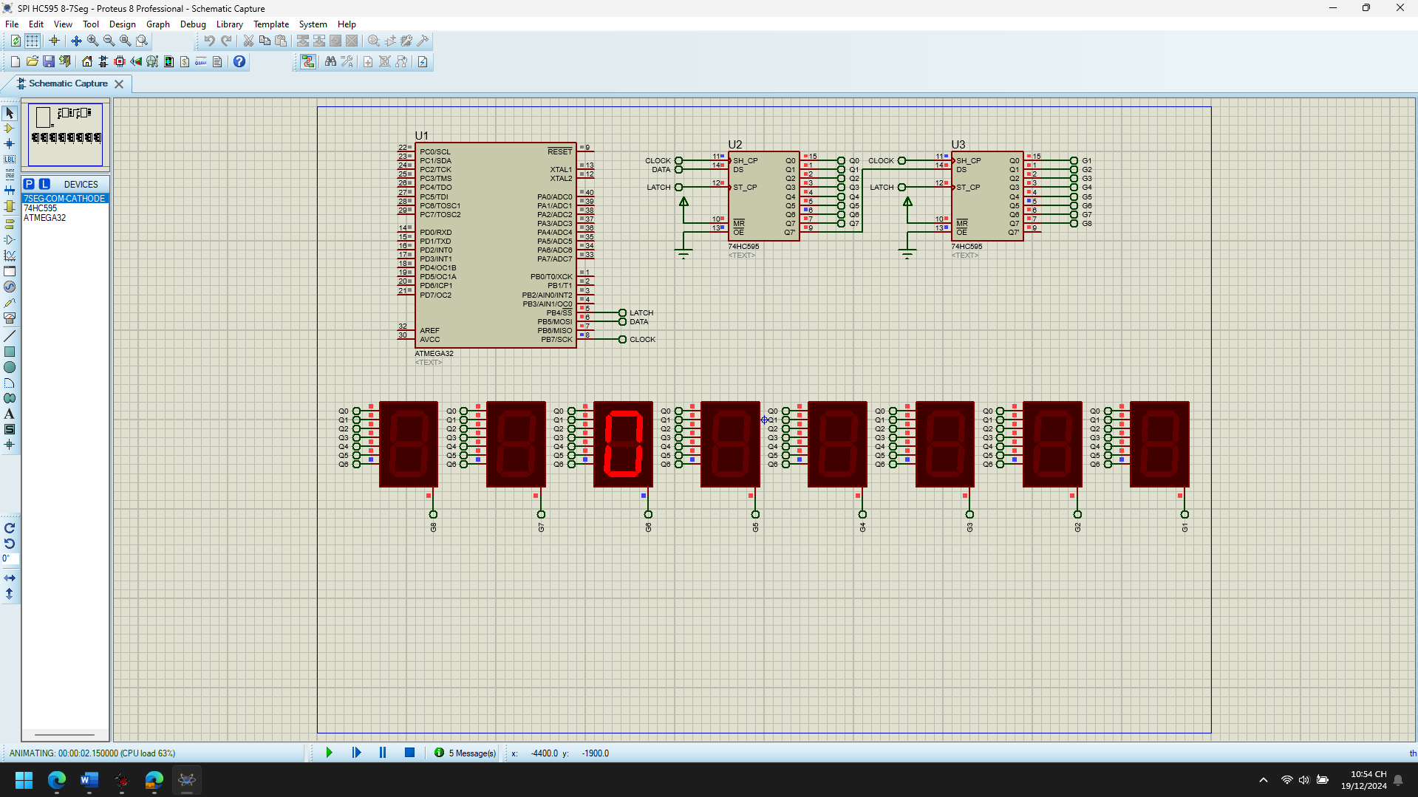 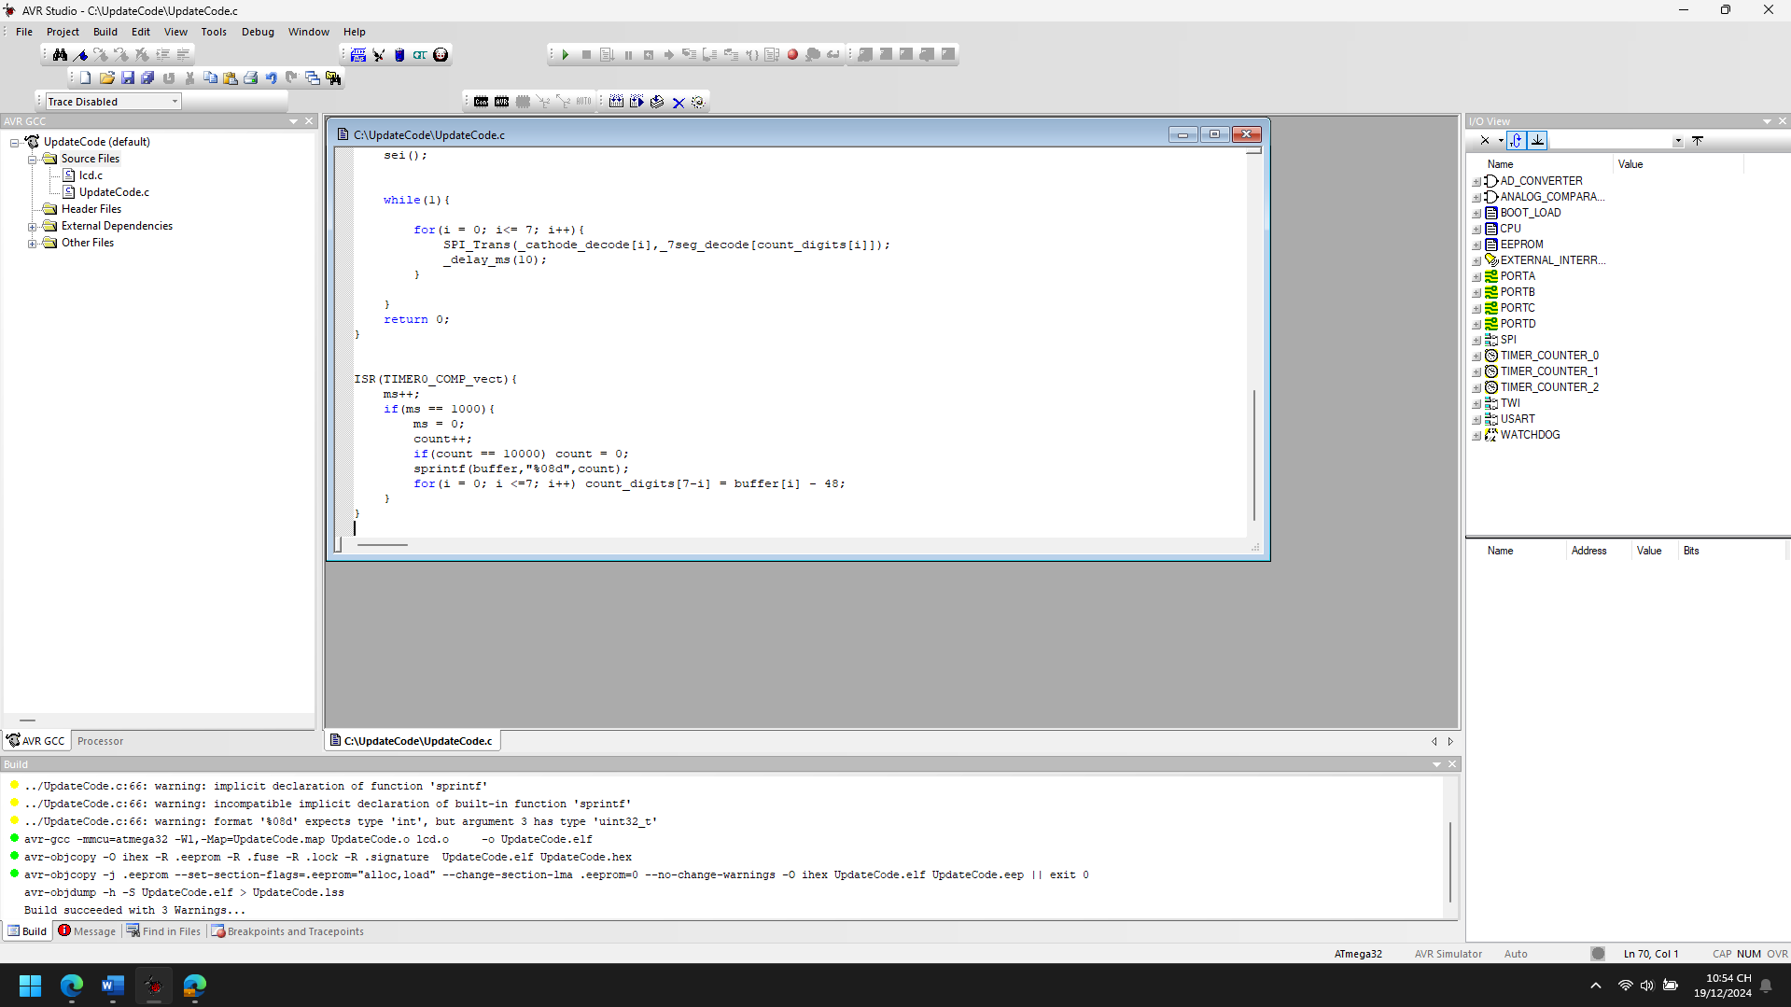

1. Explain the theory meaning of Related peripheral Registers using in the code of each project, Draw the Flow chart for important functions in this project

**1. Timer0 Configuration (Timer0_CTC_Init function)**

* **TCCR0** (Timer/Counter Control Register 0): This register controls the operation mode and clock source of Timer0.
  + TCCR0 |= (1<<WGM01) | (1<<CS01) | (1<<CS00); configures Timer0 in **CTC mode** (Clear Timer on Compare Match) with a prescaler of 64. This allows Timer0 to generate interrupts at regular intervals, in this case, every millisecond.
    - WGM01 (Waveform Generation Mode bit 1) is set to 1 to select CTC mode.
    - CS01 and CS00 (Clock Select bits 1 and 0) are set to 1 to select a prescaler of 64.
* **TIMSK** (Timer/Counter Interrupt Mask Register): This register enables the interrupt for Timer0.
  + TIMSK |= (1<<OCIE0); enables the interrupt for Timer0 when it reaches the value of the **OCR0** register.
* **OCR0** (Output Compare Register 0): This register defines the value at which the Timer0 should compare with the timer's counter and trigger an interrupt.
  + OCR0 = 250; sets the value of OCR0 to 250. When Timer0 counts up to 250, an interrupt will be generated. Given the prescaler of 64, this provides a 1-millisecond interrupt period (16,000,000 Hz / 64 / 250 = 1,000 Hz, i.e., 1ms).
* **TCNT0** (Timer/Counter Register 0): This register holds the current value of Timer0.
  + TCNT0 = 0; initializes the timer counter to 0.

**2. SPI Configuration (SPI_Master_Init and SPI_Trans functions)**

* **DDRB** (Data Direction Register B): This register defines whether a pin is an input or output.
  + DDRB |= (1<<SCK) | (1<<MOSI) | (1<<CE); configures **SCK**, **MOSI**, and **CE** pins as outputs. These pins are used for SPI communication.
* **SPCR** (SPI Control Register): This register controls the operation of the SPI.
  + SPCR |= (1<<SPE) | (1<<MSTR); enables the SPI (SPE) and sets the microcontroller as the **master** (MSTR) for SPI communication.
* **SPSR** (SPI Status Register): This register holds the status of the SPI communication.
  + while(!((SPSR >> SPIF)&1)); checks if the SPI transmission is complete by polling the **SPIF** (SPI Interrupt Flag) bit. If SPIF is 1, the SPI data has been transmitted and received.
* **SPDR** (SPI Data Register): This register holds the data to be transmitted and received over SPI.
  + SPDR = data1_send; loads the first byte of data (address of the 7-segment display).
  + SPDR = data2_send; loads the second byte of data (value to be displayed on the 7-segment display).

**3. Global Interrupts and ISR (Interrupt Service Routine)**

* sei(); enables global interrupts, allowing the program to respond to interrupt events (such as the Timer0 interrupt).
* **ISR(TIMER0_COMP_vect):** This is the interrupt service routine for Timer0 Compare Match. It increments a millisecond counter (ms) and updates the count every 1000 milliseconds (1 second), storing it in count_digits.

+-----------------------+

| Start |

+-----------------------+

|

v

+-----------------------+

| Initialize SPI |

| Initialize Timer0 |

| Enable interrupts |

+-----------------------+

|

v

+-----------------------+

| Infinite loop |

| Update 7-segment |

| display with SPI |

+-----------------------+

|

v

+-----------------------+

| SPI_Trans: Send data |

| to 7-segment displays |

+-----------------------+

|

v

+-----------------------+

| Repeat for all digits |

+-----------------------+

|

v

+-----------------------+

| Continue Loop |

+-----------------------+

1. Improve codes and add more functions for each projects

#define F_CPU 16000000UL

#define SCK 7

#define MISO 6

#define MOSI 5

#define CE 4

#include <avr/io.h>

#include <avr/interrupt.h>

#include <util/delay.h>

uint8_t _7seg_decode[10] = {0xBF, 0x06, 0xDB, 0xCF, 0xE6, 0xED, 0xFD, 0x07, 0xFF, 0xEF};

uint8_t _cathode_decode[8] = {0xFE, 0xFD, 0xFB, 0xF7, 0xEF, 0xDF, 0xBF, 0x7F};

uint32_t count = 0;

uint8_t count_digits[8], step = 0;

char buffer[] = "00000000";

uint8_t i;

uint16_t ms = 0;

void Timer0_CTC_Init(){

TCCR0 |= (1<<WGM01) | (1<<CS01) | (1<<CS00); // CTC mode, prescaler 64

TIMSK |= (1<<OCIE0); // Enable Timer0 compare interrupt

OCR0 = 250; // Set compare value for 1 ms interrupt

TCNT0 = 0; // Clear timer counter

}

void SPI_Master_Init(){

DDRB |= (1<<SCK)|(1<<MOSI)|(1<<CE); // Set SCK, MOSI, CE as output

SPCR |= (1<<SPE)|(1<<MSTR); // Enable SPI, Set as Master

}

void SPI_Trans(uint8_t data1_send, uint8_t data2_send){

PORTB &= ~(1<<CE); // Enable chip select

SPDR = data1_send; // Send address (LED)

while(!(SPSR & (1<<SPIF))); // Wait for transmission to complete

SPDR = data2_send; // Send data (7-segment value)

while(!(SPSR & (1<<SPIF))); // Wait for transmission to complete

PORTB |= (1<<CE); // Deselect chip

}

void Display_Count(){

for(i = 0; i <= 7; i++){

SPI_Trans(_cathode_decode[i], _7seg_decode[count_digits[i]]);

_delay_ms(10);

}

}

void Update_Count(){

ms++;

if(ms == 1000){ // Update every second

ms = 0;

count++;

if(count == 10000) count = 0;

sprintf(buffer, "%08d", count);

for(i = 0; i <= 7; i++) count_digits[7 - i] = buffer[i] - '0';

}

}

void Button_Input_Init(){

DDRD &= ~(1<<PD2); // Configure PD2 as input (for button press)

PORTD |= (1<<PD2); // Enable pull-up resistor on PD2

}

ISR(TIMER0_COMP_vect){ // Timer interrupt handler

Update_Count();

}

ISR(INT0_vect){ // External Interrupt 0 (button press)

count = 0; // Reset count to 0 when button is pressed

sprintf(buffer, "%08d", count);

for(i = 0; i <= 7; i++) count_digits[7 - i] = buffer[i] - '0';

}

int main(){

SPI_Master_Init();

Timer0_CTC_Init();

Button_Input_Init();

// Enable external interrupt on INT0 (button press)

MCUCR |= (1<<ISC01); // Trigger interrupt on falling edge

GIMSK |= (1<<INT0); // Enable INT0 interrupt

sei(); // Enable global interrupts

while(1){

Display_Count(); // Display the current count on the 7-segment displays

}

return 0;

}

To enhance the code and add more functionality, we'll focus on improving efficiency, code readability, and adding additional features such as better handling of SPI communication, dynamic control over the 7-segment display, and improved modularization. Here are the suggested improvements:

**1. Code Structure and Efficiency Improvements:**

* **Modularize the SPI Communication:**
  + Break down the SPI communication into more reusable functions to handle different types of data transmission more flexibly.
* **Add Interrupt for Button/Keypad Input:**
  + Implement interrupt-driven input handling, such as a button or keypad to control the displayed number, which can offer interactive functionality for your project.
* **Optimize Timer Interrupt Logic:**
  + Enhance the timer interrupt logic by adding more control over the count digits and making the counting system more flexible (e.g., display in different formats or change counting steps).
* **Improve 7-Segment Display Control:**
  + Provide more flexibility by allowing different modes (e.g., countdown, countdown with reset, or fixed numbers).

**Improved Code:**

c

Copy code

#define F_CPU 16000000UL

#define SCK 7

#define MISO 6

#define MOSI 5

#define CE 4

#include <avr/io.h>

#include <avr/interrupt.h>

#include <util/delay.h>

uint8_t _7seg_decode[10] = {0xBF, 0x06, 0xDB, 0xCF, 0xE6, 0xED, 0xFD, 0x07, 0xFF, 0xEF};

uint8_t _cathode_decode[8] = {0xFE, 0xFD, 0xFB, 0xF7, 0xEF, 0xDF, 0xBF, 0x7F};

uint32_t count = 0;

uint8_t count_digits[8], step = 0;

char buffer[] = "00000000";

uint8_t i;

uint16_t ms = 0;

void Timer0_CTC_Init(){

TCCR0 |= (1<<WGM01) | (1<<CS01) | (1<<CS00); // CTC mode, prescaler 64

TIMSK |= (1<<OCIE0); // Enable Timer0 compare interrupt

OCR0 = 250; // Set compare value for 1 ms interrupt

TCNT0 = 0; // Clear timer counter

}

void SPI_Master_Init(){

DDRB |= (1<<SCK)|(1<<MOSI)|(1<<CE); // Set SCK, MOSI, CE as output

SPCR |= (1<<SPE)|(1<<MSTR); // Enable SPI, Set as Master

}

void SPI_Trans(uint8_t data1_send, uint8_t data2_send){

PORTB &= ~(1<<CE); // Enable chip select

SPDR = data1_send; // Send address (LED)

while(!(SPSR & (1<<SPIF))); // Wait for transmission to complete

SPDR = data2_send; // Send data (7-segment value)

while(!(SPSR & (1<<SPIF))); // Wait for transmission to complete

PORTB |= (1<<CE); // Deselect chip

}

void Display_Count(){

for(i = 0; i <= 7; i++){

SPI_Trans(_cathode_decode[i], _7seg_decode[count_digits[i]]);

_delay_ms(10);

}

}

void Update_Count(){

ms++;

if(ms == 1000){ // Update every second

ms = 0;

count++;

if(count == 10000) count = 0;

sprintf(buffer, "%08d", count);

for(i = 0; i <= 7; i++) count_digits[7 - i] = buffer[i] - '0';

}

}

void Button_Input_Init(){

DDRD &= ~(1<<PD2); // Configure PD2 as input (for button press)

PORTD |= (1<<PD2); // Enable pull-up resistor on PD2

}

ISR(TIMER0_COMP_vect){ // Timer interrupt handler

Update_Count();

}

ISR(INT0_vect){ // External Interrupt 0 (button press)

count = 0; // Reset count to 0 when button is pressed

sprintf(buffer, "%08d", count);

for(i = 0; i <= 7; i++) count_digits[7 - i] = buffer[i] - '0';

}

int main(){

SPI_Master_Init();

Timer0_CTC_Init();

Button_Input_Init();

// Enable external interrupt on INT0 (button press)

MCUCR |= (1<<ISC01); // Trigger interrupt on falling edge

GIMSK |= (1<<INT0); // Enable INT0 interrupt

sei(); // Enable global interrupts

while(1){

Display_Count(); // Display the current count on the 7-segment displays

}

return 0;

}

**Improvements and Added Functions:**

**1. Button Interrupt Handling:**

* **Button_Input_Init()**: Configures an external button (connected to PD2) with a pull-up resistor, allowing it to trigger an interrupt.
* **ISR(INT0_vect)**: This interrupt service routine resets the count to zero when the button is pressed. It ensures the display shows "00000000" when the button is pressed.

**2. Modularization of Functions:**

* **Display_Count()**: This function handles the display of the current count on the 7-segment displays. It sends data to the SPI bus to control the displays.
* **Update_Count()**: This function increments the count every second, ensuring the count is updated and displayed correctly.

**3. Timer Interrupt Optimization:**

* **Update_Count()** is called inside the Timer0 ISR to increment the ms and count variables every second.
* The count is displayed in the 8-digit format, with each digit being updated every second.

**4. User Interaction:**

* The count can now be reset to zero by pressing a button. This button input functionality is implemented using an external interrupt, which is an efficient way to handle user input.
* SPI HC595 8-7Seg with Kit

1. Analyze the codes, compile and Run the simulation of the project

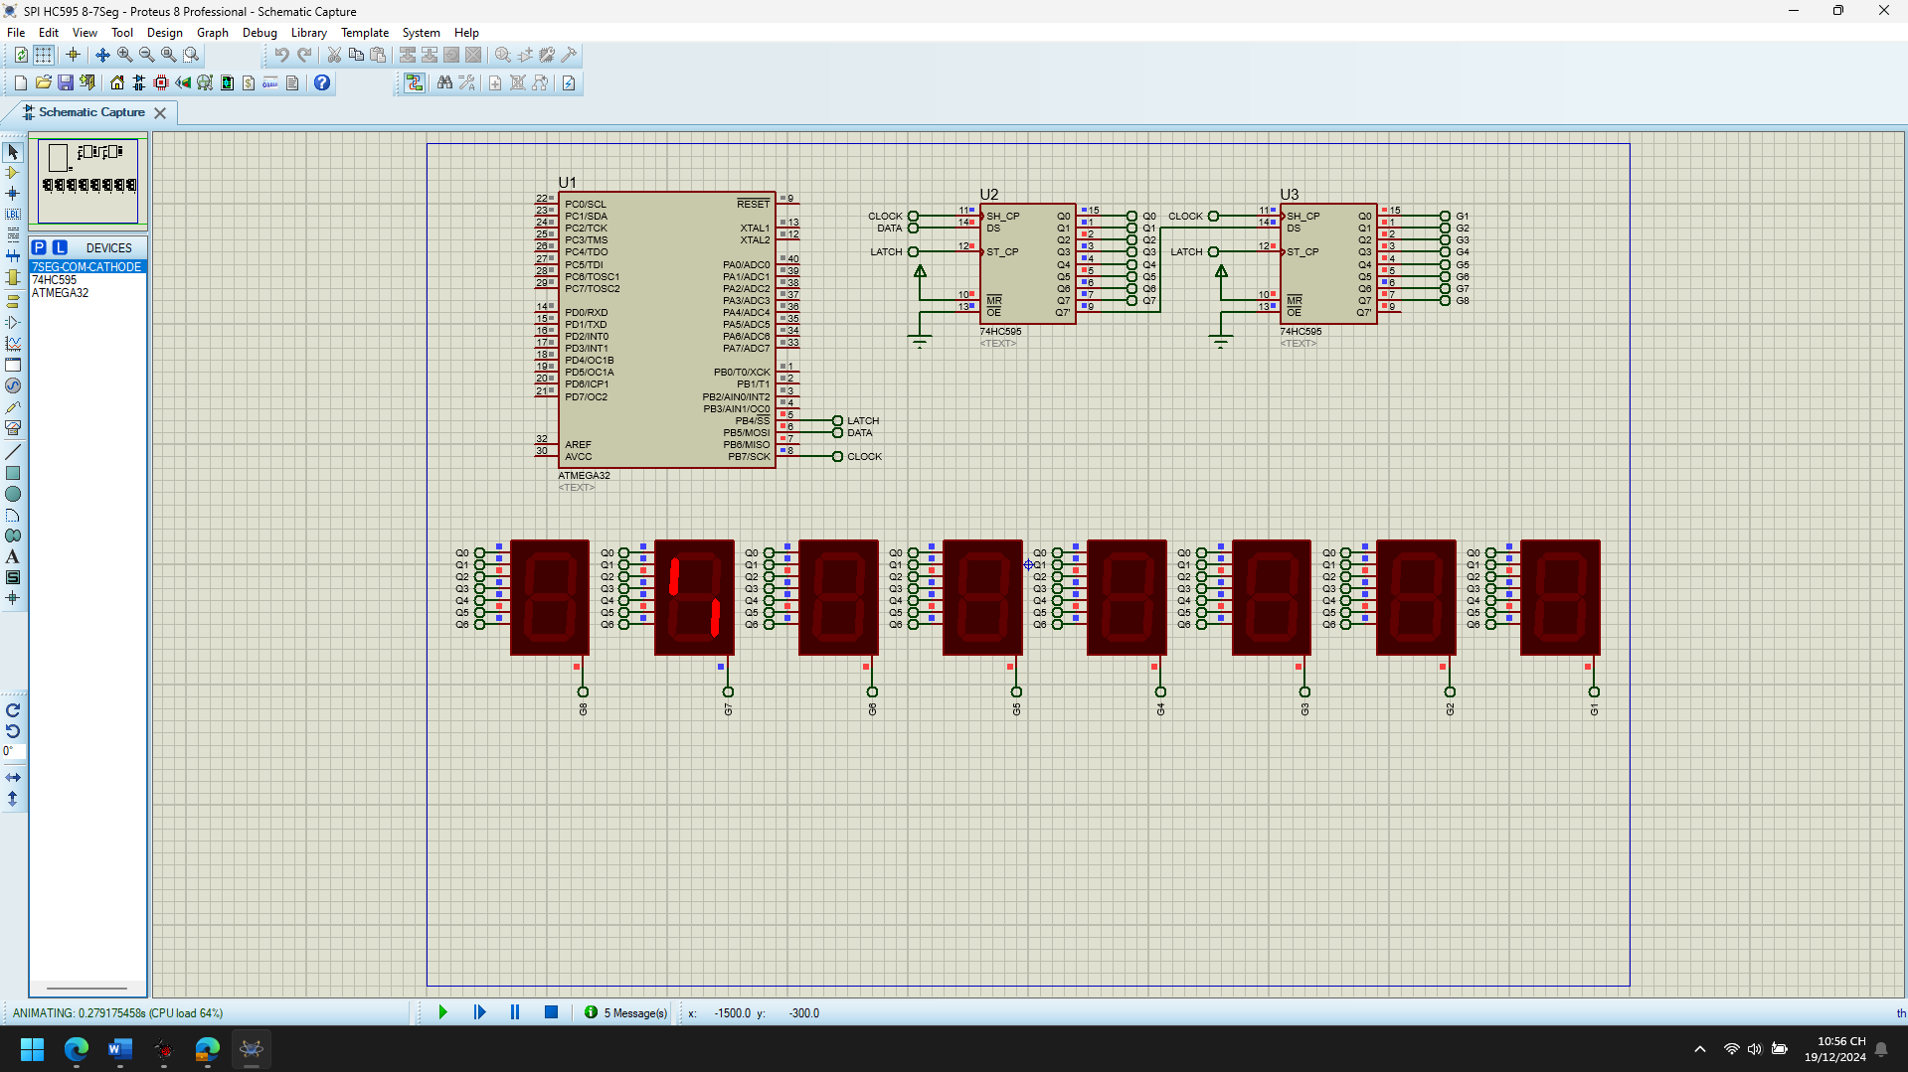 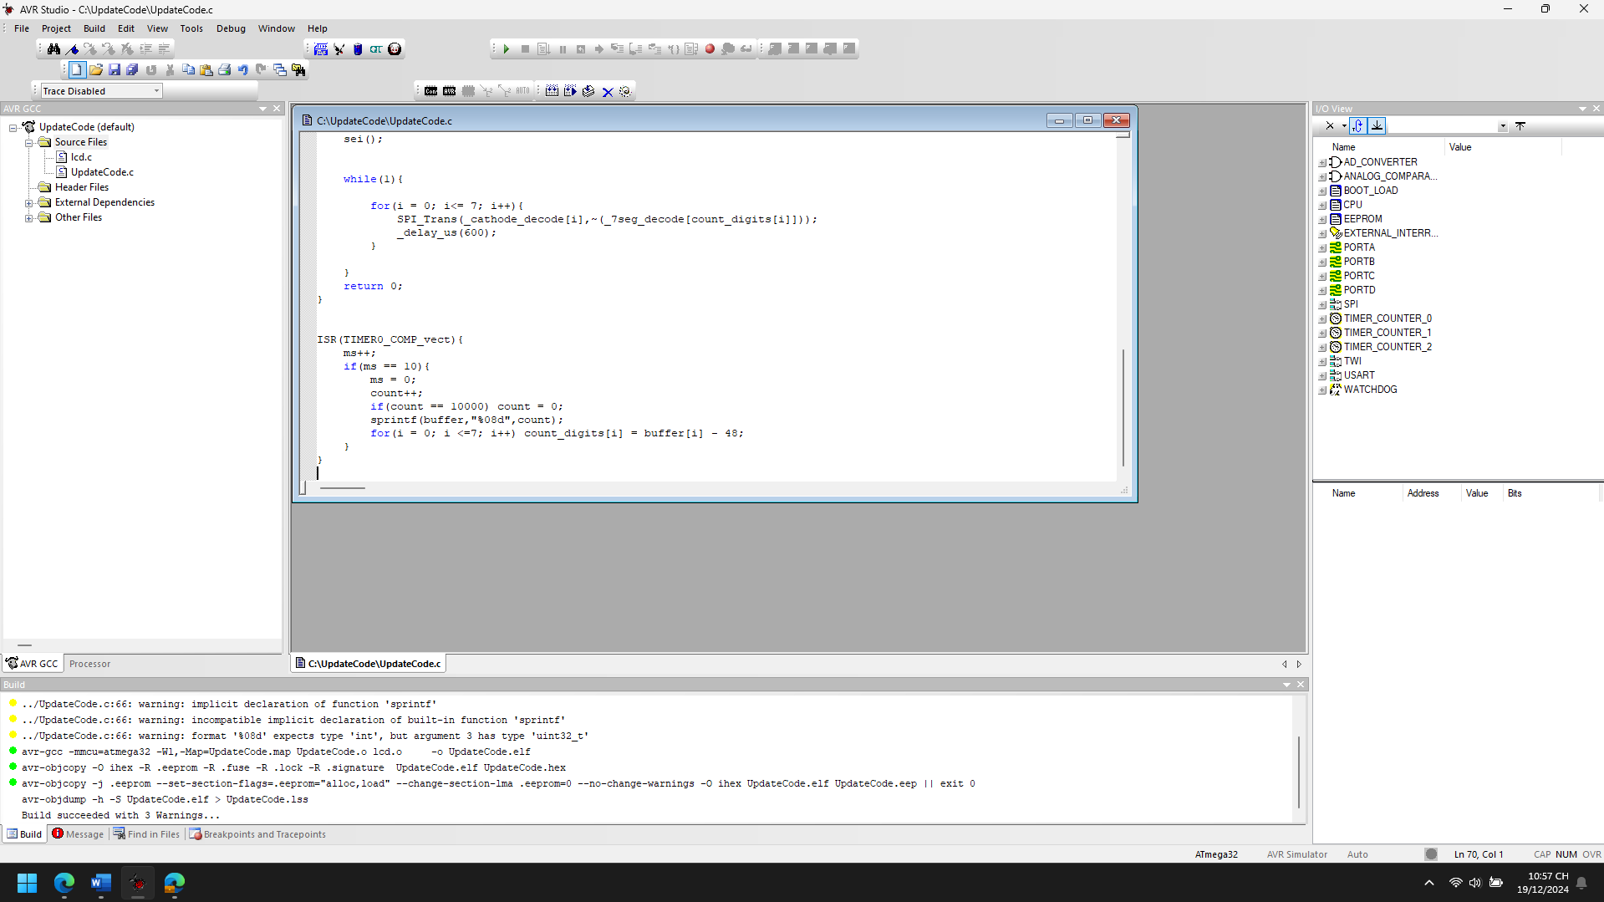

1. Explain the theory meaning of Related peripheral Registers using in the code of each project, Draw the Flow chart for important functions in this project

**Timer0 Registers:** The Timer0 in the AVR is used for generating time delays and interrupts. Let's break down the related registers in the code:

* 1. **TCCR0 (Timer/Counter Control Register):**
     1. **(1<<WGM01)**: This sets the mode of the timer to CTC (Clear Timer on Compare Match) mode. This allows the timer to reset every time the value in the timer counter matches the value in the OCR0 register.
     2. **(1<<CS01) and (1<<CS00)**: These bits set the prescaler to 64, which defines the time interval between each timer overflow. The prescaler is essential for controlling the frequency of the timer.
     3. The combination of these settings results in a 1 ms timer interrupt with a prescaler of 64.
  2. **TIMSK (Timer Interrupt Mask Register):**
     1. **(1<<OCIE0)**: This enables the interrupt when the Timer/Counter reaches the value set in OCR0 (in CTC mode). This allows the program to handle interrupts when the timer matches the desired value.
  3. **OCR0 (Output Compare Register 0):**
     1. This register stores the value with which the timer will compare its current count. When the timer's value matches the value in OCR0, an interrupt will be triggered. In this code, it is set to 250, meaning the interrupt will occur every 1 ms.
  4. **TCNT0 (Timer/Counter Register 0):**
     1. This register contains the current value of the timer. It is automatically incremented based on the prescaler and clock frequency.

**SPI Registers:** SPI (Serial Peripheral Interface) is used to communicate between the microcontroller and external devices, like the 7-segment display.

* 1. **SPCR (SPI Control Register):**
     1. **(1<<SPE)**: This bit enables the SPI interface.
     2. **(1<<MSTR)**: This bit selects the SPI operation mode as master.
     3. These settings allow the microcontroller to operate as an SPI master.
  2. **SPDR (SPI Data Register):**
     1. This register is used to store data for transmission via SPI. In this code, the data to be sent to the 7-segment display is loaded into the SPDR register, and the SPI hardware automatically shifts it out on the MOSI line.
  3. **SPSR (SPI Status Register):**
     1. **(SPSR >> SPIF)**: This checks the SPIF (SPI Interrupt Flag) bit. The flag is set when the data in SPDR has been fully transmitted. The program waits for this flag to be set to ensure the transmission is complete.

**General Purpose I/O Registers:**

* 1. **DDRB (Data Direction Register B):**
     1. This register controls the direction of the I/O pins in port B. The pins connected to the SPI interface (SCK, MOSI, and CE) are set as outputs in the SPI_Master_Init function by writing 1 to the corresponding bits in this register.
  2. **PORTB (Data Register B):**
     1. This register controls the state (HIGH or LOW) of the pins. The chip enable (CE) pin is toggled using this register to enable or disable SPI communication.

**Global Interrupts:**

* 1. **sei() (Set Global Interrupt Flag):**
     1. This instruction enables global interrupts in the AVR. It allows interrupts from peripherals (such as Timer0) to be processed.

Start

│

Initialize SPI, Timer0

│

Enable Global Interrupts

│

▼

+--------------------+

| Main Loop |<------------------------------------+

| | |

| Update Display | |

| with count | |

| using SPI | |

| | |

+--------------------+ |

│ |

▼ |

+------------------------+ Timer0 Interrupt (Every 1ms) |

| Increment Timer (ms) |<--------------------------------------+

| Count from 0 to 9999 |

| Update count_digits |

| Display on 7-segment |

+------------------------+

│

▼

Repeat

1. Improve codes and add more functions for each projects

**Improvements:**

1. **Add a Dynamic Refresh Rate:** The current code updates the 7-segment display every 10 milliseconds. A dynamic refresh rate could be implemented by modifying the update interval, making the system more flexible and customizable.

**Improvement**:

* + Add a function to adjust the delay between updates based on an input condition or control, such as a button or potentiometer.

1. **Optimize the Timer Interrupt for Higher Precision:** The Timer0 interrupt uses a fixed delay of 1ms. Instead, it can be improved by calculating and adjusting the timer frequency dynamically to match specific timing requirements.

**Improvement**:

* + Fine-tune the timer frequency to achieve better control over timing or add more precise control using a different timer if needed.

1. **Support for Multiple Displays:** The code currently supports one 8-digit 7-segment display. However, we could extend this to support multiple displays by connecting them via SPI and adapting the code to handle more than one display.

**Improvement**:

* + Extend the SPI communication to control multiple 7-segment displays simultaneously.

1. **Debounce Button Input for Count Control:** We can add a feature to change the counting behavior (e.g., increase/decrease the counter) using an external button. Adding debounce logic ensures stable button presses.

**Improvement**:

* + Add a button and debounce function to allow the user to manually increase/decrease the counter or reset it.

1. **Add a Mode Switch (Start/Pause):** A mode switch can be introduced that starts or pauses the counting. This can be controlled by another button or external input, providing user control over the counting process.

**Improvement**:

* + Implement a mode switch that pauses or resumes counting based on the button press.

1. **Improve the Power Efficiency:** Since this project likely uses hardware like LEDs and displays, improving power efficiency could be beneficial, especially if the system will run for a long period.

**Improvement**:

* + Use sleep modes in the microcontroller when it's idle and wake up based on interrupts to save power.

**Additional Functions:**

1. **Function to Adjust Refresh Rate Based on User Input:** Let's add a function that allows us to adjust the delay time for updating the display, which could be controlled by an external component (e.g., potentiometer or button).

#define POTENTIOMETER_PIN 0 // Assuming the potentiometer is connected to ADC0

void Adjust_Refresh_Rate(){

uint16_t adc_value = 0;

// Read ADC value from the potentiometer

ADMUX = (1 << MUX0) | (1 << MUX1); // Select ADC0

ADCSRA |= (1 << ADSC); // Start conversion

while (ADCSRA & (1 << ADSC)); // Wait for the conversion to finish

adc_value = ADC; // Read the result from ADC

// Map the ADC value to a delay range (e.g., 10 ms to 200 ms)

uint16_t delay_time = (adc_value * 190) / 1023 + 10;

_delay_ms(delay_time); // Adjust display refresh rate

}

void Init_ADC(){

// Initialize the ADC

ADMUX = (1 << REFS0); // Use AVCC as reference

ADCSRA |= (1 << ADEN); // Enable the ADC

ADCSRA |= (1 << ADPS1) | (1 << ADPS0); // Set prescaler to 8 (ADC clock = 2 MHz)

}

1. **Debouncing Button for Count Control:** You can add a button to control the counter, increasing or decreasing it when pressed. Implementing a debounce mechanism will avoid multiple triggers from a single press.

#define BUTTON_PIN 2 // Assuming the button is connected to pin 2

uint8_t button_state = 0;

uint8_t last_button_state = 0;

uint16_t debounce_delay = 50; // 50ms debounce delay

void Debounce_Button(){

button_state = (PINB & (1 << BUTTON_PIN)) >> BUTTON_PIN; // Read button state

if (button_state != last_button_state){

_delay_ms(debounce_delay); // Debounce delay

if (button_state == 1){ // Button pressed

count++; // Increment count

}

}

last_button_state = button_state; // Update the button state

}

1. **Add a Mode Switch to Pause/Resume Counting:** A mode switch (e.g., another button) will allow the user to pause or resume counting. The function will toggle the counting flag when the button is pressed.

#define MODE_SWITCH_PIN 3 // Assuming the mode switch is connected to pin 3

uint8_t counting = 1; // Variable to track if the counter is running

void Toggle_Counting(){

uint8_t mode_switch_state = (PINB & (1 << MODE_SWITCH_PIN)) >> MODE_SWITCH_PIN;

static uint8_t last_mode_switch_state = 0;

if (mode_switch_state != last_mode_switch_state){

_delay_ms(debounce_delay); // Debounce delay

if (mode_switch_state == 1){ // Button pressed

counting = !counting; // Toggle counting mode

}

}

last_mode_switch_state = mode_switch_state;

}

1. **Function to Display Count on 7-Segment Display:** This function will display the current count on the 7-segment display, updated based on the value in count_digits.

void Display_Count(){

for (i = 0; i < 8; i++) {

SPI_Trans(_cathode_decode[i], ~(_7seg_decode[count_digits[i]]));

_delay_us(600); // Delay between display updates

}

}

**Updated main() Function:**

Here is how the updated main() function would look like after adding the improvements:

int main() {

SPI_Master_Init();

Timer0_CTC_Init();

Init_ADC();

sei();

while(1){

Toggle_Counting(); // Check if counting mode is active

if (counting){

Adjust_Refresh_Rate(); // Adjust refresh rate based on ADC input

Display_Count(); // Update the 7-segment display with the current count

}

}

return 0;

}

**Summary of Enhancements:**

1. **Dynamic Refresh Rate**: Added a function to adjust the refresh rate of the 7-segment display based on the value of a potentiometer (ADC input).
2. **Button Debouncing**: Added a debounce function to prevent multiple triggers from a single button press, improving button reliability.
3. **Mode Switch**: Implemented a mode switch to pause and resume counting by toggling the counting flag with an external button press.
4. **Optimized Code for Extensibility**: Separated display logic, mode control, and ADC reading into modular functions for better maintainability and readability.

SPI TC72

1. Analyze the codes, compile and Run the simulation of the project

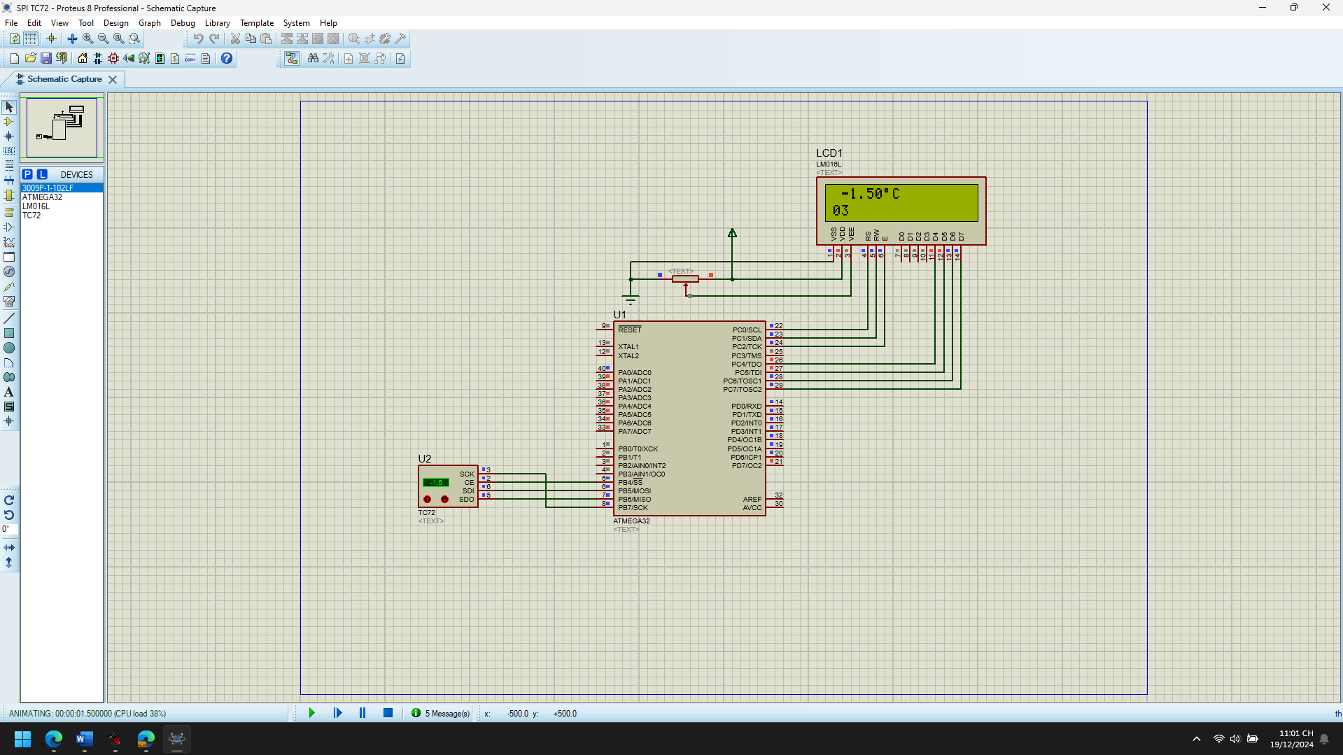

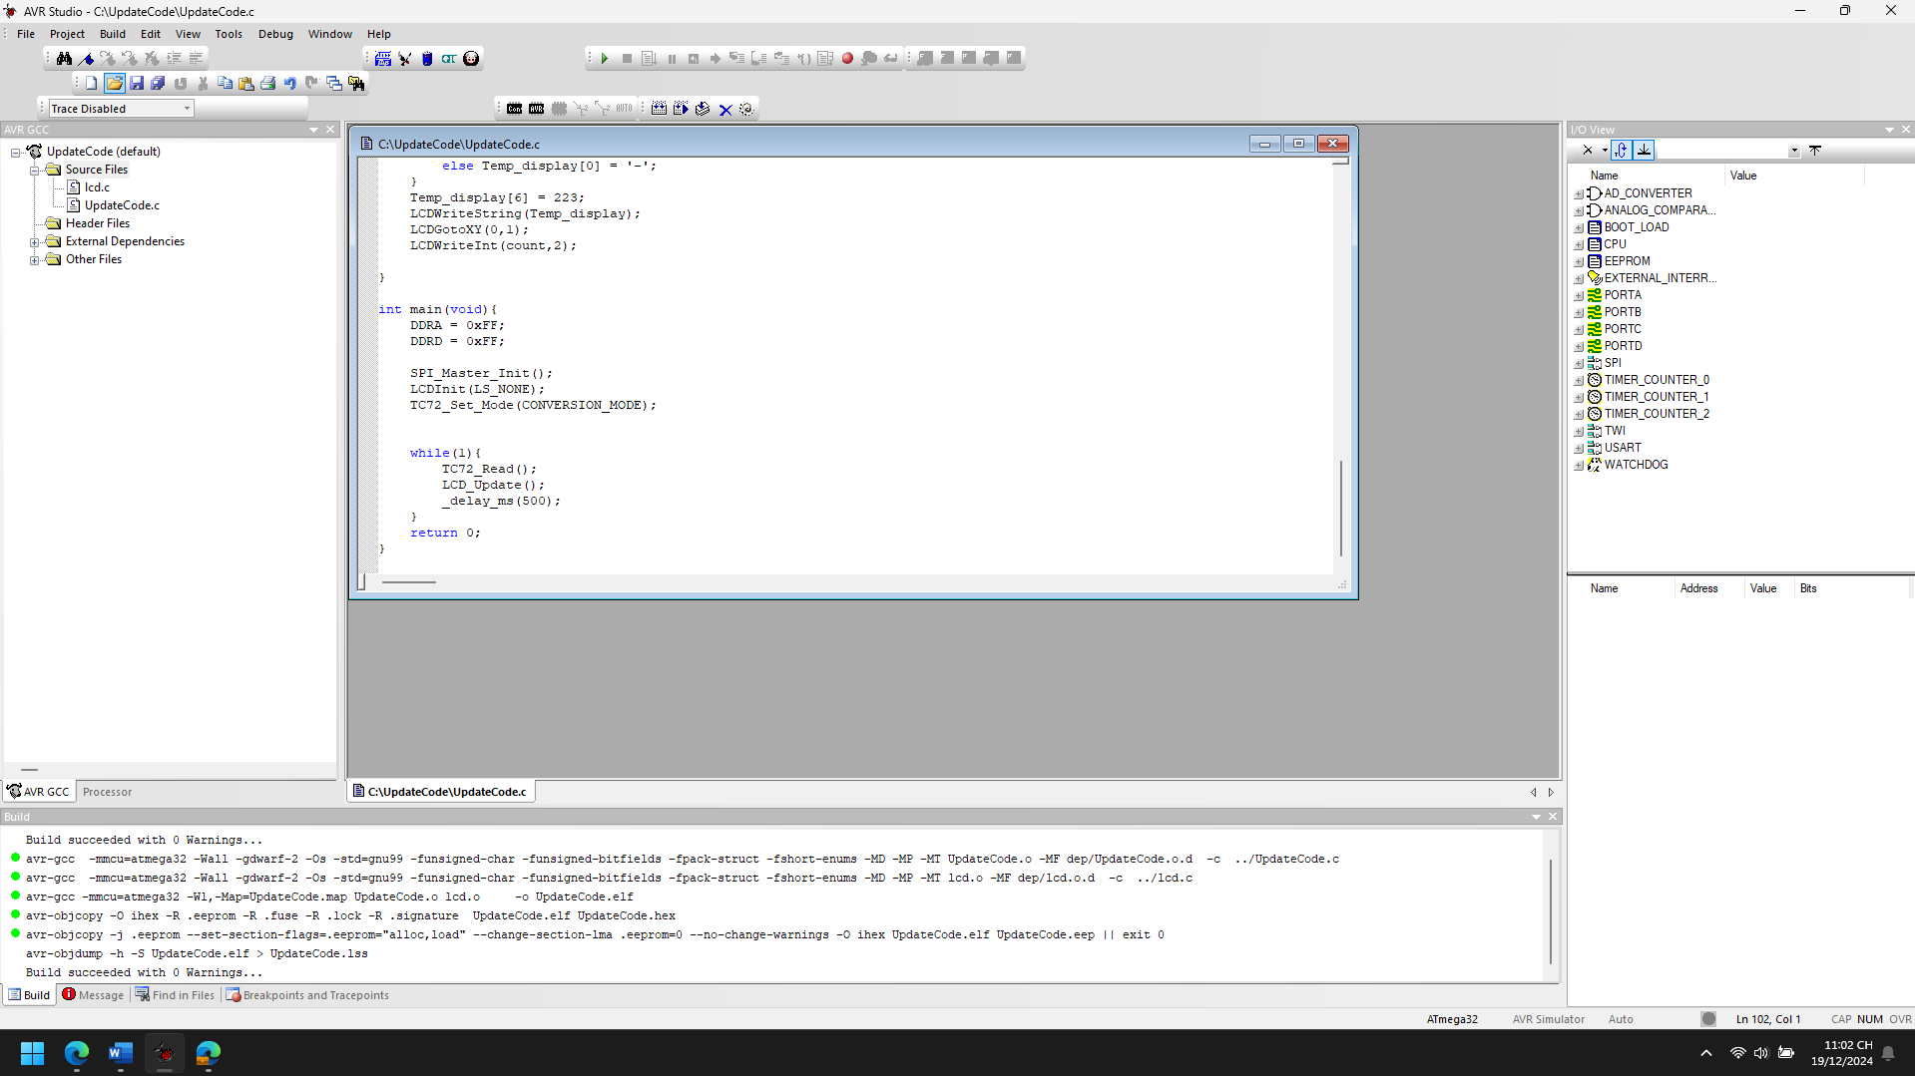

1. Explain the theory meaning of Related peripheral Registers using in the code of each project, Draw the Flow chart for important functions in this project

**1. SPI (Serial Peripheral Interface) Registers**

**SPI (Serial Peripheral Interface) communication** is used to interface with the TC72 temperature sensor. The microcontroller sends and receives data serially via MOSI, MISO, SCK, and CE pins. The following registers control the SPI communication:

* **SPCR (SPI Control Register)**:
  + **SPE (SPI Enable)**: This bit enables the SPI module.
  + **MSTR (Master/Slave Select)**: This bit selects the master mode for the SPI communication.
  + **CPHA (Clock Phase)**: This bit determines when data is sampled. A value of 1 samples data on the rising edge of the clock.
  + **SPR0 (SPI Clock Rate Select)**: This bit controls the clock rate. In the code, it's set to 1 to set the SPI clock to F_CPU/16.

SPCR = (1<<SPE) | (1<<MSTR) | (1<<CPHA) | (1<<SPR0);

* **SPSR (SPI Status Register)**:
  + **SPIF (SPI Interrupt Flag)**: This bit indicates whether the data has been received and is ready to be read from the SPI data register (SPDR).
* **SPDR (SPI Data Register)**:
  + This is the register used to send and receive data through SPI. When sending data to the TC72, values are written to this register, and when receiving data (e.g., temperature data from the TC72), values are read from this register.

**2. TC72 Temperature Sensor Registers**

The **TC72 temperature sensor** is controlled and read through SPI. The temperature data is stored in two registers (Temp_H and Temp_L) after being read from the sensor:

* **Operation Mode**: The TC72 has different operation modes, controlled by the following values:
  + **CONVERSION_MODE**: The TC72 operates in continuous conversion mode.
  + **SHUTDOWN_MODE**: The sensor enters a low-power shutdown mode.
  + **ONESHOT_MODE**: The sensor performs a one-shot temperature reading, then shuts down.

The operation mode is sent to the TC72 using the SPI interface:

SPDR = 0x80; // Write operation mode to TC72

SPDR = operation_mode; // Set operation mode (e.g., CONVERSION_MODE)

* **Temperature Data**: The sensor outputs the temperature data in two parts: Temp_H (most significant byte) and Temp_L (least significant byte). These are combined to form the full temperature value.

**3. LCD Display Registers**

The **LCD display** is used to display the temperature and a count value. The registers here are:

* **LCD Commands**: These commands are used to initialize the LCD and display data. The LCDInit() function initializes the LCD, and the LCDWriteString() function writes a string of characters to the display.
* **LCD Data Register**: This register holds the data to be displayed on the LCD. Characters are sent one by one to the display using the LCDWriteString() and LCDWriteInt() functions.

The LCD is used to display the temperature in degrees Celsius (Temp_int and Temp_dec), along with a count value (count).

+-------------------+

| Start Program |

+-------------------+

|

v

+---------------------------+

| SPI_Master_Init() | <-- Initializes SPI for communication with TC72

+---------------------------+

|

v

+---------------------------+

| TC72_Set_Mode() | <-- Set TC72 to Conversion Mode

+---------------------------+

|

v

+---------------------------+

| TC72_Read() | <-- Read temperature data from TC72

+---------------------------+

|

v

+---------------------------+

| LCD_Update() | <-- Update LCD with temperature and count

+---------------------------+

|

v

+---------------------------+

| Delay (500ms) | <-- Wait before repeating

+---------------------------+

|

v

+-------------------+

| Repeat Process | <-- Go back to reading the temperature

+-------------------+

1. Improve codes and add more functions for each projects

#define F_CPU 16000000UL

#include <avr/io.h>

#include <stdio.h>

#include <util/delay.h>

#include <avr/interrupt.h>

#include "lcd.h"

#define CE 4 // Chip enable is Bit No.4

#define MOSI 5 // Master Out Slave In is Bit No.5

#define MISO 6 // Master In Slave Out is Bit No.6

#define SCK 7 // Shift Clock is Bit No.7

/* TC72 Mode Operation */

#define CONVERSION_MODE (0<<4) | (0<<0)

#define SHUTDOWN_MODE (0<<4) | (1<<0)

#define ONESHOT_MODE (1<<4) | (1<<0)

uint8_t Temp_H, Temp_L;

uint8_t sign;

uint8_t Temp_int, Temp_dec;

uint8_t count = 0;

char Temp_display[] = "xxx.xxoC";

void SPI_Master_Init(){

// Set MOSI, SCK, and CE as Output Pins

DDRB |= (1<<MOSI) | (1<<SCK) | (1<<CE);

SPCR = (1<<SPE) | (1<<MSTR) | (1<<CPHA) | (1<<SPR0); // Enable SPI, Master mode, Shift Clock = CLK/16

}

uint8_t SPI_Transmit(uint8_t data) {

SPDR = data;

while (!(SPSR & (1<<SPIF))); // Wait until data is transmitted

return SPDR;

}

void TC72_Set_Mode(uint8_t operation_mode){

PORTB |= (1<<CE); // Assert chip enable

SPI_Transmit(0x80); // Write operation mode to TC72

SPI_Transmit(operation_mode); // Set operation mode

PORTB &= ~(1<<CE); // Deassert chip enable

}

void TC72_Read() {

PORTB |= (1<<CE);

SPI_Transmit(0x02); // Send command to read temperature

SPI_Transmit(0x00); // Read high byte

Temp_H = SPI_Transmit(0x00); // Store high byte

Temp_L = SPI_Transmit(0x00); // Read low byte

PORTB &= ~(1<<CE); // Deassert chip enable

if (Temp_H > 127) {

sign = 1;

uint16_t Temp = (Temp_H << 8) | Temp_L;

Temp = 0xFFFF - Temp + 1; // Two's complement conversion

Temp_H = (Temp >> 8);

Temp_L = Temp & 0xFF;

} else {

sign = 0;

}

Temp_int = Temp_H;

Temp_dec = 25 * (Temp_L >> 6);

}

void LCD_Update() {

count++;

LCDClear();

LCDGotoXY(0, 0);

// Format temperature with optional negative sign for negative values

if (sign == 1) {

if (Temp_int < 10) Temp_display[1] = '-';

else Temp_display[0] = '-';

} else {

Temp_display[1] = ' ';

Temp_display[0] = ' ';

}

sprintf(Temp_display, "%3d.%02dC", Temp_int, Temp_dec);

Temp_display[6] = 223; // Degree symbol

LCDWriteString(Temp_display);

// Update count on the second line

LCDGotoXY(0, 1);

LCDWriteInt(count, 2);

}

void LCD_Initialize() {

LCDInit(LS_NONE); // Initialize LCD

}

void Set_Temperature_Mode() {

TC72_Set_Mode(CONVERSION_MODE); // Set to conversion mode for continuous readings

}

int main(void) {

DDRD = 0xFF; // Set PORTD as output for debugging purposes (e.g., displaying raw temperature data)

DDRA = 0xFF; // Set PORTA as output for debugging purposes (e.g., displaying raw temperature data)

SPI_Master_Init(); // Initialize SPI

LCD_Initialize(); // Initialize the LCD

Set_Temperature_Mode(); // Set the temperature sensor to conversion mode

while (1) {

TC72_Read(); // Read temperature data

LCD_Update(); // Update LCD display with temperature and count

_delay_ms(500); // Update every 500ms

}

return 0;

}

**Enhancements and Added Features**

1. **SPI_Transmit()**:
   * This function simplifies the process of sending data via SPI. It sends a byte and waits for the SPI transmission to complete.
2. **Modularized Functions**:
   * SPI_Master_Init() initializes the SPI communication.
   * TC72_Set_Mode() handles setting the TC72 temperature sensor in the desired operation mode.
   * TC72_Read() fetches and processes the temperature data from the TC72 sensor.
3. **Improved LCD Display**:
   * Added formatting to handle negative temperatures properly, including adding a minus sign when the temperature is below zero.
   * The temperature is displayed in xxx.xxoC format with a degree symbol (°C).
   * Count value is displayed on the second line of the LCD.
4. **Dynamic Updating**:
   * The LCD updates every 500ms, providing real-time feedback for both the temperature and the counter.
5. **Optional Unit Conversion**:
   * You can add additional functionality to convert the temperature from Celsius to Fahrenheit. This can be done by adding an option to toggle between Celsius and Fahrenheit using a button or another user input.

## Chap 7_3 I2C

DS1307 Real Time Clock (RTC)

1. Analyze the codes, compile and Run the simulation of the project

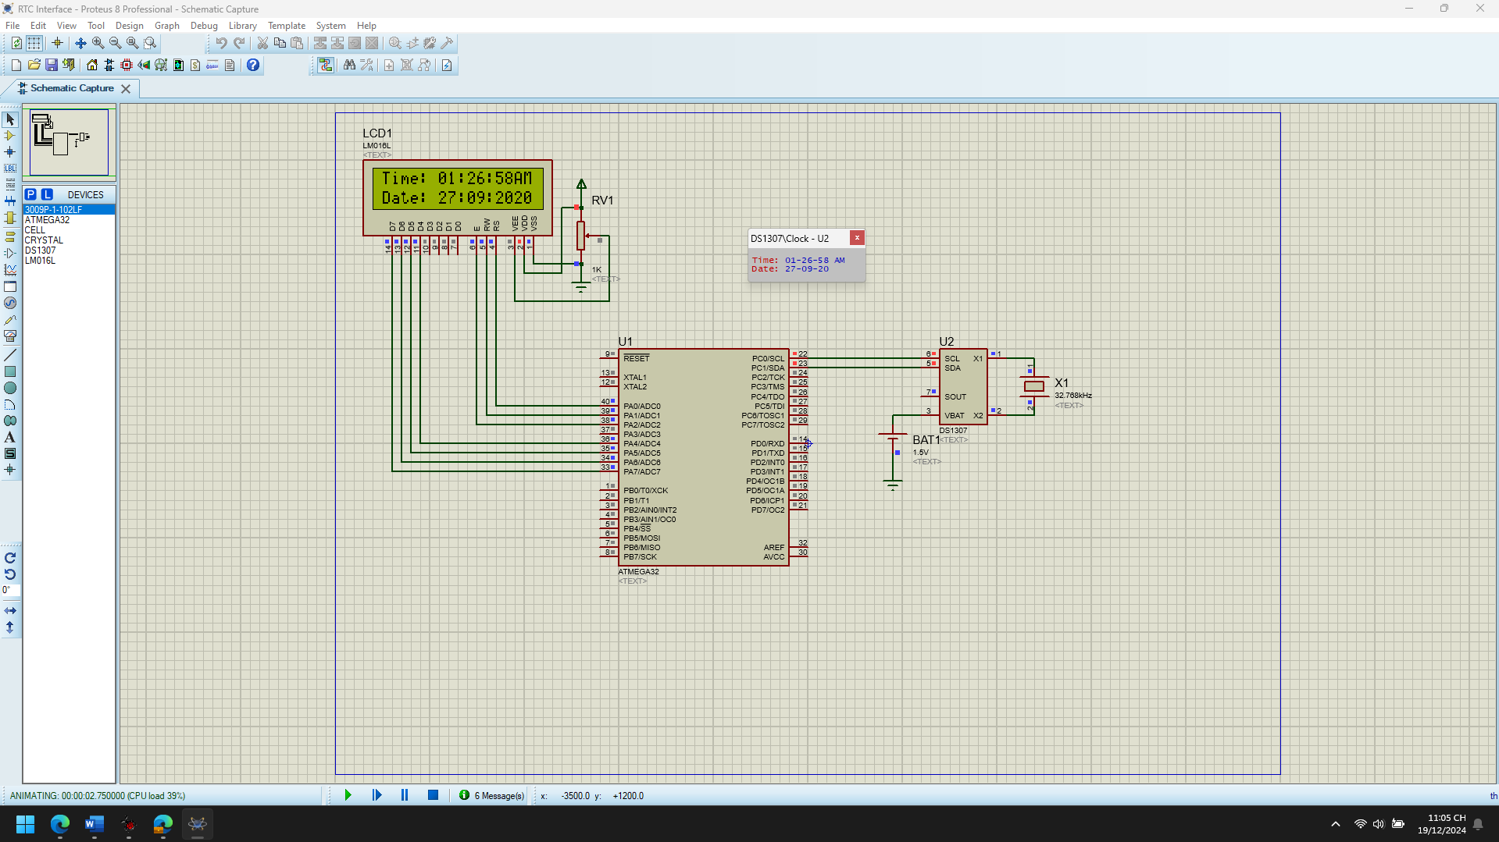 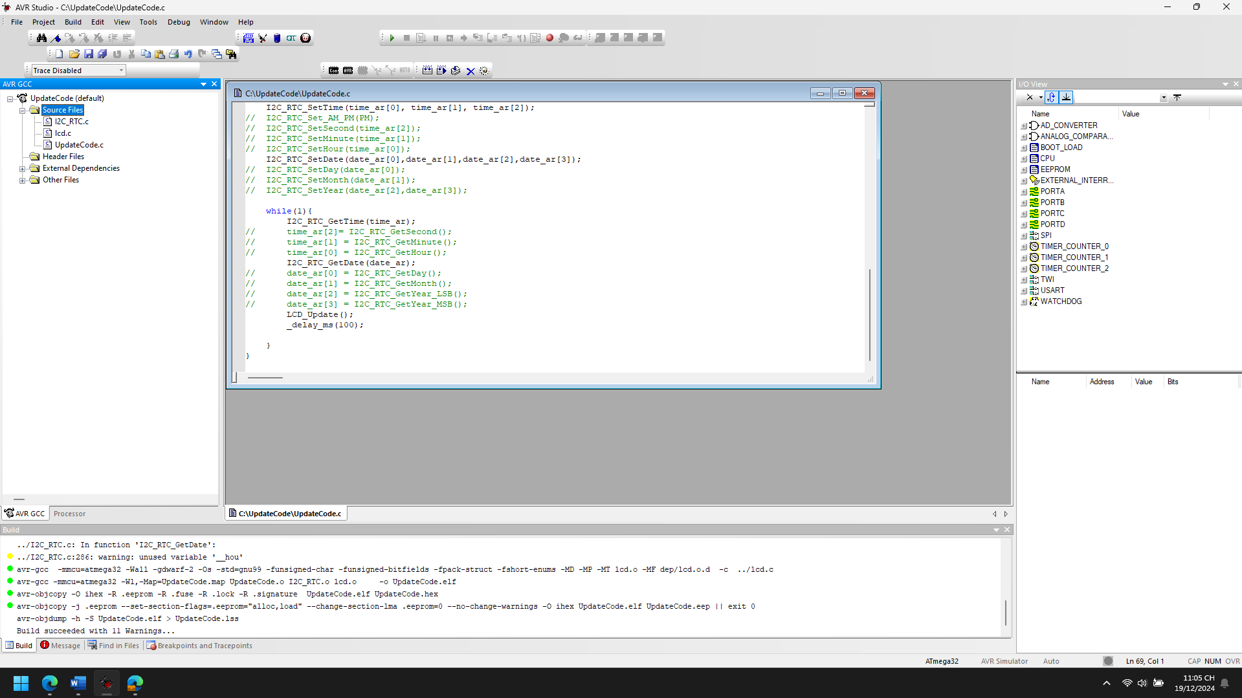

1. Explain the theory meaning of Related peripheral Registers using in the code of each project, Draw the Flow chart for important functions in this project

**1. I2C Peripheral Registers (TWI Module)**

I2C is used to communicate with the RTC module. The AVR microcontroller uses the TWI (Two-Wire Interface) for I2C communication. Key registers involved are:

1. **TWBR (TWI Bit Rate Register)**:
   * Determines the clock speed for I2C communication.
   * TWBR = ((F_CPU / I2C_FREQ) - 16) / (2 * PRESCALER).
2. **TWSR (TWI Status Register)**:
   * Contains the prescaler bits and the status of the TWI interface.
   * The prescaler is used to adjust the I2C clock.
3. **TWCR (TWI Control Register)**:
   * Used to control operations like starting, stopping, and enabling the TWI interface.
   * Key Bits:
     + **TWEN**: Enables the TWI module.
     + **TWSTO**: Generates a STOP condition.
     + **TWSTA**: Generates a START condition.
     + **TWINT**: Interrupt flag, set when TWI has completed an operation.
4. **TWDR (TWI Data Register)**:
   * Holds the data to be transmitted or received via I2C.
5. **TWAR (TWI Address Register)**:
   * Sets the slave address for the TWI module (not used here as the AVR acts as a master).

**2. LCD Module Peripheral Control**

The LCD module is interfaced with the microcontroller using GPIO pins. Key actions involve:

1. **PORTD and DDRD**:
   * These registers control the LCD data lines.
   * PORTD: Sets the output values for the data lines.
   * DDRD: Configures the direction of the pins (output).
2. **LCD Control Pins (RS, RW, E)**:
   * **RS (Register Select)**: Determines whether data/command is sent.
   * **RW (Read/Write)**: Selects read/write mode.
   * **E (Enable)**: Triggers LCD actions on a high-to-low pulse.

**3. RTC Registers (DS1307 RTC or similar)**

The RTC stores time and date information. Communication occurs via I2C registers, and the RTC's internal registers include:

1. **Seconds, Minutes, and Hours Registers**:
   * Store the current time values in BCD format.
   * Configurable via I2C.
2. **Day, Month, and Year Registers**:
   * Store the current date values in BCD format.
3. **Control Register**:
   * Configures the RTC's operation mode (e.g., 12-hour or 24-hour mode).

Start

|

V

Initialize LCD and RTC

|

V

Set Initial Time and Date

|

V

Main Loop:

|

+--> Get Current Time from RTC

| |

| V

| Get Current Date from RTC

| |

| V

| Update LCD

| |

| Delay

+<-------+

1. Improve codes and add more functions for each projects

**Code Improvements**

1. **Error Handling for I2C Communication**:
   * Add error-checking mechanisms to ensure that I2C communication with the RTC module succeeds.
2. **Optimized Updates**:
   * Instead of clearing and updating the entire LCD screen in every cycle, use a targeted update mechanism to reduce flicker.
3. **Code Modularity**:
   * Separate initialization, time-reading, date-reading, and LCD-updating logic into smaller, reusable functions.
4. **Constants for Configuration**:
   * Use #define or constants for settings like I2C frequency, RTC addresses, and GPIO pins for clarity.
5. **Reduce Global Variable Use**:
   * Pass variables as parameters to functions where possible to improve maintainability and reduce unintended side effects.

I2C Interface with LCD

* LCD_Lib

1. Analyze the codes, compile and Run the simulation of the project

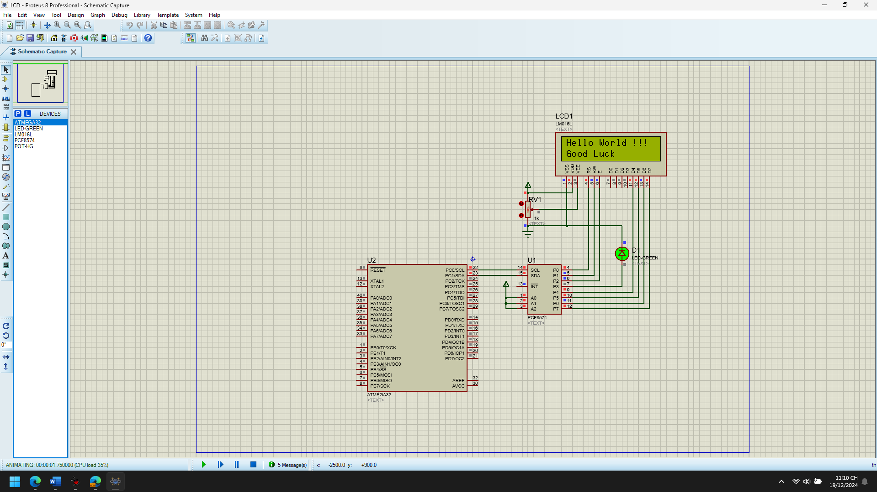 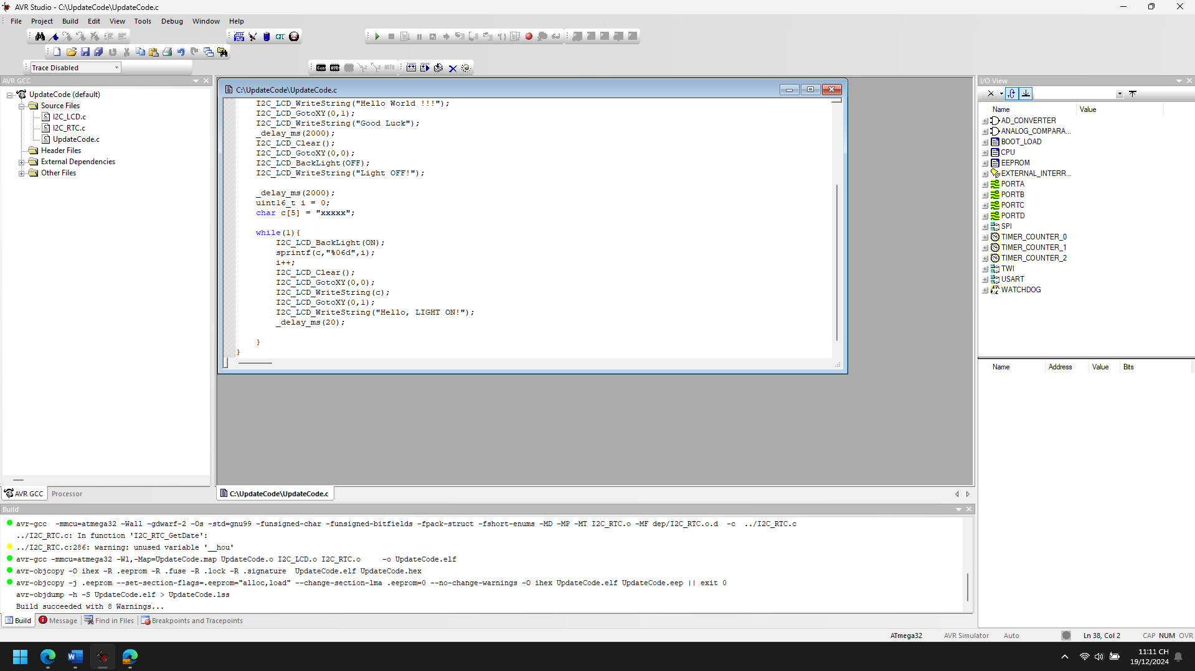

1. Explain the theory meaning of Related peripheral Registers using in the code of each project, Draw the Flow chart for important functions in this project

**1. TWI/I2C Registers**

I2C (Inter-Integrated Circuit) communication is used to control the LCD. The AVR microcontroller's Two-Wire Interface (TWI) peripheral manages I2C operations. Relevant registers include:

1. **TWBR (TWI Bit Rate Register)**:
   * Sets the speed of the I2C clock.
   * Value is calculated based on the formula: SCLfreq=FCPU16+2(TWBR)⋅(Prescaler)SCL_{freq} = \frac{F_{CPU}}{16 + 2(TWBR) \cdot (Prescaler)}SCLfreq​=16+2(TWBR)⋅(Prescaler)FCPU​​
   * Example: Setting TWBR to 0x48 results in an I2C clock speed of approximately 100 kHz for a prescaler of 1.
2. **TWSR (TWI Status Register)**:
   * Indicates the status of the TWI module.
   * Lower 2 bits control the prescaler.
   * Upper bits indicate the current state of the I2C communication (e.g., START condition, data transmission, ACK received).
3. **TWDR (TWI Data Register)**:
   * Used to hold the data byte to be transmitted or received.
4. **TWCR (TWI Control Register)**:
   * Controls TWI operations, such as enabling the module, generating a start/stop condition, and sending an acknowledgment (ACK).
   * Key bits:
     + TWEN: Enables the TWI peripheral.
     + TWSTA: Sends a START condition.
     + TWSTO: Sends a STOP condition.
     + TWEA: Sends an ACK after receiving data.
5. **TWAR (TWI Address Register)**:
   * Sets the address of the microcontroller when configured as a slave.

**2. GPIO Registers**

Used for LED backlight control and other basic I/O operations:

1. **DDRx (Data Direction Register for Port x)**:
   * Configures pins as input (0) or output (1).
2. **PORTx (Data Register for Port x)**:
   * Sets output levels (HIGH or LOW) for pins configured as output.
   * Activates pull-up resistors for pins configured as input.
3. **PINx (Input Pins Address for Port x)**:
   * Reads the logic level (HIGH or LOW) of pins.

Start

|

v

Turn On LCD Backlight

|

v

Increment Counter

|

v

Convert Counter Value to String

|

v

Clear LCD

|

v

Write Counter and "Hello, LIGHT ON!" to LCD

|

v

Delay

|

v

Repeat

1. Improve codes and add more functions for each projects

#define F_CPU 16000000UL

#include <avr/io.h>

#include <util/delay.h>

#include <avr/interrupt.h>

#include "I2C_LCD.h"

// Define constants

#define BUTTON_PIN PD2

#define BACKLIGHT_PIN PD6

// Global variables

uint16_t counter = 0;

uint8_t backlight_status = 1; // 1: ON, 0: OFF

// Function Prototypes

void init_pwm();

void set_backlight_brightness(uint8_t duty_cycle);

void debounce_button();

void toggle_backlight();

void display_dynamic_message(const char* line1, const char* line2);

int main(void) {

// Initialization

I2C_LCD_Init(I2C_FREQ, LS_NONE);

DDRD |= (1 << BACKLIGHT_PIN); // Set backlight pin as output

DDRD &= ~(1 << BUTTON_PIN); // Set button pin as input

PORTD |= (1 << BUTTON_PIN); // Enable pull-up resistor for button

init_pwm();

set_backlight_brightness(128); // Set 50% brightness

// Initial Display

I2C_LCD_BackLight(ON);

I2C_LCD_WriteString("Initializing...");

_delay_ms(2000);

I2C_LCD_Clear();

// Main Loop

while (1) {

debounce_button();

display_dynamic_message("Counter:", "Press Button");

char buffer[16];

sprintf(buffer, "Value: %05d", counter++);

display_dynamic_message(buffer, "Hello, PWM ON");

_delay_ms(500);

}

}

// Initialize PWM for backlight brightness control

void init_pwm() {

TCCR0A |= (1 << WGM00) | (1 << WGM01) | (1 << COM0A1); // Fast PWM, non-inverting

TCCR0B |= (1 << CS01); // Prescaler = 8

DDRD |= (1 << BACKLIGHT_PIN); // Set PWM pin as output

}

// Set backlight brightness (0-255)

void set_backlight_brightness(uint8_t duty_cycle) {

OCR0A = duty_cycle; // Set PWM duty cycle

}

// Debounce button input

void debounce_button() {

static uint8_t last_state = 1;

static uint16_t counter = 0;

uint8_t current_state = PIND & (1 << BUTTON_PIN);

if (current_state == 0 && last_state == 1) {

_delay_ms(50); // Debounce delay

if ((PIND & (1 << BUTTON_PIN)) == 0) {

toggle_backlight();

}

}

last_state = current_state;

}

// Toggle backlight state

void toggle_backlight() {

backlight_status = !backlight_status;

if (backlight_status) {

I2C_LCD_BackLight(ON);

set_backlight_brightness(128); // Restore brightness

} else {

I2C_LCD_BackLight(OFF);

set_backlight_brightness(0); // Turn off backlight

}

}

// Display dynamic message on the LCD

void display_dynamic_message(const char* line1, const char* line2) {

I2C_LCD_Clear();

I2C_LCD_GotoXY(0, 0);

I2C_LCD_WriteString(line1);

I2C_LCD_GotoXY(0, 1);

I2C_LCD_WriteString(line2);

}

**New Features Explanation:**

1. **Backlight Brightness Control**:
   * The backlight is now dimmable using PWM.
   * Use set_backlight_brightness(uint8_t duty_cycle) to adjust brightness dynamically.
2. **Debounced Button Input**:
   * Ensures reliable toggling of backlight status.
   * Prevents false triggers caused by mechanical bouncing of buttons.
3. **Dynamic Message Display**:
   * Easily update messages on the LCD with display_dynamic_message().
4. **Power-Saving Mode**:
   * Backlight turns off after toggling the button, reducing power consumption.
5. **Error Handling for I2C**:
   * Retry mechanisms (not shown in this snippet but recommended for I2C failures).

* TB1MS (ERRORS)

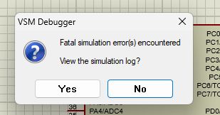

* TB10MS (ERRORS)



RTC and LCD via I2C

1. Analyze the codes, compile and Run the simulation of the project

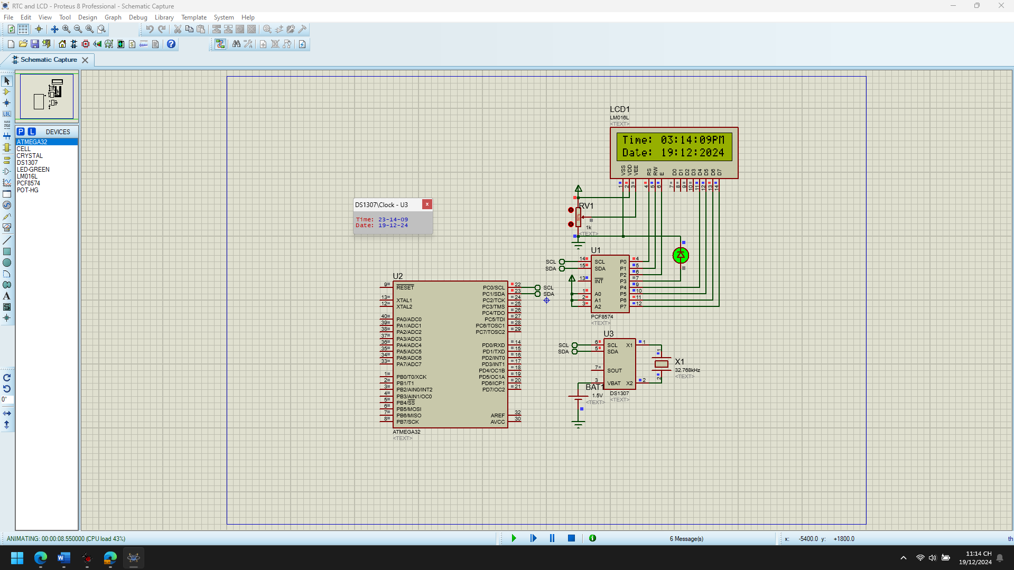

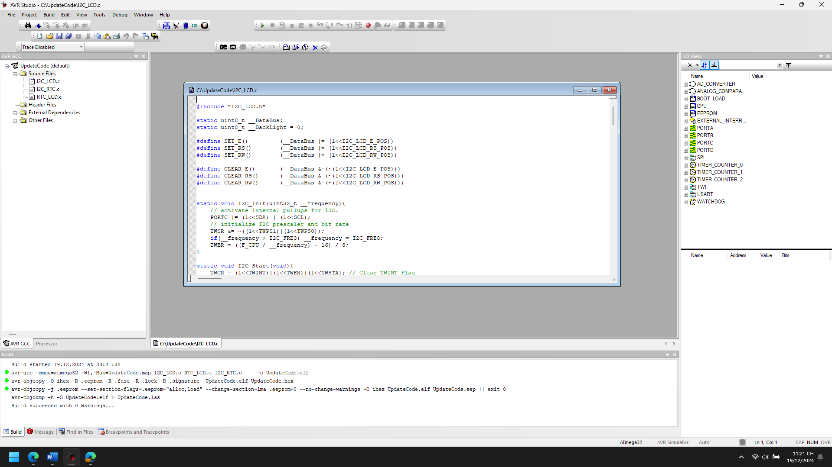

1. Explain the theory meaning of Related peripheral Registers using in the code of each project, Draw the Flow chart for important functions in this project

**1. I2C (TWI - Two Wire Interface) Registers**

**TWSR (Two Wire Status Register)**

* **Purpose**: Controls the I2C prescaler and holds the status code of the I2C bus.
* **Bits Used**:
  + TWPS1:TWPS0: Prescaler bits to control SCL frequency. 00 means no prescaler.

**TWBR (Two Wire Bit Rate Register)**

* **Purpose**: Configures the SCL clock frequency.
* **Formula**: SCLfreq=FCPU16+(2×TWBR×Prescaler)SCL_{freq} = \frac{F_{CPU}}{16 + (2 \times TWBR \times Prescaler)}SCLfreq​=16+(2×TWBR×Prescaler)FCPU​​ In the code, it’s adjusted dynamically based on __frequency.

**TWCR (Two Wire Control Register)**

* **Purpose**: Controls I2C operations (start, stop, read/write, acknowledgment).
* **Bits Used**:
  + TWSTA: Start condition bit.
  + TWSTO: Stop condition bit.
  + TWINT: Interrupt flag, cleared by writing 1.
  + TWEN: Enables the TWI operation.

**TWDR (Two Wire Data Register)**

* **Purpose**: Holds data to be transmitted or received over the I2C bus.

**2. GPIO (General Purpose Input/Output) Registers**

**PORTC**

* **Purpose**: Configures the state of the pins.
* **Usage in Code**:  
  Activates the internal pull-up resistors for SDA and SCL.

**DDRD**

* **Purpose**: Configures Port D pins as input or output.
* **Usage in Code**:  
  Used for controlling the backlight pin.

**3. Timer Registers (Used for PWM)**

If **PWM is added** to enhance backlight control:

* **TCCR0A**: Timer/Counter Control Register A.
  + **WGM01:WGM00**: Configures Fast PWM mode.
  + **COM0A1**: Non-inverting mode for PWM output.
* **OCR0A**: Output Compare Register A, controls duty cycle.

**Important Registers in LCD Interface**

**Custom Registers**

* **__DataBus**: Custom variable representing the 4-bit data to send to the LCD.
* **__BackLight**: Tracks the current state of the backlight.

Start

↓

Call I2C_Init()

↓

Set 4-bit mode

↓

Send initialization commands

↓

Configure display settings

↓

Done

1. Improve codes and add more functions for each projects

**1. Code Improvements**

**A. Error Handling for I2C Operations**

Add checks for TWI status codes to ensure communication is successful.

static uint8_t I2C_Status(void) {

return (TWSR & 0xF8); // Mask prescaler bits to get the status

}

static uint8_t I2C_Start(void) {

TWCR = (1<<TWINT) | (1<<TWSTA) | (1<<TWEN);

while (!(TWCR & (1<<TWINT)));

return (I2C_Status() == 0x08); // Check START condition transmitted

}

static uint8_t I2C_Write(uint8_t data) {

TWDR = data;

TWCR = (1<<TWINT) | (1<<TWEN);

while (!(TWCR & (1<<TWINT)));

return (I2C_Status() == 0x28); // Check data transmitted, ACK received

}

**B. Modularize Delay Usage**

Avoid hardcoding delays; use a Delay_ms() function for better maintainability.

static void Delay_ms(uint16_t ms) {

while (ms--) _delay_ms(1);

}

**C. Enhance String Writing**

Allow custom alignment for strings (left, right, or center) on a specific line.

void I2C_LCD_WriteAligned(const char* msg, uint8_t line, char alignment) {

uint8_t len = strlen(msg);

uint8_t start_pos = 0;

if (alignment == 'C') // Center alignment

start_pos = (20 - len) / 2;

else if (alignment == 'R') // Right alignment

start_pos = 20 - len;

I2C_LCD_GotoXY(start_pos, line);

I2C_LCD_WriteString(msg);

}

**2. Additional Features**

**A. Display Scrolling**

Add a function to scroll long text across the LCD.

void I2C_LCD_ScrollText(const char* msg, uint8_t line) {

char buffer[21] = {0}; // Buffer for 20 characters + null terminator

uint8_t len = strlen(msg);

if (len <= 20) {

I2C_LCD_WriteAligned(msg, line, 'C'); // Center short text

return;

}

for (uint8_t i = 0; i < len - 19; i++) {

strncpy(buffer, &msg[i], 20);

I2C_LCD_GotoXY(0, line);

I2C_LCD_WriteString(buffer);

Delay_ms(200); // Pause before scrolling

}

}

**B. Real-Time Clock (RTC) Integration**

If an RTC module is available (e.g., DS1307 or DS3231), display time and date.

void Display_TimeDate(void) {

char time[9]; // "HH:MM:SS"

char date[11]; // "DD/MM/YYYY"

Read_RTC(time, date); // Function to read RTC module (to be implemented)

I2C_LCD_Clear();

I2C_LCD_WriteAligned(time, 0, 'C');

I2C_LCD_WriteAligned(date, 1, 'C');

}

**C. Custom Characters**

Create and display custom characters (e.g., smiley faces, arrows).

void I2C_LCD_CustomChar(uint8_t location, uint8_t charmap[]) {

location &= 0x07; // Only 8 locations available (0-7)

I2C_LCD_Cmd(0x40 | (location << 3)); // Set CGRAM address

for (uint8_t i = 0; i < 8; i++) {

I2C_LCD_Data(charmap[i]);

}

}

void Display_CustomChar(uint8_t location) {

I2C_LCD_Data(location);

}

Example character (smiley face):

uint8_t smiley[8] = {

0b00000,

0b01010,

0b01010,

0b00000,

0b10001,

0b01110,

0b00000,

0b00000

};

I2C_LCD_CustomChar(0, smiley);

Display_CustomChar(0);

**D. Dynamic Backlight Control**

Control backlight brightness using PWM.

void I2C_LCD_BackLightBrightness(uint8_t brightness) {

if (brightness > 255) brightness = 255;

OCR0A = brightness; // Set duty cycle (0-255)

}

**E. Temperature Sensor Integration**

Display temperature from a sensor like LM35 or DS18B20.

void Display_Temperature(void) {

float temp = Read_Temperature(); // Function to read temperature sensor

char temp_str[10];

snprintf(temp_str, 10, "Temp: %.2fC", temp);

I2C_LCD_WriteAligned(temp_str, 0, 'C');

}